

**Preview Press Kit**

**Commercial Vehicle Show   
in Birmingham**

**2021**

**CV Show 31st August – 02nd September 2021**  
  
Preview Press Kit

**Contents**

* **Preview:** Hankook are proud to present a renewed lineup of commercial tyres and brands at the 2021 Commercial Vehicle Show.
* **SmartFlex AH51/DH 51**: Hankook deploys new material, design and tread technologies to extend the premium status of the SmartFlex product range
* **MAN OE:** Hankook supplies Original Equipment Tyres to MAN
* **SCANIA OE:** Hankook truck tyres for construction site use now as Original Equipment on all Scania trucks
* **MBT OE**: Hankook Tire supplies sizes for original fitment on premium trucks
* **SmartWork:** Treads for mixed on-road and off-road use
* **SmartCity AU04+:** First Hankook bus tyre designed specifically for electromotive use
* **SmartTouring AL22:** SmartTouring is Hankook’s ultra-modern tyre for long-distance coaches
* **SmartTouring DL22**: rounds off the Hankook tyre portfolio for long-distance coaches
* **SmartFlex AH35/DH35:** Hankook's all-year truck tyres for regional traffic
* **e-cube Blue AL/DL/TL20**: ultra-fuel-efficent tyre family for long distance traffic
* **Vantra LT:** Hankook’s light truck tyre. Durable, powerful and fuel efficient
* **Vantra ST AS 2:** Hankook rounds off its 2019/20 winter tyre line-up and presents new winter and all season treads for vans/light trucks

Further material on Hankook’s line-up can be found on our Media Center:  
<https://www.hankooktire-mediacenter.com/cv-show-2021>

**Hankook presents new commercial tyre solutions at the 2021 Commercial Vehicle Show**

**Hankook Tire will be exhibiting at the Commercial Vehicle Show – the largest and most comprehensive road transport and commercial vehicle event in the UK from 31st August to 2nd September at Birmingham’s National Exhibition Centre. The premium tyre maker will be presenting a comprehensive range of commercial vehicle tyres, including brand new SmartFlex patterns and its Laufenn truck tyre line-up.**

***Birmingham, UK, 31st August 2021 –*** Premium tyre makerHankook will be presenting its expanding portfolio of commercial vehicle tyres at the Commercial Vehicle Show in Birmingham. Taking place from 31st August to 2nd September 2021 at the National Exhibition Centre (NEC), the company’s stand will be located in Hall 5, number 5B50. At the show, Hankook will be presenting its all new ‘SmartFlex patterns, which will have their world premiere at the CV Show and explain how Hankook Premium Technologies reduce rolling resistance and keep driving performance and grip to a high level, even when the tyres are partly worn.

As part of the Hankook truck tyre portfolio, the successful SmartFlex line covers a particularly wide range of applications, ranging from regional to local traffic distributions. The spectrum even extends, to the long-haul transportation and construction site applications, if necessary. In addition, this will all be possible throughout the calendar year thanks to the 3PMSF certification. Premium tyre maker Hankook is now further expanding its tyre portfolio within the successful SmartFlex line with two completely new treads, the SmartFlex AH51 for the steering axle and the SmartFlex DH51 for the driving axle.

Compared to their predecessors, there has been a considerable increase in mileage performance for both new tyre patterns, 15 percent for the steering axle and 20 percent for the driving axle. Moreover, the 10 percent reduction in rolling resistance for the AH/DH51 contributes to a further reduction in fuel consumption when compared to the already well performing 31 series tyres. When looking at the CPK indicator (cost per kilometre), which is becoming increasingly important for the entire transportation industry, both new SmartFlex treads are able to support economical fleet operations in an increasingly sustainable manner.

“Hankook Premium truck and bus tyres have long been in the premium category globally and have therefore been used for some time now by many well-known and leading vehicle manufacturers as original equipment worldwide,” says Sanghoon Lee, President of Hankook Tire Europe. “As a company, we place a high value on the sustainability of our products, and therefore our newly developed smart treads fulfil our aspirations for ensuring sustainable and future-proof tyres, and of course also in conjunction with significantly increased customer benefits.”

The stand will also display a comprehensive range of existing Hankook truck and bus tyres, including the steer (SmartWork AM11), drive (SmartWork DM11) and trailer (SmartWork TM11) tyres from the recently expanded SmartWork series, for regional on/off road. The new all-season Vantra ST AS2 (RA30) multi-performance van tyre for reliable driving in all weather conditions will also be exhibited, along with tyres from the new Laufenn TBR-line-up.

The development of the new Laufenn truck tyres is a result of the research in the ever-evolving commercial tyre market to further increase the company’s market share dominance in the UK. The new Laufenn commercial portfolio is based on a recognised brand with high quality products, and innovative technologies. The second-line brand offers good value for money, and guaranteed retreadability throughout the range, not only to reduce costs, but to lessen the impact the products have on the environment.

Paul Emery, Sales Director for Hankook Tyre UK said, “As Hankook is viewed as the leader in the UK truck tyre replacement market and the Commercial Vehicle Show is the largest road transport and commercial vehicle event in the UK, it is the ideal opportunity to present our brand new products, alongside our existing innovative tyre solutions. Hankook continues to build on its reputation for producing outstanding tyres delivering superb mileage and reliability and the new Hankook SmartFlex patterns, as well as the new Laufenn TBR product family further demonstrates our understanding of the market and how customer needs are changing.”

He continues, “Our share of the market has grown considerably in recent years and fleets looking to maximise value for money in every area of their business have returned time and time again to Hankook, which prides itself on providing reliable products and service for customers and linking this with excellent cost per mile figures.”

Hankook Tyre UK looks forward to welcoming visitors and press to the Hankook stand (Hall 5, Stand 5B50) between 8.30 am and 5.00 pm.

**###**

**Hankook deploys new material, design and tread   
technologies to extend the premium status of the   
SmartFlex product range.**

* **Debut of several Hankook premium tyre technologies**
* **Significant reduction in rolling resistance and CPK**
* **Improved mileage and wet performance**
* **Self-regenerating treads – performance in all conditions from first to last millimetres of wear**
* **SmartLife technology for up to 250% multiple lives performance**

**Within its successful SmartFlex series, Hankook has introduced new treads in the truck segment for regional up to long-distance traffic in Europe. The SmartFlex AH51 for the steering axle, and the SmartFlex DH51 for the driving axle, respectively offer 15 and 20 percent better mileage in comparison to the previous models. In addition to numerous other features from the Hankook SmartLife concept, with both new tread patterns technologies self-regeneration of tread patterns will be established within the Hankook truck tyre family. The first six dimensions will be available in a selection of European markets starting November 2021.**

As part of the Hankook truck tyre portfolio, the successful SmartFlex line covers a particularly wide range of applications, ranging from regional to local traffic distributions. The spectrum even extends, to the long-haul transportation and construction site applications, if necessary. In addition, this will all be possible throughout the calendar year thanks to the 3PMSF certification. Premium tyre manufacturer Hankook is now further expanding its tyre portfolio within the successful SmartFlex line with two completely new treads, the SmartFlex AH51 for the steering axle and the SmartFlex DH51 for the driving axle.

Compared to their predecessors, there has been a considerable increase in mileage performance for both new tyre patterns, 15 percent for the steering axle and 20 percent for the driving axle. Moreover, the 10 percent reduction in rolling resistance for the SmartFlex AH51 and DH51 contributes to a further reduction in fuel consumption when compared to the already well performing 31 series tyres. When looking at the CPK indicator (cost per kilometre), which is becoming increasingly important for the entire transportation industry, both new SmartFlex treads are able to support economical fleet operations in an increasingly sustainable manner.

“Hankook truck and bus tyres have long been in the premium category globally and have therefore been used for some time now by many well-known and leading vehicle manufacturers as original equipment worldwide,” says Sanghoon Lee, President of Hankook Tire Europe. “As a company, we place a high value on the sustainability of our products, and therefore our newly developed smart treads fulfil our aspirations for ensuring sustainable and future-proof tyres, and of course also in conjunction with significantly increased customer benefits.”

In the development of both tyres, the company's design engineers used the Hankook SmartLife concept, which particularly focuses on sustainability. The focus here is on the requirement for the products to always offer the highest possible performance from the first to the last millimetre of tread depth. Like all modern Hankook truck tyres, the two new treads can be regrooved thanks to the latest technologies and are of course retreadable. In addition, the Hankook SmartLife Premium casing, in combination with the Hankook Premium retreading, ensures an increase in tyre life of up to 250 percent and thus an even further increase in resource conservation and cost efficiency.

“As a premium tyre maker, the focus of our tyre development is always on premium quality and long service life. In addition, permanent operational safety and achieving the highest possible performance are also decisive criteria,” explains Guy Heywood, Marketing Director Truck & Bus Tyres at Hankook Tire Europe. “Intensive testing has shown that, compared to competitors in the premium category, both new SmartFlex products achieve significantly higher performance standards in the lifetime performance chapter, even when the tyre are 2/3 worn, for example in terms of braking distance on wet roads as well as grip and safety in a wide range of road conditions.”

The base compound of both patterns of AH51 and DH51 was consistently designed for efficiency. The increase in the proportion of low-damping materials contributes significantly to the reduction of principle viscoelastic power loss throughout the tread, therefore less energy is lost, and fuel efficiency is improved. The sidewall compounds were also freshly developed for the new SmartFlex generation. Hankook developers have placed a considerable emphasis on significantly increased resistance to crack formation and material fatigue. Thus, the overall resistance of the SmartLife carcasses used on AH51 and DH51 has been further enhanced compared to the predecessor treads. The new DH51 tyre also has a distinct feature in its notch-tough tread compounds, where special high-performance resins improve the resistance and durability by increasing the molecular weight of the polymers used, thus contributing to an overall higher mileage performance.

The innovative Hankook mixing process IMS (Innovative Mixing System) ensures an even distribution of carbon black particles and rubber molecules within the compounds. In combination with the extension of the mixing times at lowered temperatures, a significant increase in the bonding rate between the carbon black and rubber molecules can thus be achieved. As a result, SmartFlex tyres generate less heat during operation.

The SCCT (Stiffness Control Contour Theory) design technology used in SmartFlex products ensures that the internal pressure distribution is as evenly balanced as possible depending on the application. This results in more stability and less movement in the tyre casing during use, which leads to high durability of the SmartLife carcasses and very good retreadability. For both the belt plies and the carcass itself, the AH51 and DH51 each use special high-strength steel cord materials. Together with the SCCT contour, this results in a consistent contact patch for even wear, as well as improved traction and braking performance.

3D sipes with self-regenerating tread features incorporated into the AH51 and DH51 treads emerge after a degree of wear of between 40 and 70 percent in the tread pattern. The task of these “regenerating” grooves is to lock the tread blocks together in the rolling movement and thus ensure higher overall tread stability and thus resulting in extended mileage over the entire service life. They also make the tyre more robust and less susceptible to external influences, such as poor road surfaces. So-called “hidden grooves” appear from a wear level of around 70 percent and ensure continued high traction and wet grip even in wet conditions until the tread is completely worn out.

The wide tread blocks of the SmartFlex AH51, which can also be used as an all-position tyre, are equipped with additional supports (T.W.E.S. - Tread Wear Equalised Stepper) in the outer grooves and significantly increase the tread stiffness in conjunction with its broad tyre shoulder ribs. They ensure particularly even wear across the entire width of the tyre. This results in further improvements in mileage and rolling resistance. The SmartFlex DH51 has a wider contact patch than its predecessor, which increases traction while improving mileage and rolling resistance. Special sipes on the shoulder blocks, which naturally are under stress on drive axle tyres, help to reduce cracking even during peak loads. In addition, they support tread drainage to further increase traction performance.

###

*Available sizes of the SmartFlex AH51/DH51*

available from market launch in Germany, France, Great Britain, Italy, Spain, Netherlands, Austria and Switzerland:

|  |  |  |  |  |  |  |
| --- | --- | --- | --- | --- | --- | --- |
| **Profile** | **Size** | **LI/SS** | **EU label** |  | **M+S** | **Market launch** |
| **SmartFlex**  **AH51** | 315/70R22.5 * | 156/150L | C/B/A (72dB) | 🗹 | 🗹 | Nov 2021 |
| 315/80R22.5 | 156/150L  (154/150M) | C/B/A (72dB) | 🗹 | 🗹 | Nov 2021 |
| 385/65R22.5 20PR | 160K (158L) | B/B/A (72dB) | 🗹 | 🗹 | Nov 2021 |
| 385/65R22.5 24PR * | 164K | B/B/A (72dB) | 🗹 | 🗹 | Nov 2021 |
| **SmartFlex DH51** | 315/70R22.5 * | 154/150L | D/B/B (76dB) | 🗹 | 🗹 | Dec 2021 |
| 315/80R22.5 | 156/150L  (154/150M) | D/B/B (76dB) | 🗹 | 🗹 | Feb 2022 |

* Size also available in Nordics, Hungary, Czech Republic and Poland.

Range will be progressively extended during 2022 in sizes and markets.

**Technical properties of the SmartFlex AH51 and SmartFlex DH51**

***Hankoook premium tyre technologies***

***Hidden groove (AH51/DH51)***

* New gripping surfaces and water evacuation channels appear on the tyre tread in worn
* Ensure consistent traction and wet grip from the first to last millimetre of tread wear

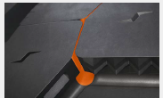SmartFlex AH51:

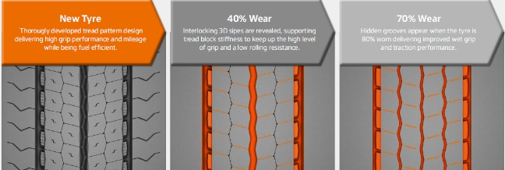

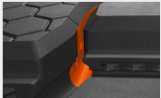SmartFlex DH51:

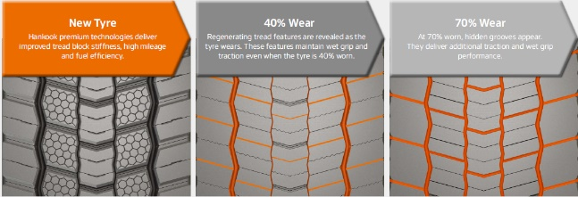

***3-dimension sipe (AH51/DH51)***

* Zigzag interlocking sipes extending to the base of the tread reduce block movement in the tyre contact pattern.
* Delivers high traction and braking performance during the whole tyre life
* Improved overall mileage

SmartFlex AH51:

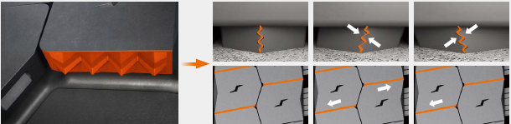

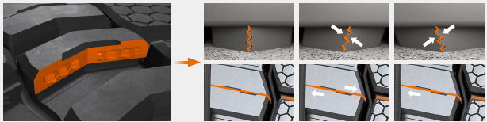SmartFlex DH51:

***Optimised tread block size and Tread Wear Equalisation Step (T.W.E.S.), AH51***

* Delivers increased tread block stiffness
* Ensuring even wear across the entire width of the tyre
* Improvements in mileage and rolling resistance

Ein Bild, das Text, Tastatur enthält.

***Performance diagram (AH51)\****

* Premium materials, design and tread technologies deliver significant gains in tyre performance

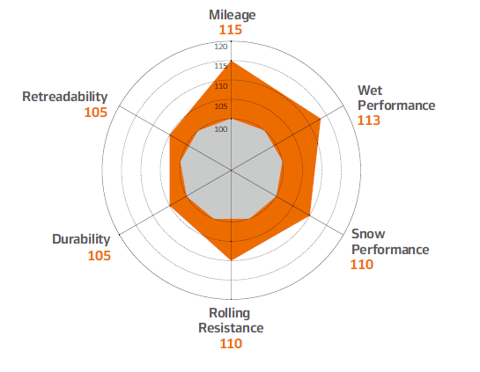

*compared to predecessors

***Wide tread block (DH51)***

* Increases tread width and reduced channels 5 to 4 mean increased tyre contact area
* Improved traction performance
* Increased mileage, improved traction and reduced rolling resistance

Ein Bild, das Text, Tastatur, drinnen enthält.

***Horn-shaped self-regenerating sipes (DH51)***

* Full depth sipes and regenerating tread groove
* Enhanced water evacuation and tread block cooling
* Improved milage and traction

Ein Bild, das Text enthält.

***Performance diagram (DH51*)***

* Premium materials, designs and tread technologies deliver significant gains in tyre performances

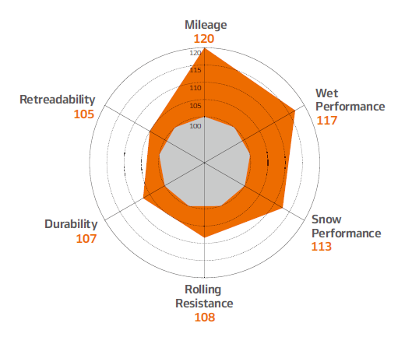

*compared to predecessors

***Test results: Comparison with worn tyre***

* Hankook premium tyre technologies deliver benchmark grip and safety in all conditions from first to last millimeter of tread.
* Shorter braking distance and safer driving

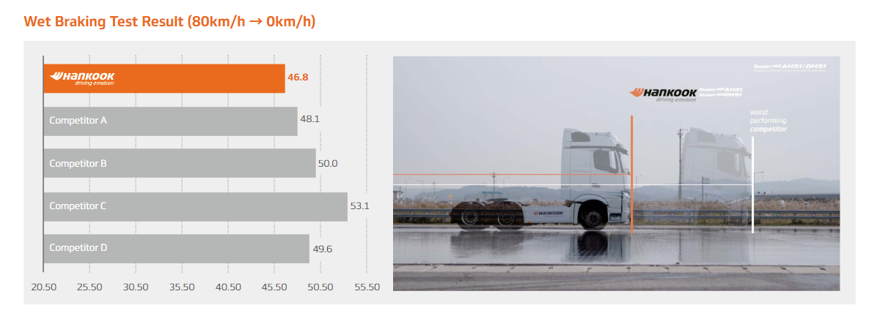

Tyre size: 315/70R22.5

Location: Korea automobile testing & research institute Proving Ground

Vehicle: Mercedes Benz Actros 25t tractor

80 km/h to 0 km/h - 5mm tread depth remaining

**Hankook Supplies Original Equipment Tyres to MAN**

**The MAN Truck & Bus AG belongs to the Volkswagen Group, one of Hankook's largest OE customers worldwide. The OE business with Hankook truck tyres for MAN covers dimensions in the 17.5, 19.5, 22.5 and 24 inch range. Hankook's Original Equipment range for the bus and truck manufacturer includes the supply of the tyre lines e-cube MAX, SmartFlex and SmartWork for various MAN models to the production facilities of the Munich-based manufacturer in Germany, Austria and Poland. The tyre ranges have been specially adapted for European conditions, boasting both ecological and economic advantages.**

Premium tyre maker Hankook is listed as an OE supplier for MAN with the truck tyre ranges e-cube MAX, SmartFlex and SmartWork. The commercial vehicles specialist and the tyre maker have been cooperating since the first quarter of 2015. Stephan Brückner, OE Account Manager for Truck and Bus tyres comments: “The partnership with MAN in the commercial vehicles segment is of great strategic importance to us, as we can now offer further treads and dimensions for light to heavy-duty trucks from MAN. The truck and bus tyre market is of growing importance.”

The tyres will be fitted to the multi-award-winning MAN vehicle series TGX, TGS, TGM and TGL which are used for national and international long-haul, delivery and construction site traffic. Tyres used include the e-cube MAX line, which is tried-and-trusted for international long-haul traffic, the new SmartFlex all-year tyre range for flexible use between long-haul and delivery traffic, as well as construction site treads from the SmartWork series. Specially adapted for use on vehicles of the EURO 6 emission class, the treads – both as special steering and drive axle versions – score highly for environmental friendliness and mileage. This is also relevant to the TCO (Total Cost of Ownership), important for Original Equipment.

One special feature of the Hankook’s Original Equipment portfolio for MAN are the numerous sizes in the low-line segment and also launching the latest tread patterns, the AL20w, in 355/50R22.5. With these, the premium tyre maker is demonstrating that its portfolio has already integrated the current market trend, namely the growing importance of low-line sizes in the truck business.

**###**

***Hankook's range of Original Equipment tyres for MAN:***

|  |  |  |  |  |  |  |  |
| --- | --- | --- | --- | --- | --- | --- | --- |
| **Tread** | **Size** | **Model** | **LI** | **Marking** | **cid:image001.jpg@01D3AFE9.FBA08C40** | **M+S** | **Availability** |
| **AL10+** | 315/80R22.5 | TGX | 156/150L (154/150M) | B/B/W1 70dB | - | - | þ |
| 385/65R22.5 | TGX | 160K (158L) | B/B/W1 70dB |  |  | þ |
| **AL 10** | 295/80R22.5 | TGX | 152/148M (154/149L) | C/C/W1 70dB | þ | - | þ |
| 385/55R22. | TGX | 160K (158L) | B/C/W1 70dB | - | - | þ |
| **DL10** | 295/80R22.5 | TGX | 152/148M | C/C/W2 75dB | - | þ  þ | þ |
| **AL20w** | 315/70R22.5 | TGX | 156/150L | B/C/W1 68dB | þ | þ | Nov 2021 |
| 315/60R22.5 | TGX | 154/148L | B/C/W1 70dB | þ | þ | þ |
| 295/60R22.5 | TGX | 150/147L | B/C/W1 70dB | þ | þ | þ |
| 355/50R22.5 | TGX | 156L | B/C/W1 72dB | þ | þ | Nov 2021 |
| **DL20w** | 315/80R22.5 | TGX | 156/150L (154/150M) | B/C/W1 70dB | þ | þ | þ |
| 315/70R22.5 | TGX | 154/150L (152/148M) | B/C/W1 69dB | þ | þ | Nov 2021 |
| 315/60R22.5 | TGX | 152/148L | B/C/W1 72dB | þ | þ | þ |
| 295/60R22.5 | TGX | 150/147L | B/C/W1 72dB | þ | þ | þ |
| **AH31** | 295/80R22.5 | TGM & TGS / TGX | 154/149M | C/B/W1 73dB | þ | þ | þ |
| 315/70R22.5 | TGM & TGS / TGX | 156/150L | C/B/W2 73dB | þ | þ | þ |
| 315/80R22.5 | TGM & TGS / TGX | 156/150L | C/B/W2 73dB | þ | þ | þ |
| (154/150M) |
| 385/65R22.5 | TGS / TGX | 160K (158L) | C/B/W1 69dB | þ | þ | þ |
| 315/60R22.5 | TGS / TGX | 154/158L | C/B/W1 71dB | þ | þ | þ |
| 385/55R22.5 | TGS / TGX | 160K (158L) | C/B/W1 69dB | þ | þ | þ |
| **DH31** | 295/80R22.5 | TGM & TGS / TGX | 152/148M | D/C/W2 75dB | þ | þ | þ |
| 315/80R22.5 | TGM & TGS / TGX | 156/150L | D/C/W2 75dB | þ | þ | þ |
| (154/150M) |
| 315/70R22.5 | TGM & TGS / TGX | 154/150L | D/C/W2 75dB | þ | þ | þ |
| 315/60R22.5 | TGS / TGX | 152/148L | D/C/W2 75dB | þ | þ | þ |
|  |
| **AH35** | 215/75R17.5 | MAN TGL | 128/126M | D/C/W1 65dB | þ | þ | þ |
| 235/75R17.5 | MAN TGL | 132/130M | D/C/W1 67dB | þ | þ | þ |
| 265/70R17.5 | MAN TGL | 140/138M | C/C/W1 67dB | þ | þ | þ |
| 265/70R19.5 | MAN TGM | 140/138M | C/C/W1 67dB | þ | þ | þ |
| 285/70R19.5 | MAN TGM | 146/144M | C/C/W1 67dB | þ | þ | þ |
| **DH35** | 215/75R17.5 | MAN TGL | 126/124M | D/C/W1 66dB | þ | þ | þ |
| 235/75R17.5 | MAN TGL | 132/130M | D/C/W1 70dB | þ | þ | þ |
| 265/70R17.5 | MAN TGM | 140/138M | D/C/W1 73dB | þ | þ | þ |
| 265/70R19.5 | MAN TGM | 140/138M | D/B/W1 73dB | þ | þ | þ |
| 285/70R19.5 | MAN TGM | 146/144M | D/B/W1 73dB | þ | þ | þ |
| **AM09 TT** | 325/95R24 | MAN TGS | 162/160K | D/C/W1 69dB | þ | þ | þ |
| **AM09** | 325/95R24 | MAN TGS | 162/160K | D/C/W1 69dB | þ | þ | þ |
| **DM06 TT** | 325/95R24 | MAN TGS | 162/160K | D/B/W1 73dB | - | þ | þ |
| **DM06** | 325/95R24 | MAN TGS | 162/160K | D/B/W1 73dB | - | þ | þ |
| **AM15+** | 385/65R22.5 | MAN TGS | 160K (158L) | C/C/W2 74dB | - | þ | þ |
| **AM09** | 315/80R22.5 | MAN TGS | 156/150K | D/B/W1 67dB | - | þ | þ |
| 13R22.5 | MAN TGS | 156/150K | D/C/W1 68dB | - | þ | þ |
|  | 315/80R22.5 | MAN TGS | 156/150K | D/C/W1 70dB | þ | þ | þ |
| **DM09** | 13R22.5 | MAN TGS | 156/150K | D/C/W2 75dB | þ | þ | þ |

**Hankook truck tyres for all standard applications as Original Equipment on all Scania trucks**

**Premium tyre maker Hankook is supplying various tread~~s~~ patterns of its truck tyre~~,~~ portfolio to the Swedish commercial vehicles manufacturer Scania as Original Equipment (OE). 33 dimensions for 22.5 and 24 inches are listed, which fleet customers and transport companies can order from the three European Scania plants in Zwolle (Netherlands), Södertälje (Sweden) and Angers (France). The new Scania XT generation of construction vehicles is one of the models to be equipped with Hankook tyres.**

Premium tyre maker Hankook is supplying tread~~s~~ patternsfor all Scania models including their new XT generation of construction vehicles. These are the steering axle SmartWork AM09, SmartWork AM09 TT and SmartWork AM15+ as well as the SmartWork DM06, SmartWork DM06 TT and SmartWork DM09 treads for the drive axle.

The commercial vehicle manufacturer is part of the Volkswagen Group and truck OE partner for Hankook. Hankook’s OE business with truck tyres for Scania is currently concentrating on Europe and covers a total of 33 dimensions in the 22.5 and 24 inch range. Alongside truck tyres for construction site use, Hankook is supplying the Swedish commercial vehicle manufacturer with the e-cube MAX, a truck tyre range for long-haul traffic as well as the SmartFlex, an all-year tyre for medium-haul applications. The range has been specially adapted for European conditions, boasting both ecological and economic advantages. Both tyre ranges can also be fitted to Scania buses.

Hankook is also expanding its OE business with Scania in size 275/70R22.5. of the SmartCity AU04+ for urban buses. The tyre was also tested under bad weather conditions. It stands out in particular due to its low rolling resistance which helps to ease the strain on the energy storage units of electric-powered public transport vehicles in urban areas. The OE cooperation with Scania is Hankook’s second within the Volkswagen Group in the heavy commercial vehicle segment; Hankook has been supplying various models to MAN Truck & Bus since 2015.

Stephan Brückner, OE Account Manager for Truck and Bus tyres: “We are looking forward to expanding our cooperation with Scania. We ~~to~~ focus on maximum durability and environmental friendliness when designing tyres, which results in very low costs per kilometre; all our Smart lines were able to completely convince the Scania engineers.”

**###**

***Hankook's range of Original Equipment tyres for Scania:***

|  |  |  |  |  |  |  |
| --- | --- | --- | --- | --- | --- | --- |
| **Tread** | **Size** | **LI** | **Marking** | **cid:image001.jpg@01D3AFE9.FBA08C40** | **M+S** | **Availability** |
| **AM09 TT** | 325/95R24 | 162/160K | D/C/W1 69 | þ | þ | þ |
| **AM09** | 315/80R22.5 | 156/150K | D/B/W1 67dB | - | þ | þ |
|  | 13R22.5 | 156/150K | D/C/W1 68dB | - | þ | þ |
|  | 325/95R24 | 162/160K | D/C/W1 69 | þ | þ | þ |
| **DM09** | 315/80R22.5 | 156/150K | D/C/W1 70dB | þ | þ | þ |
|  | 13R22.5 | 156/150K | D/C/W2 75dB | þ | þ | þ |
| **AM15+** | 385/65R22.5 | 158L(160K) | C/C/W2 74dB | - | þ | þ |
| **DM 06 TT** | 325/95R24 | 162/160K | D/C/W2 73dB | þ | þ | þ |
| **DM06** | 325/95R24 | 162/160K | D/C/W2 73dB | þ | þ | þ |
| **AL10+** | 385/65R22.5 | 160K(158L) | B/B/W1 70dB | - | - | þ |
| **AL 10** | 385/55R22.5 | 160K (158L) | B/C/W1 70dB | - | - | þ |
| **DL10** | 295/80R22.5 | 152/148M | C/C/W1 72dB | þ | þ | þ |
| **AL20w** | 315/70R22.5 | 156/150L | B/C/W1 68dB | þ | þ | Nov. 2021 |
|  | 315/60R22.5 | 154/148L | B/C/W1 70dB | þ | þ | þ |
|  | 295/60R22.5 | 150/147L | B/C/W1 70dB | þ | þ | þ |
|  | 355/50R22.5 | 156L | B/C/W1 72dB | þ | þ | Nov. 2021 |
| **DL20w** | 315/80R22.5 | 156/150L (154/150M) | B/C/W1 70dB | þ | þ | þ þ |
|  | 315/70R22.5 | 154/150L (152/148M) | B/C/W1 69dB | þ | þ | Nov. 2021 |
|  | 315/60R22.5 | 152/148L | B/C/W1 72dB | þ | þ | þ |
|  | 295/60R22.5 | 150/147L | B/C/W1 72dB | þ | þ | þ |
| **AH31** | 295/80R22.5 | 154/149M | C/B/W1 73dB | þ | þ | þ |
|  | 315/70R22.5 | 156/150L | C/B/W1 73dB | þ | þ | þ |
|  | 315/80R22.5 | 156/150L (154/150M) | C/B/W1 73dB | þ | þ | þ |
|  | 385/65R22.5 | 164K | C/B/W1 69dB | þ | þ | þ |
|  | 385/55R22.5 | 160K (158L) | C/B/W1 69dB | þ | þ | þ |
| **DH31** | 295/80R22.5 | 152/148M | D/C/W2 75dB | þ | þ | þ |
|  | 315/70R22.5 | 154/150L | D/C/W2 75dB | þ | þ | þ |
|  | 315/80R22.5 | 156/150L (154/150M) | D/C/W2 75dB | þ | þ | þ |
| **AL 22** | 295/80R22.5 | 154/149M | C/B/W1 69db | þ | þ | þ |
|  | 315/80R22.5 | 156/150L | C/B/W1 69dB | þ | þ | þ |
| **AU04+** | 275/70R22.5 | 150/148J (154/150M) | D/B/W1 67dB | þ | þ | þ |

**Hankook Tire supplies sizes**

**for original fitment on premium trucks**

**The Hankook original fitment portfolio for Daimler AG includes the tyre families; e-cube MAX for long-haul traffic, SmartWork for construction site applications and SmartFlex as an all-year solution. The tyre maker supplies for original fitment for the European market, including the complete Mercedes-Benz Actros family and Atego series. This includes 12 sizes of 17.5 and 19.5 inch SmartFlex all-year tyres. This means the range of dimensions supplied to the commercial vehicles sector at Daimler AG for original fitment business in Europe.**

Hankook’s original fitment portfolio for the Stuttgart-based truck manufacturer starts with ten sizes for the Atego series. They are availabe in in 17.5 and 19.5 inch versions of the all-year tread SmartFlex AH35 for the steering axle and SmartFlex DH35 for the drive axle. Tyre maker Hankook is supplying its original equipment (OE) portfolio in the medium duty and heavy commercial vehicle segment, as part of its existing OE agreements for the Mercedes-Benz truck model range: Actros, Arocs, Econic and Atego. The tyre maker currently provides a total of 33 dimensions of original equipment for Daimler AG in Europe. The portfolio includes the Hankook treads AL10+ e-cube MAX, DL10+ e-cube MAX as well as the SmartFlex AH31 and SmartFlex DH31- all of which have been specially developed for the European market. Supplying the OE tyre solutions in the medium duty and heavy duty truck segment is strengthening the Hankook brand on the European truck tyre market and is yet another milestone in the company’s endeavour for sustainable growth on the European continent.

Multi-3D sipes anchored in the tread guarantee high traction for the SmartFlex treads AH35 and DH35. The mixture of straight and wave-shaped tread grooves improves water discharge and reduces the aquaplaning risk long term. M+S marking and 3PFMS symbol (snowflake) document complete suitability for wintry weather conditions. In addition, the high rigidity of the tread blocks promotes fuel-saving rolling. Equally, the special tread design especially supports even tyre abrasion. Together with the wide contact area, the SmartFlex treads care for a long service life.

**###**

*Hankook original equipment releases for Mercedes-Benz trucks:*

|  |  |  |  |  |  |  |  |  |
| --- | --- | --- | --- | --- | --- | --- | --- | --- |
| **Tyre**  **line** | **Tread** | **Size** | **Load and speed index** | **EU label** |  | **M+S** | **Avail-**  **ability** | **Mercedes-Benz**  **vehicles** |
| **SmartFlex**  **e-cube MAX** | **AH35**  **DH35** | 215/75R17.5 | 128/124M | C/B/W1 65dB | R | R | R | Atego |
| 235/75R17.5 | 132/130M | D/C/W1 67dB | R | R | R | Atego |
| 245/70R17.5 | 136/134M | C/C/W1 67dB | R | R | R | Atego |
| 265/70R19.5 | 140/138M | C/C/W1 67dB | R | R | R | Atego |
| 285/70R19.5 | 146/144M | C/C/W1 66dB | R | R | R | Atego |
| 215/75R17.5 | 126/124M | D/C/W1 66dB | R | R | R | Atego |
| **DH35**  **AH31** | 235/75R17.5 | 132/130M | D/C/W1 70dB | R | R | R | Atego |
| 245/70R17.5 | 136/134M | D/C/W1 70dB | R | R | R | Atego |
| 265/70R19.5 | 140/138M | D/B/W1 73dB | R | R | R | Atego |
| 285/70R19.5 | 146/144M | D/B/W1 73dB | R | R | R | Atego |
| 315/80R22.5 | 156/150L | C/B/W2 73dB | R | R | R | Actros, Arocs, Econic |
| 285/70R19.5 | (154/150M) | D/B/W1 73dB | ☑ | ☑ | ☑ | Atego |
| **AH31**  **DH31** | 315/70R22.5 | 156/150L | C/B/W2 73dB | R | R | R | Actros, Arocs, Econic |
| 315/60R22.5 | 154/148L | C/B/W1 70dB | R | R | R | Actros, Arocs, Econic |
| 385/65R22.5 | 160K (158L) | C/B/W1 69dB | R | R | R | Actros, Arocs, Econic |
| 385/55R22.5 | 160K (158L) | C/B/W1 69dB | R | R | R | Actros, Arocs, Econic |
| 315/80R22.5 | 156/150L | D/C/W2 75dB | R | R | R | Actros, Arocs, Econic |
| 385/55R22.5 | (154/150M) | C/B/W1 69dB | ☑ | ☑ | ☑ | Actros, Antos, Arocs, Axor, Econic |
| **DH31**  **AL10+** | 315/70R22.5 | 154/150L | D/C/W2 75dB | R | R | R | Actros, Arocs, Econic |
| 315/60R22.5 | 152/148 L | D/C/W2 75dB | R | R | R | Actros, Arocs, Econic |
| 315/80R22.5 | 156/150L | B/B/W1 70dB | - |  | R | Actros, Arocs, Econic |
| 315/60R22.5 | (154/150M) | D/C/W2 75dB | ☑ | ☑ | ☑ | Actros, Antos, Arocs, Axor, Econic |
| **e-cube MAX** | **AL10+** | 315/70R22.5 | 156/150L | B/B/W1 70dB | - | - | R | Actros, Arocs, Econic |
| 385/65R22.5 | 160K (158L) | B/B/W1 70dB | - | - | R | Actros, Arocs, Econic |
| 315/60R22.5 | 154/148L | C/B/W1 70dB | - | - | R | Actros, Arocs, Econic |
| **DL10+** | 315/80R22.5 | 156/150L | C/C/W1 73dB | R | R | R | Actros, Arocs, Econic |
| 315/70R22.5 | (154/150M) | C/C/W1 73dB | ☑ | ☑ | ☑ | Actros, Antos, Arocs, Axor, Econic |
| 315/70R22.5 | 154/150L | C/C/W1 73dB | R | R | R | Actros, Arocs, Econic |
| **e-cube**  **e-cube** | **AL 10** | 385/55R22.5 | (152/148M) | B/C/W1 70dB | - | - | ☑ | Actros, Antos, Arocs, Axor, Econic |
| 315/60R22.5 | 152/148L | C/C/W1 73dB | R | R | R | Actros, Arocs, Econic |
| **AL 10** | 385/55R22.5 | 158L (160K) | B/C/W1 70dB | - | - | R | Actros, Arocs, Econic |
| **Trailer** | **TH22** | 215/75R17.5 | 135/133J | D/B/W1 70dB | - | R | R | Actros |
| **SmartWork**  **SmartWork**  **SmartFlex** | **AM15+** | 385/65R22.5 | 158L (160K) | D/C/W2 74dB | - | ☑ | ☑ | (leading axle) |
| **AM15+** | 385/65R22.5 | 158L (160K) | D/C/W2 74dB | - | R | R | Actros, Arocs, Econic |
| **AM15**  **AM06** | 275/70R22.5 | 148/145K | D/B/W2 74dB | - | R | R | Atego |
| 13R22.5 | 154/150K | D/C/W2 72dB | - | - | R | Actros, Arocs |
| 12R22.5 | (156/150G) | D/C/W2 72dB | - | - | ☑ | Actros, Arocs, Axor |
| 315/80R22.5 |  | D/C/W2 74dB | - | - | R | Actros, Arocs, Econic |
| 315/80R22.5 | 156/150K | D/C/W2 74dB | - | - | ☑ | Actros Antos, Arocs, Axor, Econic |
| **DM03**  **AH35** | 13R22.5 | 154/150K (156/150G) | D/C/W2 72dB | - | R | R | Actros, Arocs |
| 315/80R22.5 | 156/150K | D/C/W2 72dB | - | R | R | Actros, Arocs, Econic |
| 215/75R17.5 | 128/124M | C/B/W1 65dB | R | R | R | Atego |
| 235/75R17.5 | 132/130M | D/C/W1 67dB | R | R | R | Atego |

**Treads for mixed on-road and off-road use supplement Hankook’s SmartWork line**

**The SmartWork AM11 tyre tread for the steering axle, DM11 for the drive axle and the TM11 trailer tyre for mixed on-road and off-road use complement Hankook’s existing tyre line for construction site applications. The products are primarily designed to meet the needs of construction site delivery traffic. This means the series not only holds its own with good traction on site, it performs well on the road too, with a long service life amongst other things.**

The treads in the Hankook SmartWork line, AM11, DM11 and TM11, have been specifically developed for construction site vehicles used for the supply and removal of raw materials, gravel, waste or similar to or from construction sites and thus cover most of their miles on public roads. Steering axle, drive axle and trailer tyres offer both a long service life for use on the road and high traction for off-road use on construction sites. The tread design to match all the axle positions on the vehicle and the specially developed rubber compound make sure of that.

The SmartWork AM11 for the steering axle or use on all axles, has three extra-wide main drainage tread grooves in a zigzag design to improve hydroplaning safety. Special rubber blocks in the tread grooves stop stones from becoming lodged. An angular sipe design guarantees optimum traction, while chamfered block edges and special sipes on the tread blocks contribute towards more block stability and also improve the braking and handling response. The SmartWork AM11 also has a closed shoulder design for more driving stability, lateral stability and even abrasion for a longer service life.

The trailer tyre TM11 differs from the SmartWork AM11 in that it has a half-open shoulder design. Lateral grooves enhance tyre traction particularly on muddy or snow-covered roads and on construction sites. Both the SmartWork AM11 and the SmartWork TM11 have M+S marking.

The SmartWork DM11 is available for the drive axle. The directional V-shaped tread design enables improved displacement of mud and water in the construction site area. The interblock tie-bars at the centre of the SmartWork DM11 ensure high block stability and guarantee outstanding straight driving performance and impact dispersion for blocks, thereby improving durability. Three-dimensional sipes also enhance tyre traction. The SmartWork DM11 also has the snowflake symbol, which means it can even be used under very wintry conditions.

**###**

*Available sizes of the SmartWork AM11/DM11/TM11*

|  |  |  |  |  |  |  |
| --- | --- | --- | --- | --- | --- | --- |
| **Tread** | **Size** | **LI** | **Marking** |  | **M+S** | **Availability** |
| **AM11** | 315/80R22.5 | 156/150K | C/B/W2 (73dB) | - | 🗹 | 🗹 |
| **DM11** | 315/80R22.5 | 156/150K | C/B/W2 (74dB) | 🗹 | 🗹 | 🗹 |
| **TM11** | 385/65R22.5 | 160K | C/B/W2 (73dB) | 🗹 | 🗹 | 🗹 |

**Technical properties of the SmartWork AM11**

1. ***Wide zigzag grooves for improved hydroplaning safety and optimised braking response***

* Three extra-wide tread grooves in a zigzag design guarantee optimum water displacement both on tarmacked roads and off-road.
* Angular sipes for optimum traction.
* Additional pimples in the grooves support the tyre's self-cleaning function.

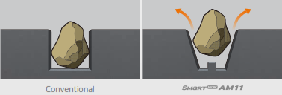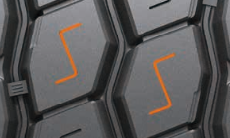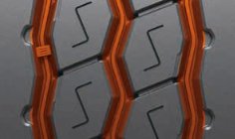

1. ***Polygonal stepped blocks for a more pronounced edge effect***

* Special edge angle at the individual tread blocks and chamfered block edges for optimum braking response.

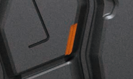

1. ***Closed shoulder design increases the tyre’s driving stability***

* Improved resistance against forces acting at the side.
* Protection against damage to the block edges.
* Shoulder lugs help to reduce heat development while driving.

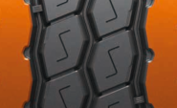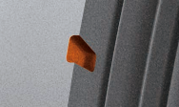

**Technical properties of the SmartWork DM11**

1. ***Directional tread design***

* V-shaped directional tread design for the outstanding displacement of mud and water.

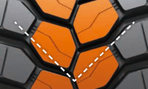

1. ***Bars between the tread blocks***

- Bars between the tread blocks stabilise the tyre.

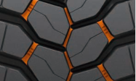

**Technical properties of the SmartWork TM11**

1. ***Wide zigzag grooves for improved hydroplaning safety and optimised braking response***

* Three extra-wide tread grooves in a zigzag design guarantee optimum water displacement both on tarmacked roads and off-road.
* Angular sipes for optimum traction.
* Additional pimples in the grooves support the tyre's self-cleaning function.



1. ***Polygonal stepped blocks for a more pronounced edge effect***

* Special notches at the individual tread blocks and chamfered block edges for optimum braking response.



1. ***Half-open shoulder design***

* Half-open shoulder design for enhanced traction particularly on muddy or snow-covered roads, or within the construction site

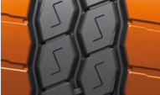

**First Hankook bus tyre specification**

**for electromotive use**

**Hankook is presenting the SmartCity AU04+, its first tyre specification for electric buses. The tyre manufacturer is following increasing customer requirements for tyre solutions specifically for use on electric-powered urban buses. As these vehicles are generally heavier than conventional buses due to their energy storage units, the tyres also have an increased load index. To keep battery energy loss to a minimum, the SmartCity AU04+ also stands out on account of its very low rolling resistance. In urban stop and go traffic, bus tyres must be able to cope with a particularly heavy load and guarantee safe use at the same time; therefore, special attention was paid to adaptation of the shoulder width and structure during development of the electric bus tyre, in order to ensure extremely even wear. The tread of the AU04+, which has been designed as an all-year tyre, is suitable for all wintry conditions without restriction and bears the snowflake symbol (3PMSF). It goes without saying that the new city bus tyre size is equally suitable for use on city buses with conventional drive concepts.**

Hankook is expanding its tyre portfolio in the urban/city bus sector. For the first time, the premium tyre maker is supplying a city bus tyre in the size 315/60 R 22.5, optimised for electromotive use. The SmartCity AU04+ stands out in particular due to its very low rolling resistance which helps to ease the strain on the energy storage units of electric-powered urban buses. On account of the increased vehicle weight resulting from the battery weight, the tyre not only has a stable carcass but also an increased load capacity of 154/148J (156/152F) which corresponds to a weight of 8 tonnes per axle. The standard load bearing capacity is usually 7 tonnes per axle for this size.

During development of the bus tyre, special attention was paid to a high traction and braking performance, particularly on wet road surfaces. Dipl.-Ing. Klaus Krause, head of the European Research and Development Centre, explains: “Unlike conventional combustion engines, an electric motor is able to deliver the full torque immediately. This means the vehicle and the tyres respond faster to speed or the changing road conditions. Consequently more demands are made on tyres for electric-powered vehicles. The high grip level avoids irregular tyre wear without having to do without optimum mileage.”

The high mileage is guaranteed by the optimised zigzag grooves which ensure higher block rigidity thanks to their modified layout, among other things. The constant starting and stopping in city traffic puts a heavy and irregular load on bus tyres. “For this reason we have adapted the shoulder width and design for the SmartCity AU04+ to the increased requirements, thus guaranteeing more even wear. The improved molecular structure of the new tread compound makes the tyre much more heat-resistant and is a further contributing factor to a longer service life,” Dipl.-Ing. Klaus Krause adds.

Completely in line with the safety aspect, the SmartCity AU04+ also has a further reinforced sidewall. This protects the tyre from damage following the often unavoidable contact with the curb in city traffic: “The reinforced sidewall is particularly important for the protection of electric bus tyres, since they accelerate much more quickly on account of the system and also build up a more aggressive contact to curbstones” Klaus Krause explains.

###

*Available sizes of the AU04+*

|  |  |  |  |  |  |  |
| --- | --- | --- | --- | --- | --- | --- |
| **Tread** | **Size** | **LI** | **Marking** | **Snowflake** | **M+S** | **Availability** |
| **AU04+**  **for electromotive use** | 315/60R22.5 | 154/148J (156/152F) | C/B/W1/73db | ☑ | ☑ | ☑ |
| **AU04+** | 315/60R22.5 | 154/148J (156/152F) | C/B/W1/73dB | ☑ | ☑ | ☑ |
| **AU04+** | 275/70R22.5 | 150/148J  (152/148F) | D/B/W1/67 dB | ☑ | ☑ | ☑ |

**Technical properties of the AU04+**

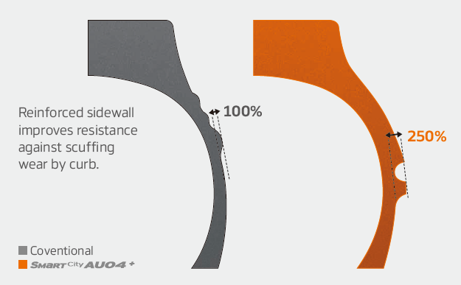

***Wide shoulders and reinforced sidewalls***

* Wide shoulders and reinforced sidewalls ensure   
  excellent wet grip and driving stability
* New shape and position of the sidewall indicator   
  makes determining the tyre condition easier

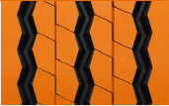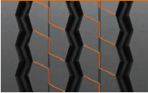***Improved tread design***

* Stabilising 3D tread blocks guarantee improved traction
* Higher mileage through optimised rib spacing
* 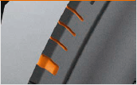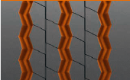Three zigzag grooves guarantee excellent traction, particularly

in the wet

* Adapted shoulder width and removed lugs and ribs ensure more   
  even wear

***Innovative rubber compound***

* Improved chemical structure makes the tyre more heat-resistant

**SmartTouring is Hankook’s ultra-modern tyre for long-  
distance coaches**

**With the SmartTouring AL22, tyre maker Hankook has a coach tyre for long-distance travel in their portfolio. The company is anticipating that long-distance coach travel will grow in significance, and thus there will be an increasing demand for high-technology coach tyres in this category. The Hankook SmartTouring AL22 can be used on all axle positions and provides maximum ride and rolling comfort, excellent concentricity, a very low rolling noise and, as is customary with Hankook tyres, optimised rolling resistance and low wear for particularly efficient travel.**

The SmartTouring AL22 is premium tyre maker Hankook’s state-of-the-art tyre for long-distance coach travel that includes the 3-PMSF symbol for the European market. This is available in the sizes 295/80R22.5 and 315/80R22.5 and is suitable for all long-distance coach wheels in all axle positions. Klaus Krause, Vice President and Head of the European Development Centre in Hanover, adds: “During development of the SmartTouring line, we focused particularly on ride and rolling comfort as well as on a straight driving performance. The characteristics of the SmartTouring AL22 not only allow maximum travel comfort for passengers, they also maximise driving and handling comfort for the driver on long-distance trips.”

The carcass contour of the SmartTouring AL22 ensures the best suspension properties and contributes to a particularly safe driving style. The longitudinal 5-rib profile with its closed, solid central rib makes an excellent straight driving performance possible at all times. Special Multi-3D sipes guarantee both good traction and an outstanding braking response.

The bead area guarantees a particularly precise rim joint stiffness, which results in excellent concentricity and travel comfort. The individual belt layers of the SmartTouring AL22 are structurally arranged in such a way that significantly less heat is developed in operation compared with conventional tyres. This effect not only reduces rolling resistance, thus economising on fuel, it also considerably extends the service life of the tyre.

Fuel savings through reduced heat development have been achieved not only by the belt structure but also by the tread compound used for the Hankook SmartTouring AL22. Special soot molecules with a larger volume and a particularly stable structure are used for the basic tread rubber in particular, leading to a significant reduction in energy loss during movement. These so-called highly structured carbon molecules also guarantee enhanced abrasion resistance and, in combination with the other technologies, help to increase the mileage of the SmartTouring AL22 compared with conventional products by more than 17 percent.

###

*Available sizes of the AL22*

|  |  |  |  |  |  |  |
| --- | --- | --- | --- | --- | --- | --- |
| **Tread** | **Size** | **LI** | **Marking** |  | **M+S** | **Availability** |
| **AL22** | 295/80R22.5 | 154/149M | C/B/W1 69dB | 🗹 | 🗹 | 🗹 |
| 315/80R22.5 | 156/150L | C/B/W1 69dB | 🗹 | 🗹 | 🗹 |

**Technical properties of the SmartTouring AL22**

1. ***Longitudinal tread profile with Multi-3D sipes and solid central rib***

* - High directional stability and comfortable handling response.
* Excellent straight driving.
* Very good braking and traction performance.



1. ***Special brake structure and newly developed bead area***

* Reduced heat development.
* High retreadability.

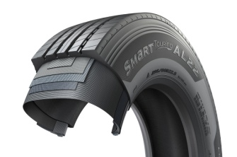

**Powerful coach range: SmartTouring DL22 rounds off the Hankook tyre portfolio for long-distance coaches**

**Premium tyre maker Hankook presents the drive axle tyre for long-distance coaches in Europe, SmartTouring DL22. Along with the SmartTouring AL22, Hankook has a complete portfolio of coach tyres available for long-distance routes. The company is responding to the growing importance of travelling long-distance by coach and to the increasing demand for high-tech coach tyres with low rolling noise, a high ride and rolling comfort.**

With the introduction of the SmartTouring DL22 in the past, premium tyre maker Hankook offers a complete portfolio of coach tyres for long-distance routes to its coach fleet customers. The company is responding to the continuing increase in long-distance coach travel. The tyre maker is rounding off its range in this segment with tyres for the drive axle for use on long-distance coaches.

The SmartTouring DL22 has a particularly low noise level and therefore offers high ride comfort. The special tyre tread design guarantees uniform tyre wear even during permanent use and makes a high mileage and long service life possible. Like most drive axle tyres from Hankook, the all-year tyre has the 3PMSF symbol and M+S marking. The 3D sipes arranged in a V-shape make top grip and traction properties possible in the snow and wet, without having a negative effect on the mileage performance. The sipe technology of the SmartTouring DL22 also provides good longitudinal and lateral grip as well as directional and lateral stability. Low rolling resistance on the SmartTouring DL22 makes efficient fuel consumption possible.

###

*Available sizes of the SmartTouring DL22:*

|  |  |  |  |  |  |  |
| --- | --- | --- | --- | --- | --- | --- |
| **Tread** | **Size** | **LI** | **Marking** | **Snowflake** | **M+S** | **Availability** |
| **DL22** | 295/80R22.5 | 154/149M | C/B/W1/72dB | ☑ | ☑ | ☑ |

**Technical properties of the SmartTouring DL22**

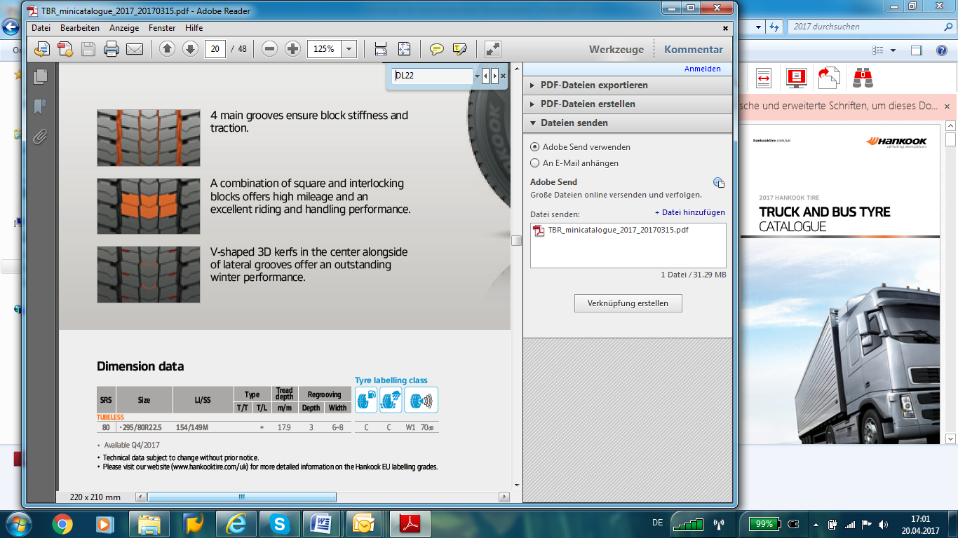

1. ***Four main grooves***

* The four main grooves guarantee high tread block rigidity and are decisive for the outstanding traction of the SmartTouring DL22.



1. ***Arrangement of the tread blocks***

* The combination of standard and 3D sipes guarantees a high mileage, high ride comfort and low noise development. This results in reliable longitudinal and lateral grip and excellent directional stability.

1. ***V-shaped 3D sipes***

* The 3D sipes arranged in a V-shape offer an outstanding winter performance.

**Hankook's all-year truck tyres SmartFlex AH35 and SmartFlex DH35 for regional traffic**

**With the steering axle tyre SmartFlex AH35 and the drive axle tyre SmartFlex DH35, premium tyre maker Hankook has an all-year truck tyre for regional traffic. The all-year tyres, winners of the Red Dot Design Award in 2016, have particularly high traction on account of special Multi-3D sipes. In addition, the rigid tread blocks with minimum block movement promote fuel-efficient driving.**

With the SmartFlex AH35 and SmartFlex DH35, fleets and forwarding agents benefit from a low-fuel, high-mileage and high-traction all-year tyre solution for the steering and drive axles. It is also possible to fit SmartFlex AH35 to all axles. In 2016, they were presented with the Red Dot Design Award. Whilst the SmartFlex AH31 and SmartFlex DH31 are intended mainly for larger wheel sizes such as 22.5 inch, the SmartFlex AH35 and its counterpart SmartFlex DH35 for the drive axle are designated to the smaller 17.5/19.5 inch sizes.

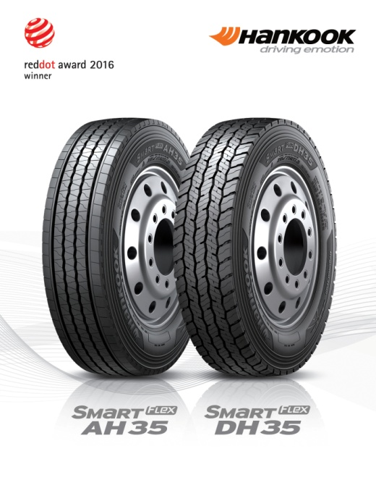The Multi-3D sipes anchored in the tread of the SmartFlex AH35 guarantee outstanding traction. The mixture of straight and wave-shaped grooves improves water drainage and prevents hydroplaning long-term. Without losing sight of the summer properties, the M+S marking and the 3PMFS symbol (snowflake) indicate that the tyre is also perfectly equipped for all wintry weather conditions such as slush, ice and snow. The rigidity of the tread blocks promotes particularly fuel-efficient driving. Equally, the special tread design supports even tyre wear so that the Total Cost of Ownership for fleet and forwarding agent companies can be reduced long term in terms of service life. The high mileage and performance of the tyre are guaranteed by a wide contact area.

Just like the steering axle tyre, the drive axle tyre SmartFlex DH35 has M+S marking and the snowflake symbol. In addition, the tyre also has a wide contact area with four zigzag groove lines over the whole tread surface, enhancing mileage and driving performance under different road and traffic conditions. Furthermore, the 3D sipes ensure high traction and low rolling resistance. The innovative tread sipe design supports low rolling resistance and tyre traction for the drive axle in road traffic.

###

*Available sizes of the SmartFlex AH35/DH35:*

|  |  |  |  |  |  |  |
| --- | --- | --- | --- | --- | --- | --- |
| **Tread** | **Size** | **LI** | **Marking** |  | **M+S** | **Availability** |
| **AH35** | 8.5R17.5 | 121/120L | D/C/W1 67dB | 🗹 | 🗹 | 🗹 |
| 9.5.R17.5 | 129/127L | D/C/W1 67dB | 🗹 | 🗹 | 🗹 |
| 8R19.5 | 117/116L | D/C/W1 71dB | 🗹 | 🗹 | 🗹 |
| 205/75R17.5 | 124/122M | D/C/W1 65dB | 🗹 | 🗹 | 🗹 |
| 215/75R17.5. | 126/124M | D/C/W1 65dB | 🗹 | 🗹 | 🗹 |
| 215/75R17.5. | 128/126M | D/C/W1 65dB | 🗹 | 🗹 | 🗹 |
| 225/75R17.5 | 129/127M | C/C/W1 67dB | 🗹 | 🗹 | 🗹 |
| 235/75R17.5 | 132/130M | C/C/W1 67dB | 🗹 | 🗹 | 🗹 |
| 245/70R17.5 | 136/134M | C/C/W1 67dB | 🗹 | 🗹 | 🗹 |
| 245/70R19.5 | 136/134M | C/C/W1 67dB | 🗹 | 🗹 | 🗹 |
| 265/70R17.5 | 140/138M | C/C/W1 67dB | 🗹 | 🗹 | 🗹 |
| 265/70R19.5 | 140/138M | C/C/W1 67dB | 🗹 | 🗹 | 🗹 |
| 285/70R19.5 | 146/144M | C/C/W1 67dB | 🗹 | 🗹 | 🗹 |
|  | 305/70R19.5 | 148/145M | C/C/W1 71dB | 🗹 | 🗹 | 🗹 |
| **DH 35** | 205/75R17.5 | 124/122M | D/C/W1 66dB | 🗹 | 🗹 | 🗹 |
| 215/75R17.5 | 126/124M | D/C/W1 66dB | 🗹 | 🗹 | 🗹 |
| 225/75R17.5 | 129/127M | D/C/W1 73dB | 🗹 | 🗹 | 🗹 |
| 235/75R17.5 | 132/130M | D/C/W1 73dB | 🗹 | 🗹 | 🗹 |
| 245/70R17.5 | 136/134M | D/C/W1 73dB | 🗹 | 🗹 | 🗹 |
| 8.5R17.5 | 121/120L | D/C/W1 73dB | 🗹 | 🗹 | 🗹 |
| 9.5R17.5 | 129/127L | D/C/W1 73dB | 🗹 | 🗹 | 🗹 |
| 245/70R19.5 | 136/134M | D/C/W1 73dB | 🗹 | 🗹 | 🗹 |
| 265/70R17.5 | 140/138M | D/C/W1 73dB | 🗹 | 🗹 | 🗹 |
| 265/70R19.5 | 140/138M | D/C/W1 73dB | 🗹 | 🗹 | 🗹 |
| 285/70R19.5 | 146/144M | D/C/W1 73dB | 🗹 | 🗹 | 🗹 |
| 305/70R19.5 | 148/145M | D/C/W1 73dB | 🗹 | 🗹 | 🗹 |

**Technical properties of the SmartFlex AH35**

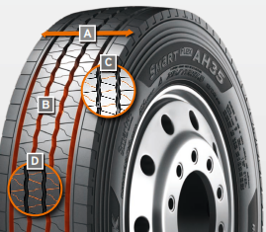

1. ***Wide contact area:***

* The wide contact area guarantees high mileage.

1. ***Four wave-shaped and straight grooves:***

* The combination of four wave-shaped and straight grooves over the whole tread surface on a wide range of different road surfaces guarantees excellent water drainage

1. ***Multi-3D sipe tread:***

* The Multi-3D sipe tread offers outstanding traction and thus promotes improved driving stability.
* The rigidity of the tread blocks and the resulting minimum block movement lead to significant fuel savings.

1. ***Special tread design with “semi-sipes”:***

* Special tread design with “semi sipes” guarantees an even wear pattern over the entire service life

*Wide contact area*

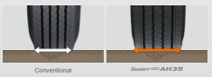

*Multi-3D sipes*

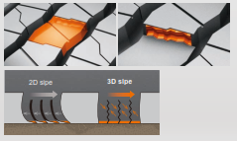

**Technical properties of the SmartFlex DH35**

1. 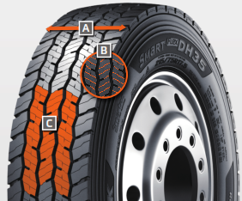***Wide contact area with 4 zigzag grooves:***

* The wide contact area and the 4 all-round zigzag tread grooves ensure high mileage and overall performance.

1. ***Multi-3D sipes:***

* The special tread design with Multi-3D sipes promotes low rolling resistance and outstanding traction.

1. ***Innovative tread design:***

* The special tread design guarantees low rolling resistance and optimum traction under a wide range of different conditions.

**Hankook presents e-cube Blue, an ultra-fuel-efficient tyre family for long-distance traffic**

**Tyre maker Hankook presents its ultra-efficient and fuel-saving e-cube Blue tyre family as a complete solution for long-distance traffic, which bears the rolling resistance label A for all axle positions. As a long-distance traffic system solution, the economical tyre family is characterised in particular by maximum fuel efficiency.**

Premium tyre maker Hankook presents its complete particularly proficient and fuel-efficient tyre family for long-distance truck traffic under the name ***e-cube Blue***. Hankook therefore presents a complete solution with A-label marking in terms of rolling resistance for all axle positions. The new e-cube Blue line enables fleet customers to profit from an additional eight percent tyre related fuel efficiency and provides them with up 55 percent more durability (less irregular wear among others, higher mileage etc.) compared with other products.

The tread design, which is tailored for each particular axle position is one of the factors which helps to further reduce fuel consumption and increase mileage without affecting dynamic characteristics such as braking and traction performance.

Both central rib tread blocks of the ***e-cube Blue AL20*** steering axle tyres support each other through their interlocking design, which increases tread block rigidity and helps to reduce rolling resistance. The stepped main tread groove design gives extra support for each tread block side. Moreover, they provide for excellent straight stability and good steering response. The largely closed tread design in the shoulder rib area ensures particularly uniform tyre wear.

The tread appearance of the ***e-cube Blue DL20*** drive axle tyres is characterised by a central 4-block design of the solid central rib. The offset arrangement of the individual tread blocks guarantees interlocking action on both sides and results in mutual support for very good traction performance while reducing rolling resistance at the same time. In addition, the horizontally arranged semi-deep extra sipes in combination with tie bars in the open shoulder block area further promote traction.

Moreover, the extra-wide contour of the ***e-cube Blue TL20*** trailer tyres supports a very high driving stability and optimises wear resistance. The so-called multi-sipes added in the central rib area prevent uneven wear without affecting tread rib stability. The closed 4-groove tread design guarantees excellent lateral stability and also a very low rolling noise.

Common to all three e-cube Blue products is the newly developed tread compound with highly structured carbon black molecules for high fuel efficiency. The complete e-cube Blue tyre family naturally also includes all the basic technologies of the successful Hankook e-cube product group. The innovative Hankook mixing process IMS (Innovative Mixing System) is used, which ensures the particularly even distribution of soot particles and rubber molecules within the compounds. In conjunction with the extension of the mixing times at lower temperatures, a significant increase in the bonding rate between carbon black and rubber molecules is achieved. As a result, e-cube tyres generate less heat. The patented Hankook Stiffness Control Contour Theory (SCCT) design technology provides an even distribution of pressure inside the tyre and thus promotes more stability and less movement in the tyre. This results in high carcass durability and offers customers very good retreadability and economy.

###

*Available sizes of the AL20/DL/20/TL20:*

|  |  |  |  |  |  |  |
| --- | --- | --- | --- | --- | --- | --- |
| **Tread** | **Size** | **LI** | **Marking** |  | **M+S** | **Availability** |
| **AL 20** | 385/55R22.5 | 160K | A/ C/W1 70dB | 🗹 | 🗹 | 🗹 |
| **DL 20** | 315/70R22.5 | 154/150L | A/ C/W1 72dB | 🗹 | 🗹 | in production |
| **TL 20** | 385/55R22.5 | 160K | A/ C/W1 66dB | - | - | 🗹 |
| 385/65R22.5 | 160K | A/ C/W1 66dB | - | - | 🗹 |
| 435/50R19.5 | 160J | A/C/W1 70dB | - | - | 🗹 |
| 445/45R19.5 | 160K | A/C/W1 70dB | - | - | 🗹 |

**Technical properties of the e-cube Blue line**



* The tyre provides up to eight percent improved tyre related fuel efficiency.
* 55 percent more durability in comparison to conventional products, e.g. through a significant reduction of uneven tyre

wear

* Higher mileage thanks to new tread compound

**e-cube Blue AL 20: Steering axle tyres**

1. ***Reinforced tread blocks***

* Interlocking central rib tread blocks for low rolling resistance

1. ***Shoulder block design***

* The largely closed tread design in the shoulder rib area ensures particularly uniform tyre wear.

1. ***Sipes design***

* 3D deep sipes guarantee high braking performance throughout the life of the tyre



**e-cube Blue DL 20: Drive axle tyres**



1. ***Block design***

* Central four-block design of the solid central rib for high traction combined with reduced rolling resistance

1. ***Tie bars***

* Tie-bars in the open shoulder block area for more traction and reduction of uneven wear

1. ***Sipes design***

* 3D deep sipes guarantee high traction and braking performance throughout the life of the tyre



**e-cube Blue TL 20: Trailer tyres**



1. ***Tyre contour***

* Extra wide tread area for very high driving stability and improved wear resistance

1. ***Multi-sipes***

* Reduction of uneven wear without affecting tread rib stability



**Hankook light truck tyre Vantra LT:**

**Durable, powerful and fuel-efficient**

**Hankook presents a modern summer tyre for minibuses, transporters and light trucks with the Vantra LT. The innovative design ensures up to 13% higher fuel efficiency with 12% higher mileage at the same time. In addition, the optimised tread profile, which is specially tailored to car and goods transport, ensures good wet grip and short braking distances.**

The Hankook Vantra LT is a summer tyre variant for transporters and vans. The light truck tyre was developed in view of the high demands that are placed on passenger and goods transport vehicles in regional traffic. The engineers focused on maximising the mileage, coupled with optimised fuel efficiency by minimising energy losses while driving, for an overall high level of economy. Thanks to many innovative design features, the new Hankook Vantra LT offers not only robustness, mileage and fuel efficiency, but also excellent braking and wet weather performance. It is now available in 49 dimensions.

Frequent use in start/stop traffic can place additional demands on tyres. In commercial passenger and goods transport, the overall cost-effectiveness, i.e. mileage, resistance to external influences and fuel efficiency are the focus of the purchasing decision. At the same time, safety-relevant tyre properties such as wet braking behaviour and track stability must not be neglected. The Hankook Vantra LT offers a variety of new technologies such as the sidewall shield as well as optimised tread block arrangement and structure ("Durable Contact Patch Technology") for improved driving characteristics and safety even at high speeds, in addition to reduced tread wear. The mileage potential of the tyre could therefore be increased by up to 12% compared to its predecessor.

Furthermore, three wide centre grooves in combination with newly developed 3D transverse grooves ensure faster water displacement and significantly reduce the risk of aquaplaning. The innovative tread pattern also guarantees excellent wet braking characteristics while ensuring high traction even in wet conditions and low temperatures. The new and more angular tread of the Vantra LT allows an improved arrangement of the tread grooves. This is particularly beneficial for the stability in the area of the outer tread ribs. In combination with the innovative double steel belt structure of the Vantra LT, a very even ground pressure distribution was achieved. As a result, the Vantra LT delivers significantly increased driving and tracking stability even at higher speeds and loads. In addition, the lower deformation of the tyre reduces rolling resistance, improving the tyre's fuel efficiency by up to 13%.

###

**Technical properties of the Vantra LT**

1. **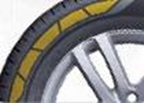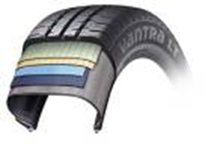*Optimised tyre structure for longer service life and greater safety***

* The double belt structure guarantees consistent performance thanks to the high-strength belt bandages.
* Special core rider for an improved rim seat for optimised driving characteristics.
* Sidewall protector for the prevention of sidewall damage.

1. 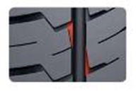***Improved driving characteristics and wet grip***

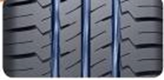

* Three wide circumferential main drainage grooves and 3D transverse grooves for 14% improved aquaplaning performance over conventional treads.
* Innovative tread pattern for high traction and braking performance even in wet, cold weather.

1. ***Improved fuel efficiency & higher mileage***

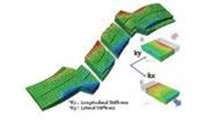

* Up to 12% improved abrasion behaviour due to innovative tread structure and mixing technology.
* Optimised carcass tread for up to 13% more fuel efficiency by minimising energy losses while driving.

1. ***Increased robustness & driving stability***

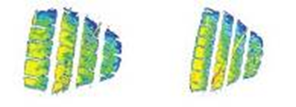

* Angular tread pattern with improved tread groove arrangement for increased stability in the area of the outer tread ribs for increased driving and tracking stability even at higher speeds and loads.

1. ***Available sizes***

* The Vantra LT is available in 49 dimensions in sizes from 12 to 17 inches in the 82 to 60 series and in tread widths from 155 to 235, and is consistently marked with the M+S identifier.

**Hankook rounded off its winter tyre line-up and presents new winter and all-season treads for vans/light trucks**

**Tyre maker Hankook expanded its portfolio for the winter season 2019/2020 and added two more treads. The Winter i*cept LV complements the popular i*cept family for passenger cars and SUVs with a winter specialist for vans and transporters. In addition, the Vantra ST AS 2, an all-season tyre launched during the same winter season for vans/light trucks, has been introduced to meet the increased demand in this segment.**

Premium tyre maker Hankook presents the Winter i*cept LV for vans and transporters for the wintertime. The model of the popular and high-performance i*cept series convinces not only with its special winter suitability but also with significantly increased mileage and therefore good economy: The Hankook engineers achieved an increase in mileage of about 10% compared to conventional models, including a wider tread design. An optimised groove structure on the shoulder block prevents irregular wear and contributes to increased mileage and economy, which is of particular interest to fleet managers. The Hankook Winter i*cept LV is available in a total of 39 sizes from 13 - 17 inches with tread widths from 165 - 235 mm and aspect ratios from 80 - 55 in the R and T speed indices.

Hankook is also expanding its portfolio for the van and light truck category with the Vantra ST AS 2, an all-season tyre with the 3PMSF symbol. The Vantra ST AS 2 shows its strengths particularly on road surfaces common in urban areas during the cold season and, with its specially developed "Ice-Philic-Technology", ensures increased grip even at lower temperatures. This innovation in Hankook’s all-season tyre line-up is available on the UK market in 15 sizes from 14 to 16 inches with tread widths of 185 - 235 mm and aspect ratios of 80 - 60 in the speed indices Q, R, S, T and H.

###

**About Hankook Tire**

Hankook Tire manufactures globally innovative, award winning radial tyres of proven superior quality for passenger cars, light trucks, SUVs, RVs, trucks, and buses as well as motorsports (circuit racing/rallies).

Aspiring to bring consumers the utmost excellence in product quality, technological excellence and driving satisfaction, Hankook Tire continuously invests in research and development maintaining five R&D centres and eight production facilities around the world. Bespoke tyre solutions for the European markets as well as European Original Equipment according to the requirements of leading premium car manufacturers, are developed in the company’s regional Technical Centre in Hanover/Germany. Production for the European region is taking place in the state-of-the-art manufacturing site in Rácalmás/Hungary which was inaugurated in June 2007 and is continuously being expanded. Currently around 3,000 employees produce up to 19 million tyres a year for passenger cars, SUVs and light trucks.

Hankook Tire’s European headquarters are located in Neu-Isenburg near Frankfurt am Main in Germany. The manufacturer operates further branches in Czech Republic, France, Germany, Hungary, Italy, the Netherlands, Austria, Poland, Russia, Serbia, Spain, Sweden, Turkey, UK and Ukraine. Hankook products are sold directly through regional distributors in other local markets. Hankook Tire employs approximately 21,000 people worldwide and are selling their products in over 180 countries. Internationally leading car manufacturers rely on tyres made by Hankook for their original equipment. Approximately 34 percent of the company's global sales are generated within the European and CIS-Region. Hankook Tire has been represented in the renowned Dow Jones Sustainability Index World (DJSI World) since 2016.

For more information please visit [www.hankooktire-mediacenter.com](http://www.hankooktire-mediacenter.com) or [www.hankooktire.com](http://www.hankooktire.com)

**Media contact UK:**

**Hankook Tyre UK Ltd, Fawsley Drive, Heartlands Business Park, Daventry, Northamptonshire NN11 8UG**

Zoë Baldwin, Marketing Manager

Tel.: +44 (0) 1327 304 146

Mobile: +44 (0) 7948 247048

[zbaldwin@hankooktyres.co.uk](mailto:zbaldwin@hankooktyres.co.uk)

**Media-Contact EU:**

**Hankook Tire Europe GmbH | Corporate Communications Europe/CIS**

**Siemensstr. 14, 63263 Neu-Isenburg | Germany**

Felix Kinzer, Director

Tel.: +49 (0) 61 02 8149 – 170

[f.kinzer@hankookreifen.de](mailto:f.kinzer@hankookreifen.de)

Lisa Schmid, PR Manager

Tel.: +49 (0) 6102 8149 – 172

[l.schmid@hankookn.com](mailto:l.buesch@hankookreifen.de)

Stefan Prohaska, Public Relations

Tel.: +49 (0) 6102 8149 – 171

[s.prohaska@hankookreifen.de](mailto:s.prohaska@hankookreifen.de)