

**Press Kit**

**Commercial Vehicle Show**

**Birmingham 2019**

**Commercial Vehicle Show**

**30th April – 2nd May 2019**

Press Kit  
**Contents**

* Hankook Tyre UK presents commercial tyre solutions at the 2019 Commercial Vehicle Show
* The 2019 truck & bus tyre year with Hankook
* **Smart City AU04+:** First Hankook bus tyre specification for electromotive use
* **SmartFlex & SmartWork:** Hankook Supplies Original Equipment Tyres with 41 Sizes to MAN
* **E-Cube Max & SmartFlex:** Hankook Tire expands Original Fitment supply volume to include additional sizes for premium trucks
* **SmartWork:** Hankook truck tyres for construction site use now as Original Equipment on all Scania trucks
* Hankook and Schmitz Cargobull – a successful partnership
* **SmartTouring:** is Hankook’s ultra-modern tyre for long-distance coaches
* Winner of the Red Dot Design Award: Hankook's all-year truck tyres **SmartFlex AH35 and SmartFlex DH35** for regional traffic
* **SmartFlex AH31 & SmartFlex DH31:** All-rounders for all-year tyres
* **SmartCity AU03+:** For even more safety:Hankook is reinforcing the sidewalls of the bus tyre AU03+ on all axle positions
* **Hankook AL10+ e-cube MAX:** Low-line sizes for the steering axle
* **Hankook SmartWork:** Sturdy and durable for on and off-road
* **Hankook TH22:** Trailer tyres for low-bed truck transport
* **Hankook light truck tyre Vantra LT:** Energy efficient, safe and exceptionally durable
* **Hankook ‘alphatread’ for the UK market:** Bead-to-bead retread truck tyre range

You will find further material on Hankook’s line-up on our Media Center Website: https://www.hankooktire-mediacenter.com/cv-show-2019

**Hankook presents new commercial tyre solutions at the   
2019 Commercial Vehicle Show**

**Hankook Tyre UK shall be once again exhibiting at the Commercial Vehicle Show - the largest and most comprehensive road transport and commercial vehicle event in the UK. From 30th April to 2nd May 2019 at Birmingham’s National Exhibition Centre, the premium tyre maker will be presenting a comprehensive range of their commercial vehicle tyres including its first bus tyre for electric buses.**

***Daventry, UK, 30th April 2019 –*** Hankook Tyre UK shall be presenting their expanding portfolio of commercial vehicle tyres at the Commercial Vehicle Show in Birmingham. Taking place from 30th April to 2nd May 2019 at the National Exhibition Centre (NEC), the company’s stand will be located in Hall 5, number 5B60. The stand will again be featuring a wide range of tyres, including the SmartWork for on and off road and the SmartFlex range for regional haul which has been extended to offer a new trailer tyre. Both the SmartFlex and SmartWork are selected as Original Equipment for MAN, Mercedes-Benz and Scania trucks.

Brett Emerson, Managing Director for the UK said “Our share of the market has grown considerably in recent years, thanks to our reputation for producing outstanding tyres delivering superb mileage and reliability which is just what businesses need especially when the focus is on Total Cost of Ownership. Fleets looking to maximise value for money in every area of their business have returned time and time again to Hankook, which prides itself on providing reliable products for customers and linking this with excellent cost per mile figures.”

“As a result, we are viewed as the leader in the UK truck tyre replacement market, so the CV Show is an important date in the Hankook calendar. We are delighted to be once again demonstrating our continued investment in research and development to deliver value to our customers.”

Hankook remains a well-recognised and respected tyre choice for many UK based Blue Chip logistics companies characterised for most expedient, cost-effective and unbiased transportation solutions. The decision to fit Hankook tyres is the result of lengthy evaluations, which proved that Hankook tyres belong to the most attractive tyre fitment for many fleets with regard to tyre economics, reliability and eco-friendliness. This is echoed through the premium tyre maker’s commercial tyre sales which shows continual year on year growth, testament to the quality and value of Hankook’s products and services.

To showcase the commitment of Hankook to be a driving force in the future mobility, the Hankook stand will also feature the concept tyres from the 2018 Hankook Tyre Design Innovation Programme 'Extend Future Life Beyond Mobility'. Designed by students from the Royal College of Art in London, the futuristic tyres present a vision of future mobility through tyres. Hankook Tyre UK looks forward to welcoming visitors to the Hankook stand (Hall 5, Stand 5B50) between 8.30 am and 5.00 pm.

###

**The 2019 truck & bus tyre year with Hankook**

**Tyre maker Hankook will again be represented at numerous trade fairs and events in the truck and bus sector in 2019. Hankook will be presenting its truck and bus portfolio at the Truck Grand Prix at Nürburgring, the Commercial Vehicle Show in Birmingham, the Autopromotec in Bologna/Italy as well as during the Transport Logistic in Munich. The tyre maker is planning more than 15 appearances at various European trade fairs and events in the truck and bus sector.**

Premium tyre maker Hankook is once again presenting ideal tyre solutions for many new kinds of challenges in the truck and bus sector. At the beginning of the year, treads for trailers and trucks were presented at the AutoZum in Salzburg/Austria and at the Italian trade fair Transpotec in Verona at the end of February. The next date in the calendar is the Commercial Vehicle Show at the National Exhibition Centre (NEC) in Birmingham, where Hankook will be exhibiting from 30th April to 2nd May in Hall 5, stand 5B50. Another important stop is the Autopromotec Show in Bologna from 22nd to 26th May, Hall 20, stand A70. Additionally, Hankook will have a powerful presentation ready for its customers at the ADAC Truck Grand Prix at the Nürburgring from 19th to 21st July, taking part for the fifth time. Product highlights at the trade fairs and events listed include treads for mixed on- and off-road use, which are supplementing the existing Smart Work tyre line for construction site use. Furthermore, the first bus tyre solution Smart City AU04+ in size 315/60 R 22.5 will be on display, which can be fitted to electric-powered city buses among other vehicles.

“We have expanded our portfolio for the bus and truck segment even further since last year and are looking forward to presenting our customers and visitors to our trade fair stand again this year to view the latest developments. Hankook has prepared a powerful presentation at numerous trade fairs and events for the European markets. As part of the Hankook team, we look forward to meeting our fleet customers and dealer partners at these important events throughout 2019,” explains Guy Heywood, Hankook’s Marketing and Strategy Director for its European truck and bus business.

Other stations on the European fair tour are the Bus Expo in Budapest/Hungary in May this year, the Transport Logistic in Munich from 4th to 7th June and the Solutrans trade fair in Lyon/France from 19th to 23rd November.

**Overview of expected trade fair dates**

Commercial Vehicle Show in Birmingham, UK – 30th April – 2nd May 2019

Bus Expo in Budapest, Hungary – 8th May 2019

Autopromotec in Bologna, Italy – 22nd – 26th May 2019

Transport Logistic in Munich, Germany – 4th – 7th June 2019

Truck Grand Prix at the Nürburgring, Germany – 19th – 21th July 2019

Solutrans in Lyon, France – 19th – 23rd November 2019

###

**First Hankook bus tyre specification**

**for electromotive use**

**Hankook is presenting the SmartCity AU04+, its first tyre specification for electric buses. The tyre manufacturer is following increasing customer requirements for tyre solutions specifically for use on electric-powered urban buses. As these vehicles are generally heavier than conventional buses due to their energy storage units, the tyres also have an increased load index. To keep battery energy loss to a minimum, the SmartCity AU04+ also stands out on account of its very low rolling resistance. In urban stop and go traffic, bus tyres must be able to cope with a particularly heavy load and guarantee safe use at the same time; therefore, special attention was paid to adaptation of the shoulder width and structure during development of the new electric bus tyre, in order to ensure extremely even wear. The tread of the AU04+, which has been designed as an all-year tyre, is suitable for all wintry conditions without restriction and bears the snowflake symbol (3PMSF). It goes without saying that the new city bus tyre size is equally suitable for use on city buses with conventional drive concepts.**

Hankook is expanding its tyre portfolio in the scheduled urban/city bus sector. For the first time, the premium tyre maker is supplying a city bus tyre in the size 315/60 R 22.5 optimised for electromotive use. The SmartCity AU04+ stands out in particular due to of its very low rolling resistance which helps to ease the strain on the energy storage units of electric-powered urban buses. On account of the increased vehicle weight resulting from the battery weight, the tyre not only has a stable carcass but also an increased load capacity of 154/148J (156/152F) which corresponds to a weight of 8 tonnes per axle. The standard load bearing capacity is usually 7 tonnes per axle for this size.

During development of the new bus tyre, special attention was paid to a high traction and braking performance, particularly on wet road surfaces. Dipl.-Ing. Klaus Krause, head of the European Research and Development Centre, explains: “Unlike conventional combustion engines, an electric motor is able to deliver the full torque immediately. This means the vehicle and the tyres respond faster to speed or the changing road conditions. Consequently more demands are made on tyres for electric-powered vehicles. The high grip level avoids irregular tyre wear without having to do without optimum mileage.”

The high mileage is guaranteed by the optimised zigzag grooves which ensure higher block rigidity thanks to their modified layout, among other things. The constant starting and stopping in city traffic puts a heavy and irregular load on bus tyres. “For this reason we have adapted the shoulder width and design for the SmartCity AU04+ to the increased requirements, thus guaranteeing more even wear. The improved molecular structure of the new tread compound makes the tyre much more heat-resistant and is a further contributing factor to a longer service life,” Dipl.-Ing. Klaus Krause adds.

Completely in line with the safety aspect, the SmartCity AU04+ also has a further reinforced sidewall. This protects the tyre from damage following the often unavoidable contact with the curb in city traffic: “The reinforced sidewall is particularly important for the protection of electric bus tyres, since they accelerate much more quickly on account of the system and also build up a more aggressive contact to curbstones” Klaus Krause explains.

*Available sizes of the AU04+ / AU03+ and AU03:*

|  |  |  |  |  |  |  |
| --- | --- | --- | --- | --- | --- | --- |
| **Tread** | **Size** | **LI** | **Marking** |  | **M+S** | **Availability** |
| **AU04+**  **for electromotive use** | 315/60R22.5 | 154/148J (156/152F) | C/B/W1/73db | 🗹 | 🗹 | 🗹 |
| **AU04+** | 315/60R22.5 | 154/148J (156/152F) | C/B/W1/73dB | 🗹 | 🗹 | 🗹 |
| **AU04+** | 275/70R22.5 | 150/148J  (152/148F) | D/B/W1/67 dB | 🗹 | 🗹 | 🗹 |
| **AU04** | 11R22.5 | 148/145J | D/B/W170 | 🗹 | 🗹 | 🗹 |
| 295/80R22.5 | 152/148J | D/B/W1/67 | 🗹 | 🗹 | 🗹 |
| **AU03+** | 275/70R22.5 | 150/145J  (152/148) | D/C/W1/71dB | 🗹 | 🗹 | 🗹 |
| **AU03** | 11R22.5 | 148/145J | C/B W1/71dB | - | 🗹 | 🗹 |
| 275/80R22.5 | 149/146J | D/C W1/71dB | - | 🗹 | 🗹 |
| 295/80R22.5 | 152/148J | C/C W1 71dB | 🗹 | 🗹 | 🗹 |
| 245/70R19.5 | 136/134L | D/C W1 71dB | 🗹 | 🗹 | 🗹 |
| 265/70R19.5 | 104/138M | D/C W1 71dB | 🗹 | 🗹 | 🗹 |

**Technical features of the Hankook AU04+**

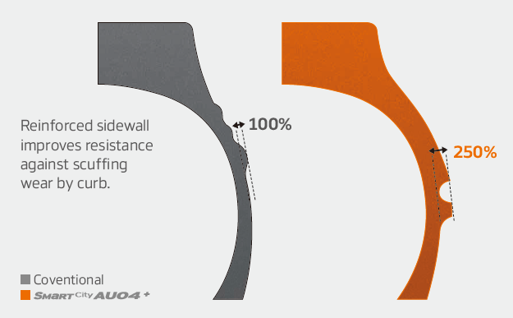

***Wide shoulders and reinforced sidewalls***

* Wide shoulders and reinforced sidewalls ensure excellent wet grip, grip and driving stability.
* New shape and position of the sidewall indicator makes determining the tyre condition easier.

***Improved tread design***

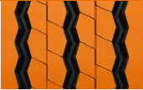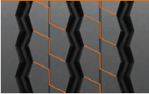

* Stabilising 3D tread blocks guarantee improved traction
* Longer service life through optimised rib spacing
* Three zigzag grooves guarantee excellent traction, particularly under wet conditions

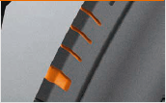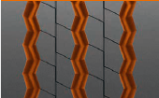

* Adapted should width and removed lugs and ribs ensure more even wear

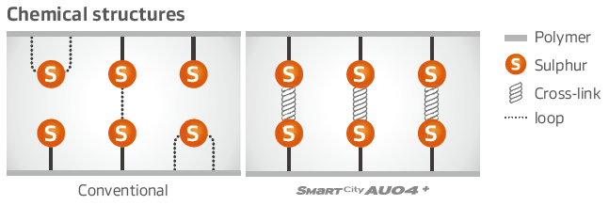

***Innovative rubber compound***

* Improved chemical structure makes the tyre more heat-resistant

###

**Hankook supplies Original Equipment tyres with 41   
sizes to MAN**

**Tyre maker Hankook is consistently expanding its Original Equipment commitment in the truck segment and already supplies original equipment tyres in 41 sizes to MAN. The MAN Truck & Bus AG belongs to the Volkswagen Group, one of Hankook's largest OE customers worldwide. The OE business with Hankook truck tyres for MAN covers a total of 41 dimensions in the 17.5, 19.5, 22.5 and 24 inch range. Hankook's Original Equipment range for the bus and truck manufacturer includes the supply of the tyre lines e-cube MAX, SmartFlex and SmartWork for various MAN models to the production facilities of the Munich-based manufacturer in Germany, Austria and Poland. The tyre ranges have been specially adapted for European conditions, boasting both ecological and economic advantages.**

Premium tyre maker Hankook is listed as an OE supplier for MAN with 41 dimensions, including the truck tyre ranges e-cube MAX, SmartFlex and SmartWork. The commercial vehicles specialist and the tyre maker have been cooperating since the first quarter of 2015. Han-Jun Kim, Hankook COO for Europe comments: “The expansion of OE business in the commercial vehicles segment with MAN is of great strategic importance to us, as we can now offer further treads and dimensions for light to heavy-duty trucks from MAN.”

The tyres will be fitted to the multi-award-winning MAN vehicle series TGX, TGS, TGM and TGL which are used for national and international long-haul, delivery and construction site traffic. Tyres used include the e-cube MAX line, which is tried-and-trusted for international long-haul traffic, the new SmartFlex all-year tyre range for flexible use between long-haul and delivery traffic, as well as construction site treads from the SmartWork series. Specially adapted for use on vehicles of the EURO 6 emission class, the treads – both as special steering and drive axle versions – score highly for environmental friendliness and mileage. This is also relevant to the TCO (Total Cost of Ownership), important for Original Equipment.

One special feature of the Hankook’s Original Equipment portfolio for MAN are the numerous sizes in the low-line segment; the latest size to be added is 355/50R22.5. With these, the premium tyre maker is demonstrating that its portfolio has already integrated the current market trend, namely the growing importance of low-line sizes in the truck business.

*Hankook's range of Original Equipment tyres for MAN:*

|  |  |  |  |  |  |  |  |
| --- | --- | --- | --- | --- | --- | --- | --- |
| **Tread** | **Size** | **Model** | **LI** | **Marking** |  | **M+S** | **Availability** |
| **AL10+** | 315/80R22.5 | TGX | 156/150L (154/150M) | B/B/W1 70dB | - | - | ☑ |
| 315/70R22.5 | TGX | 156/150L | B/B/W1 70dB | - | - | ☑ |
| 315/60R22.5 | TGX | 154/148L | B/C/W1 70dB | - | - | ☑ |
| 295/60R22.5 | TGX | 150/147L | C/B/W1 70dB | - | - | ☑ |
| 355/50R22.5 | TGX | 156L | C/B/W2 76dB | - | - | ☑ |
| **DL10+** | 315/80R22.5 | TGX | 156/150L (154/150M) | C/C/W2 73dB | ☑ | ☑ | ☑ |
| 315/70R22.5 | TGX | 154/150L  (152/148M) | C/C/W2 73dB | ☑ | ☑ | ☑ |
| 315/60R22.5 | TGX | 152/148L | C/C/W2 73dB | ☑ | ☑ | ☑ |
| 295/60R22.5 | TGX | 150/147K | C/C/W1 73dB | ☑ | ☑ | ☑ |
| **AL 10** | 295/80R22.5 | TGX | 152/148M (154/149L) | C/C/W1 70dB | ☑ | - | ☑ |
| 385/55R22. | TGX | 160K (158L) | B/C/W1 70dB | - | - | ☑ |
| **DL10** | 295/80R22.5 | TGX | 152/148M | C/C/W2 75dB | - | ☑ | ☑ |
| **AH31** | 295/80R22.5 | TGM & TGS / TGX | 154/149M | C/B/W1 73dB | ☑ | ☑ | ☑ |
| 315/70R22.5 | TGM & TGS / TGX | 156/150L | C/B/W2 73dB | ☑ | ☑ | ☑ |
| 315/80R22.5 | TGM & TGS / TGX | 156/150L  (154/150M) | C/B/W2 73dB | ☑ | ☑ | ☑ |
| 385/65R22.5 | TGS / TGX | 160K (158L) | C/B/W1 69dB | ☑ | ☑ | ☑ |
| 315/60R22.5 | TGS / TGX | 154/158L | C/B/W1 70dB | ☑ | ☑ | ☑ |
| 385/55R22.5 | TGS / TGX | 160K (158L) | C/B/W1 69dB | ☑ | ☑ | ☑ |
| **DH31** | 295/80R22.5 | TGM & TGS / TGX | 152/148M | D/C/W2 75dB | ☑ | ☑ | ☑ |
| 315/80R22.5 | TGM & TGS / TGX | 156/150L  (154/150M) | D/C/W2 75dB | ☑ | ☑ | ☑ |
| 315/70R22.5 | TGM & TGS / TGX | 154/150L | D/C/W2 75dB | ☑ | ☑ | ☑ |
| 315/60R22.5 | TGS / TGX | 152/148L | D/C/W2 75dB | ☑ | ☑ | ☑ |
| **AH35** | 215/75R17.5 | MAN TGL | 128/126M | D/C/W1 65dB | ☑ | ☑ | ☑ |
| 235/75R17.5 | MAN TGL | 132/130M | D/C/W1 67dB | ☑ | ☑ | ☑ |
| 265/70R17.5 | MAN TGL | 140/138M | C/C/W1 67dB | ☑ | ☑ | ☑ |
| 265/70R19.5 | MAN TGM | 140/138M | C/C/W1 67dB | ☑ | ☑ | ☑ |
| 285/70R19.5 | MAN TGM | 146/144M | C/C/W1 67dB | ☑ | ☑ | ☑ |
| **DH35** | 215/75R17.5 | MAN TGL | 126/124M | D/C/W1 66dB | ☑ | ☑ | ☑ |
| 235/75R17.5 | MAN TGL | 132/130M | D/C/W1 70dB | ☑ | ☑ | ☑ |
| 265/70R17.5 | MAN TGM | 140/138M | D/C/W1 73dB | ☑ | ☑ | ☑ |
| 265/70R19.5 | MAN TGM | 140/138M | D/B/W1 73dB | ☑ | ☑ | ☑ |
| 285/70R19.5 | MAN TGM | 146/144M | D/B/W1 73dB | ☑ | ☑ | ☑ |
| **AM06 TT** | **3**25/95R24 | MAN TGS | 162/160K | D/C/W2 72dB | - | ☑ | ☑ |
| **AM06** | 325/95R24 | MAN TGS | 162/160K | D/C/W2 72dB | - | ☑ | ☑ |  |
| **DM06 TT** | 325/95R24 | MAN TGS | 162/160K | D/B/W1 73dB | - | ☑ | ☑ |
| **DM06** | 325/95R24 | MAN TGS | 162/160K | D/B/W1 73dB | - | ☑ | ☑ |
| **AM15+** | 385/65R22.5 | MAN TGS | 160K (158L) | C/C/W2 74dB | - | ☑ | ☑ |
| **AM09** | 315/80R22.5 | MAN TGS | 156/150K | D/B/W1 67dB | - | ☑ | ☑ |
| 13R22.5 | MAN TGS | 156/150K | D/C/W1 68dB | - | ☑ | ☑ |
| **DM09** | 315/80R22.5 | MAN TGS | 156/150K | D/C/W1 70dB | ☑ | ☑ | ☑ |
| 13R22.5 | MAN TGS | 156/150K | D/C/W2 75dB | ☑ | ☑ | ☑ |

###**Hankook Tire supplies additional all-season sizes**

**for original fitment on premium trucks**

**The Hankook original fitment portfolio for Daimler AG includes the tyre families; e-cube MAX for long-haul traffic, SmartWork for construction site applications and SmartFlex as an all-year solution. The tyre maker already supplies 43 dimensions for original fitment for the European market, including the complete Mercedes-Benz Actros family and Atego series. These now include 12 new sizes of 17.5 and 19.5 inch SmartFlex all-year tyres. This means the range of dimensions supplied to the commercial vehicles sector at Daimler AG for original fitment business in Europe, has been increased four-fold since the cooperation began in 2014.**

Hankook’s original fitment portfolio for the Stuttgart-based truck manufacturer has been extended by 12 sizes in 17.5 and 19.5 inch versions of the all-year tread SmartFlex AH35 for the steering axle and SmartFlex DH35 for the drive axle. Tyre maker Hankook is thus continually expanding its original equipment (OE) portfolio in the medium duty and heavy commercial vehicle segment, as part of its existing OE agreements for the Mercedes-Benz truck model range: Actros, Antos, Arocs, Axor, Econic and Atego. The tyre maker currently provides a total of 43 dimensions of original equipment for Daimler AG in Europe. The portfolio includes the Hankook treads AL10+ e-cube MAX, DL10+ e-cube MAX as well as the SmartFlex AH31 and SmartFlex DH31- all of which have been specially developed for the European market. Extending the OE tyre solutions in the medium duty and heavy duty truck segment is strengthening the Hankook brand on the European truck tyre market and is yet another milestone in the company’s endeavour for sustainable growth on the European continent.

Multi-3D sipes anchored in the tread guarantee high traction for the SmartFlex treads AH35 and DH35. The mixture of straight and wave-shaped tread grooves improves water discharge and reduces the aquaplaning risk long term. M+S marking and 3PFMS symbol (snowflake) document complete suitability for wintry weather conditions. In addition, the high rigidity of the tread blocks promotes fuel-saving rolling. Equally, the special tread design especially supports even tyre abrasion. Together with the wide contact area, the SmartFlex treads guarantee a long service life.

*Hankook original equipment releases for Mercedes-Benz trucks:*

|  |  |  |  |  |  |  |  |  |
| --- | --- | --- | --- | --- | --- | --- | --- | --- |
| **Tyre**  **line** | **Tread** | **Size** | **Load and speed index** | **EU label** |  | **M+S** | **Avail-**  **ability** | **Mercedes-Benz**  **vehicles** |
| **SmartFlex** | **AH35** | 215/75R17.5 | 128/124M | C/B/W1 65dB | ☑ | ☑ | ☑ | Atego |
| 235/75R17.5 | 132/130M | D/C/W1 67dB | ☑ | ☑ | ☑ | Atego |
| 245/70R17.5 | 136/134M | C/C/W1 67dB | ☑ | ☑ | ☑ | Atego |
| 245/70R19.5 | 136/134M | C/C/W1 67dB | ☑ | ☑ | ☑ | Atego |
| 265/70R19.5 | 140/138M | C/C/W1 67dB | ☑ | ☑ | ☑ | Atego |
| 285/70R19.5 | 146/144M | C/C/W1 66dB | ☑ | ☑ | ☑ | Atego |
| **DH35** | 215/75R17.5 | 126/124M | D/C/W1 66dB | ☑ | ☑ | ☑ | Atego |
| 235/75R17.5 | 132/130M | D/C/W1 70dB | ☑ | ☑ | ☑ | Atego |
| 245/70R17.5 | 136/134M | D/C/W1 70dB | ☑ | ☑ | ☑ | Atego |
| 245/70R19.5 | 136/134M  (136/135J) | D/C/W1 73dB | ☑ | ☑ | ☑ | Atego |
| 265/70R19.5 | 140/138M | D/B/W1 73dB | ☑ | ☑ | ☑ | Atego |
| 285/70R19.5 | 146/144M | D/B/W1 73dB | ☑ | ☑ | ☑ | Atego |
| **AH31** | 295/80R22.5 | 152/148M  (154/149L) | C/B/W1 72dB | ☑ | ☑ | ☑ | Actros, Antos, Arocs, Axor, Econic |
| 315/80R22.5 | 156/150L  (154/150M) | C/B/W2 73dB | ☑ | ☑ | ☑ | Actros, Antos, Arocs, Axor, Econic |
| 315/70R22.5 | 156/150L | C/B/W2 73dB | ☑ | ☑ | ☑ | Actros, Antos, Arocs, Axor, Econic |
| 315/60R22.5 | 154/148L | C/B/W1 70dB | ☑ | ☑ | ☑ | Actros, Antos, Arocs, Axor, Econic |
| 385/65R22.5 | 160K (158L) | C/B/W1 69dB | ☑ | ☑ | ☑ | Actros, Antos, Arocs, Axor, Econic |
| 385/55R22.5 | 160K (158L) | C/B/W1 69dB | ☑ | ☑ | ☑ | Actros, Antos, Arocs, Axor, Econic |
| **DH31** | 295/80R22.5 | 152/148M | D/C/W2 75dB | ☑ | ☑ | ☑ | Actros, Antos, Arocs, Axor, Econic |
| 315/80R22.5 | 156/150L  (154/150M) | D/C/W2 75dB | ☑ | ☑ | ☑ | Actros, Antos, Arocs, Axor, Econic |
| 315/70R22.5 | 154/150L | D/C/W2 75dB | ☑ | ☑ | ☑ | Actros, Antos, Arocs, Axor, Econic |
| 315/60R22.5 | 152/148 L | D/C/W2 75dB | ☑ | ☑ | ☑ | Actros, Antos, Arocs, Axor, Econic |
| **e-cube MAX** | **AL10+** | 315/80R22.5 | 156/150L  (154/150M) | B/B/W1 70dB | - |  | ☑ | Actros, Antos, Arocs, Axor, Econic |
| 315/70R22.5 | 156/150L | B/B/W1 70dB | - | - | ☑ | Actros, Antos, Arocs, Axor, Econic |
| 315/60R22.5 | 154/148L | C/B/W1 70dB | - | - | ☑ | Actros, Antos, Arocs, Axor, Econic |
| **DL10+** | 315/80R22.5 | 156/150L  (154/150M) | C/C/W1 73dB | ☑ | ☑ | ☑ | Actros, Antos, Arocs, Axor, Econic |
| 315/70R22.5 | 154/150L  (152/148M) | C/C/W1 73dB | ☑ | ☑ | ☑ | Actros, Antos, Arocs, Axor, Econic |
| 315/60R22.5 | 152/148L | C/C/W1 73dB | ☑ | ☑ | ☑ | Actros, Antos, Arocs, Axor, Econic |
| **e-cube** | **AL 10** | 385/55R22.5 | 158L (160K) | B/C/W1 70dB | - | - | ☑ | Actros, Antos, Arocs, Axor, Econic |
| 295/80R22.5 | 152/148M  (154/149L) | C/C/W1 70dB | - | - | ☑ | Actros, Antos, Arocs, Axor, Econic |
| **DL 10** | 295/80R22.5 | 152/148M | C/C/W2 75dB | - | ☑ | ☑ | Actros, Antos, Arocs, Axor, Econic |
| **Trailer** | **TH22** | 215/75R17.5 | 135/133J | D/B/W1 70dB | - | ☑ | ☑ | Actros  (leading axle) |
| **SmartWork** | **AM15+** | 385/65R22.5 | 158L (160K) | D/C/W2 74dB | - | ☑ | ☑ | Actros, Antos, Arocs, Axor, Econic |
| **AM15** | 275/70R22.5 | 148/145K | D/B/W2 74dB | - | ☑ | ☑ | Atego |
| **AM06** | 10R22.5 | 144/142K | C/B/W2 72dB | - | - | ☑ | Atego |
| 11R22.5 | 148/145K | D/B/W2 72dB | - | - | ☑ | Atego |
| 12R22.5 | 152/148K | D/C/W2 72dB | - | - | ☑ | Actros, Arocs, Axor |
| 13R22.5 | 154/150K  (156/150G) | D/C/W2 72dB | - | - | ☑ | Actros, Arocs, Axor |
| 315/80R22.5 | 156/150K | D/C/W2 74dB | - | - | ☑ | Actros Antos, Arocs, Axor, Econic |
| **DM03** | 11R22.5 | 148/145K | D/C/W2 72dB | - | ☑ | ☑ | Atego |
| 12R22.5 | 152 / 148 K | D/C/W2 72dB | - | ☑ | ☑ | Actros, Arocs, Axor |
| 13R22.5 | 154/150K (156/150G) | D/C/W2 72dB | - | ☑ | ☑ | Actros, Arocs, Axor |
| 315/80R22.5 | 156/150K | D/C/W2 72dB | - | ☑ | ☑ | Actros, Antos, Arocs, Axor, Econic |

###

**Hankook truck tyres for construction site use as Original Equipment on all Scania trucks**

**Premium tyre maker Hankook is supplying various treads of its SmartWork truck tyre series for use in construction site traffic, to the Swedish commercial vehicles manufacturer Scania as Original Equipment (OE). Nine dimensions for 22.5 and 24 inches are initially listed, which fleet customers and transport companies can now order from the three European Scania plants in Zwolle (Netherlands), Södertälje (Sweden) and Anger (France). The new Scania XT generation of construction vehicles is one of the models to be equipped with Hankook tyres.**

Premium tyre maker Hankook is now supplying seven treads for all Scania models designed for use on construction sites, including their new XT generation of construction vehicles. These are the steering axle tyres SmartWork AM06, SmartWork AM06 TT, SmartWork AM09 and SmartWork AM15+ as well as the SmartWork DM06, SmartWork DM06 TT and SmartWork DM09 treads for the drive axle.

The commercial vehicle manufacturer is part of the Volkswagen Group and the latest truck OE partner for Hankook. Hankook’s OE business with truck tyres for Scania is currently concentrating on Europe and covers a total of 34 dimensions in the 22.5 and 24 inch range. Alongside truck tyres for construction site use, Hankook is supplying the Swedish commercial vehicle manufacturer with the e-cube MAX, a truck tyre range for long-haul traffic as well as the SmartFlex, an all-year tyre for medium-haul applications. The range has been specially adapted for European conditions, boasting both ecological and economic advantages. Both tyre ranges can also be fitted to Scania buses.

The OE cooperation with Scania is Hankook’s second within the Volkswagen Group in the heavy commercial vehicle segment; Hankook has been supplying various models to MAN Truck & Bus since 2015.

Han-Jun Kim, Head of Hankook Tire Europe commented: “We are looking forward to expanding our cooperation with Scania. We have to rely on maximum durability when designing tyres for construction site traffic; our SmartWork line was able to completely convince the Scania engineers.”

*Hankook's range of Original Equipment tyres for Scania:*

|  |  |  |  |  |  |  |
| --- | --- | --- | --- | --- | --- | --- |
| **Tread** | **Size** | **LI** | **Marking** |  | **M+S** | **Availability** |
| **AM09** | 315/80R22.5 | 156/150K | D/B/W1 67dB | - | ☑ | ☑ |
| 13R22.5 | 156/150K | D/C/W1 68dB | - | ☑ | ☑ |
| **DM09** | 315/80R22.5 | 156/150K | D/C/W1 70dB | ☑ | ☑ | ☑ |
| 13R22.5 | 156/150K | D/C/W2 75dB | ☑ | ☑ | ☑ |
| **AM15+** | 385/65R22.5 | 160K (158L) | C/C/W2 74dB | - | ☑ | ☑ |
| **AM06** | 325/95R24 | 162/160K | D/C/W1 72dB | - | ☑ | ☑ |
| **DM06** | 325/95R24 | 162/160K | D/C/W1 73dB | - | ☑ | ☑ |
| **AL10+** | 315/80R22.5 | 156/150L (154/150M) | B/B/W1 70dB | - | - | ☑ |
| 315/70R22.5 | 156/150L | B/B/W1 70dB | - | - | ☑ |
| 315/60R22.5 | 154/148L | C/B/W1 70dB | - | - | ☑ |
| 355/50R22.5 | 156L | C/B/W1 70dB | - | - | ☑ |
| **DL10+** | 315/80R22.5 | 156/150L (154/150M) | C/C/W1 73dB | ☑ | ☑ | ☑ |
| 315/70R22.5 | 154/150L (152/148M) | C/C/W1 73dB | ☑ | ☑ | ☑ |
| 315/60R22.5 | 152/148L | C/C/W1 73dB | ☑ | ☑ | ☑ |
| **AL10** | 295/60R22.5 | 150/147K  (149/146L) | C/C/W1 70dB | - | - | ☑ |
| 295/80R22.5 | 152/148M (154/149L) | C/C/W1 70dB | - | - | ☑ |
| 385/55R22.5 | 160K (158L) | B/C/W1 70dB | - | - | ☑ |
| **DL10** | 295/80R22.5 | 152/148M | C/C/W2 72dB | - | ☑ | ☑ |
| 295/60R22.5 | 150/147K (149/146L) | D/C/W2 75dB | - | ☑ | ☑ |
| **AH31** | 295/80R22.5 | 154/149M | C/B/W1 73dB | ☑ | ☑ | ☑ |
| 315/70R22.5 | 156/150L | C/B/W1 73dB | ☑ | ☑ | ☑ |
| 315/80R22.5 | 156/150L (154/150M) | C/B/W1 73dB | ☑ | ☑ | ☑ |
| 385/65R22.5 | 160K | C/B/W1 69dB | ☑ | ☑ | ☑ |
| 385/55R22.5 | 160K (158L) | C/B/W1 69dB | ☑ | ☑ | ☑ |
| **DH31** | 295/80R22.5 | 152/148M | D/C/W2 75dB | ☑ | ☑ | ☑ |
| 315/70R22.5 | 154/150L | D/C/W2 75dB | ☑ | ☑ | ☑ |
| 315/80R22.5 | 156/150L (154/150M) | D/C/W2 75dB | ☑ | ☑ | ☑ |

###

**Hankook and Schmitz Cargobull – a successful partnership**

**Hankook and the trailer manufacturer Cargobull have been working together successfully since 2013. The Europe-wide cooperation covers original fitment of eleven different trailer models, strategic cooperation in the fleet business and the full-service business. In 2016 the two partners extended their cooperation by three years. Schmitz Cargobull honoured Hankook with the title “Strategic Partner” in 2017 for the successful collaboration.**

Premium tyre maker Hankook and Schmitz Cargobull AG, Europe’s leading manufacturer of truck trailers, have been cooperating closely and successfully for more than five years. Schmitz Cargobull specialises in the production of semitrailers for heavy-duty trucks and sets benchmarks for particularly efficient transport solutions on account of its innovative manufacturing and intelligent production technologies. Premium tyre maker Hankook has been supplying Schmitz Cargobull AG with its complete range of trailer tyres for original fitment for several years now. These state-of-the-art tyres have been adapted for European conditions and are eco-friendly. The range covers the truck trailer tyres of the Hankook e-cube MAX and SmartWork series among others. The original fitment business for national and international heavy-duty traffic with Hankook TBR trailer tyres for Schmitz Cargobull is initially concentrating on the European market and currently covers 13 trailer sizes in the 19.5 and 22.5 inch range, including the mega-trailer size 445/45R19.5, 435/50R19.5 and 455/40R22.5 of the Hankook e-cube family. All Hankook tyres are delivered directly to the production plants of the trailer manufacturer, which is based in Altenberge in North Rhine-Westphalia.

The long-standing cooperation is concentrating on strategic collaboration in the fleet business on a European level and extending the existing supply contracts in the OE segment. In 2016, and ahead of time, the two partners agreed to extend their cooperation until 2019 and intensify their business relationship. This more intensive collaboration covers the expansion of the full-service range as well as the development of the spare parts business of Hankook trailer tyres through the existing sales cooperation between the Schmitz Cargobull Service Partner network and joint service partner Pneunet.

Manfred Zoni, Truck Sales Director for the German-speaking market, sees lots of potential in an even closer cooperation with Schmitz Cargobull: “Stepping up our partnership with Schmitz Cargobull is of strategic importance to us, particularly since it boosts both our original fitment and spare parts business in the trailer segment.”

Schmitz Cargobull also values the close and reliable collaboration with the premium tyre maker. As a mark of recognition, the company awarded the **“Strategic Partnership”** prize to Hankook in 2017.

Bernhard Schmitz, Deputy General Manager for Strategic Purchasing at Cargobull, is relying on synergy effects. “Hankook’s strategy supports the Schmitz Cargobull strategy. We are convinced that the long-term collaboration with Hankook will complement our premium products so that we can deliver optimum transport solutions to our customers.”

**###**

SmartTouring is Hankook’s ultra-modern tyre for long-distance coaches

**With the SmartTouring AL22, tyre maker Hankook now has a coach tyre for long-distance travel in their portfolio. The company is anticipating that long-distance coach travel will grow in significance, and thus there will be an increasing demand for high-technology coach tyres in this category. The Hankook SmartTouring AL22 can be used on all axle positions and provides maximum ride and rolling comfort, excellent concentricity, a very low rolling noise and, as is customary with Hankook tyres, optimised rolling resistance and low wear for particularly efficient travel.**

With the SmartTouring AL22, premium tyre maker Hankook has a state-of-the-art tyre for long-distance coach travel on the European market. This is available in the sizes 295/80R22.5 and 315/80R22.5 and is suitable for all long-distance coach wheels in all axle positions possessing likewise excellent winter conditions having the 3PMSF marking. Klaus Krause, Vice President and Head of the European Development Centre in Hanover, adds: “During development of the SmartTouring line, we focused particularly on ride and rolling comfort as well as on a straight driving performance. The characteristics of the SmartTouring AL22 not only allow maximum travel comfort for passengers, they also maximise driving and handling comfort for the driver on long-distance trips.”

The carcass contour of the SmartTouring AL22 ensures the best suspension properties and contributes to a particularly safe driving style. The longitudinal 5-rib profile with its closed, solid central rib makes an excellent straight driving performance possible at all times. Special Multi-3D sipes guarantee both good traction and an outstanding braking response.

The new bead area guarantees a particularly precise rim joint stiffness, which results in excellent concentricity and travel comfort.

The individual belt layers of the new SmartTouring AL22 are structurally arranged in such a way that significantly less heat is developed in operation compared with conventional tyres. This effect not only reduces rolling resistance, thus economising on fuel, it also considerably extends the service life of the tyre.

Fuel savings through reduced heat development have been achieved not only by the belt structure but also by the tread compound used for the Hankook SmartTouring AL22. Special soot molecules with a larger volume and a particularly stable structure are used for the basic tread rubber in particular, leading to a significant reduction in energy loss during movement. These so-called highly structured carbon molecules also guarantee enhanced abrasion resistance and, in combination with the other technologies, help to increase the mileage of the SmartTouring AL22 compared with conventional products by more than 17 percent.

***Available dimensions***

|  |  |  |  |  |  |  |
| --- | --- | --- | --- | --- | --- | --- |
| **Tread** | **Size** | **LI** | **Marking** |  | **M+S** | **Availability** |
| **AL22** | 295/80R22.5 | 154M | C/B/W1 71dB | 🗹 | 🗹 | 🗹 |
| 315/80R22.5 | 156/150L | C/B/W1 71dB | 🗹 | 🗹 | 🗹 |

**Hankook SmartTouring AL22: Technical properties**

***Longitudinal tread profile with Multi-3D sipes and solid central rib***

- High directional stability and comfortable handling response.

- Excellent straight driving.

- Very good braking and traction performance.



***Special brake structure and newly developed bead area***

- Reduced heat development.

- High retreadability.

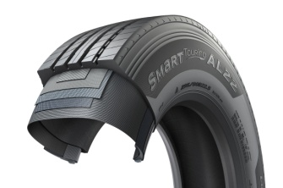

**###**

Winner of the Red Dot Design Award: Hankook's all-year truck tyres SmartFlex AH35 and SmartFlex DH35 for regional traffic

**With the steering axle tyre SmartFlex AH35 and the drive axle tyre SmartFlex DH35, premium tyre maker Hankook has an all-year truck tyre for regional traffic. The all-year tyres, winners of the Red Dot Design Award in 2016, have particularly high traction on account of special Multi-3D sipes. In addition, the rigid tread blocks with minimum block movement promote fuel-efficient driving.**

With the SmartFlex AH35 and SmartFlex DH35, fleets and forwarding agents benefit from a low-fuel, high-mileage and high-traction all-year tyre solution for the steering and drive axles. It is also possible to fit SmartFlex AH35 to all axles. In 2016, they were presented with the Red Dot Design Award. Whilst the SmartFlex AH31 and SmartFlex DH31 are intended mainly for larger wheel sizes such as 22.5 inch, the SmartFlex AH35 and its counterpart SmartFlex DH35 for the drive axle are designated to the smaller 17.5/19.5 inch sizes.

The Multi-3D sipes anchored in the tread of the SmartFlex AH35 guarantee outstanding traction. The mixture of straight and wave-shaped grooves improves water drainage and prevents hydroplaning long-term. Without losing sight of the summer properties, the M+S marking and the 3PMFS symbol (snowflake) indicate that the tyre is also perfectly equipped for all wintry weather conditions such as slush, ice and snow. The rigidity of the tread blocks promotes particularly fuel-efficient driving. Equally, the special tread design supports even tyre wear so that the Total Cost of Ownership for fleet and forwarding agent companies can be reduced long term in terms of service life. The high mileage and performance of the tyre are guaranteed by a wide contact area.

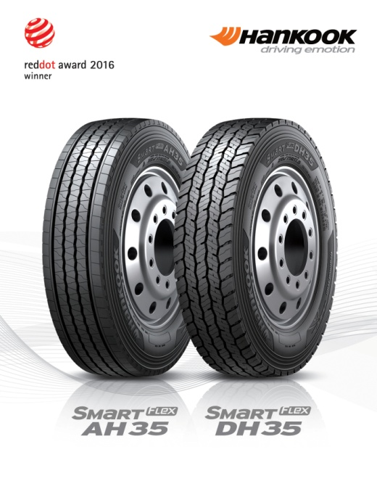

Just like the steering axle tyre, the drive axle tyre SmartFlex DH35 has M+S marking and the snowflake symbol. In addition, the tyre also has a wide contact area with four zigzag groove lines over the whole tread surface, enhancing mileage and driving performance under different road and traffic conditions. Furthermore, the 3D sipes ensure high traction and low rolling resistance. The innovative tread sipe design supports low rolling resistance and tyre traction for the drive axle in road traffic.

*Sizes of the SmartFlex tyre line available*

|  |  |  |  |  |  |  |
| --- | --- | --- | --- | --- | --- | --- |
| **Tread** | **Size** | **LI** | **Marking** |  | **M+S** | **Availability** |
| **AH35** | 8.5R17.5 | 121/120L | D/C/W1 67dB | 🗹 | 🗹 | 🗹 |
| 9.5.R17.5 | 131/129L | D/C/W1 67dB | 🗹 | 🗹 | 🗹 |
| 8R19.5 | 124/122L | D/C/W1 67dB | 🗹 | 🗹 | 🗹 |
| 205/75R17.5 | 124/122M | D/C/W1 65dB | 🗹 | 🗹 | 🗹 |
| 215/75R17.5. | 126/124M | D/C/W1 65dB | 🗹 | 🗹 | 🗹 |
| 215/75R17.5. | 128/124M | D/C/W1 65dB | 🗹 | 🗹 | 🗹 |
| 225/75R17.5 | 129/127M | C/C/W1 67dB | 🗹 | 🗹 | 🗹 |
| 235/75R17.5 | 132/130M | C/C/W1 69dB | 🗹 | 🗹 | 🗹 |
| 245/70R17.5 | 136/134M | C/C/W1 69dB | 🗹 | 🗹 | 🗹 |
| 245/70R19.5 | 136/134M | C/C/W1 67dB | 🗹 | 🗹 | 🗹 |
| 265/70R17.5 | 140/136M | C/C/W1 65dB | 🗹 | 🗹 | 🗹 |
| 265/70R19.5 | 140/138M | C/C/W1 67dB | 🗹 | 🗹 | 🗹 |
| 285/70R19.5 | 146/144M | C/C/W1 67dB | 🗹 | 🗹 | 🗹 |
|  | 305/70R19.5 | 148/145M | C/C/W1 65dB | 🗹 | 🗹 | 🗹 |
| **DH 35** | 205/75R17.5 | 124/122M | D/C/W1 66dB | 🗹 | 🗹 | 🗹 |
| 215/75R17.5 | 126/124M | D/C/W1 66dB | 🗹 | 🗹 | 🗹 |
| 225/75R17.5 | 129/127M | D/C/W1 73dB | 🗹 | 🗹 | 🗹 |
| 235/75R17.5 | 132/130M | D/C/W1 73dB | 🗹 | 🗹 | 🗹 |
| 245/70R17.5 | 136/134M | D/C/W1 73dB | 🗹 | 🗹 | 🗹 |
| 8.5R17.5 | 121/120L | D/C/W1 73dB | 🗹 | 🗹 | 🗹 |
| 9.5R17.5 | 131/129L | D/C/W1 73dB | 🗹 | 🗹 | 🗹 |
| 245/70R19.5 | 136/134M | D/C/W1 73dB | 🗹 | 🗹 | 🗹 |
| 265/70R17.5 | 139/136M | D/C/W1 73dB | 🗹 | 🗹 | 🗹 |
| 265/70R19.5 | 140/138M | D/B/W1 73dB | 🗹 | 🗹 | 🗹 |
| 285/70R19.5 | 146/144M | D/B/W1 73dB | 🗹 | 🗹 | 🗹 |
| 305/70R19.5 | 148/145M | D/B/W1 73dB | 🗹 | 🗹 | 🗹 |

**Technical properties of the SmartFlex AH35**

***A Wide contact area:***

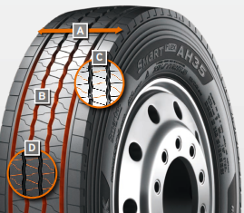

The wide contact area guarantees high mileage.

***B Four wave-shaped and straight grooves:***

The combination of four wave-shaped and straight grooves over the whole tread surface on a wide range of different road surfaces guarantees excellent water drainage

***C Multi-3D sipe tread:***

The Multi-3D sipe tread offers outstanding traction and thus promotes improved driving stability.

The rigidity of the tread blocks and the resulting minimum block movement lead to significant fuel savings.

***D Special tread design with “semi-sipes”***

Special tread design with “semi sipes” guarantees an even wear pattern over the entire service life

*Wide contact area*

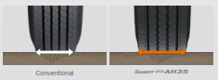

*Multi-3D sipes*

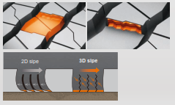

**Technical properties of the SmartFlex DH35**

***A Wide contact area with 4 zigzag grooves:***

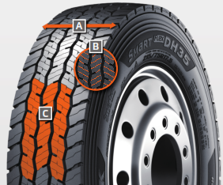

The wide contact area and the 4 all-round zigzag tread grooves ensure high mileage and overall performance.

***B Multi-3D sipes:***

The special tread design with Multi-3D sipes promotes low rolling resistance and outstanding traction.

***C Innovative tread design:***

The special tread design guarantees low rolling resistance and optimum traction under a wide range of different conditions.

*Wide contact area*



**###**

All-rounders for all-year tyres

**Particularly in changeable weather conditions, Hankook recommends that truck and bus customers use the SmartFlex all-weather tyre line for medium and long haul trips. Commercial vehicle customers can rely in particular on a high level of driving safety as well as the current trend of increased load-bearing capacity for some sizes.**

Both the steering axle tyres SmartFlex AH31 and the drive axle tyres SmartFlex DH31 have M+S marking and the snowflake (3PMSF) symbol, which means good traction is guaranteed even if drivers should be surprised by wintry road conditions. The Hankook SmartFlex DH31 has a 6-rib tread with special hexagonal tread blocks that guarantees more even wear behaviour and thus a longer tyre service life. Hankook's patented self-cleaning sipes in the middle of each block prevent damage to the block edges and thus guarantee excellent traction throughout the tyre life.

The SmartFlex all-year tyre line is completed by the corresponding trailer tyre SmartFlex TH31, which celebrated its première at the 66th IAA for Commercial Vehicles. Its wide, closed shoulder area supports stable straight driving and ensure good lateral stability. Chamfered tread grooves help prevent splintering.

Whilst the SmartFlex AH31 and SmartFlex DH31 are designated mainly for larger wheel sizes in the 22.5 inch range, SmartFlex AH35 and its drive axle counterpart SmartFlex DH35 is more designated for smaller wheels with 17.5/19.5 inch sizes.

*Sizes of the SmartFlex tyre line available*

|  |  |  |  |  |  |  |  |
| --- | --- | --- | --- | --- | --- | --- | --- |
| **Tread** | **Size** | **LI** | **Marking** |  | **M+S** | **Availability** | **Remark** |
| **AH31** | 295/80R22.5 | 152/148M (154M/149L) | C/B/W1 73 dB | 🗹 | 🗹 | 🗹 | - |
| 295/80R22.5 | 154/149M | C/B/W1 73 dB | 🗹 | 🗹 | 🗹 | Tyre with higher load-bearing capacity |
| 315/80R22.5 | 156/150L | C/B/W1 73 dB | 🗹 | 🗹 | 🗹 | - |
| 315/70R22.5 | 156/150L | C/B/W1 73 dB | 🗹 | 🗹 | 🗹 | - |
| 385/65R22.5 | 164K | C/B/W1 69 dB | 🗹 | 🗹 | 🗹 | - |
| 385/65R22.5 | 160K | C/B/W1 69 dB | 🗹 | 🗹 | 🗹 | - |
| 315/60R22.5 | 154/148L | C/B/W1 70 dB | 🗹 | 🗹 | 🗹 | - |
| 385/55R22.5 | 160K | C/B/W1 69 dB | 🗹 | 🗹 | 🗹 | - |
| 355/50R22.5 | 156L | C/B/W1 69 dB | 🗹 | 🗹 | 🗹 | - |
| **DH31** | 295/80R22.5 | 152/148M | D/C/W2 75 dB | 🗹 | 🗹 | 🗹 | - |
| 315/80R22.5 | 156/150L | D/C/W2 75 dB | 🗹 | 🗹 | 🗹 | - |
| 315/70R22.5 | 154/150L | D/C/W2 75 dB | 🗹 | 🗹 | 🗹 | - |
| 295/60R22.5 | 150/147K | D/C/W2 75 dB | 🗹 | 🗹 | 🗹 | - |
| 315/60R22.5 | 152/148L | D/C/W2 75 dB | 🗹 | 🗹 | 🗹 | - |
| **TH31** | 385/65R22.5 | 160K | B/B/W1 69 dB | - | 🗹 | 🗹 | - |
| 435/50R19.5 | 160J | B/B/W2 73 dB | - | 🗹 | 🗹 | - |
| 455/40R22.5 | 160J |  |  |  | In production | - |

**Technical properties of the Hankook SmartFlex all-year tyre line**

**SmartFlex AH31**

***Truck all-year tyres for the steering axle for medium to long-haul applications***

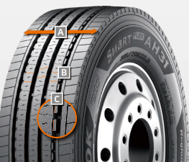

***An Extra-wide tread and shoulder area:***

* The extra-wide-open shoulder area supports a high mileage and traction as well as outstanding handling properties

***B Multi-3D sipe treads:***

* High traction and mileage with even

wear

***C Tread Wear Equalizer Stepper Technology (T.W.E.S.):***

* Stabilisers on profile blocks
* Reduction of uneven/one-sided wear

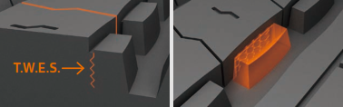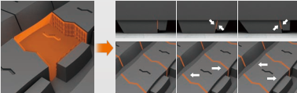

**SmartFlex DH31**

***Truck all-year tyres for the drive axle for medium to long-haul applications***

***A Multi-3D sipes:***

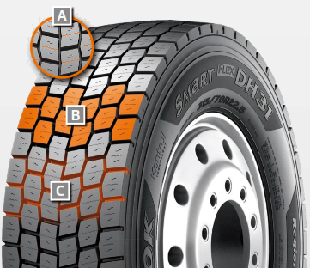

* High traction and mileage with even wear

***B 6-rib block tread:***

* Sturdy 6-rib block tread with special hexagonal tread blocks

***C Self-cleaning sipes:***

* Constant traction over the entire service life
* Protection against splintering at the corners of the sipes

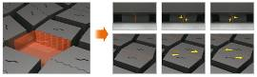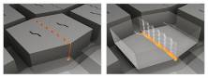

**SmartFlex TH31**

***Truck all-year tyres for the trailer axle for medium to long-haul applications***

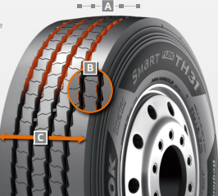

***A 4 Zigzag sipes:***

* 4 main tread grooves ensure optimum water displacement

***B Chamfered profile block design:***

* Chamfered profile blocks sipes help to prevent material splintering

***C Extra-wide tread and shoulder area:***

* The extra-wide closed shoulder area supports high driving stability and ensures good lateral stability as well as even wear

**###**

For even more safety: Hankook is reinforcing the sidewalls of the bus tyre AU03+ on all axle positions

**Hankook’s bus tyre AU03+ was developed particularly with the requirements of stop-and-go traffic in mind and is especially suitable for use on regular city bus services. The all-year tyre provides an optimum profile especially suitable for city traffic and urban roads and is designed with a high level of safety in mind, whilst being economic and environmentally friendly at the same time.**

The sidewalls have been reinforced to guarantee even safer and more efficient use in city traffic, with an even wider and deeper sidewall indicator being incorporated at the same time. The AU03+ is available in size 275/70R22.5 and with M+S marking and the 3PMSF (3 Peak Mountain Snowflake) symbol. In addition to the AU03 +, the AU03 is available in 11R22.5, 275 / 80R22.5, 295 / 80R22.5, 245 / 70R19.5 and 265 / 70R19.5.

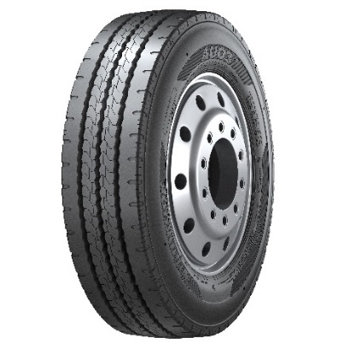

Safety is a fundamental factor that Hankook considers for each of its products. That’s why safety performance with short braking distances and superior wet performance is also a key component of the AU03+. Furthermore, the reinforced sidewall protects the tyre from damages including stone chips and curb contacts.

The profile of Hankook’s AU03+ guarantees excellent traction which is supported through an optimised kerf arrangement without leaving mileage behind.

*Sizes of the AU03+ / AU03 available:*

|  |  |  |  |  |  |  |
| --- | --- | --- | --- | --- | --- | --- |
| **Tread** | **Size** | **LI** | **Marking** | **Snowflake** | **M+S** | **Availability** |
| **AU03+** | 275/70R22.5 | 150/145J  (152/148) | D/C/W1/71 dB | ☑ | ☑ | ☑ |
| **AU03** | 11R22.5 | 148/145J | C/B W1 71 dB | - | ☑ | ☑ |
| 275/80R22.5 | 149/146J | D/C W1 71 dB | - | ☑ | ☑ |
| 295/80R22.5 | 152/148J | C/C W1 71 dB | ☑ | ☑ | ☑ |
| 245/70R19.5 | 136/134L | D/C W1 71 dB | ☑ | ☑ | ☑ |
| 265/70R19.5 | 104/138M | D/C W1 71 dB | ☑ | ☑ | ☑ |

**Technical features of the AU03+:**

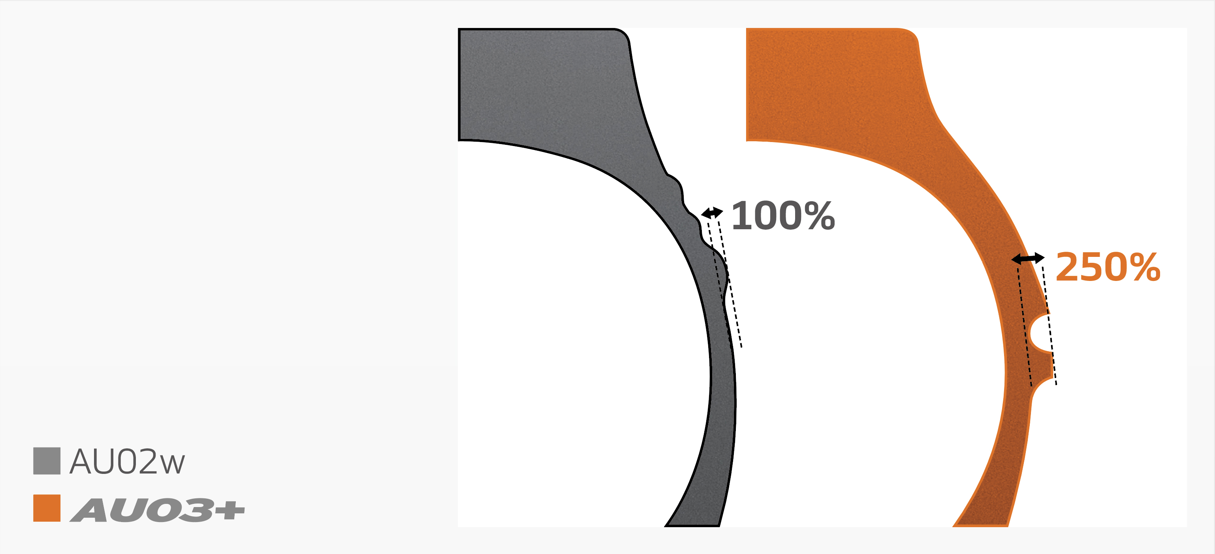

***Wide shoulder and reinforced sidewalls***

* The wide shoulder and reinforced sidewalls ensure excellent wet grip, dry grip and driving stability.

***Horizontal kerfs and deep sipes***



* Kerfs incorporated horizontally in the cap rib and a tread with deep sipes guarantee outstanding traction and mileage performance.

***Zigzag grooves***



* Four zigzag tread grooves guarantee excellent lateral guidance and ensure optimum water drainage.

**###**

Hankook AL10+ e-cube MAX:  
Low-line sizes for the steering axle

**In times when the trend is going more and more towards volume transportation, the legally permissible outside height of four metres for commercial vehicles means that fleet operators are quickly reaching their limits. The issues get amplified if the freight forwarder wants to transport heavy standard goods in addition to volume transports. Therefore, premium tyre maker Hankook has released the AL10+ e-cube MAX long distance tyre for the low-line segment as well. With the dimension of 355/50R22.5, the new low-profile tyre for the truck steering axle is designed especially for the requirements of volume transports.**

Until now, fleet operators with truck tyres of series 60 to 80 have often not been able to completely utilise the maximum inner load height of three metres without exceeding the legally permissible total height of four metres. Therefore, load capacity is lost, which in turn can result in economic disadvantages. As a consequence, premium tyre maker Hankook is offering its customers a truck tyre for the steering axle in series 50: the AL10+ e-cube MAX was developed in size 355/50R22.5 exclusively for use on jumbo trucks for long distances, and it provides a load index of 156, which means that the axle can be loaded with a weight of up to 8 tons. With its small diameter, it lowers the coupling height of the tractor engine, with the result that the inner load height increases and the three-metre loading platform can be fully utilised thanks to the lower profile tyres.

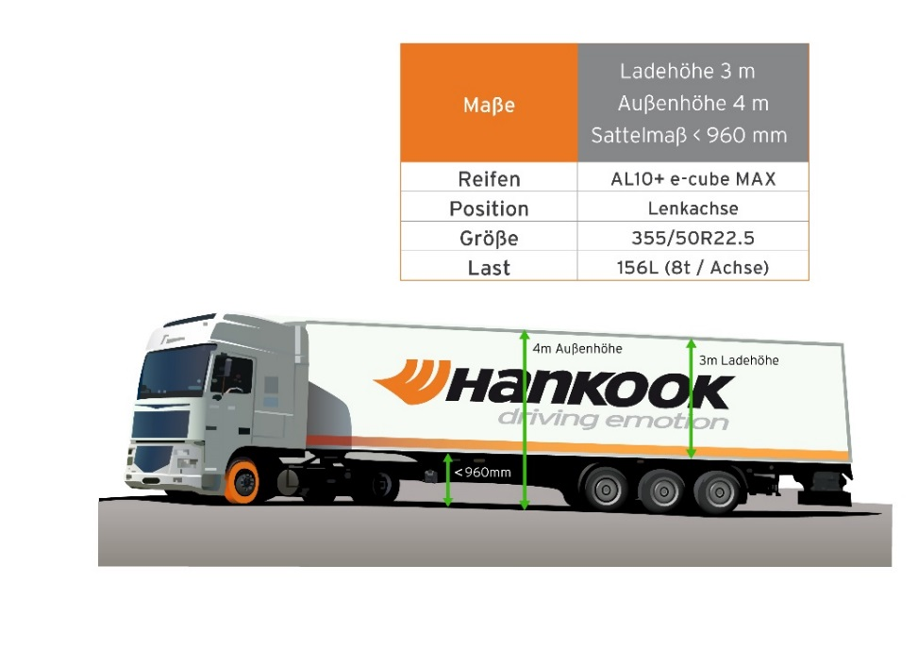

The tyre profile e-cube MAX for commercial vehicles represents maximum cost effectiveness, energy efficiency and environmental friendliness: due to its longitudinal grooved tread with wave structure, the AL10+ e-cube MAX for the steering axle prevents uneven wear. Therefore, the AL10+ e-cube MAX guarantees an increased service life. The improved tread compound and high load index of the tyre increase the fuel efficiency while offering higher load capacity at the same time. The linear groove structure supports stable directional stability as well as maximum steering precision and improved water dispersal.

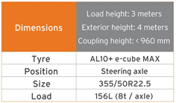

The long-distance specialist for the steering axle is supported by its counterpart for the drive axle, the DL10+ e-cube MAX from the same tyre line. Due to its three-dimensional lamellae, it offers drivers outstanding traction, while the extra-wide profile block and deep grooves ensure increased mileage. The block stabilisers of the DL10+ e-cube MAX also contribute to a high service life and low rolling resistance. The e-cube MAX series is completed by the matching trailer tyre TL10+, which is characterised by maximum driving stability and low rolling resistance. Furthermore, the TL10 completes the e-cube package, which is available in sizes 275/70R22.5, 445/65R22.5 and 445/45R19.5.

*Sizes of the e-cube MAX tyre line available*

|  |  |  |  |  |  |  |
| --- | --- | --- | --- | --- | --- | --- |
| **Tread** | **Size** | **LI** | **Marking** |  | **M+S** | **Availability** |
| **AL 10+** | 315/80R22.5 | 156/150L (154/150M) | B/B/W1 70dB | - | - | 🗹 |
| 315/70R22.5 | 156/150L | B/B/W1 70dB | - | - | 🗹 |
| 385/65R22.5 | 160K | B/B/W1 70dB | - | - | 🗹 |
| 295/60/R22.5 | 150/147L | C/B/W1 70dB | - | - | 🗹 |
| 315/60R22.5 | 154/148L | C/B/W1 70dB | - | - | 🗹 |
| 355/50R22.5 | 156L | B/B/W1 70dB | - | - | 🗹 |
| **DL 10+** | 315/80R22.5 | 156/150L (154/150M) | C/C/W1 73dB | 🗹 | 🗹 | 🗹 |
| 295/60R22.5 | 150/147K | C/C/W1 73dB | 🗹 | 🗹 | 🗹 |
| 315/60R22.5 | 152/148L | C/C/W1 73dB | 🗹 | 🗹 | 🗹 |
| 295/55R22.5 | 147/145K | C/C/W1 73dB | 🗹 | 🗹 | 🗹 |
| 315/45R22.5 | 147/145L | D/C/W2 75dB | 🗹 | 🗹 | In production |
| **TL10+** | 215/75R22.5 | 135/133J | C/B/W1 69dB | - | - | 🗹 |
| 235/75R22.5 | 143/141J | B/B/W1 69dB | - | - | 🗹 |
| 245/70R17.5 | 143/141J (146/146F) | B/B/W1 69dB | - | - | 🗹 |
| 265/70R19.5 | 143/141J | B/B/W1 69dB | - | - | 🗹 |
| 435/50R19.5 | 160J | B/B/W2 73dB | - | - | 🗹 |
| 455/40R22.5 | 160J | B/B/W2 71dB | - | - | 🗹 |

**###**

**New treads for mixed on-road and off-road use supplement Hankook’s SmartWork line**

**New treads for mixed on-road and off-road use are supplementing Hankook’s existing tyre line for use on construction sites, Hankook SmartWork. The new products SmartWork AM11 for the steering axle, DM11 for the drive axle and the trailer tyre TM11, have been designed with the requirements of construction site supply vehicles in mind. This means the new series not only holds its own with good traction on site, it performs well on the road too, with a long service life amongst other things.**

The new treads in the Hankook SmartWork line, AM11, DM11 and TM11, have been specifically developed for construction site vehicles used for the supply and removal of raw materials, gravel, waste or similar to or from construction sites and thus cover most of their miles on public roads. Steering axle, drive axle and trailer tyres offer both a long service life for use on the road and high traction for off-road use on construction sites. The tread design to match all the axle positions on the vehicle and the specially developed rubber compound make sure of that.

The SmartWork AM11 for the steering axle or use on all axles, has three extra-wide main drainage tread grooves in a zigzag design to improve hydroplaning safety. Special rubber blocks in the tread grooves stop stones from becoming lodged. An angular sipe design guarantees optimum traction, while chamfered block edges and special sipes on the tread blocks contribute towards more block stability and also improve the braking and handling response. The SmartWork AM11 also has a closed shoulder design for more driving stability, lateral stability and even abrasion for a longer service life.

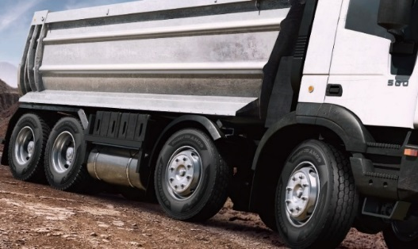

The trailer tyre TM11 differs from the SmartWork AM11 in that it has a half-open shoulder design. Lateral grooves enhance tyre traction particularly on muddy or snow-covered roads and on construction sites. Both the SmartWork AM11 and the SmartWork TM11 have M+S marking.

The SmartWork DM11 is available for the drive axle. The directional V-shaped tread design enables improved displacement of mud and water in the construction site area. The interblock tie-bars at the centre of the SmartWork DM11 ensure high block stability and guarantee outstanding straight driving performance and impact dispersion for blocks, thereby improving durability. Three-dimensional sipes also enhance tyre traction. The SmartWork DM11 also has the snowflake symbol, which means it can even be used under very wintry conditions.

*Sizes of the SmartWork line available*

|  |  |  |  |  |  |  |
| --- | --- | --- | --- | --- | --- | --- |
| **Tread** | **Size** | **LI** | **Marking** |  | **M+S** | **Availability** |
| **AM11** | 315/80R22.5 | 156/150K | C/B/W2 (71dB) | - | 🗹 | Q2/2019 |
| **DM11** | 315/80R22.5 | 156/150K | C/B/W2 (74dB) | 🗹 | 🗹 | Q2/2019 |
| **TM11** | 385/65R22.5 | 160K | C/B/W2 (73dB) | - | 🗹 | Q2/2019 |

**Technical properties of the Hankook SmartWork AM11**

1. ***Wide zigzag grooves for improved hydroplaning safety and optimised braking response***

* Three extra-wide tread grooves in a zigzag design guarantee optimum water displacement both on tarmacked roads and off-road.
* Angular sipes for optimum traction.
* Additional pimples in the grooves support the tyre's self-cleaning function.

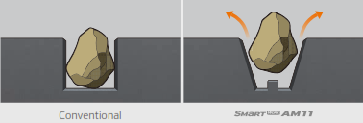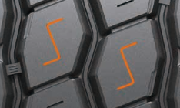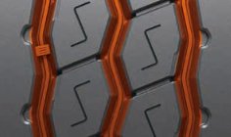

1. ***Polygonal stepped blocks for a more pronounced edge effect***

* Special edge angle at the individual tread blocks and chamfered block edges for optimum braking response.

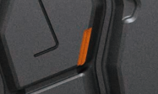

1. ***Closed shoulder design increases the tyre’s driving stability***

* Improved resistance against forces acting at the side.
* Protection against damage to the block edges.
* Shoulder lugs help to reduce heat development while driving.

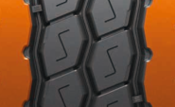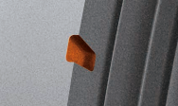

1. ***Closed shoulder design increases the tyre's driving stability:***

* Improved resistance against forces acting at the side.
* Protection against damage to the block edges.
* Shoulder lugs help to produce less heat while driving.

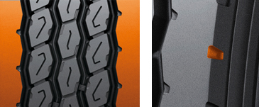

**Technical properties of the Hankook SmartWork DM11**

1. ***Directional tread design***

* V-shaped directional tread design for the outstanding displacement of mud and water.

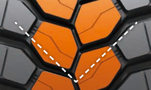

1. ***Bars between the tread blocks***

- Bars between the tread blocks stabilise the tyre.

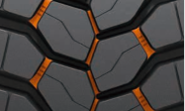

**Technical properties of the Hankook SmartWork TM11**

1. ***Wide zigzag grooves for improved hydroplaning safety and optimised braking response***

* Three extra-wide tread grooves in a zigzag design guarantee optimum water displacement both on tarmac roads and off-road.
* Angular sipes for optimum traction.
* Additional pimples in the grooves support the tyre's self-cleaning function.



1. ***Polygonal stepped blocks for a more pronounced edge effect***

* Special notches at the individual tread blocks and chamfered block edges for optimum braking response.



1. ***Half-open shoulder design***

* Half-open shoulder design for enhanced traction particularly on muddy or snow-covered roads, or within the construction site

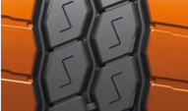

Hankook TH22: Trailer tyres for low-bed truck transport

**The TH22 is Hankook's trailer specialist when it comes to transporting heavy loads in regional traffic, along country roads for example. Because alongside the standard sizes, the TH22 is available in smaller sizes which can then be fitted to low-bed trucks, making maximum loading volume possible.**

The Hankook TH22 is the successful trailer tyre from the premium tyre maker for regional and delivery traffic. The TH22 is available in standard sizes 425/65R22.5 and 385/55R22.5 and also in smaller sizes especially for use on low-bed trailers.

The profile and carcass design of the Hankook TH22 trailer tyre optimises wear resistance as well as rolling resistance. The smaller sizes have a closed 4-rib block profile with extra-broad, solid shoulder ribs which was especially developed for low rolling resistance and good lateral stability. At the same time, the tread design supports even wear and 10 percent higher mileage than its predecessor. Wave-shaped tread sipes and transverse sipes right down to the base of the groove additionally provide for effective water displacement, making the TH22 a true all-round talent when it comes to handling. The large sizes have the same characteristics, the only difference being that the block profile is made up of five ribs.

The low design height ensures maximum loading volume and, coupled with the high load-bearing capacity, makes the Hankook TH22 in the sizes 205/65R17.5 and 215/75R17.5 particularly suitable for low-bed trailer heavy-duty transport on country roads, such as car, construction vehicle or construction element transport.

*Available sizes of the TH22*

|  |  |  |  |  |  |  |
| --- | --- | --- | --- | --- | --- | --- |
| **Tread** | **Size** | **LI** | **Marking** |  | **M+S** | **Availability** |
| **TH22** | 9.5R17.5 | 143/141J | D/B/W1 70dB | - | 🗹 | 🗹 |
| 11R22.5 | 148/146L | C/B/W1 70dB | - | 🗹 | 🗹 |
| 215/75R17.5 | 135/133J | D/B/W1 70dB | - | 🗹 | 🗹 |
| 235/75R17.5 | 143/141J | C/B/W1 70dB | - | 🗹 | 🗹 |
| 245/70R17.5 | 143/141J (146/146F) | C/B/W1 70dB | - | 🗹 | 🗹 |
| 245/70R19.5 | 141/140J | C/B/W1 67dB | - | 🗹 | 🗹 |
| 265/70R19.5 | 143/141J | C/B/W1 70dB | - | 🗹 | 🗹 |
| 285/70R19.5 | 150/148J | C/B/W1 70dB | - | 🗹 | 🗹 |
| 205/65R17.5 | 129/127K(132/132F) |  | - | 🗹 | 🗹 |
| 425/65R22.5 | 165K | B/B/W1 71dB | - | 🗹 | 🗹 |
| 385/55R22.5 | 160K (158L) | B/B/W1 71dB | - | 🗹 | 🗹 |

**Technical properties of the Hankook TH22**

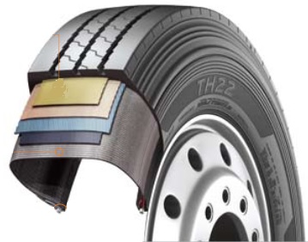

**1.** ***Tyre design***

- Belt structure: Less belt deformation guarantees very

low rolling resistance

- Carcass structure: The wider carcass profile with reinforced

belt cord guarantees

excellent durability

- Bead structure: Reinforced bead structure ensures a long service life

even at high load weights

**2.** ***Tread design***

- Optimised zigzag rib design for good self-cleaning

- Wide and firm shoulder package for improved mileage and even wear

- Solid, continuous centre rib improves rolling characteristics and lateral stability

**###**

Hankook light truck tyre Vantra LT:   
Energy efficient, safe and exceptionally durable

**Hankook presents the Vantra LT, the Summer tyre for commercial vans and transporters. The innovative design features improves fuel efficiency by up to 13 % while reducing wear by 12 % for extended mileage. Designed specifically for the high demands placed on passenger and goods transport vehicles ensuring optimised durability and reduced breaking distances.**

Hankook Tire introduce the Vantra LT designed for commercial vans and transporters. The light truck tyre was developed in view of the high demands that are placed on passenger and goods transport vehicles in regional traffic. Durability, fuel efficiency and mileage played a key role during development as well as safety-related driving characteristics such as short breaking distances and superior wet performance. The Vantra LT is available in 37 dimensions.

Frequent use in start/stop traffic places special demands on tyres: a long service-life with high economic efficiency to maximise mileage and robustness against external influences are important while safety performance is playing a key role as well. The Hankook Vantra LT’s innovative design features such as a sidewall protect shield and optimised groove location with durable contact patch technology enables increased performance and assure safety at high speeds. At the same time, they reduce tread wear and improve the tyre’s fuel efficiency. In addition, 3-channel wide central grooves and 3D lateral grooves enable fast water dispersion to reduce hydroplaning and guarantee superior performance in wet and even cold weather conditions.

Hankook Vantra LT’s footprint is designed to improve durability by applying square shape contact patch technology that allows for an optimised groove position, increasing stability in the outer grounding footprint area. In combination with the tyre’s innovative reinforced belt structure featuring a double steel belt this allows a more even distribution of the ground pressure resulting in an improved wear performance. In addition, the reduced tyre deformation results in a lowered rolling resistance, resulting in higher fuel efficiency and thus heightened cost-effectiveness – a key factor for tyres used for start/stop traffic. The additionally applied sidewall protect shield effectively helps to prevent sidewall damage.

The innovative pattern not only guarantees superior wet braking performance and effectively prevents hydroplaning but also improves fuel efficiency by minimising energy loss while driving. The Vantra LT’s optimised block stiffness further improves the tyre’s handling performance in wet, dry and even cold weather conditions without sacrificing block strength. The running smoothness of the tyre – and thus control and driving comfort – is perceptibly greater as well.

**Technical features of the Vantra LT**

1. ***Optimised interior structure ensures durability and safety***

The reinforced belt structure of the Vantra LT ensures durable performance by applying a reinforced belt layer and double steel belt. In combination with special bead filler for enhanced rim joint stiffness also handling performance is improved. The tyre’s Sidewall Protect Shield prevents sidewall damage under low-pressure conditions.

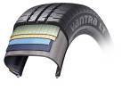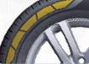

1. ***Increased handling and wet performance***

3-channel wide grooves in combination with 3D lateral grooves reduce the risk of hydroplaning and ensure increased performance and safety at higher speed as well as enhanced wet and cold weather

performance without sacrificing block strength. The Vantra LT’s innovative new straight main grove improves hydroplaning performance by up to 14% by ensuring better water runoff.

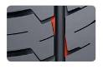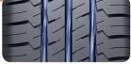

1. ***Improved wear performance, fuel efficiency and extended mileage***

By applying an optimised structure with innovative compound technology, the wear performance has improvement of up to 12% compared to a conventional tyre. In addition, an optimised carcass profile allows for up to 13 % improved fuel efficiency by minimising energy loss in driving.

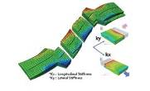

1. ***Increased durability and driving stability***

The Vantra LT’s square shape contact patch improves the tyre’s durability while the optimised groove position ensures additional stability in the outer grounding footprint area.

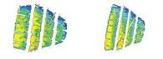

1. ***Available sizes***

The Vantra LT is available in 35 dimensions in sizes from 12 to 16 inches in series 82 to 60 and cover tread width from 155 to 235 all marked M+S.

**###**

**The innovative Hankook mixing method IMS (Innovative Mixing System)**

The innovative Hankook mixing method IMS (Innovative Mixing System) ensures a particularly even distribution of carbon black particles and rubber molecules within the mixtures. Together with longer mixing times at lower temperatures, a significant increase of the bonding rate between the carbon black and rubber molecules can be achieved. As a result, the tyre generates less heat during the drive, which has a positive effect on the rolling resistance and thereby on fuel consumption as well.



**Hankook Stiffness Control Contour Theory (SCCT)**

The patented Hankook Stiffness Control Contour Theory (SCCT) design technology provides an even distribution of pressure inside the tyre and thus promotes more stability and less movement in the tyre. This results in high carcass durability and offers customers very good retreadability and economy.

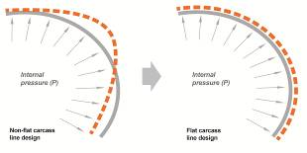

**###**

Hankook ‘alphatread’ for the UK market:  
Bead-to-bead retread truck tyre range

‘alphatread’ is the environmentally conscious bead to bead retread truck tyre range from premium tyre maker Hankook Tyre UK. The ‘alphatread’ line-up designed for medium haul purposes consists of sizes for the drive axle position together with a corresponding trailer tyre size. It aims to meet customer demands for reducing fleets running costs by providing a ‘cradle to grave’ tyre solution.

The ever-increasing demands in the area of environmental friendliness and continued pressure upon fleets to reduce their running costs have led to the development of the Hankook ‘alphatread’ range. The premium manufacturer’s retread truck tyre line has been specifically designed to maximise mileage as the casings of Hankook’s 1st life A1 grade tyres are used to mirror Hankook’s existing tyre patterns to produce the alphatread tyre. For the time being the products are available in the UK market in two drive axle sizes and a corresponding trailer size.

The Hankook alphatread R-DH05 is a drive axle tyre for medium haul, available in three sizes 295/80R22.5, 315/80R22.5 and now the 315/70 R22.5. With its wide outline and a unique compound, the R-DH05 provides excellent wet and dry performance, driving stability and long-lasting wear. While the extra wide tread and deep grooves ensure high mileage, the optimised block shape provides block rigidity also under heavy loads for an outstanding traction and tread stability. Its lateral oriented tread design with high density grooves help to provide excellent traction in all weather conditions.

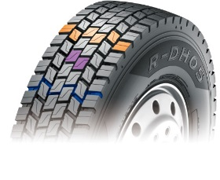

The Hankook alphatread R-TH22 sized 385/65R22.5 is the corresponding trailer tyre for medium haul purposes. It provides a 5 rib tread design and a so called cool running compound for optimum performance. Optimised zigzag grooves care for stone ejection and crack prevention. The wide, solid shoulder area provides a higher mileage and helps to prevent belt separation. Its massive kerfless centre rib enhances free-rolling on axle thus increasing the trailer’s riding stability.

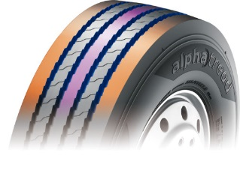

Hankook’s alphatread tyres contribute to the environment by using significantly less raw material as well as energy during manufacturing.

**Current sizes of the Hankook alphatread line-up:**

|  |  |  |  |  |  |  |
| --- | --- | --- | --- | --- | --- | --- |
| **Tread** | **Size** | **LI** | **Regrooving depth** | **Snow flake** | **M+S** | **Availability** |
| **R-DH05** | 295/80R22.5 | 152/148K | 3.0 mm |  | 🗹 | 🗹 |
| 315/80R22.5 | 154/150K | 3.0 mm |  | 🗹 | 🗹 |
| 315/70R22.5 | 154/150K | 3.0 mm |  | 🗹 | 🗹 |
| **R-TH22** | 385/65R22.5 | 160J | 3.0 mm |  |  | 🗹 |

**###**

**About Hankook**

Hankook Tire manufactures globally innovative, award winning radial tyres of proven superior quality for passenger cars, light trucks, SUVs, RVs, trucks, and buses as well as motorsports (circuit racing/rallies).

Aspiring to bring consumers the utmost excellence in product quality, technological excellence and driving satisfaction, Hankook Tire continuously invests in research and development maintaining five R&D centres and eight production facilities around the world. Bespoke tyre solutions for the European markets as well as European Original Equipment according to the requirements of leading premium car manufacturers, are developed in the company’s regional Technical Centre in Hanover/Germany. Production for the European region is taking place in the state-of-the-art manufacturing site in Rácalmás/Hungary which was inaugurated in June 2007 and is continuously being expanded. Currently around 3,000 employees produce up to 19 million tyres a year for passenger cars, SUVs and light trucks.

Hankook Tire’s European headquarters are located in Neu-Isenburg near Frankfurt am Main in Germany. The manufacturer operates further branches in Czech Republic, France, Germany, Hungary, Italy, the Netherlands, Poland, Russia, Spain, Sweden, Turkey, UK and Ukraine. Hankook products are sold directly through regional distributors in other local markets. Hankook Tire employs approximately 21,000 people worldwide and are selling their products in over 180 countries. Internationally leading car manufacturers rely on tyres made by Hankook for their original equipment. Approximately 30 percent of the company's global sales are generated within the European and CIS-Region. Hankook Tire has been represented in the renowned Dow Jones Sustainability Index World (DJSI World) since 2016.

**Media contact UK:**

**Hankook Tyre UK Ltd, Fawsley Drive, Heartlands Business Park, Daventry, Northamptonshire NN11 8UG**

Zoë Baldwin, Marketing Communication Manager

Tel.: +44 (0) 1327 304 146

Mobile: +44 (0) 7948 247048

zbaldwin@hankooktyres.co.uk

**European Media contacts:**

**Hankook Tire Europe GmbH | Corporate Communications Europe/CIS**

**Siemensstr. 14, 63263 Neu-Isenburg | Germany**

Anna Pasternak, PR Manager

LT and Truck & Bus Tyres, Intl. Motorsports, CSR

Tel.: +49 (0) 6102 8149 – 173

Mobile: +49 151 65641014

a.pasternak@hankookreifen.de