

**Press Kit for**

**Commercial Vehicle Show**

**Birmingham 2018**

**Contents**

* **Hankook Tyre UK presents commercial tyre solutions at the 2018 Commercial Vehicle Show**
* **Hankook presents its new city bus tyre SmartCity AU04+ with an even longer service life**
* **Hankook announces new large-scale expansion plans**

**for its European factory**

* **Hankook Supplies Original Equipment Tyres with 38 Sizes to MAN**
* **Hankook Tire expands Original Fitment supply volume to include additional sizes for premium trucks**
* **Hankook truck tyres for construction site use now as Original Equipment on all Scania trucks**
* **Hankook Honoured in “Strategic Partnership” category by Schmitz Cargobull**
* **SmartTouring is Hankook’s ultra-modern tyre for long-distance coaches**
* **Winner of the Red Dot Design Award: Hankook's all-year truck tyres SmartFlex AH35 and SmartFlex DH35 for regional traffic**
* **All-rounders for all-year tyres**
* **Hankook AU03+:** For even more safety:Hankook is reinforcing the sidewalls of the bus tyre AU03+ on all axle positions
* **Hankook AL10+ e-cube MAX:** Low-line sizes for the steering axle
* **Hankook SmartWork:** Sturdy and durable for on and off-road
* **Hankook TH22:** Trailer tyres for low-bed truck transport
* **Hankook light truck tyre Vantra LT:** Energy efficient, safe and exceptionally durable
* **Hankook ‘alphatread’ for the UK market:** Bead-to-bead retread truck tyre range

**Hankook presents commercial tyre solutions at the**

**2018 Commercial Vehicle Show**

**Hankook Tyre UK will be once again exhibiting at the Commercial Vehicle Show - the largest and most comprehensive road transport and commercial vehicle event in the UK. From 24th to 26th April 2018 at Birmingham’s National Exhibition Centre, the premium tyre maker will be presenting a comprehensive range of their commercial vehicle tyres including a new bus tyre for city traffic.**

Hankook Tyre UK will be presenting their expanding portfolio of commercial vehicle tyres at the Commercial Vehicle Show in Birmingham. Taking place from 24th to 26th April 2018 at the National Exhibition Centre (NEC), the company’s stand will be located in Hall 5, number 5C60. The stand will be featuring a wide range of tyres including the SmartFlex for regional haul, and the SmartWork for on and off road, both of which are selected as Original Equipment for MAN, Mercedes-Benz and Scania trucks. Furthermore, the premium tyre maker will be launching a new all-position bus tyre for city traffic.

David Thorp, UK Sales Manager for the commercial vehicle market said “As we are seen as the leader in the UK truck tyre replacement market, the CV Show is an important date in the Hankook calendar. We are delighted to be once again demonstrating our continued investment in research and development with a showcase of innovative tyre solutions.”

“Our share of the market has grown in recent years, thanks to our reputation for producing reliable tyres which companies need especially when priorities put increased emphasis on Total Cost of Ownership. Fleets looking to maximise value for money in every area of business have returned time and time again to Hankook, which prides itself on providing reliable products for customers and reasonable cost per mile figures.”

Hankook remains a well-recognised and respected tyre choice for many UK based Blue Chip logistics companies characterised for most expedient, cost-effective and unbiased transportation solutions. The decision to fit Hankook tyres is the result of lengthy evaluations, which proved that Hankook tyres belong to the most attractive tyre fitment for many fleets with regard to tyre economics, reliability and eco-friendliness. This is echoed through the premium tyre manufacturer’s commercial tyre sales which shows continual year on year growth, testament to the quality and value of Hankook’s products.

New for 2018, the Hankook stand will also feature the concept tyres from the 2016 Hankook Tyre Design Innovation Programme 'Connect to the Connected World'. Designed by students from the University of Cincinnati, the three futuristic tyres present a vision of future mobility through tyres.

Visitors to the stand are invited to play a ‘Strike-a-Light’ game where they can compete for a place on the leaderboard and ultimately the chance to win the daily top prize of a 4K Ultra HD 55” TV. The winners shall be announced after the exhibition ends. Hankook Tyre UK looks forward to welcoming visitors to the Hankook stand (Hall 5, Stand 5C60) between 8.30 am and 5.00 pm.

Hankook presents its new city bus tyre SmartCity AU04+ with an even longer service life

**In the stop-and-go business of city traffic bus tyres must be able to withstand a heavy load and guarantee safe and efficient use at the same time. With the SmartCity AU04+ Hankook is launching the ideal city bus tyre on the market. The improved tread of the all-season tyre ensures as low and as even a wear as possible. The innovative tread compound and new tyre structure guarantee high safety and make efficient and eco-friendly use in city traffic a reality. Thus Hankook has a comprehensive range of city bus tyres available, comprising the AU03, AU03+ and the new SmartCity AU04+.**

Premium tyre maker Hankook is extending its range for city buses by a new tyre line: SmartCity AU04+. The bus tyre for city traffic impresses through efficient fuel consumption and maximum wear resistance. The tread design has been adapted. An improved rib spacing, stabilising 3D tread blocks and optimised zigzag grooves ensure outstanding traction without restricting mileage. The constant starting and stopping in city traffic puts a heavy and irregular load on bus tyres. “For this reason, Hankook has adapted the shoulder width and design for the SmartCity AU04+, thus guaranteeing more even wear. The improved structure of the new tread compound makes the tyre much more heat-resistant, thus reducing wear and make a longer service life possible“, adds Dipl.-Ing. Klaus Krause, Hankook’s Vice President and Head of the European Technical Center in Hanover.

The safety aspect is a major factor for Hankook during tyre development. The entire city tyre range from Hankook implements this claim. Like the AU03+, the SmartCity AU04+ is characterised by a reinforced sidewall. This protects the tyre from damage following contact with kerbstones. In addition, all three city bus tyre models have impressive brake distance values; the AU04+ stands out particularly through its excellent behaviour in wet road conditions due to the improved sipe arrangement. The deep sidewall indicator on the SmartCity AU04+ makes it easier to determine the tyre condition and thus supports timely damage prevention.

The SmartCity AU04+ is available in size 275/70R22.5 and has the M+S marking as well as the 3PMSF symbol (3 Peak Mountain Snowflake).

*Available sizes of the AU04+ / AU03+ and AU03:*

|  |  |  |  |  |  |  |
| --- | --- | --- | --- | --- | --- | --- |
| **Tread** | **Size** | **LI** | **Marking** | **Snowflake** | **M+S** | **Availability** |
| **AU04+** | 275/70R22.5 | 150/145J | D/B/W1/67 dB | ☑ | ☑ | ☑ |
| **AU03+** | 275/70R22.5 | 150/145J  (152/148) | D/C/W1/71 dB | ☑ | ☑ | ☑ |
| **AU03** | 11R22.5 | 148/145J | C/B W1 71 dB | - | ☑ | ☑ |
| 275/80R22.5 | 149/146J | D/C W1 71 dB | - | ☑ | ☑ |
| 295/80R22.5 | 152/148J | C/C W1 71 dB | ☑ | ☑ | ☑ |
| 245/70R19.5 | 136/134L | D/C W1 71 dB | ☑ | ☑ | ☑ |
| 265/70R19.5 | 104/138M | D/C W1 71 dB | ☑ | ☑ | ☑ |

**Technical features of the Hankook AU04+**

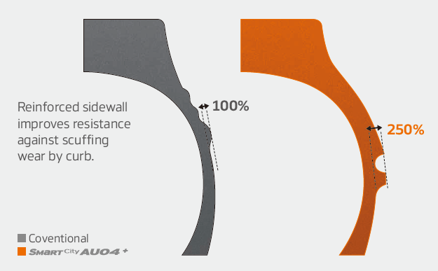

***Wide shoulders and reinforced sidewalls***

* Wide shoulders and reinforced sidewalls ensure excellent wet grip, grip and driving stability.
* New shape and position of the sidewall indicator makes determining the tyre condition easier.

***Improved tread design***

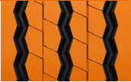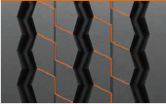

* Stabilising 3D tread blocks guarantee improved traction
* Longer service life through optimised rib spacing
* Three zigzag grooves guarantee excellent traction, particularly under wet conditions

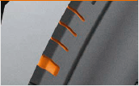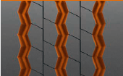

* Adapted should width and removed lugs and ribs ensure more even wear

***Innovative rubber compound***

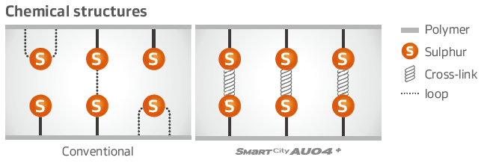

* Improved chemical structure makes the tyre more heat-resistant

# # #

**Hankook announces new large-scale expansion plans**

**for its European factory**

**The premium tyre maker announced expansion plans for the construction of a new truck tyre production unit in Rácalmás, Hungary. The works are set to begin during the 1st half of 2018, while the start of production is expected to commence around 2 years later. The expansion − in a value of around 290 million EUR − is the 4th one in the history of the Company's European plant, which was initially opened in 2007. It will play a pivotal role in Hankook Tire’s long-term strategy to cater to European market demands in both the original equipment and replacement truck and bus tyre sector.**

The Hungarian plant is a key part of Hankook’s European strategy, as it is the only production unit within the region. As such, it is responsible for catering to the needs of the continent’s tyre market. The 4th phase of the expansion is expected to reach an investment amount of around 290 million EUR, creating approximately 150 new jobs and provide a production capacity of over 550 thousand medium and heavy truck and bus tyres yearly. Due to the large-scale investment, the Rácalmás factory is now among the largest employers and most significant economic players in Hungary, whilst maintaining its top class corporate citizen status.

Since laying down the foundation stone in July 2006, the factory has been continuously expanded and updated over the years. Thanks to the latest developments, production capacity has reached more than 55 thousand tyres per day, equating to a current production capacity of up to 19 million tyres a year, offering almost 900 size and model variations for passenger cars, SUVs, vans and light trucks. Since the initial phase, the capacity has already increased 3.5 times, whilst maintaining excellent production quality proven by the original equipment supply for various popular automobile brands, such as Audi, BMW, Fiat, Ford, Hyundai, Kia, Mercedes-Benz, MINI, Opel, Peugeot, Porsche, Seat, Skoda and, VW.

During the past 10 years the company has also strengthened its position within the medium and large size truck and bus tyre segment in Europe. Mercedes-Benz selected Hankook in 2014 as its original tyre supplier, followed by MAN in 2015 and Scania in 2016. Since 2013 it has also been providing tyres to Schmitz Cargobull, the largest trailer manufacturer in Europe. Currently Hankook Tire is supplying the European truck tyre market mainly from one of its Korean factories. After seeing a significant and stable increase in demand over the years, the decision was made to establish a Europe-based truck and bus tyre production facility at the company's Hungarian factory. The construction is set to begin in June 2018, and the new unit is expected to start its production from around June 2020.

“As a strategic partner to many leading vehicle makers, Hankook Tire has become well-known worldwide for its first-class technology and premium quality tyres in the car and SUV segment, and for some years in the medium and large size truck and bus segment too", explained Han-Jun Kim, President of Hankook Tire Europe. "Thus we have noticed a sharp increase in demand for our truck and bus tyres within the European market, and we hope to soon satisfy our customers increasing demands with the help of our new Hungarian truck and bus tyre unit.”

**###**

**Hankook Supplies Original Equipment Tyres**

**with 38 Sizes to MAN**

**Tyre maker Hankook is consistently expanding its Original Equipment commitment in the truck segment and already supplies original equipment tyres in 38 sizes to MAN. The MAN Truck & Bus AG belongs to the Volkswagen Group, one of Hankook's largest OE customers worldwide. The OE business with Hankook truck tyres for MAN covers a total of 38 dimensions in the 17.5, 19.5, 22.5 and 24 inch range. Hankook's Original Equipment range for the bus and truck manufacturer includes the supply of the tyre lines e-cube MAX, SmartFlex and SmartWork for various MAN models to the production facilities of the Munich-based manufacturer in Germany, Austria and Poland. The tyre ranges have been specially adapted for European conditions, boasting both ecological and economic advantages.**

Premium tyre maker Hankook is listed as an OE supplier for MAN with 38 dimensions, including the truck tyre ranges e-cube MAX, SmartFlex and SmartWork. The commercial vehicles specialist and the tyre maker have been cooperating since the first quarter of 2015. Han-Jun Kim, Hankook COO for Europe comments: “The expansion of OE business in the commercial vehicles segment with MAN is of great strategic importance to us, as we can now offer further treads and dimensions for light to heavy-duty trucks from MAN.”

The tyres will be fitted to the multi-award-winning MAN vehicle series TGX, TGS, TGM and TGL which are used for national and international long-haul, delivery and construction site traffic. Tyres used include the e-cube MAX line, which is tried-and-trusted for international long-haul traffic, the new SmartFlex all-year tyre range for flexible use between long-haul and delivery traffic, as well as construction site treads from the SmartWork series. Specially adapted for use on vehicles of the EURO 6 emission class, the treads – both as special steering and drive axle versions – score highly for environmental friendliness and mileage. This is also relevant to the TCO (Total Cost of Ownership), important for Original Equipment.

One special feature of the Hankook’s Original Equipment portfolio for MAN are the numerous sizes in the low-line segment; the latest size to be added is 355/50R22.5. With these, the premium tyre maker is demonstrating that its portfolio has already integrated the current market trend, namely the growing importance of low-line sizes in the truck business.

*Hankook's range of Original Equipment tyres for MAN:*

|  |  |  |  |  |  |  |  |
| --- | --- | --- | --- | --- | --- | --- | --- |
| **Tread** | **Size** | **Model** | **LI** | **Marking** |  | **M+S** | **Availability** |
| **AL10+** | 315/80R22.5 | TGX | 156/150L (154/150M) | B/B/W1 70dB | - | - | ☑ |
| 315/70R22.5 | TGX | 156/150L | B/B/W1 70dB | - | - | ☑ |
| 315/60R22.5 | TGX | 154/148L | B/C/W1 70dB | - | - | ☑ |
| 295/60R22.5 | TGX | 150/147L | C/B/W1 70dB | - | - |  |
| 355/50R22.5 | TGX | 156L | C/B/W2 76dB | - | - | ☑ |
| **DL10+** | 315/80R22.5 | TGX | 156/150L (154/150M) | C/C/W2 75dB | ☑ | ☑ | ☑ |
| 315/70R22.5 | TGX | 154/150L  (152/148M) | C/C/W2 75dB | ☑ | ☑ | ☑ |
| 315/60R22.5 | TGX | 152/148L | C/C/W2 75dB | ☑ | ☑ | ☑ |
| 295/60R22.5 | TGX | 150/147L | C/C/W1 73dB | ☑ | ☑ |  |
| **AL10** | 295/60R22.5 | TGX | 150/147K  (149/146L) | C/C/W1 70dB | - | - | ☑ |
| 295/80R22.5 | TGX | 152/148M | C/C/W1 70dB | - | - | ☑ |
| 385/55R22.5 | TGX | 158L (160K) | B/C/W1 70dB | - | - | ☑ |
| **DL10** | 295/80R22.5 | TGX | 152/148M | C/C/W2 75dB | - | ☑ | ☑ |
| 295/60R22.5 | TGX | 150/147K (149/146L) | D/C/W2 75dB | - | ☑ | ☑ |
| **AH31** | 295/80R22.5 | TGM & TGS | 152/148M | C/B/W1 72dB | ☑ | ☑ | ☑ |
| 315/70R22.5 | TGM & TGS | 156/150L | C/B/W2 73dB | ☑ | ☑ | ☑ |
| 315/80R22.5 | TGM & TGS | 156/150L  (154/150M) | C/B/W2 73dB | ☑ | ☑ | ☑ |
| 385/65R22.5 | TGM & TGS | 160K | C/B/W1 69dB | ☑ | ☑ | ☑ |
| 315/60R22.5 | TGM & TGS | 154L | C/B/W1 70dB | ☑ | ☑ | ☑ |
| 385/55R22.5 | TGM & TGS | 160K | C/B/W1 69dB | ☑ | ☑ | ☑ |
| **DH31** | 295/80R22.5 | TGM & TGS | 152/148M | D/C/W2 75dB | ☑ | ☑ | ☑ |
| 315/80R22.5 | TGM & TGS | 156/150L  (154/150M) | D/C/W2 75dB | ☑ | ☑ | ☑ |
| 315/70R22.5 | TGM & TGS | 154/150L | D/C/W2 75dB | ☑ | ☑ | ☑ |
| 315/60R22.5 | TGM & TGS | 152/148L | D/C/W2 75dB | ☑ | ☑ | ☑ |
| **AH35** | 215/75R17.5 | MAN TGL | 128/126M | D/C/W1 65dB | ☑ | ☑ | ☑ |
| 235/75R17.5 | MAN TGL | 132/130M | D/C/W1 66dB | ☑ | ☑ | ☑ |
| 265/70R19.5 | MAN TGL | 140/138M | C/C/W1 67dB | ☑ | ☑ | ☑ |
| 285/70R19.5 | MAN TGL | 145/143M | C/C/W1 67dB | ☑ | ☑ | ☑ |
| **DH35** | 215/75R17.5 | MAN TGL | 126/124M | D/C/W1 66dB | ☑ | ☑ | ☑ |
| 235/75R17.5 | MAN TGL | 132/130M | D/C/W1 71dB | ☑ | ☑ | ☑ |
| 265/70R19.5 | MAN TGL | 140/138M | D/B/W1 73dB | ☑ | ☑ | ☑ |
| 285/70R19.5 | MAN TGL | 146/144M | D/B/W1 70dB | ☑ | ☑ | ☑ |
| **AM06** | 325/95R24 | MAN TGS | 162/160K | D/C/W2 75dB | - | ☑ | ☑ |
| **DM06** | 325/95R24 | MAN TGS | 162/160K | D/B/W1 73dB | - | ☑ | ☑ |
| **AM15+** | 385/65R22.5 | MAN TGS | 160K (158L) | C/C/W2 74dB | - | ☑ | ☑ |
| **AM09** | 315/80R22.5 | MAN TGS | 156/150K | D/B/W1 67dB | - | ☑ | ☑ |
| 13R22.5 | MAN TGS | 156/150K | D/C/W1 68dB | - | ☑ | ☑ |
| **DM09\*** | 315/80R22.5 | MAN TGS | 156/150K | D/C/W1 70dB | - | ☑ | ☑ |
| 13R22.5 | MAN TGS | 156/150K | D/C/W2 75dB | - | ☑ | ☑ |

Hankook Tire expands Original Fitment supply volume to include additional sizes for premium trucks

**Hankook supplies 42 sizes of its premium truck tyres as Original Equipment to the European market, including for the complete Mercedes-Benz Actros family and Atego model ranges. Just recently, Hankook also become the standard equipment supplier for the steering and drive axles for the Mercedes-Benz Actros family in the low-line size 315/60R22.5 as well. This refers to the SmartFlex product line. Overall, the Hankook portfolio for Daimler includes the e-cube MAX, SmartFlex and SmartWork tyre families. The range of sizes available from Hankook for the commercial vehicle segment at Daimler AG has more than quadrupled since the cooperation for Original Equipment for Europe began in 2014.**

Premium tyre maker Hankook is continually expanding its original equipment (OE) portfolio in the heavy commercial vehicle (HCV) and medium duty segment as part of its existing OE agreements for Mercedes-Benz truck model range: Actros, Antos, Arocs, Axor, Econic and Atego and equips the premium commercial vehicle manufacturer with no less than 42 sizes in Europe alone. The tyre maker’s latest original equipment portfolio includes among others the Hankook treads AL10+ e-cube MAX and DL10+ e-cube MAX, as well as the SmartFlex AH31 and SmartFlex DH31, all of which have been specially developed for the European market. Just recently, Hankook also became the standard equipment supplier for the Mercedes-Benz Actros family both with the SmartFlex AH31 tread for the steering axle and the SmartFlex DH31 tyre for the drive axle in the low-line size 315/60R22.5. The tyre maker is thus following the steadily growing market demand for commercial vehicle tyres in the low-line segment.

In addition, Hankook supplies multiple options for 22.5 inch tyres, the top-selling standard wheel size for heavy duty trucks in Europe, as well as for commercial vehicle tyres in the 17.5 and 19.5 inch sizes. Extending the OE fitment of the most-demanded heavy duty and medium duty trucks further strengthens the Hankook brand in a highly competitive market and is yet another milestone in the company’s endeavour for sustainable growth in the TBR business. Since the start of their original equipment business with Daimler AG, Hankook has expanded its portfolio for the Stuttgart-based truck and bus manufacturer to include more than 42 dimensions.

The e-cube MAX AL10+ (all position long haul) utilises linear grooves with waved walls to prevent uneven wear, enhancing durability and providing improved long-term fuel efficiency. The improved tread compound and high load index of the AL10+ increases fuel efficiency whilst simultaneously increasing load capacity. The e-cube MAX DL10+ (drive axle long haul) offers drivers excellent traction with three-dimensional kerfs and superior long mileage performance with extra-wide tread blocks and deep grooves. The block supporter also provides the DL10+ with boosted longevity and low rolling resistance. Both of these treads will be supplied in three sizes: 315/80R22.5, 315/70R22.5 and 315/60R22.5.

The SmartFlex AH31 is an all-season TBR tyre well-suited for variable road conditions, providing even wear and long mileage performance with significantly lower rolling resistance. The revolutionary drive axle tyre SmartFlex DH31 is perfectly matched for a number of different applications with its cutting-edge technology providing excellent traction in a number of different operating conditions. These include regional, long-haul and winter conditions due to the 3PMSF (Three Peak Mountain Snowflake), and also guarantee high mileage durability. The SmartFlex AH31 and SmartFlex DH31 will be available as original equipment in four sizes: 295/80R22.5, 315/60R22.5, 315/70R22.5 and 315/80R22.5.

###

**Hankook truck tyres for construction site use now**

**as Original Equipment on all Scania trucks**

**Premium tyre maker Hankook is now supplying various treads of its SmartWork truck tyre series for use in construction site traffic, to the Swedish commercial vehicles manufacturer Scania as Original Equipment (OE). Seven dimensions for 22.5 and 24 inches are initially listed, which fleet customers and transport companies can now order from the three European Scania plants in Zwolle (Netherlands), Södertälje (Sweden) and Anger (France). The new Scania XT generation of construction vehicles is one of the models to be equipped with Hankook tyres.**

Premium tyre maker Hankook is now supplying five additional tyre treads for all Scania models designed for use on construction sites, including their new XT generation of construction vehicles. These are the steering axle tyres SmartWork AM06, SmartWork AM09 and SmartWork AM15+ as well as the SmartWork DM06 and SmartWork DM09 treads for the drive axle.

The commercial vehicle manufacturer is part of the Volkswagen Group and the latest truck OE partner for Hankook. Hankook’s OE business with truck tyres for Scania is currently concentrating on Europe and covers a total of 27 dimensions in the 22.5 and 24 inch range. Alongside truck tyres for construction site use, Hankook is supplying the Swedish commercial vehicle manufacturer with the e-cube MAX, a truck tyre range for long-haul traffic as well as the SmartFlex, an all-year tyre for medium-haul applications. The range has been specially adapted for European conditions, boasting both ecological and economic advantages. Both tyre ranges can also be fitted to Scania buses. The OE cooperation with Scania is Hankook’s second within the Volkswagen Group in the heavy commercial vehicle segment; Hankook has been supplying various models to MAN Truck & Bus since 2015.

Han-Jun Kim, Head of Hankook Tire Europe commented: “We are looking forward to expanding our cooperation with Scania. We have to rely on maximum durability when designing tyres for construction site traffic; our SmartWork line was able to completely convince the Scania engineers.”

**# # #**

*Hankook's range of Original Equipment tyres for Scania:*

|  |  |  |  |  |  |  |
| --- | --- | --- | --- | --- | --- | --- |
| **Tread** | **Size** | **LI** | **Marking** |  | **M+S** | **Availability** |
| **AM09** | 315/80R22.5 | 156/150K | D/B/W1 67dB | - | ☑ | ☑ |
| 13R22.5 | 156/150K | D/C/W1 68dB | - | ☑ | ☑ |
| **DM09** | 315/80R22.5 | 156/150K | D/C/W1 70dB | ☑ | ☑ | ☑ |
| 13R22.5 | 156/150K | D/C/W2 75dB | ☑ | ☑ | ☑ |
| **AM15+** | 385/65R22.5 | 160K (158L) | C/C/W2 74dB | - | ☑ | ☑ |
| **AM06** | 325/95R24 | 162/160K | D/C/W1 72dB | - | ☑ | ☑ |
| **DM06** | 325/95R24 | 162/160K | D/C/W1 73dB | - | ☑ | ☑ |
| **AL10+** | 315/80R22.5 | 156/150L (154/150M) | B/B/W1 70dB | - | - | ☑ |
| 315/70R22.5 | 156/150L | B/B/W1 70dB | - | - | ☑ |
| 315/60R22.5 | 154/148L | C/B/W1 70dB | - | - | ☑ |
| 355/50R22.5 | 156L | C/B/W1 70dB | - | - | ☑ |
| **DL10+** | 315/80R22.5 | 156/150L (154/150M) | C/C/W1 73dB | ☑ | ☑ | ☑ |
| 315/70R22.5 | 154/150L (152/148M) | C/C/W1 73dB | ☑ | ☑ | ☑ |
| 315/60R22.5 | 152/148L | C/C/W1 73dB | ☑ | ☑ | ☑ |
| **AL10** | 295/60R22.5 | 150/147K  (149/146L) | C/C/W1 70dB | - | - | ☑ |
| 295/80R22.5 | 152/148M (154/149L) | C/C/W1 70dB | - | - | ☑ |
| 385/55R22.5 | 160K (158L) | B/C/W1 70dB | - | - | ☑ |
| **DL10** | 295/80R22.5 | 152/148M | C/C/W2 72dB | - | ☑ | ☑ |
| 295/60R22.5 | 150/147K (149/146L) | D/C/W2 75dB | - | ☑ | ☑ |
| **AH31** | 295/80R22.5 | 154/149M | C/B/W1 73dB | ☑ | ☑ | ☑ |
| 315/70R22.5 | 156/150L | C/B/W1 73dB | ☑ | ☑ | ☑ |
| 315/80R22.5 | 156/150L (154/150M) | C/B/W1 73dB | ☑ | ☑ | ☑ |
| 385/65R22.5 | 160K | C/B/W1 69dB | ☑ | ☑ | ☑ |
| 385/55R22.5 | 160K (158L) | C/B/W1 69dB | ☑ | ☑ | ☑ |
| **DH31** | 295/80R22.5 | 152/148M | D/C/W2 75dB | ☑ | ☑ | ☑ |
| 315/70R22.5 | 154/150L | D/C/W2 75dB | ☑ | ☑ | ☑ |
| 315/80R22.5 | 156/150L (154/150M) | D/C/W2 75dB | ☑ | ☑ | ☑ |

Hankook honoured in “Strategic Partnership” category by Schmitz Cargobull

**In 2017, the first Schmitz Cargobull Supplier Day took place as part of the recent celebrations for Schmitz Cargobull’s 125-year anniversary. The trailer manufacturer honoured suppliers in a variety of categories during the event. Hankook was the only tyre maker to take home a prize.**

Premium tyre maker Hankook was honoured with the “Strategic Partnership” award at the trailer manufacturer's 125 year anniversary celebration. Hyun-Jun Cho, Vice President Global Product Planning and Dietmar Olbrich, Vice President Sales & Marketing for German-speaking markets, both representing the Hankook management, received the award from Schmitz Cargobull during the festivities in September. Hankook and Schmitz Cargobull have been involved in OEM business since 2013, which primarily concentrates on the European market.

Bernhard Schmitz (Deputy General Manager Purchasing) from Schmitz Cargobull highlighted during the celebration: “We are able to offer our clients optimum transport solutions through our long-term partnership with Hankook. For this reason, we’re especially happy to give this prize to Hankook. We look forward to many more joint projects together.”

Dietmar Olbrich commented “Thanks to our many joint ideas, our entrepreneurial spirit, and our innovative corporate cultures, Hankook and Schmitz Cargobull have a unique business relationship and partnership. We feel very honoured to receive this award from Europe's leading trailer manufacturer. This prize shows that Hankook has established itself as a key player in the truck market.”

**###**

SmartTouring is Hankook’s ultra-modern tyre for long-distance coaches

**With the SmartTouring AL22, tyre maker Hankook now has a coach tyre for long-distance travel in their portfolio. The company is anticipating that long-distance coach travel will grow in significance, and thus there will be an increasing demand for high-technology coach tyres in this category. The Hankook SmartTouring AL22 can be used on all axle positions and provides maximum ride and rolling comfort, excellent concentricity, a very low rolling noise and, as is customary with Hankook tyres, optimised rolling resistance and low wear for particularly efficient travel.**

With the SmartTouring AL22, premium tyre maker Hankook has a state-of-the-art tyre for long-distance coach travel on the European market. This is available in the sizes 295/80R22.5 and 315/80R22.5 and is suitable for all long-distance coach wheels in all axle positions. Klaus Krause, Vice President and Head of the European Development Centre in Hanover, adds: “During development of the SmartTyre line, we focused particularly on ride and rolling comfort as well as on a straight driving performance. The characteristics of the SmartTouring AL22 not only allow maximum travel comfort for passengers, they also maximise driving and handling comfort for the driver on long-distance trips.”

The carcass contour of the SmartTouring AL22 ensures the best suspension properties and contributes to a particularly safe driving style. The longitudinal 5-rib profile with its closed, solid central rib makes an excellent straight driving performance possible at all times. Special Multi-3D sipes guarantee both good traction and an outstanding braking response.

The new bead area guarantees a particularly precise rim joint stiffness, which results in excellent concentricity and travel comfort.

The individual belt layers of the new SmartTouring AL22 are structurally arranged in such a way that significantly less heat is developed in operation compared with conventional tyres. This effect not only reduces rolling resistance, thus economising on fuel, it also considerably extends the service life of the tyre.

Fuel savings through reduced heat development have been achieved not only by the belt structure but also by the tread compound used for the Hankook SmartTouring AL22. Special soot molecules with a larger volume and a particularly stable structure are used for the basic tread rubber in particular, leading to a significant reduction in energy loss during movement. These so-called highly structured carbon molecules also guarantee enhanced abrasion resistance and, in combination with the other technologies, help to increase the mileage of the SmartTouring AL22 compared with conventional products by more than 17 percent.

***Available dimensions***

|  |  |  |  |  |  |  |
| --- | --- | --- | --- | --- | --- | --- |
| **Tread** | **Size** | **LI** | **Marking** |  | **M+S** | **Availability** |
| **AL22** | 295/80R22.5 | 154M | C/B/W1 71dB |  | 🗹 | 🗹 |
| 315/80R22.5 | 156/150L | C/B/W1 71dB |  | 🗹 | 🗹 |

**Hankook SmartTouring AL22: Technical properties**

***Longitudinal tread profile with Multi-3D sipes and solid central rib***

- High directional stability and comfortable handling response.

- Excellent straight driving.

- Very good braking and traction performance.



***Special brake structure and newly developed bead area***

- Reduced heat development.

- High retreadability.

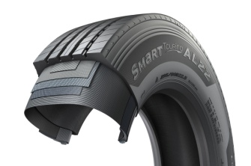

**###**

Winner of the Red Dot Design Award: Hankook's all-year truck tyres SmartFlex AH35 and SmartFlex DH35 for regional traffic

**With the steering axle tyre SmartFlex AH35 and the drive axle tyre SmartFlex DH35, premium tyre maker Hankook has an all-year truck tyre for regional traffic. The all-year tyres, winners of the Red Dot Design Award in 2016, have particularly high traction on account of special Multi-3D sipes. In addition, the rigid tread blocks with minimum block movement promote fuel-efficient driving.**

With the SmartFlex AH35 and SmartFlex DH35, fleets and forwarding agents benefit from a low-fuel, high-mileage and high-traction all-year tyre solution for the steering and drive axles. It is also possible to fit SmartFlex AH35 to all axles. In 2016, they were presented with the Red Dot Design Award. Whilst the SmartFlex AH31 and SmartFlex DH31 are intended mainly for larger wheel sizes such as 22.5 inch, the SmartFlex AH35 and its counterpart SmartFlex DH35 for the drive axle are designated to the smaller 17.5/19.5 inch sizes.

The Multi-3D sipes anchored in the tread of the SmartFlex AH35 guarantee outstanding traction. The mixture of straight and wave-shaped grooves improves water drainage and prevents hydroplaning long-term. Without losing sight of the summer properties, the M+S marking and the 3PMFS symbol (snowflake) indicate that the tyre is also perfectly equipped for all wintry weather conditions such as slush, ice and snow. The rigidity of the tread blocks promotes particularly fuel-efficient driving. Equally, the special tread design supports even tyre wear so that the Total Cost of Ownership for fleet and forwarding agent companies can be reduced long term in terms of service life. The high mileage and performance of the tyre are guaranteed by a wide contact area.

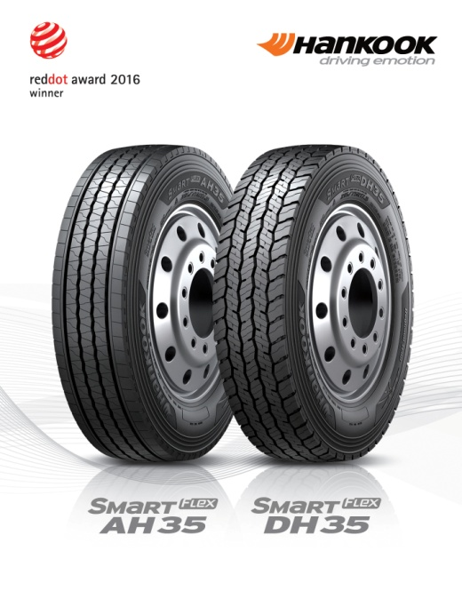

Just like the steering axle tyre, the drive axle tyre SmartFlex DH35 has M+S marking and the snowflake symbol. In addition, the tyre also has a wide contact area with four zigzag groove lines over the whole tread surface, enhancing mileage and driving performance under different road and traffic conditions. Furthermore, the 3D sipes ensure high traction and low rolling resistance. The innovative tread sipe design supports low rolling resistance and tyre traction for the drive axle in road traffic.

*Sizes of the SmartFlex tyre line available*

|  |  |  |  |  |  |  |
| --- | --- | --- | --- | --- | --- | --- |
| **Tread** | **Size** | **LI** | **Marking** |  | **M+S** | **Availability** |
| **AH35** | 8.5R17.5 | 121/120L | D/C/W1 67dB | 🗹 | 🗹 | 🗹 |
| 9.5.R17.5 | 131/129L | D/C/W1 67dB | 🗹 | 🗹 | 🗹 |
| 8R19.5 | 124/122L | D/C/W1 67dB | 🗹 | 🗹 | 🗹 |
| 205/75R17.5 | 124/122M | D/C/W1 65dB | 🗹 | 🗹 | 🗹 |
| 215/75R17.5. | 126/124M | D/C/W1 65dB | 🗹 | 🗹 | 🗹 |
| 215/75R17.5. | 128/124M | D/C/W1 65dB | 🗹 | 🗹 | 🗹 |
| 225/75R17.5 | 129/127M | C/C/W1 67dB | 🗹 | 🗹 | 🗹 |
| 235/75R17.5 | 132/130M | C/C/W1 69dB | 🗹 | 🗹 | 🗹 |
| 245/70R17.5 | 136/134M | C/C/W1 69dB | 🗹 | 🗹 | 🗹 |
| 245/70R19.5 | 136/134M | C/C/W1 67dB | 🗹 | 🗹 | 🗹 |
| 265/70R17.5 | 140/136M | C/C/W1 65dB | 🗹 | 🗹 | 🗹 |
| 265/70R19.5 | 140/138M | C/C/W1 67dB | 🗹 | 🗹 | 🗹 |
| 285/70R19.5 | 146/144M | C/C/W1 67dB | 🗹 | 🗹 | 🗹 |
|  | 305/70R19.5 | 148/145M | C/C/W1 65dB | 🗹 | 🗹 | 🗹 |
| **DH 35** | 205/75R17.5 | 124/122M | D/C/W1 66dB | 🗹 | 🗹 | 🗹 |
| 215/75R17.5 | 126/124M | D/C/W1 66dB | 🗹 | 🗹 | 🗹 |
| 225/75R17.5 | 129/127M | D/C/W1 73dB | 🗹 | 🗹 | 🗹 |
| 235/75R17.5 | 132/130M | D/C/W1 73dB | 🗹 | 🗹 | 🗹 |
| 245/70R17.5 | 136/134M | D/C/W1 73dB | 🗹 | 🗹 | 🗹 |
| 8.5R17.5 | 121/120L | D/C/W1 73dB | 🗹 | 🗹 | 🗹 |
| 9.5R17.5 | 131/129L | D/C/W1 73dB | 🗹 | 🗹 | 🗹 |
| 245/70R19.5 | 136/134M | D/C/W1 73dB | 🗹 | 🗹 | 🗹 |
| 265/70R17.5 | 139/136M | D/C/W1 73dB | 🗹 | 🗹 | 🗹 |
| 265/70R19.5 | 140/138M | D/B/W1 73dB | 🗹 | 🗹 | 🗹 |
| 285/70R19.5 | 146/144M | D/B/W1 73dB | 🗹 | 🗹 | 🗹 |
| 305/70R19.5 | 148/145M | D/B/W1 73dB | 🗹 | 🗹 | 🗹 |

**Technical properties of the SmartFlex AH35**

***A Wide contact area:***

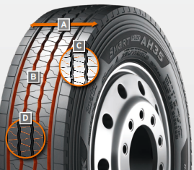

The wide contact area guarantees high mileage.

***B Four wave-shaped and straight grooves:***

The combination of four wave-shaped and straight grooves over the whole tread surface on a wide range of different road surfaces guarantees excellent water drainage

***C Multi-3D sipe tread:***

The Multi-3D sipe tread offers outstanding traction and thus promotes improved driving stability.

The rigidity of the tread blocks and the resulting minimum block movement lead to significant fuel savings.

***D Special tread design with “semi-sipes”***

Special tread design with “semi sipes” guarantees an even wear pattern over the entire service life

*Wide contact area*

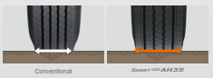

*Multi-3D sipes*

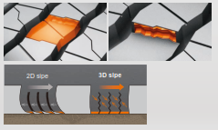

**Technical properties of the SmartFlex DH35**

***A Wide contact area with 4 zigzag grooves:***

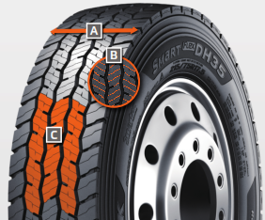

The wide contact area and the 4 all-round zigzag tread grooves ensure high mileage and overall performance.

***B Multi-3D sipes:***

The special tread design with Multi-3D sipes promotes low rolling resistance and outstanding traction.

***C Innovative tread design:***

The special tread design guarantees low rolling resistance and optimum traction under a wide range of different conditions.

*Wide contact area*



**###**

All-rounders for all-year tyres

**Particularly in changeable weather conditions, Hankook recommends that truck and bus customers use the SmartFlex all-weather tyre line for medium and long haul trips. Commercial vehicle customers can rely in particular on a high level of driving safety as well as the current trend of increased load-bearing capacity for some sizes.**

Both the steering axle tyres SmartFlex AH31 and the drive axle tyres SmartFlex DH31 have M+S marking and the snowflake (3PMSF) symbol, which means good traction is guaranteed even if drivers should be surprised by wintry road conditions. The Hankook SmartFlex DH31 has a 6-rib tread with special hexagonal tread blocks that guarantees more even wear behaviour and thus a longer tyre service life. Hankook's patented self-cleaning sipes in the middle of each block prevent damage to the block edges and thus guarantee excellent traction throughout the tyre life.

The SmartFlex all-year tyre line is completed by the corresponding trailer tyre SmartFlex TH31, which celebrated its première at the 66th IAA for Commercial Vehicles. Its wide, closed shoulder area supports stable straight driving and ensure good lateral stability. Chamfered tread grooves help prevent splintering.

Whilst the SmartFlex AH31 and SmartFlex DH31 are designated mainly for larger wheel sizes in the 22.5 inch range, SmartFlex AH35 and its drive axle counterpart SmartFlex DH35 is more designated for smaller wheels with 17.5/19.5 inch sizes.

*Sizes of the SmartFlex tyre line available*

|  |  |  |  |  |  |  |  |
| --- | --- | --- | --- | --- | --- | --- | --- |
| **Tread** | **Size** | **LI** | **Marking** |  | **M+S** | **Availability** | **Remark** |
| **AH31** | 295/80R22.5 | 152/148M (154M/149L) | C/B/W1 73 dB | 🗹 | 🗹 | 🗹 | - |
| 295/80R22.5 | 154/149M | C/B/W1 73 dB | 🗹 | 🗹 | 🗹 | Tyre with higher load-bearing capacity |
| 315/80R22.5 | 156/150L | C/B/W1 73 dB | 🗹 | 🗹 | 🗹 | - |
| 315/70R22.5 | 156/150L | C/B/W1 73 dB | 🗹 | 🗹 | 🗹 | - |
| 385/65R22.5 | 164K | C/B/W1 69 dB | 🗹 | 🗹 | 🗹 | - |
| 385/65R22.5 | 160K | C/B/W1 69 dB | 🗹 | 🗹 | 🗹 | - |
| 315/60R22.5 | 154/148L | C/B/W1 70 dB | 🗹 | 🗹 | 🗹 | - |
| 385/55R22.5 | 160K | C/B/W1 69 dB | 🗹 | 🗹 | 🗹 | - |
| 355/50R22.5 | 156L | C/B/W1 69 dB | 🗹 | 🗹 | 🗹 | - |
| **DH31** | 295/80R22.5 | 152/148M | D/C/W2 75 dB | 🗹 | 🗹 | 🗹 | - |
| 315/80R22.5 | 156/150L | D/C/W2 75 dB | 🗹 | 🗹 | 🗹 | - |
| 315/70R22.5 | 154/150L | D/C/W2 75 dB | 🗹 | 🗹 | 🗹 | - |
| 295/60R22.5 | 150/147K | D/C/W2 75 dB | 🗹 | 🗹 | 🗹 | - |
| 315/60R22.5 | 152/148L | D/C/W2 75 dB | 🗹 | 🗹 | 🗹 | - |
| **TH31** | 385/65R22.5 | 160K | B/B/W1 69 dB | - | 🗹 | In production | - |
| 435/50R19.5 | 160J | B/B/W2 | - | 🗹 | In production | - |
| 455/40R22.5 | 160J |  |  |  | In production | - |

**Technical properties of the Hankook SmartFlex all-year tyre line**

**SmartFlex AH 31**

***Truck all-year tyres for the steering axle for medium to long-haul applications***

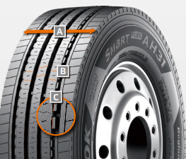

***An Extra-wide tread and shoulder area:***

* The extra-wide-open shoulder area supports a high mileage and traction as well as outstanding handling properties

***B Multi-3D sipe treads:***

* High traction and mileage with even

wear

***C Tread Wear Equalizer Stepper Technology (T.W.E.S.):***

* Stabilisers on profile blocks
* Reduction of uneven/one-sided wear

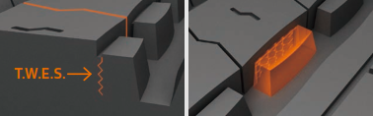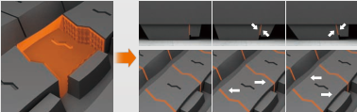

**SmartFlex DH 31**

***Truck all-year tyres for the drive axle for medium to long-haul applications***

***A Multi-3D sipes:***

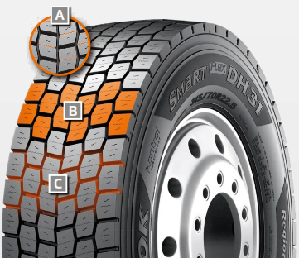

* High traction and mileage with even wear

***B 6-rib block tread:***

* Sturdy 6-rib block tread with special hexagonal tread blocks

***C Self-cleaning sipes:***

* Constant traction over the entire service life
* Protection against splintering at the corners of the sipes

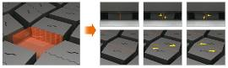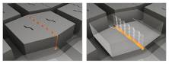

**SmartFlex TH 31**

***Truck all-year tyres for the trailer axle for medium to long-haul applications***

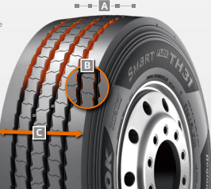

***A 4 Zigzag sipes:***

* 4 main tread grooves ensure optimum water displacement

***B Chamfered profile block design:***

* Chamfered profile blocks sipes help to prevent material splintering

***C Extra-wide tread and shoulder area:***

* The extra-wide closed shoulder area supports high driving stability and ensures good lateral stability as well as even wear

**###**

For even more safety: Hankook is reinforcing the sidewalls of the bus tyre AU03+ on all axle positions

**Hankook’s bus tyre AU03+ was developed particularly with the requirements of stop-and-go traffic in mind, and is especially suitable for use on regular city bus services. The all-year tyre provides an optimum profile especially suitable for city traffic and urban roads and is designed with a high level of safety in mind, whilst being economic and environmentally friendly at the same time.**

The sidewalls have recently been reinforced to guarantee even safer and more efficient use in city traffic, with an even wider and deeper sidewall indicator being incorporated at the same time. The AU03+ is available in size 275/70R22.5 and with M+S marking and the 3PMSF (3 Peak Mountain Snowflake) symbol. In addition to the AU03 +, the AU03 is available in 11R22.5, 275 / 80R22.5, 295 / 80R22.5, 245 / 70R19.5 and 265 / 70R19.5.

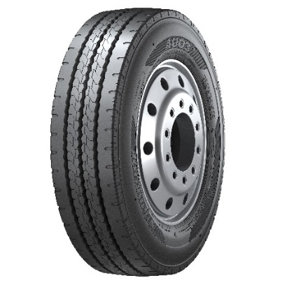

Safety is a fundamental factor that Hankook considers for each of its products. That’s why safety performance with short braking distances and superior wet performance is also a key component of the AU03+. Furthermore, the reinforced sidewall protects the tyre from damages including stone chips and curb contacts.

The profile of Hankook’s AU03+ guarantees excellent traction which is supported through an optimised kerf arrangement without leaving mileage behind.

*Sizes of the AU03+ / AU03 available:*

|  |  |  |  |  |  |  |
| --- | --- | --- | --- | --- | --- | --- |
| **Tread** | **Size** | **LI** | **Marking** | **Snowflake** | **M+S** | **Availability** |
| **AU03+** | 275/70R22.5 | 150/145J  (152/148) | D/C/W1/71 dB | ☑ | ☑ | ☑ |
| **AU03** | 11R22.5 | 148/145J | C/B W1 71 dB | - | ☑ | ☑ |
| 275/80R22.5 | 149/146J | D/C W1 71 dB | - | ☑ | ☑ |
| 295/80R22.5 | 152/148J | C/C W1 71 dB | ☑ | ☑ | ☑ |
| 245/70R19.5 | 136/134L | D/C W1 71 dB | ☑ | ☑ | ☑ |
| 265/70R19.5 | 104/138M | D/C W1 71 dB | ☑ | ☑ | ☑ |

**Technical features of the AU03+:**

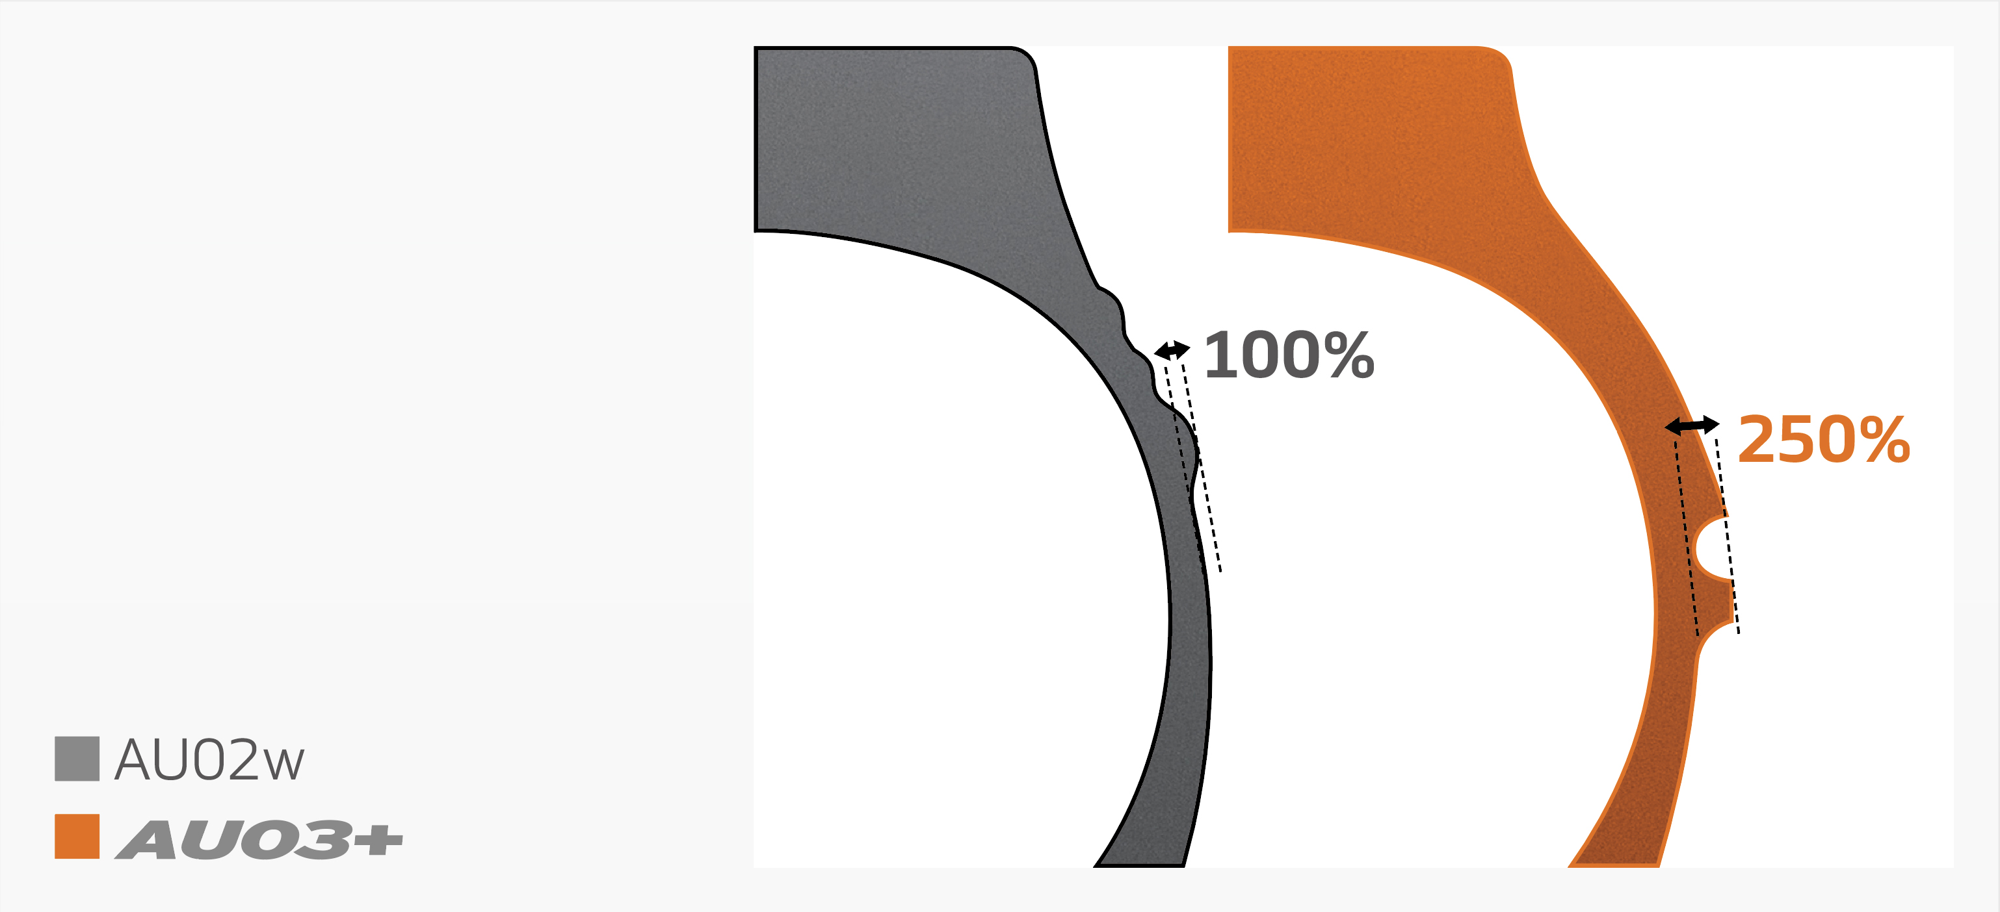

***Wide shoulder and reinforced sidewalls***

* The wide shoulder and reinforced sidewalls ensure excellent wet grip, dry grip and driving stability.

***Horizontal kerfs and deep sipes***



* Kerfs incorporated horizontally in the cap rib and a tread with deep sipes guarantee outstanding traction and mileage performance.

***Zigzag grooves***



* Four zigzag tread grooves guarantee excellent lateral guidance and ensure optimum water drainage.

**###**

Hankook AL10+ e-cube MAX:  
Low-line sizes for the steering axle

**In times when the trend is going more and more towards volume transportation, the legally permissible outside height of four metres for commercial vehicles means that fleet operators are quickly reaching their limits. The issues get amplified if the freight forwarder wants to transport heavy standard goods in addition to volume transports. Therefore, premium tyre maker Hankook has now released the AL10+ e-cube MAX long distance tyre for the low-line segment as well. With the dimension of 355/50R22.5, the new low-profile tyre for the truck steering axle is designed especially for the requirements of volume transports.**

Until now, fleet operators with truck tyres of series 60 to 80 have often not been able to completely utilise the maximum inner load height of three metres without exceeding the legally permissible total height of four metres. Therefore, load capacity is lost, which in turn can result in economic disadvantages. As a consequence, premium tyre maker Hankook is offering its customers a truck tyre for the steering axle in series 50: the AL10+ e-cube MAX was developed in size 355/50R22.5 exclusively for use on jumbo trucks for long distances, and it provides a load index of 156, which means that the axle can be loaded with a weight of up to 8 tons. With its small diameter, it lowers the coupling height of the tractor engine, with the result that the inner load height increases and the three-metre loading platform can be fully utilised thanks to the lower profile tyres.

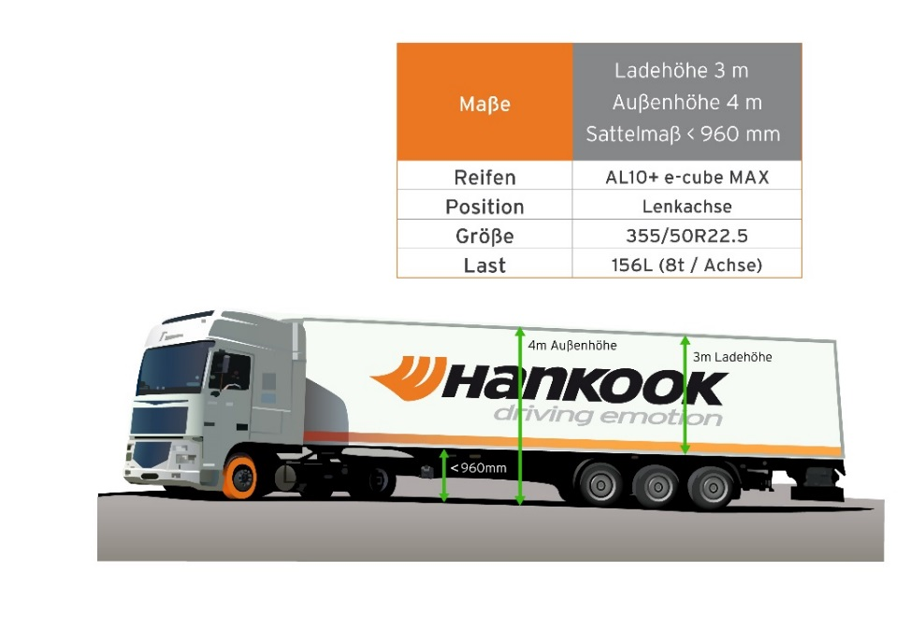

The tyre profile e-cube MAX for commercial vehicles represents maximum cost effectiveness, energy efficiency and environmental friendliness: due to its longitudinal grooved tread with wave structure, the AL10+ e-cube MAX for the steering axle prevents uneven wear. Therefore, the AL10+ e-cube MAX guarantees an increased service life. The improved tread compound and high load index of the tyre increase the fuel efficiency while offering higher load capacity at the same time. The linear groove structure supports stable directional stability as well as maximum steering precision and improved water dispersal.

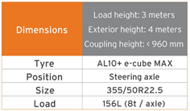

The long-distance specialist for the steering axle is supported by its counterpart for the drive axle, the DL10+ e-cube MAX from the same tyre line. Due to its three-dimensional lamellae, it offers drivers outstanding traction, while the extra-wide profile block and deep grooves ensure increased mileage. The block stabilisers of the DL10+ e-cube MAX also contribute to a high service life and low rolling resistance. The e-cube MAX series is completed by the matching trailer tyre TL10+, which is characterised by maximum driving stability and low rolling resistance. Furthermore, the TL10 completes the e-cube package, which is available in sizes 275/70R22.5, 445/65R22.5 and 445/45R19.5.

*Sizes of the e-cube MAX tyre line available*

|  |  |  |  |  |  |  |
| --- | --- | --- | --- | --- | --- | --- |
| **Tread** | **Size** | **LI** | **Marking** |  | **M+S** | **Availability** |
| **AL 10+** | 315/80R22.5 | 156/150L (154/150M) | B/B/W1 70dB | - | - | 🗹 |
| 315/70R22.5 | 156/150L | B/B/W1 70dB | - | - | 🗹 |
| 385/65R22.5 | 160K | B/B/W1 70dB | - | - | 🗹 |
| 295/60/R22.5 | 150/147L | C/B/W1 70dB | - | - | 🗹 |
| 315/60R22.5 | 154/148L | C/B/W1 70dB | - | - | 🗹 |
| 355/50R22.5 | 156L | B/B/W1 70dB | - | - | 🗹 |
| **DL 10+** | 315/80R22.5 | 156/150L (154/150M) | C/C/W1 73dB | 🗹 | 🗹 | 🗹 |
|  |  |  |  |  |  |
| 295/60R22.5 | 150/147K | C/C/W1 73dB | 🗹 | 🗹 | 🗹 |
| 315/60R22.5 | 152/148L | C/C/W1 73dB | 🗹 | 🗹 | 🗹 |
| 295/55R22.5 | 147/145K | C/C/W1 73dB | 🗹 | 🗹 | 🗹 |
| 315/45R22.5 | 147/145L | D/C/W2 75dB | 🗹 | 🗹 | In production |
| **TL10+** | 215/75R22.5 | 135/133J | C/B/W1 69dB | - | - | 🗹 |
| 235/75R22.5 | 143/141J | B/B/W1 69dB | - | - | 🗹 |
| 245/70R17.5 | 143/141J (146/146F) | B/B/W1 69dB | - | - | 🗹 |
| 265/70R19.5 | 143/141J | B/B/W1 69dB | - | - | 🗹 |
|  |  |  |  |  |  |
| 385/65R22.5 | 160K | B/B/W1 69dB | - | - | 🗹 |
| 435/50R19.5 | 160J | B/B/W2 73dB | - | - | 🗹 |
| 455/40R22.5 | 160J | B/B/W2 71dB | - | - | 🗹 |

**###**

Hankook SmartWork: Sturdy and durable for on and off-road

**Hankook's truck range for use on construction sites, comprising of the tyres SmartWork AM09, SmartWork AM15/AM15+ for the steering axle, the SmartWork DM09 for the drive axle and the SmartWork TM15 for the trailer, was developed especially for the demanding tasks in the on- and off-road segment. All the tyres have been designed for heavy weights and high loads, and stand out on account of their high resistance to splintering, cuts and tread breaks. Other convincing features include their self-cleaning function and an extremely sturdy carcass structure.**

The SmartWork AM09 for the steering axle is suitable for construction site vehicles which are more frequently used on roads. Its polygonal tread blocks ensure excellent traction and outstanding braking performance even on muddy roads. Both the extra-wide tread design and the closed shoulder area provide the SmartWork AM09 with a high degree of driving stability. Special rubber blocks in the profile grooves prevent stones from becoming lodged. The SmartWork AM15/AM15+ is also suitable for the steering axle, but has been designed especially for off-road use. Its extra-wide tread blocks guarantee optimum traction on uneven surfaces like those typical of construction sites. Its open shoulder area with tie-bar also contributes to this. Extra-wide tread grooves prevent gravel becoming lodged in the tread.

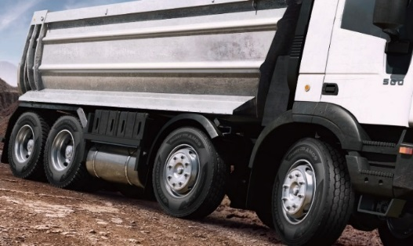

The SmartWork DM09 is available for the drive axle. The directional tread design enables improved displacement of mud and water. The interblock tie-bar at the centre of the SmartWork DM09 guarantees outstanding straight driving performance and impact dispersion for blocks, thereby improving longevity. Chamfered tread blocks on the outside of the tread surface increase resistance to lateral strains and effectively help prevent damage to the tyre's shoulder or tearing of the block edges.

The trailer tyre SmartWork TM15 included in the line has particularly high traction thanks to its high groove width. In addition, the trailer tyre stands out on account of very good water repulsion. Thanks to their M+S marking, all the treads of the SmartWork series can be utilised on and off-road all year round even in wintry conditions.

*Sizes of the SmartWork line available*

|  |  |  |  |  |  |  |
| --- | --- | --- | --- | --- | --- | --- |
| **Tread** | **Size** | **LI** | **Marking** |  | **M+S** | **Availability** |
| **AM09** | 10R22.5 | 144/142K | C/B/W1 70dB | - | 🗹 | 🗹 |
| 11R22.5 | 148/145K | D/B/W1 67dB | - | 🗹 | 🗹 |
| 12R22.5 | 152/149K | D/B/W1 69dB | - | 🗹 | 🗹 |
| 13R22.5 | 156/150K | D/C/W1 70dB | - | 🗹 | 🗹 |
| 295/80R22.5 | 152/148K (154/150J) | C/B/W1 67dB | - | 🗹 | 🗹 |
| 315/80R22.5 | 156/150K | D/B/W1 67dB | - | 🗹 | 🗹 |
| **DM09** | 11R22.5 | 148/145K | E/C/W1 70dB | - | 🗹 | 🗹 |
| 12R22.5 |  |  |  |  | 🗹 |
| 13R22.5 | 156/150K | D/C/W2 75dB | - | 🗹 | 🗹 |
| 1200R20 | 154/150K | E/C/W2 75dB | - | 🗹 | 🗹 |
| 295/80R22.5 | 152/148K | E/B/W1 70dB | - | 🗹 | 🗹 |
| 315/80R22.5 | 156/150K | D/C/W1 70dB | - | 🗹 | 🗹 |
| **AM15** | 265/70R19.5 | 143/141J | D/B/W2 74dB | - | 🗹 | 🗹 |
| 275/70R22.5 | 148/145K | D/B/W2 74dB | - | 🗹 | 🗹 |
|  |  |  |  |  |  |
| 425/65R22.5 | 165K | C/C/W2 75dB | - | 🗹 | 🗹 |
|  | 445/65R22.5 | 169K | C/C/W2 75dB | - | 🗹 | 🗹 |
| **AM15+** | 385/65R22.5 | 160K/(158L) | D/C/W2 74dB | - | 🗹 | 🗹 |
| **TM15** | 385/65R22.5 | 160K/158L | D/C/W1 69dB | - | 🗹 | 🗹 |

**Technical properties of the Hankook SmartWork AM09**

1. ***Wider zigzag grooves for high traction and optimised braking performance:***

* Four extra-wide tread grooves in a zigzag design guarantee the right grip both on tarmac roads and off-road.
* Excellent displacement of mud and water.
* Additional pimples in the grooves support the tyre's self-cleaning function.

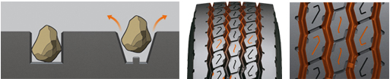

1. ***Polygonal, stepped blocks for a more pronounced edge effect:***

* Special notches on the individual tread blocks for particularly good grip.
* Shorten braking distance.

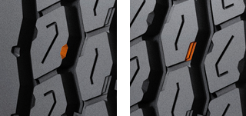

* Enhance off-road traction.

1. ***Closed shoulder design increases the tyre's driving stability:***

* Improved resistance against forces acting at the side.
* Protection against damage to the block edges.
* Shoulder lugs help to produce less heat while driving.

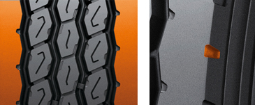

**Technical properties of the Hankook SmartWork AM15/AM15+**

1. ***Optimised tread blocks***

* Bars between the tread blocks stabilise the tyre.
* The optimised contact area prevents uneven wear.

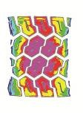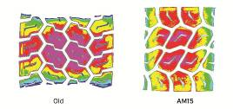

Old AM15

1. ***Particularly wide and deep grooves for better traction and to prevent stone damage***

* Grooves ideally displace water and guarantee an extremely high mileage.
* Ribs within the grooves prevent stones becoming lodged in the tread.

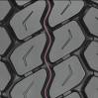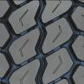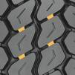

1. ***Innovative rubber compound reduces heat development***

* Specially developed mixing method slows wear and increases mileage.
* Retreading is made easier and the tyre can be used again more quickly.

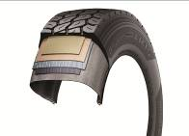

**Technical properties of the Hankook SmartWork DM09**

***1.*** ***Optimised tyre tread:***

- Block design with reinforced central rib for more even distribution of the forces acting in

use.

- More uniform abrasion pattern and minimisation of uneven wear.

- High grip on loose surfaces and very good self-cleaning properties thanks to the open

tyre shoulder design.

- Conical tread blocks on the outer side of the tread for increased resistance

to side loads and protection of the block edges in the shoulder area

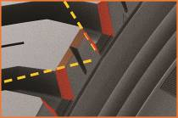

**Technical properties of the Hankook SmartWork TM15**

***Optimised tyre tread:***

* Wide tread grooves ensure high traction

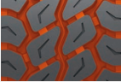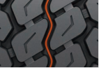

* Sipes in the centre of the three tread grooves prevent stones becoming lodge in the tread

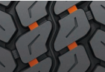

* Bars between the tread blocks increase their rigidity, thus promoting more even wear

**###**

Hankook TH22: Trailer tyres for low-bed truck transport

**The TH22 is Hankook's trailer specialist when it comes to transporting heavy loads in regional traffic, along country roads for example. Because alongside the standard sizes, the TH22 is available in smaller sizes which can then be fitted to low-bed trucks, making maximum loading volume possible.**

The Hankook TH22 is the successful trailer tyre from the premium tyre maker for regional and delivery traffic. The TH22 is available in standard sizes 425/65R22.5 and 385/55R22.5 and also in smaller sizes especially for use on low-bed trailers.

The profile and carcass design of the Hankook TH22 trailer tyre optimises wear resistance as well as rolling resistance. The smaller sizes have a closed 4-rib block profile with extra-broad, solid shoulder ribs which was especially developed for low rolling resistance and good lateral stability. At the same time, the tread design supports even wear and 10 percent higher mileage than its predecessor. Wave-shaped tread sipes and transverse sipes right down to the base of the groove additionally provide for effective water displacement, making the TH22 a true all-round talent when it comes to handling. The large sizes have the same characteristics, the only difference being that the block profile is made up of five ribs.

The low design height ensures maximum loading volume and, coupled with the high load-bearing capacity, makes the Hankook TH22 in the sizes 205/65R17.5 and 215/75R17.5 particularly suitable for low-bed trailer heavy-duty transport on country roads, such as car, construction vehicle or construction element transport.

*Available sizes of the TH22*

|  |  |  |  |  |  |  |
| --- | --- | --- | --- | --- | --- | --- |
| **Tread** | **Size** | **LI** | **Marking** |  | **M+S** | **Availability** |
| **TH22** | 9.5R17.5 | 143/141J | D/B/W1 70dB | - | 🗹 | 🗹 |
| 11R22.5 | 148/146L | C/B/W1 70dB | - | 🗹 | 🗹 |
| 215/75R17.5 | 135/133J | D/B/W1 70dB | - | 🗹 | 🗹 |
| 235/75R17.5 | 143/141J | C/B/W1 70dB | - | 🗹 | 🗹 |
| 245/70R17.5 | 143/141J (146/146F) | C/B/W1 70dB | - | 🗹 | 🗹 |
| 245/70R19.5 | 141/140J | C/B/W1 67dB | - | 🗹 | 🗹 |
| 265/70R19.5 | 143/141J | C/B/W1 70dB | - | 🗹 | 🗹 |
| 285/70R19.5 | 150/148J | C/B/W1 70dB | - | 🗹 | 🗹 |
| 205/65R17.5 | 129/127K(132/132F) |  | - | 🗹 | 🗹 |
| 425/65R22.5 | 165K | B/B/W1 71dB | - | 🗹 | 🗹 |
| 385/55R22.5 | 160K (158L) | B/B/W1 71dB | - | 🗹 | 🗹 |

**Technical properties of the Hankook TH22**

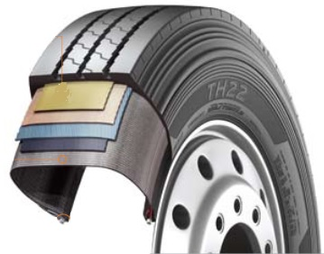

**1.** ***Tyre design***

- Belt structure: Less belt deformation guarantees very

low rolling resistance

- Carcass structure: The wider carcass profile with reinforced

belt cord guarantees

excellent durability

- Bead structure: Reinforced bead structure ensures a long service life

even at high load weights

**2.** ***Tread design***

- Optimised zigzag rib design for good self-cleaning

- Wide and firm shoulder package for improved mileage and even wear

- Solid, continuous centre rib improves rolling characteristics and lateral stability

**###**

Hankook light truck tyre Vantra LT:   
Energy efficient, safe and exceptionally durable

**Hankook presents the Vantra LT, the Summer tyre for commercial vans and transporters. The innovative design features improves fuel efficiency by up to 13 % while reducing wear by 12 % for extended mileage. Designed specifically for the high demands placed on passenger and goods transport vehicles ensuring optimised durability and reduced breaking distances.**

Hankook Tire introduce the Vantra LT designed for commercial vans and transporters. The light truck tyre was developed in view of the high demands that are placed on passenger and goods transport vehicles in regional traffic. Durability, fuel efficiency and mileage played a key role during development as well as safety-related driving characteristics such as short breaking distances and superior wet performance. The Vantra LT is available in 35 dimensions.

Frequent use in start/stop traffic places special demands on tyres: a long service-life with high economic efficiency to maximise mileage and robustness against external influences are important while safety performance is playing a key role as well. The Hankook Vantra LT’s innovative design features such as a sidewall protect shield and optimised groove location with durable contact patch technology enables increased performance and assure safety at high speeds. At the same time, they reduce tread wear and improve the tyre’s fuel efficiency by up to 13 per cent versus its predecessor. In addition, 3-channel wide central grooves and 3D lateral grooves enable fast water dispersion to reduce hydroplaning and guarantee superior performance in wet and even cold weather conditions.

Hankook Vantra LT’s footprint is designed to improve durability by applying square shape contact patch technology that allows for an optimised groove position, increasing stability in the outer grounding footprint area. In combination with the tyre’s innovative reinforced belt structure featuring a double steel belt this allows a more even distribution of the ground pressure resulting in an improved wear performance of up to 12%. In addition, the reduced tyre deformation results in a lowered rolling resistance, resulting in higher fuel efficiency and thus heightened cost-effectiveness – a key factor for tyres used for start/stop traffic. The additionally applied sidewall protect shield effectively helps to prevent sidewall damage.

The innovative pattern not only guarantees superior wet braking performance and effectively prevents hydroplaning but also improves fuel efficiency by minimising energy loss while driving. The Vantra LT’s optimised block stiffness further improves the tyre’s handling performance in wet, dry and even cold weather conditions without sacrificing block strength. The running smoothness of the tyre – and thus control and driving comfort – is perceptibly greater as well.

**Technical features of the Vantra LT**

1. ***Optimised interior structure ensures durability and safety***

The reinforced belt structure of the Vantra LT ensures durable performance by applying a reinforced belt layer and double steel belt. In combination with special bead filler for enhanced rim joint stiffness also handling performance is improved. The tyre’s Sidewall Protect Shield prevents sidewall damage under low-pressure conditions.

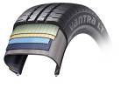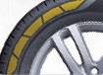

1. ***Increased handling and wet performance***

3-channel wide grooves in combination with 3D lateral grooves reduce the risk of hydroplaning and ensure increased performance and safety at higher speed as well as enhanced wet and cold weather

performance without sacrificing block strength. The Vantra LT’s innovative new straight main grove improves hydroplaning performance by up to 14% by ensuring better water runoff.

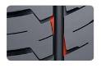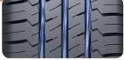

1. ***Improved wear performance, fuel efficiency and extended mileage***

By applying an optimised structure with innovative compound technology, the wear performance has improvement of up to 12% compared to a conventional tyre. In addition, an optimised carcass profile allows for up to 13 % improved fuel efficiency by minimising energy loss in driving.

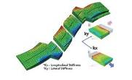

1. ***Increased durability and driving stability***

The Vantra LT’s square shape contact patch improves the tyre’s durability while the optimised groove position ensures additional stability in the outer grounding footprint area.

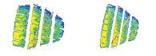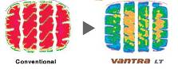

1. ***Available sizes***

The Vantra LT is available in 35 dimensions in sizes from 12 to 16 inches in series 82 to 60 and cover tread width from 155 to 235 all marked M+S.

**###**

**The innovative Hankook mixing method IMS (Innovative Mixing System)**

The innovative Hankook mixing method IMS (Innovative Mixing System) ensures a particularly even distribution of carbon black particles and rubber molecules within the mixtures. Together with longer mixing times at lower temperatures, a significant increase of the bonding rate between the carbon black and rubber molecules can be achieved. As a result, the tyre generates less heat during the drive, which has a positive effect on the rolling resistance and thereby on fuel consumption as well.

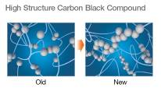

**Hankook Stiffness Control Contour Theory (SCCT)**

The patented Hankook Stiffness Control Contour Theory (SCCT) design technology provides an even distribution of pressure inside the tyre and thus promotes more stability and less movement in the tyre. This results in high carcass durability and offers customers very good retreadability and economy.

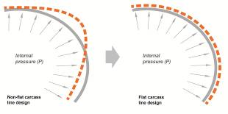

**###**

Hankook ‘alphatread’ for the UK market:  
Bead-to-bead retread truck tyre range

‘alphatread’ is the environmentally conscious bead to bead retread truck tyre range from premium tyre maker Hankook Tyre UK. The ‘alphatread’ line-up designed for medium haul purposes consists of sizes for the drive axle position together with a corresponding trailer tyre size. It aims to meet customer demands for reducing fleets running costs by providing a ‘cradle to grave’ tyre solution.

The ever-increasing demands in the area of environmental friendliness and continued pressure upon fleets to reduce their running costs have led to the development of the Hankook ‘alphatread’ range. The premium manufacturer’s retread truck tyre line has been specifically designed to maximise mileage as the casings of Hankook’s 1st life A1 grade tyres are used to mirror Hankook’s existing tyre patterns to produce the alphatread tyre. For the time being the products are available in the UK market in two drive axle sizes and a corresponding trailer size.

The Hankook alphatread R-DH05 is a drive axle tyre for medium haul, available in three sizes 295/80R22.5, 315/80R22.5 and now the 315/70 R22.5. With its wide outline and a unique compound, the R-DH05 provides excellent wet and dry performance, driving stability and long-lasting wear. While the extra wide tread and deep grooves ensure high mileage, the optimised block shape provides block rigidity also under heavy loads for an outstanding traction and tread stability. Its lateral oriented tread design with high density grooves help to provide excellent traction in all weather conditions.

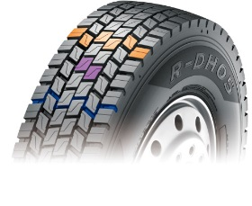

The Hankook alphatread R-TH22 sized 385/65R22.5 is the corresponding trailer tyre for medium haul purposes. It provides a 5 rib tread design and a so called cool running compound for optimum performance. Optimised zigzag grooves care for stone ejection and crack prevention. The wide, solid shoulder area provides a higher mileage and helps to prevent belt separation. Its massive kerfless centre rib enhances free-rolling on axle thus increasing the trailer’s riding stability.

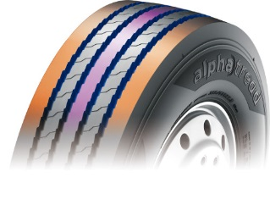

Hankook’s alphatread tyres contribute to the environment by using significantly less raw material as well as energy during manufacturing.

**Current sizes of the Hankook alphatread line-up:**

|  |  |  |  |  |  |  |
| --- | --- | --- | --- | --- | --- | --- |
| **Tread** | **Size** | **LI** | **Regrooving depth** | **Snow flake** | **M+S** | **Availability** |
| **R-DH05** | 295/80R22.5 | 152/148K | 3.0 mm |  | 🗹 | 🗹 |
| 315/80R22.5 | 154/150K | 3.0 mm |  | 🗹 | 🗹 |
| 315/70R22.5 | 154/150K | 3.0 mm |  | 🗹 | 🗹 |
| **R-TH22** | 385/65R22.5 | 160J | 3.0 mm |  |  | 🗹 |

**###**

**About Hankook**

Hankook Tire manufactures globally innovative, award winning radial tyres of proven superior quality for passenger cars, light trucks, SUVs, RVs, trucks, and buses as well as motorsports (circuit racing/rallies).

Aspiring to bring consumers the utmost excellence in product quality, technological excellence and driving satisfaction, Hankook Tire continuously invests in research and development maintaining five R&D centres and eight production facilities around the world. Bespoke tyre solutions for the European markets as well as European Original Equipment according to the requirements of leading premium car manufacturers, are developed in the company’s regional Technical Centre in Hanover/Germany. Production for the European region is taking place in the state-of-the-art manufacturing site in Rácalmás/Hungary which was inaugurated in June 2007 and is continuously being expanded. Currently around 3,000 employees produce up to 19 million tyres a year for passenger cars, SUVs and light trucks.

Hankook Tire’s European headquarters are located in Neu-Isenburg near Frankfurt am Main in Germany. The manufacturer operates further branches in Czech Republic, France, Germany, Hungary, Italy, the Netherlands, Poland, Russia, Spain, Sweden, Turkey, UK and Ukraine. Hankook products are sold directly through regional distributors in other local markets. Hankook Tire employs approximately 22,000 people worldwide and are selling their products in over 180 countries. Internationally leading car manufacturers rely on tyres made by Hankook for their original equipment. Approximately 30 percent of the company's global sales are generated within the European and CIS-Region. Hankook Tire has been represented in the renowned Dow Jones Sustainability Index World (DJSI World) since 2016.

**Media contact UK:**

**Hankook Tyre UK Ltd, Fawsley Drive, Heartlands Business Park, Daventry, Northamptonshire NN11 8UG**

Zoë Baldwin, Marketing Communication Manager

Tel.: +44 (0) 1327 304 146

Mobile: +44 (0) 7948 247048

zbaldwin@hankooktyres.co.uk

**European Media contacts:**

**Hankook Tire Europe GmbH | Corporate Communications Europe/CIS**

**Siemensstr. 14, 63263 Neu-Isenburg | Germany**

Anna Pasternak, PR Manager

LT and Truck & Bus Tyres, Intl. Motorsports, CSR

Tel.: +49 (0) 6102 8149 – 173

Mobile: +49 151 65641014

a.pasternak@hankookreifen.de

Sabine Riedel, PR Manager

LT and Truck & Bus Tyres, Hankook Media Center, SNS, Corporate

Tel.: +49 (0) 6102 8149 – 174

Mobile: +49 160 2545318

s.riedel@hankookreifen.de