ress release

Hankook Ventus iON S: new summer tyre for e-cars to join global tyre family

- Greater range per battery charge and a quieter drive
- Efficient, redeveloped product available in sizes 18 to 22 inches
- TÜV SÜD¹ certified: conflict of objectives successfully managed

Neu-Isenburg, Germany, 7 June 2022 – In May 2022, premium tyre manufacturer Hankook launched the Ventus iON S, the first summer tyre in a new product range that has been specifically designed for electric vehicles. By taking this approach, the company wants to make a decisive contribution from a tyre choice perspective to advancing the mobility transition towards zero-emission vehicles. The new summer tyre is a pioneer of the new, global “iON” tyre family designed for premium electric vehicles, which will include the Hankook Winter i*cept iON in September 2022.

Characteristics of the new tyre include reduced rolling resistance, extremely low noise rolling characteristics and high load-bearing capacity. For drivers of electric cars, this means more range per battery charge and a better driving experience compared to conventional tyres. In addition, the new Hankook iON products are specially designed for the instant high torques produced by powerful electric vehicles.

Numerous measures for EV-specific requirements

The new Hankook Ventus iON S meets the demanding everyday requirements for EV tyres (EV = Electric Vehicle) by providing an extensive set of technical measures. In particular, Hankook has countered the higher vehicle mass of electric vehicles – caused by the considerable weight of the drive batteries – with a higher load capacity. Among other things, ultra-resistant aramid fibres effectively counteract the deformation forces caused by the especially high torque in electric vehicles. The tread compound, which features a high proportion of natural resin, also ensures exemplary durability and reduced wear. The high silica content provides micro-level grip on wet roads by counteracting the formation of a film of water between the road surface and the tyres, which can be dangerous. Another special feature of the new compound is its high proportion of natural oils. This not only makes the iON products more sustainable overall, but it also has a positive impact on the durability of the tread. This means that less material is required for consistent performance, and the savings in weight of up to one kilogram per tyre improves rolling resistance.

One of the special features of the Ventus iON S is the aerodynamic optimisation so that it can exploit potential for greater levels of efficiency and range. The tyre pattern is designed in such a way that air resistance is reduced, something that is even true for the lettering on the tyre sidewalls.

A further development goal was to achieve the quietest possible running characteristics, especially since eliminating the noise of an internal combustion engine draws attention to this aspect. It is therefore all the more important that Hankook’s integrated Sound Absorber™ technology, together with the noise-reducing tyre pattern, noticeably reduces the level of noise inside the vehicle.

TÜV SÜD certified: conflict of objectives successfully managed

Hankook engineers have brilliantly resolved the conflicting objectives of minimising rolling resistance while maintaining the same quality in other important performance criteria. This has also been certified by TÜV SÜD in an independent comparative test using competitor products from the premium segment. Mounted on common premium electric vehicles, the Hankook Ventus iON S is clearly superior, without showing weakness in other important criteria.

It also achieves the best values for wet and dry braking performance. Furthermore, it is also the quietest tyre in the test.

Large potential to reduce CO₂ in replacement business

Special tyres for electric vehicles are also becoming increasingly important in the replacement business. According to forecasts by the information service IHS Markit, the global share of battery-powered electric automobiles in total vehicle sales will increase by 36.6% annually, from the current 6.4% market share to 29.5% by 2028. Because Hankook iON tyres make it possible to drive more kilometres per battery charge compared to standard tyres, they can also make a significant contribution to reducing CO₂ emissions from road traffic.

Sanghoon Lee, President of Hankook Tire Europe: “With the introduction of the Ventus iON S as the first tyre in a new range, our company is increasingly taking into account the rapidly growing demand for electric vehicles and the associated need for suitable tyres, also in terms of the need for replacements. With an improved range per battery charge, this new generation of tyres will help to further optimise the efficiency of electric vehicles in everyday use. We are pleased to say that this has already been confirmed by independent institutions.”

Klaus Krause, Head of the Hankook Tire Europe Technical Center in Hanover: “We are particularly proud that the new Hankook Ventus iON S, for example, has achieved an A/A/A rating on the EU tyre label. This corresponds to the highest performance levels in terms of rolling resistance, wet grip and tyre noise.”

The Hankook Ventus iON S is available in sizes between 18 and 22 inches. The Hankook Winter i*cept iON, designed for winter months, will follow in September 2022. An all-season version, the Hankook Ventus iON A, will also be available for the North American market. Further specific product designs are in the pipeline.

Technology exchanges between electric motorsport and road vehicles

As one of the world's leading original equipment manufacturers of electric vehicles from premium car brands, the Hankook development engineers have already documented their expertise in this demanding segment many times over. Original equipment tyres from Hankook that have been optimised for electromobility are already being used by Audi, BMW, Porsche, VW and other leading brands. From the 2022/2023 season, the premium tyre manufacturer will also be demonstrating the technical expertise it has acquired in the area of sustainability and high-performance mobility, as a supplier in the world of electric motorsport, as appointed by the Fédération Internationale de l’Automobile (FIA).

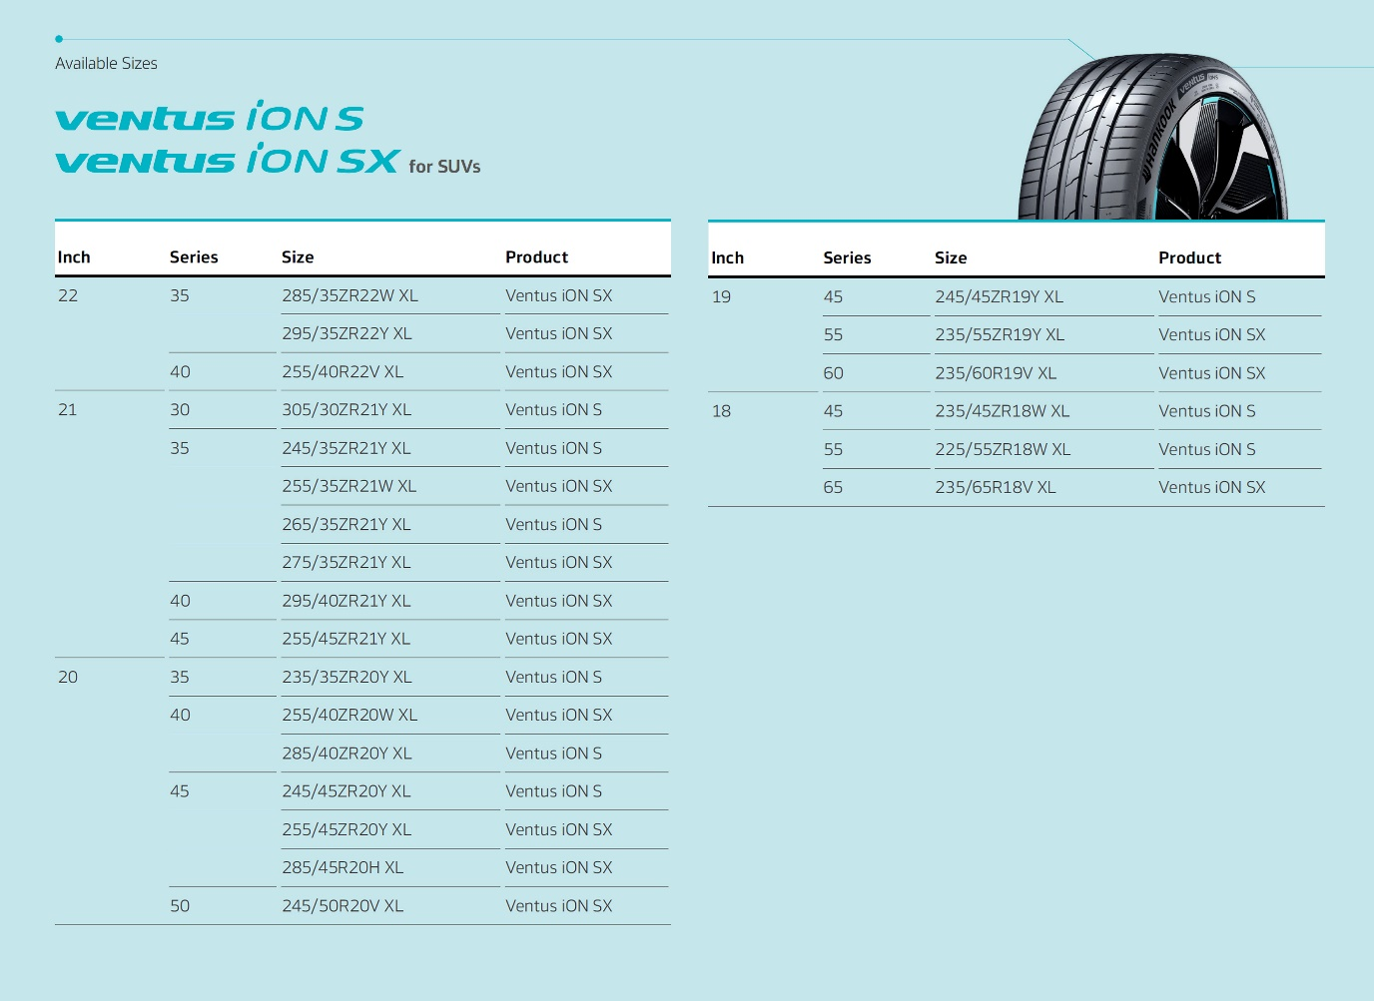

About Hankook

Hankook Tire manufactures globally innovative, award-winning radial tyres of proven superior quality for passenger cars, light trucks, SUVs, RVs, trucks, and buses as well as motorsports (circuit racing/rallies).

Aspiring to bring consumers the utmost excellence in product quality, technological excellence and driving satisfaction, Hankook Tire continuously invests in research and development maintaining five R&D centres and eight production facilities around the world. Bespoke tyre solutions for the European markets as well as European Original Equipment according to the requirements of leading premium car manufacturers, are developed in the company’s regional Technical Centre in Hanover/Germany. Production for the European region is taking place in the state-of-the-art manufacturing site in Rácalmás/Hungary which was inaugurated in June 2007 and is continuously being expanded. Currently around 3,000 employees produce up to 19 million tyres a year for passenger cars, SUVs and light trucks.

Hankook Tire’s European headquarters are located in Neu-Isenburg near Frankfurt am Main in Germany. The manufacturer operates further branches in several European countries and sells its products through regional distributors in other local markets. Hankook Tire employs approximately 20,000 people worldwide and are selling their products in over 180 countries. Internationally leading car manufacturers rely on tyres made by Hankook for their original equipment. Approximately 34 percent of the company's global sales are generated within the European and CIS-Region. Hankook Tire has been represented in the renowned Dow Jones Sustainability Index World (DJSI World) since 2016.

For more information please visit www.hankooktire-mediacenter.com or www.hankooktire.com

Contacts:
Hankook Tire Europe GmbH | Corporate Communications Europe/CIS | Siemensstr. 14, 63263 Neu-Isenburg | Germany

Felix Kinzer  Director  +49 6102 8149-170  f.kinzer@hankookreifen.de | Larissa Büsch  PR Manager  +49 6102 8149-173  l.buesch@hankookreifen.de | Lisa Schmid  PR Manager  +49 6102 8149-172  l.schmid@hankookn.com | Stefan Prohaska  Public Relations  +49 6102 8149-171  s.prohaska@hankookreifen.de

1 TÜV SÜD Tire Test 2022, Report No. 713252186-BM01, -PM01. Test period March 2022. Test of the Hankook Ventus iON S with four competitor tyres, all in the dimension 245/45 ZR19 102Y XL. Test vehicles Tesla Model S 85, Tesla Model S P100D, Audi Q5 Sportback 40 TDI, VW Tiguan 2.0 TDI. Test locations: IDIADA, Papenburg, Neubiberg, Garching. Applies to all other mentions of the TÜV SÜD Tire Test.

