Winter i*cept evo 3 & Winter i*cept evo 3 X:
Hankook starts the 2020 cold season with newly developed UHP winter tyres for cars and SUVs and independent tyre test success

Tyre maker Hankook has developed a new premium product especially for the winter conditions in Western and Central Europe. The UHP (Ultra High Performance) Winter i*cept evo 3 car tyres and the Winter i*cept evo 3 X SUV tyres follow in the footsteps of the successful predecessor model Winter i*cept evo 2, which was also factory fitted by many European premium vehicle manufacturers. The new Winter i*cept series of tyres, now in its third version, is currently available in 95 dimensions and, for the first time in the Hankook UHP winter tyre range, features a directional tread pattern. Europe's leading automobile magazine Auto Bild has already independently subjected the new tread to an extensive performance test and immediately awarded the Hankook Winter i*cept evo 3 with the top mark "Exemplary".

Neu-Isenburg, Germany, 17 September 2020 – Premium tyre maker Hankook is updating its UHP winter tyre line-up with the new Winter i*cept evo 3 for cars and the Winter i*cept evo 3 X for SUVs. This new development focuses not only on the changing weather conditions in Europe, but also on the requirements of hybrid and electric vehicles, as manufacturers which will be fitted with the Winter i*cept evo 3 as “ev” version ex works in future. For the first time, the company’s development engineers opted for a directional tread pattern on their new flagship winter tyres. This not only provides excellent grip on snow, but also helps to effectively reduce the risk of aquaplaning.

“With the Winter i*cept evo 3 and Winter i*cept evo 3 X, our development engineers have created two lines of winter tyres with a wide range of product features that are able to respond particularly well to the changing and increasingly demanding winter weather conditions,” says Sanghoon Lee, President of Hankook Tire Europe. “We are therefore confident that these new tread patterns will meet our customers’ high expectations.

“European winters have changed as a result of climate change – mild temperatures alternate with sudden onsets of winter that bring frost and snow, and dry days are unexpectedly interrupted by heavy rainfall,” says Klaus Krause, head of the ETC European Research and Development Center in Hanover, Germany. Even wet leaves on the road surface can quickly spell dangerous road conditions. This makes it all the more important for responsible drivers to use the right tyres during the cold season, and ensure they are well equipped for all winter weather conditions. “A highlight of the third i*cept evo series is hidden in the tread compound. In addition to natural resins, special additives are also used here to ensure the tyre stays flexible at all times, especially at low temperatures, while at the same time achieving significant improvements in grip on wet surfaces,” Krause continues.

This is also confirmed by the latest winter tyre test from Europe's leading automobile magazine. In its latest issue (No. 38 of 17 September 2020), the magazine Auto Bild tested a total of 56 tyres in the size 245/45 R 18 100 V on a BMW 5 Series. The result: only six treads could be recommended without reservation and awarded the highest rating "Exemplary", among them the new Hankook Winter i*cept evo 3.

The tyres are highly adapted to winter conditions thanks to technical innovations, particularly in terms of the compounds used and the tread pattern itself. The use of natural pine resins ensures the necessary flexibility at a very wide range of temperatures, prevents hardening and thus helping to improve grip on winter and wet roads due to increased elasticity of the tyre’s contact surface. In combination with the directional tread pattern, grip on snow and wet surfaces is optimised even further. The particularly efficient displacement and drainage of water (or slush) via the two main drainage grooves, which are 20% wider in the V-shaped tread pattern, play an important role in further reducing the risk of aquaplaning. The braking distance on wet roads has also been reduced by 10%, and on snowy roads by as much as 7% compared to previous tread patterns. In addition to the natural resins, a highly dispersible nano-silica compound is used, supplemented by other traction-enhancing additives. Along with the further optimised ratio of positive to negative elements in the tread pattern, this makes the Winter i*cept evo 3 very well equipped for the highly varied road conditions created by the European winter.

In addition to the high-grip tread compound, the further optimised arrangement of 3D sipes in conjunction with the directional tread pattern ensures reliable traction and lateral driving stability on snowy roads. The snow traction performance is supported by an increased number of ice-axe shaped tread block edges that grip the snow effectively.

The minimisation of block movements, achieved by the further optimised arrangement and design of the 3D sipes, has a positive effect on abrasion, as well as ensuring a high level of driving stability. The maximised edge effects also improve the general handling properties.

The new Winter i*cept evo 3 series was developed especially for use on powerful vehicles with a lot of torque. A reinforced carcass structure ensures high driving stability and a high-strength bead core maintains optimised positioning on the rim. In combination with the wide tyre shoulder and the optimised block design, this ensures more precise steering response and improved grip when cornering, as well as optimised handling even on dry roads. The shoulder area of the new Hankook UHP winter tyre, with wide interlocking shoulder blocks, also provides the tread’s necessary block stiffness, thereby increasing cornering stability even at higher speeds.

Both tread patterns are mainly manufactured in Hankook’s modern European production facility in Hungary. When it comes to market, the Winter i*cept evo 3 tread pattern for cars will be available in 50 sizes from 17 to 21 inches with tread widths from 195 to 295 mm and aspect ratios from 30 to 60 in the speed indices from H to W. The SUV version, the Winter i*cept evo 3 X, is currently available in 45 sizes from 17 to 22 inches with tread widths from 215 to 315 mm and aspect ratios from 30 to 65 in speed indices H to W. Over the course of next year the line-up will be further expanded, and the predecessor gradually replaced.

###

Hankook Winter i*cept evo 3: Technical Details

- 3D sipes

- The minimisation of block movements, which is achieved by the further optimised arrangement and design of the 3D sipes, also has a positive effect on abrasion, as well as ensuring a high level of driving stability.
- Maximised edge effects also improve the general handling properties.

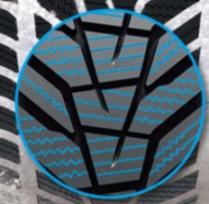

- Water Pipe Kerfs for good handling on wet surfaces

- In addition to the high-grip tread compound, Water Pipe Kerfs in conjunction with the directional tread design ensure reliable water drainage from the tread base and thus improved aquaplaning properties further.

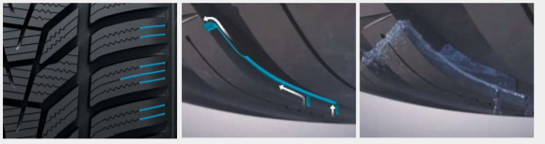

- For the first time: Directional tread pattern

- For the first time, the tyre maker’s development engineers opted for a directional tread pattern on their new flagship winter tyres.

- This not only provides excellent grip on snow, but also helps to effectively reduce the risk of aquaplaning.

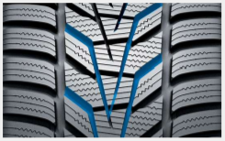

- Aqua Pine Compound

- The new Aqua Pine Compound including natural resins ensures flexibility of the tyre’s contact patch across a particularly wide range of temperatures.

- An advanced winter-optimized compound technology with highly dispersible nano-silica and traction-enhancing additives is used in the tread compound to further improve performance on wet surfaces.

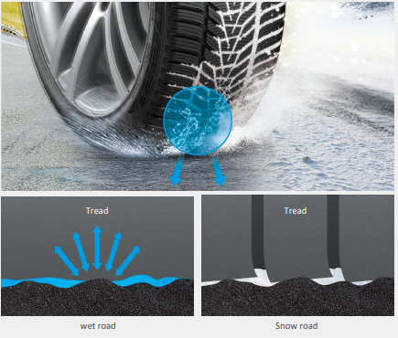

About Hankook Tire

Hankook Tire manufactures globally innovative, award winning radial tyres of proven superior quality for passenger cars, light trucks, SUVs, RVs, trucks, and buses as well as motorsports (circuit racing/rallies).

Aspiring to bring consumers the utmost excellence in product quality, technological excellence and driving satisfaction, Hankook Tire continuously invests in research and development maintaining five R&D centres and eight production facilities around the world. Bespoke tyre solutions for the European markets as well as European Original Equipment according to the requirements of leading premium car manufacturers, are developed in the company’s regional Technical Centre in Hanover/Germany. Production for the European region is taking place in the state-of-the-art manufacturing site in Rácalmás/Hungary which was inaugurated in June 2007 and is continuously being expanded. Currently around 3,000 employees produce up to 19 million tyres a year for passenger cars, SUVs and light trucks.

Hankook Tire’s European headquarters are located in Neu-Isenburg near Frankfurt am Main in Germany. The manufacturer operates further branches in Czech Republic, France, Germany, Hungary, Italy, the Netherlands, Austria, Poland, Russia, Serbia, Spain, Sweden, Turkey, UK and Ukraine. Hankook products are sold directly through regional distributors in other local markets. Hankook Tire employs approximately 20,000 people worldwide and are selling their products in over 180 countries. Internationally leading car manufacturers rely on tyres made by Hankook for their original equipment. Approximately 34 percent of the company's global sales are generated within the European and CIS-Region. Hankook Tire has been represented in the renowned Dow Jones Sustainability Index World (DJSI World) since 2016.

For more information please visit www.hankooktire-mediacenter.com or www.hankooktire.com

Contact:
Hankook Tire Europe GmbH | Corporate Communications Europe/CIS | Siemensstr. 14, 63263 Neu-Isenburg | Germany

Felix Kinzer  Director  tel.: +49 (0) 61 02 8149 – 170  f.kinzer@hankookreifen.de | Larissa Büsch  PR Manager  tel.: +49 (0) 6102 8149 – 173  l.buesch@hankookreifen.de | Stefan Prohaska  PR Assistant  tel.: +49 (0) 6102 8149 – 171  s.prohaska@hankookreifen.de

