Hankook Ultra-High-Performance Tyres for the Porsche Cayenne
Tyre maker Hankook and automobile manufacturer Dr. Ing. h.c. F. Porsche AG have expanded the original equipment with Hankook tyres on its new sports car models. Since June of this year, the Porsche Cayenne has been equipped ex works with Hankook’s ultra-high-performance Ventus S1 evo 3 SUV tyres in the 21-inch dimension, among others. The latest edition of this high-end tyre offers excellent drivability and steering precision in addition to high wet grip and low rolling resistance.
Neu-Isenburg/Germany, 07th October 2019 – Premium tyre maker Hankook has been supplying the Porsche Cayenne ex works with its UHP flagship, the Ventus S1 evo 3 SUV, since June. The ultra-high-performance tyre supplies a tailor-made original equipment tyre for the new SUV model of the Stuttgart-based sports car manufacturer, which fully meets the high demands placed on the segment.

"Porsche stands for particularly powerful sports cars with a high utility value at the same time. However, this also makes tyre development very complex," says Han-Jun Kim, President of Hankook Tire Europe. "We are therefore very pleased with this original equipment as it impressively demonstrates the performance of our products."

Based on DTM-tested technology, the new ultra-high-performance tyre offers high steering precision and very sporty handling. The mixed tyres in sizes 285/40 ZR 21 (109Y) XL at the front and 315/35 ZR 21 (111Y) XL at the rear are especially designed for use in sports SUV and ensure outstanding handling performance.

"Due to the vehicle load in combination with sporty drivability, low rolling resistance and high load capacity, it was very challenging to develop the tyre design for the Porsche Cayenne," explains Dipl.-Ing. Klaus Krause, Head of the European Research and Development Centre at Hankook. "The new Ventus S1 evo 3 SUV meets these requirements very well in both wet and dry conditions."

In addition to the sporty drivability, the new Hankook tread also offers a number of new features that optimise its environmental properties (rolling resistance and durability). The Ventus S1 evo 3 SUV uses a new generation of innovative materials based on high-performance natural resins in the tread compound. This not only increases the grip level in the peak of the power output, the tyre also remains at this high level of grip even over a much wider temperature range, giving it a very wide limit range. In addition, special nylon materials applied in the so-called "bead-packing" process in the sidewall ensure very high driving stability even under load. The CapPly hybrid aramid material over the steel cord belts in combination with the two-layer rayon carcass construction additionally ensures high resistance and durability.

###

Hankook Ventus S1 evo 3: Technical Features

- Rewarded with podium finish in Auto Bild Summer tyre test

- The all new Hankook Ventus S1 evo 3, has achieved a top grade in its very first 3rd party test from Germany’s leading automotive media Auto Bild 2019.

- Handling Performance & Further Development

- Hyper slants in the centre tread bar ribs help to increase the cornering force by enlarging the contact surface under load.

- The blocks of high rigidity and wider outer ribs of the asymmetric tread have been reinforced with additional connecting bridges to provide precise and stable handling around corners.
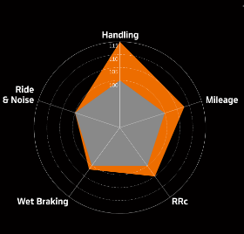

- Reduction of height growth at high speeds due to new aramid composite material

- A new 0-degree cap ply made from aramid composite further reduces the unwanted growth in rolling circumference at (300 km/h and more) speed by up to 60 per cent compared with traditional nylon-based fabrics.
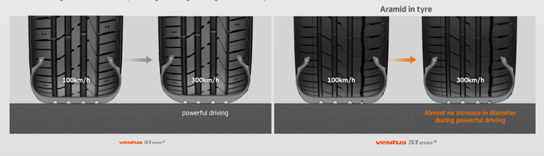

- Improved wet braking performance and reduction of rolling resistance

- A high grip silica tread compound and a special mixing technology makes for a significantly better distribution of polymers and filler material, which is also used in the tread compound. This results in a clear improvement in braking performance in the wet as well as in reducing rolling resistance.
- Hankook’s compounding experts have optimised the driving characteristics of the Ventus S1 evo 3 on wet and dry roads by using high performance natural resins in the tread compound.
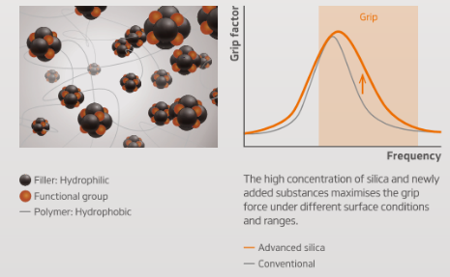
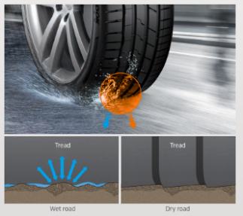

###
About Hankook Tire

Hankook Tire manufactures globally innovative, award winning radial tyres of proven superior quality for passenger cars, light trucks, SUVs, RVs, trucks, and buses as well as motorsports (circuit racing/rallies).
Aspiring to bring consumers the utmost excellence in product quality, technological excellence and driving satisfaction, Hankook Tire continuously invests in research and development maintaining five R&D centres and eight production facilities around the world. Bespoke tyre solutions for the European markets as well as European Original Equipment according to the requirements of leading premium car manufacturers, are developed in the company’s regional Technical Centre in Hanover/Germany. Production for the European region is taking place in the state-of-the-art manufacturing site in Rácalmás/Hungary which was inaugurated in June 2007 and is continuously being expanded. Currently around 3,000 employees produce up to 19 million tyres a year for passenger cars, SUVs and light trucks.
Hankook Tire’s European headquarters are located in Neu-Isenburg near Frankfurt am Main in Germany. The manufacturer operates further branches in Czech Republic, France, Germany, Hungary, Italy, the Netherlands, Poland, Russia, Spain, Sweden, Turkey, UK and Ukraine. Hankook products are sold directly through regional distributors in other local markets. Hankook Tire employs approximately 21,000 people worldwide and are selling their products in over 180 countries. Internationally leading car manufacturers rely on tyres made by Hankook for their original equipment. Approximately 30 percent of the company's global sales are generated within the European and CIS-Region. Hankook Tire has been represented in the renowned Dow Jones Sustainability Index World (DJSI World) since 2016.

For more information please visit www.hankooktire-mediacenter.com or www.hankooktire.com

Contact:
Hankook Tire Europe GmbH | Corporate Communications Europe/CIS | Siemensstr. 14, 63263 Neu-Isenburg | Germany

Felix Kinzer  Director  tel.: +49 (0) 61 02 8149 – 170  f.kinzer@hankookreifen.de | Yara Willems  PR Specialist  tel.: +49 (0) 6102 8149 – 172  y.willems@hankookreifen.de

