**First Hankook bus tyre specification**

**for electromotive use**

**Hankook is presenting the SmartCity AU04+, its first tyre specification for electric buses. The tyre manufacturer is following increasing customer requirements for tyre solutions specifically for use on electric-powered urban buses. As these vehicles are generally heavier than conventional buses due to their energy storage units, the tyres also have an increased load index. To keep battery energy loss to a minimum, the SmartCity AU04+ also stands out on account of its very low rolling resistance. In urban stop and go traffic, bus tyres must be able to cope with a particularly heavy load and guarantee safe use at the same time; therefore, special attention was paid to adaptation of the shoulder width and structure during development of the new electric bus tyre, in order to ensure extremely even wear. The tread of the AU04+, which has been designed as an all-year tyre, is suitable for all wintry conditions without restriction and bears the snowflake symbol (3PMSF). It goes without saying that the new city bus tyre size is equally suitable for use on city buses with conventional drive concepts.**

***Neu-Isenburg, Germany, 19 September 2018*** – Hankook is expanding its tyre portfolio in the scheduled urban/city bus sector. For the first time, the premium tyre maker is supplying a city bus tyre in the size 315/60 R 22.5 optimised for electromotive use. The SmartCity AU04+ stands out in particular due to of its very low rolling resistance which helps to ease the strain on the energy storage units of electric-powered urban buses. On account of the increased vehicle weight resulting from the battery weight, the tyre not only has a stable carcass but also an increased load capacity of 154/148J (156/152F) which corresponds to a weight of 8 tonnes per axle. The standard load bearing capacity is usually 7 tonnes per axle for this size.

During development of the new bus tyre, special attention was paid to a high traction and braking performance, particularly on wet road surfaces. Dipl.-Ing. Klaus Krause, head of the European Research and Development Centre, explains: “Unlike conventional combustion engines, an electric motor is able to deliver the full torque immediately. This means the vehicle and the tyres respond faster to speed or the changing road conditions. Consequently more demands are made on tyres for electric-powered vehicles. The high grip level avoids irregular tyre wear without having to do without optimum mileage.”

The high mileage is guaranteed by the optimised zigzag grooves which ensure higher block rigidity thanks to their modified layout, among other things. The constant starting and stopping in city traffic puts a heavy and irregular load on bus tyres. “For this reason we have adapted the shoulder width and design for the SmartCity AU04+ to the increased requirements, thus guaranteeing more even wear. The improved molecular structure of the new tread compound makes the tyre much more heat-resistant and is a further contributing factor to a longer service life,” Dipl.-Ing. Klaus Krause adds.

Completely in line with the safety aspect, the SmartCity AU04+ also has a further reinforced sidewall. This protects the tyre from damage following the often unavoidable contact with the curb in city traffic: “The reinforced sidewall is particularly important for the protection of electric bus tyres, since they accelerate much more quickly on account of the system and also build up a more aggressive contact to curbstones” Klaus Krause explains.

*Available sizes of the AU04+ / AU03+ and AU03:*

|  |  |  |  |  |  |  |
| --- | --- | --- | --- | --- | --- | --- |
| **Tread** | **Size** | **LI** | **Marking** | **Snowflake** | **M+S** | **Availability** |
| **AU04+**  **for electromotive use** | 315/60R22.5 | 154/148J (156/152F) | C/B/W1/73db | ☑ | ☑ | ☑ |
| **AU04+** | 315/60R22.5 | 154/148J (156/152F) | C/B/W1/73dB | ☑ | ☑ | ☑ |
| **AU04+** | 275/70R22.5 | 150/148J  (152/148F) | D/B/W1/67 dB | ☑ | ☑ | ☑ |
| **AU03+** | 275/70R22.5 | 150/145J  (152/148) | D/C/W1/71dB | ☑ | ☑ | ☑ |
| **AU03** | 11R22.5 | 148/145J | C/B W1/71dB | - | ☑ | ☑ |
| 275/80R22.5 | 149/146J | D/C W1/71dB | - | ☑ | ☑ |
| 295/80R22.5 | 152/148J | C/C W1 71dB | ☑ | ☑ | ☑ |
| 245/70R19.5 | 136/134L | D/C W1 71dB | ☑ | ☑ | ☑ |
| 265/70R19.5 | 104/138M | D/C W1 71dB | ☑ | ☑ | ☑ |

**Technical properties of the new electric bus tyre**

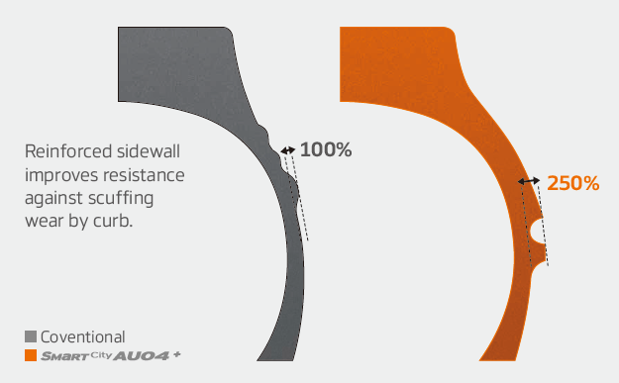

***Wide shoulders and reinforced sidewalls***

* Wide shoulders and reinforced sidewalls ensure   
  excellent wet grip and driving stability
* New shape and position of the sidewall indicator   
  makes determining the tyre condition easier

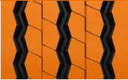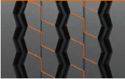***Improved tread design***

* Stabilising 3D tread blocks guarantee improved traction
* Higher mileage through optimised rib spacing
* 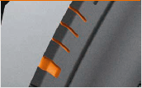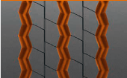Three zigzag grooves guarantee excellent traction, particularly

in the wet

* Adapted shoulder width and removed lugs and ribs ensure more   
  even wear

***Innovative rubber compound***

* Improved chemical structure makes the tyre more heat-resistant



# # #