Be equipped to face the wintry weather with Hankook

Premium tyre maker Hankook has made preparations for the imminent wintry weather with its range of winter tyres for trucks and buses. Together with the steering and drive axle treads and the trailer tread from the SmartControl series, Hankook offers its customers a complete reliable winter solution which promises top performance on ice and snow.

Neu-Isenburg, Germany, 19th September 2017 - The SmartControl AW02 is Hankook’s winter specialist for trucks, and can be used both on the steering axle as well as at all other positions. Like all the other treads in the SmartControl range, the tyre, which is suitable for use on all axles, not only impresses with the M+S marking but also verifies its high winter performance with the "Three Peak Mountain Snowflake" (3PMSF) symbol..

The tyre tread of the SmartControl DW07 has been designed especially for snow performance and safety on wintry roads. The tread is exceptionally wide on the Hankook’s truck winter specialist for the drive axle, increasing the contact area between tyre and surface and improving grip and handling. In addition, the tread design with five main drainage grooves improves hydroplaning safety.

The trailer tyre SmartControl TW01, designed as a 5-rib tread, stands out due to its excellent braking performance on wet, snow and ice-covered roads. This is guaranteed due to the inner three ribs with so-called Multi-3D sipes. The 3D sipes also provide the tread blocks with a high degree of stability which results in uniform tread wear and increased mileage and fuel efficiency.

“Particularly as the winter gets under way, drivers and fleets must be equipped to face the toughest of wintry conditions in order to avoid expensive downtimes and arrive safely at their destination. Hankook is extremely well prepared and its complete winter solution SmartControl optimum offers snow traction and safety, while maintaining a high mileage and top braking performance,” says David Thorpe, TBR Sales Manager for the UK market.

# # #

Sizes of the SmartControl AW02 available

Tread | Size | LI | Marking |  | M+S | Availability
AW02 | 295/80R22.5 | 154/149M | D/C/W1 70dB
 | 315/80R22.5 | 156/150L | D/C/W1 70dB
 | 275/70R22.5 | 150/145J (152/148E) | D/C/W1 70dB
 | 315/70R22.5 | 154/150L | D/C/W1 70dB
 | 385/65R22.5 | 160K | C/C/W1 70dB
 | 385/55R22.5 | 160K | C/C/W1 70dB

Sizes of the SmartControl DW07 available

Tread | Size | LI | Marking |  | M+S | Availability
DW07 | 12R22.5 | 152/148L | D/C/W1 72dB
 | 275/70R22.5 | 150/145J (152/148E) | D/C/W1 72dB
 | 295/80R22.5 | 152/148L | D/C/W1 72dB
 | 315/70R22.5 | 154/150L | D/C/W1 72dB
 | 315/80R22.5 | 156/150L | D/C/W1 72dB

Sizes of the SmartControl TW01 available

Tread | Size | LI | Marking |  | M+S | Availability
TW01 | 385/65R22.5 | 160K(158L) | B/C/W1 69dB
 | 385/55R22.5 | 160K | C/C/W1 69dB
 | 445/45R19.5 | 160K | C/C/W2 75dB

Technical properties of the SmartControl AW02

1. Extra-wide tread and five grooves in zigzag design
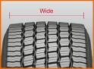
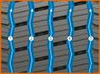

- Larger contact area
- Outstanding handling
- Excellent water drainage

2. 3D sipes, bars between the blocks and half-open shoulder design
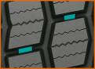
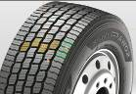
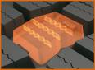

- Even tread wear
- High mileage
- High traction and outstanding handling properties

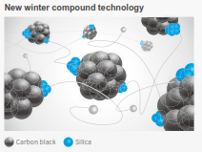
3. Innovative rubber compound

- The tread compound is tuned particularly to wintry conditions
and promotes a consistent performance and low rolling resistance,
even at cold temperatures.

Technical properties of the SmartControl DW07

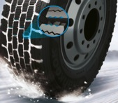
- Pentagonal block design for optimum grip on snow and ice

- Enlarged pentagonal blocks enable the load to be spread over the whole contact area for optimum winter performance.
- The serrated edges of the tread blocks generate optimum grip on wintry surfaces, high braking and traction performances.

- 3D sipe technology for driving stability and maximised traction on snow

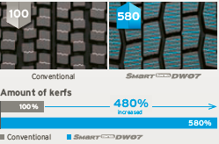
- Significantly larger numbers of 3D sipes for high snow grip and traction over the whole service life.
- Half-open shoulder design for improved traction and cornering on ice and snow-covered roads.

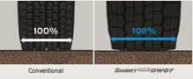
- Extra-wide tread design for optimised driving stability

- Wider shoulder blocks (+8% compared to the predecessor model) increase mileage by up to 13%.)
- Optimised block design for high traction.

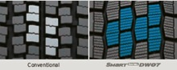

Technical properties of the SmartControl TW01

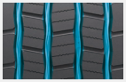
1. Zigzag grooves
- Four zigzag tread grooves guarantee excellent lateral guidance and ensure optimum water drainage.

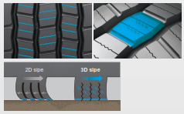

2. Multi-3D sipes
- The Multi-3D sipe tread ensures an outstanding braking performance.
- The stability of the tread blocks and the resulting minimum block movement lead to significant fuel savings.

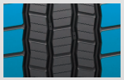
3. Wide shoulders
- The wide shoulders ensure excellent wet grip and driving stability.

4. Innovative rubber compound
- The tread compound is tuned particularly to wintry conditions and promotes a consistent performance and low rolling resistance even at cold temperatures.

About Hankook Tire

Hankook Tire is one of the global top 5 companies in the mass production of tyres and manufactures innovative, award winning radial tyres of proven superior quality for passenger cars, light trucks, SUVs, RVs, trucks and buses as well as motorsports (circuit racing/rallies).

Hankook continues to invest in research and development so that we can always offer our customers the highest level of quality, combined with technological excellence. At a total of five development centres and seven large scale factories around the world, the company develops and produces tyre solutions specially tailored to the requirements and needs of regional markets. Bespoke tyre solutions for the European markets as well as European Original Equipment according to the requirements of leading premium car manufacturers are developed in the company’s regional Technical Centre in Hanover/Germany. Production for the European region is taking place in the state-of-the-art manufacturing site in Rácalmás/Hungary which was inaugurated in June 2007 and is continuously being expanded. Currently more than 3,000 employees produce up to 19 million tyres a year for passenger cars, SUVs and light trucks.

Hankook Tire’s European headquarters are located in Neu-Isenburg near Frankfurt am Main in Germany. The manufacturer operates further branches in Germany, UK, France, Italy, Spain, the Netherlands, Hungary, Czech Republic, Russia, Turkey, Sweden and Poland. Hankook products are sold directly through regional distributors in other local markets. Hankook Tire employ more than 22,000 people worldwide and are selling their products in over 180 countries. Internationally leading car manufacturers rely on tyres made by Hankook for their original equipment. Approximately 30 percent of the company's global sales are generated within the European and CIS-Region.

For more information please visit www.hankooktire-mediacenter.com or www.hankooktire.com

Contact:

Hankook Tire Europe GmbH | Corporate Communications Europe/CIS | Siemensstr. 14, 63263 Neu-Isenburg | Germany
Anna Pasternak  PR Manager  Tel.: +49 (0) 6102 8149 – 173  a.pasternak@hankookreifen.de | Sabine Riedel  PR Manager  Tel.: +49 (0) 6102 8149 – 174  s.riedel@hankookreifen.de

