**Winter i\*cept RS²: Very good test results!**

**The Hankook Winter i\*cept RS² is “highly recommendable”, according to the editors of the Auto Zeitung in their current winter tyre test. The very good snow performance and an outstanding price-performance ratio of size 205/55 has once again impressed reviewers. Auto Bild emphasised; fuel-saving thanks to low rolling resistance as well as achieving high mileage, the Winter i\*cept RS² is economical and safe. Besides strong performance in the safety-related criteria in wet, snowy, and dry road conditions, the Winter i\*cept RS² beat 50 competitors in terms of mileage too and took the title of “Eco Master”.**

***Neu-Isenburg, Germany, 24. May 2017*** – “Aspects such as fuel efficiency and the sparing handling of resources are becoming increasingly important for tyre buyers, too,” explains Tony Lee, Hankook’s Vice President of Marketing and Sales for Europe. “Our current winter tread shows that these days modern, high-performance winter tyres can also meet customers’ requirements in terms of sustainability and environmental compatibility. We are extremely pleased with the independent test results and the related evaluations for our Hankook Winter i\*cept RS²“

Developed to deliver balanced performance in all wintery driving conditions, the Hankook Winter i\*cept RS² comes equipped with a special nano-sized, high dispersible silica compound, resistant to hardening in low temperatures, and a new solution-styrene butadiene rubber. The compound ensures the tread stays elastic even at very low temperatures, thus providing excellent traction and braking power by increasing the tyre’s contact area, in particular in the cool temperatures and wet roads typical during the colder seasons. The increased void volume of the tyre tread, designed using Hankook Aqua-Slant technology, is achieved through the highly effective interaction between two longitudinal wide grooves on the tread. This offers especially efficient water and slush displacement.

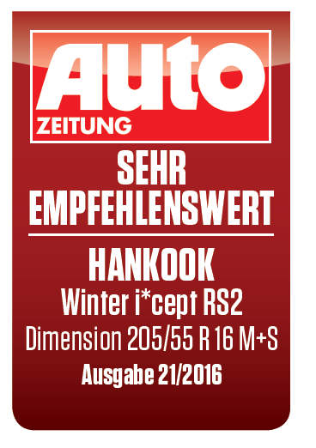

The directional V-shaped tread design of Hankook's Winter i\*cept RS² features 28% more pitches as well as increased groove and block edge length. Enhanced traction on snow covered surfaces is the result of the tread design which effectively bites into the snow. Moreover, the corrugated 3D sipes applied throughout the tyre tread increase traction and braking performance on all smooth surfaces. In addition they improve driving stability in wintery conditions by minimising block movement, abrasion and enhancing the overall handling performance through maximised edge effects. Special ice slits and grip claw 3D edges make for further improved



cornering performance and snow traction.

Further improvements to the structure of the i\*cept RS² have resulted in an even load distribution and a footprint increase of up to 5% compared to conventional products which has further enhanced the braking performance on both wet and dry roads. The stiffer sidewall and bead area of the tyre ensures more direct steering reactions and improved steering feedback and a more precise lateral stability on dry roads as well.

**Technical Characteristics of the Hankook Winter i\*cept RS²­­­­­­­:**

1. 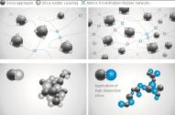*New high-dispersible nano silica ~~t~~read compound for improved winter performance*

* Improved wet traction, snow and ice performance.

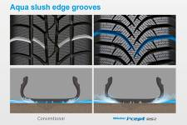

1. *Aqua slush edge grooves for improved wet performance*

* Water and slush are effectively drained away to reduce the risk of aquaplaning and improve wet braking performance.
* Significantly increased traction on snowy and slushy roads.

1. w320_F_kerf*3D sipes*

* Enhanced driving stability and improved winter performance through

minimised block movement.

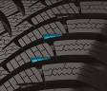

1. *Grip claw technology and increased pitch number for improved snow traction*

* 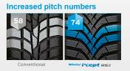3D sharp edges improve traction on snow covered roads.
* 28% increase of pitch sequence for high snow grip and increased traction

performance.

1. *Available sizes:*

* The Hankook Winter i\*cept RS² is available in 62 dimensions from 13 – 17 inches, in tread widths of 135 – 225 mm with aspect ratios from 45 – 80 series in speed indexes H and T.

\* Evaluations by Auto Bild no. 40 dated 2 October 2015, 50 tyre treads from all brands, tested on a VW Polo in size 185/60 R 15 T; award: Eco Master, and Auto Zeitung 21/16 13 tyre treads from various brands, tested on a VW Golf in size 205/55 R 16; result: “Highly recommended”.

###

**About Hankook Tire**

Hankook Tire is one of the global top 5 companies in the mass production of tyres and manufactures innovative, award winning radial tyres of proven superior quality for passenger cars, light trucks, SUVs, RVs, trucks, and buses as well as motorsports (circuit racing/rallies).

Aspiring to bring consumers the utmost excellence in product quality, technological excellence and driving satisfaction, Hankook Tire continuously invests in research and development maintaining five R&D centers and seven production facilities around the world. Bespoke tyre solutions for the European markets as well as European Original Equipment according to the requirements of leading premium car manufacturers, are developed in the company’s regional Technical Centre in Hanover/Germany. Production for the European region is taking place in the state-of-the-art manufacturing site in Rácalmás/Hungary which was inaugurated in June 2007 and is continuously being expanded. Currently more than 3,000 employees produce up to 19 million tyres a year for passenger cars, SUVs and light trucks.

Hankook Tire’s European headquarters are located in Neu-Isenburg near Frankfurt am Main in Germany. The manufacturer operates further branches in Germany, UK, France, Italy, Spain, the Netherlands, Hungary, Czech Republic, Russia, Turkey, Sweden and Poland. Hankook products are sold directly through regional distributors in other local markets. Hankook Tire employs more than 22,000 people worldwide and are selling their products in over 180 countries. Internationally leading car manufacturers rely on tyres made by Hankook for their original equipment. Approximately 30 percent of the company's global sales are generated within the European and CIS-Region.

For more information please visit [www.hankooktire-mediacenter.com](http://www.hankooktire-mediacenter.com/) or [www.hankooktire.com](http://www.hankooktire.com)

|  |  |  |  |
| --- | --- | --- | --- |
| **Contact:**  **Hankook Tire Europe GmbH |** Corporate Communications Europe/CIS **|** Siemensstr. 5a, 63263 Neu-Isenburg **|** Germany | | | |
| **Felix Kinzer**  Director  Tel.: +49 (0) 61 02 8149 – 170  [f.kinzer@hankookreifen.de](mailto:f.kinzer@hankookreifen.de) |  | **Larissa Büsch**  Public Relations  Tel.: +49 (0) 6102 8149 – 171  l.buesch@hankookreifen.de |  |