Hankook UHP Premium winter tyres:
- Optimised driving during the cold season
- Now also with Hankook SEALGUARD® technology
- Run-flat original equipment on premium vehicles

Hankook is currently applying further upgrades to its ultra high performance winter tyres for the coming season. The premium winter tyres of the i*cept evo family, which have been released in a number of sizes for up to 270 km/h, is rounded off with various new sizes for sporty cars and SUVs, run-flat sizes for premium original equipment and, for the first time, includes a SEALGUARD® version. The ultra high performance winter profiles i*cept evo, i*cept evo² and i*cept evo² SUV optimised for winter conditions in Central and Western Europe are provided with functional full-silica compounds and are already being fitted as original equipment on the new BMW 7 series. The asymmetric tread design used for all three versions ensures sporty yet comfortable handling on wet and dry roads as well as good traction and braking performance on snow-covered ground.

Neu-Isenburg, Germany, 2nd November 2016 – Premium tyre maker Hankook is continuing to expand the line-up of its current ultra high performance (UHP) winter tyre specialist. Developed in order to guarantee more safety with continued high performance and superior comfort through the increasing changeable weather conditions in the cold season, the winter tyres of the i*cept evo family have been tailored specifically for upper mid-range vehicles through to luxury saloons and sports cars. Furthermore, the Winter i*cept evo² is also available in an SUV version, which has been adapted to meet the special requirements of the popular Sports Utility Vehicle category with its double-layer carcass.

In addition, the Hankook SEALGUARD® technology is being used for the first time in a number of sizes for the 2016 winter season, e.g. for the VW models Passat and Touran. The special SEALGUARD® sealing material seals punctures up to a diameter of 5 mm in the area of the tyre tread.
Therefore journeys can be continued with no problems even in the case of damage caused by puncture. Additionally vehicles that are equipped with self-sealing tyres no longer need to carry spare tyres.
This makes more space available in the vehicle, saves weight and eliminates inconvenient wheel changing at the side of the road. In addition to their safety advantages, products equipped with Hankook SEALGUARD® technology offer particularly comfortable driving pleasure, as the tyres essentially have the same structure as the models without this technology.

Hankook Winter i*cept evo tyres are also available in various dimensions as run-flat versions with reinforced sidewall for many BMW vehicles amongst others. Thus the Hankook Winter i*cept evo in the size 245/50 R18 HRS (Hankook Runflat System) has been fitted as original equipment to the BMW 7 series.

Snow, ice, frost, heavy rain or wet leaves often produce dangerous road conditions in winter. The Hankook winter profiles i*cept evo, i*cept evo² and i*cept evo² SUV are therefore meeting these challenges with maximum-grip tread compounds and optimised design functions. Among other things, a highly dispersible nano-silica compound is used, which prevents hardening of the tyre at low temperatures and thus ensures better grip on wintry and wet roads through greater elasticity of the tyre contact area. The contact area of the tyre has been further improved thanks to further optimisation of the tyre profile, which likewise has a positive effect on grip in snow and rain and moreover ensures improved hydroplaning performance.

The outside of the traditionally asymmetric profile of the Hankook UHP profiles ensures improved snow handling and increased traction performance, whilst the inside guarantees optimised braking performance on snow, slush and wet roads. The snow traction performance is aided by an increased number of profile block edges, which effectively “grip” into the snow. By minimising block movement and wear, specially developed 3D sipes applied to the entire tread area ensure additional driving stability as well as improving the general handling properties with the aid of maximised edge effects. The transverse profiling arranged at an optimised angle on the inside of the profile likewise improves performance on snow-covered roads.

The two wide main drainage grooves offer 30 % greater volume for particularly efficient drainage of water or snow slush. With the Hankook Winter i*cept evo², they aid grip in the snow and hydroplaning performance for a safer driving experience on wet and slushy roads. In conjunction with the wide design of the tyre shoulder and the optimised cubic block design, a reinforced sidewall and bead area ensure direct steering response as well as improved cornering grip and optimised handling performance on dry roads too.

Both the Hankook winter tyre models i*cept evo, i*cept evo² and i*cept evo² SUV as well as the Hankook SEALGUARD® system are manufactured predominantly in the modern European production plants of Hankook in Hungary. The various i*cept evo versions are available in a total of 155 different dimensions for upper mid-range vehicles through to luxury saloons, sports cars and all popular SUVs.

The Hankook Winter i*cept evo is supplied in 25 dimensions from 15 - 18 inches with tread widths of 185 - 265 mm and aspect ratios of 70 - 45 in the speed indices H and V, some with HRS (Hankook Runflat System) as sidewall-reinforced run-flat tyres suitable for many BMW models.

The Hankook Winter i*cept evo² is available in a total of 87 sizes from 15 - 20 inches with tread widths of 195 - 295 mm and aspect ratios of 60 - 30 in the speed indices H, V and W, mainly as designs with increased load capacity (Extra-Load ‒ XL). The Hankook SEALGUARD® technology is being offered for the winter season 2016 initially for the tread Winter i*cept evo² in the sizes 215/60 R 16 H and 215/55 R 17 V for the Volkswagen models Passat and Touran amongst others.

The Hankook Winter i*cept evo² SUV is available in 37 sizes from 16 – 21 inches with tread widths of 215 – 315 mm and aspect ratios of 70 – 35 in the speed indices T to W.

###

Technical properties of the Hankook premium winter treads
i*cept evo, i*cept evo² and i*cept evo² SUV

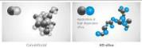
1. Highly dispersible nano-silica tread compound
- Improved traction in the wet,
better performance in ice and snow.

2. Dual-functional, asymmetric performance profile
- The outer tread with its compact shoulder profiling
offers improved handling performance on dry roads.
- The inner tread increases braking performance and traction
on wet and snowy roads.
- Particularly efficient water and slush displacement.

3. 3D sipes over the whole tread width
- Optimised driving stability in dry and wet conditions
and better winter performance due to minimised block movement.

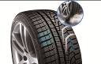

4. Ice pick shaped transverse grooves on the inside of the profile
- Improved snow traction
due to the optimised angle of the transverse grooves.

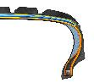

5. HRS (Hankook Runflat System) technology:
- Sidewall-reinforced tyres with run-flat properties.
- Available in different sizes including for many
BMW models in the i*cept evo profile.

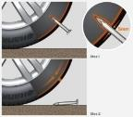
6. Hankook SEALGUARD® technology:
- The SEALGUARD® tyre contains a viscous material with which
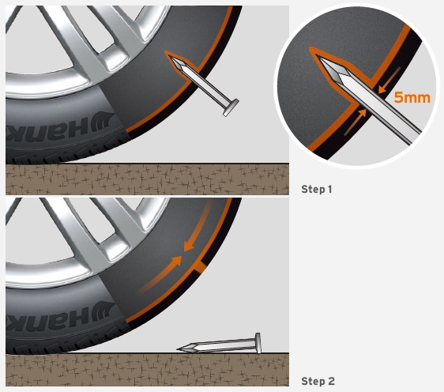the inside of the tyre is coated from shoulder to shoulder.
- In the event of a puncture, holes up to a diameter of
5 mm are sealed immediately by the Hankook SEALGUARD® technology
- Available in various sizes including for VW Passat and Touran
in the i*cept evo² profile

7. Double-layer carcass:
- Extremely even distribution of ground contact pressure leading to an ideal
tyre contact area.
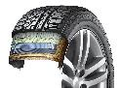
- Outstanding driving stability particularly on
high-performance, heavy vehicles
- Available in various dimensions especially for the
requirements of modern Sports Utility Vehicles
in the i*cept evo² SUV profile

About Hankook

Hankook Tire is one of the global top 5 companies in the mass production of tyres and manufactures innovative, award winning radial tyres of proven superior quality for passenger cars, light trucks, SUVs, RVs, trucks and buses as well as motorsports (circuit racing/rallies).

Aspiring to bring consumers the utmost excellence in product quality, technological excellence and driving satisfaction, Hankook Tire continuously invests in research and development maintaining five R&D centers and seven production facilities around the world. Bespoke tyre solutions for the European markets as well as European Original Equipment according to the requirements of leading premium car manufacturers are developed in the company’s regional Technical Centre in Hanover/Germany. Production for the European region is taking place in the state-of-the-art manufacturing site in Rácalmás/Hungary which was inaugurated in June 2007 and is continuously being expanded. Currently more than 3,000 employees produce up to 19 million tyres a year for passenger cars, SUVs and light trucks.

Hankook Tire’s European headquarters are located in Neu-Isenburg near Frankfurt am Main in Germany. The manufacturer operates further branches in Germany, UK, France, Italy, Spain, the Netherlands, Hungary, Czech Republic, Russia, Turkey, Sweden and Poland. Hankook products are sold directly through regional distributors in other local markets. Hankook Tire employ more than 22,000 people worldwide and sell their products in over 180 countries. Internationally leading car manufacturers rely on tyres made by Hankook for their original equipment. Approximately 30 percent of the company's global sales are generated within the European and CIS-Region.

For more information please visit www.hankooktire-mediacenter.com or www.hankooktire.com

Contact:

Hankook Tire Europe GmbH | Corporate Communications Europe/CIS | Siemensstr. 5a, 63263 Neu-Isenburg | Germany
Felix Kinzer  Director  Tel.: +49 (0) 61 02 8149 – 170  f.kinzer@hankookreifen.de | Larissa Büsch  Public Relations  Tel.: +49 (0) 6102 8149 – 171  l.buesch@hankookreifen.de

