

**Press Kit**

**Road Transport Expo**

**2022**



*https://www.hankooktire-mediacenter.com/roadtransportexpo-2022*

**Road Transport Expo 30 June – 2 July 2022**  
  
Preview Press Kit

**Content**

* **Preview:** Hankook Tyre UK exhibits at new Road Transport Expo
* **SmartFlex AH51/DH51:** Hankook deploys new material, design and tread   
  technologies to extend the premium status of the SmartFlex product range
* **Alphatread:** Hankook and Vaculug partner up for Hankook’s retreading business in UK and Ireland
* **Alphatread:** Hankook ‘alphatread’ for the UK market: Bead-to-bead retread truck tyre range
* **SmartFlex AH35/DH35:** All-year truck tyre for regional traffic
* **SmartFlex TH31:** The trailer allrounder
* **SmartWork DM09:** Tough & durable on & off-road performance
* **SmartCity AU04**+: First Hankook bus tyre specification for electromotive use
* **AU03+:** Reinforced the sidewalls of the bus tyre on all axle positions
* **Vantra LT:** Durable, powerful and fuel-efficient summer van tyre
* **Vantra ST AS2:** Hankook presents all-season tread for vans/light trucks

# **Hankook exhibiting at Road Transport Expo 2022**

* **Hankook Tyre UK is exhibiting at the new commercial vehicle industry event at NAEC Stoneleigh in Warwickshire**
* **Road Transport Expo takes place from 30 June – 2nd July**
* **Hankook will be presenting the latest SmartFlex AH51 and SmartFlexDH51 tyres alongside its comprehensive commercial tyre range**

***Stoneleigh, UK, 30 June 2022 -*** Hankook Tyre UK is showcasing its portfolio of commercial vehicle products including the new SmartFlex AH51 and SmartFlexDH51 tyres at the new Road Transport Expo trade show at the NAEC Stoneleigh in Warwickshire on Stand F4. HGVs will be at the very heart of this brand-new commercial vehicle trade show with more than 90 exhibitors from mainstream truck and trailer manufacturers and specialist heavy haulage vehicles to parts specialists and professional services. Alongside the exhibition will be a two-day programme of seminars, workshops and technical talks.

**The successful SmartFlex line covers a particularly wide range of applications**

In the development of the new SmartFlex AH51 and DH51 tyres, Hankook’s design engineers used the Hankook SmartLife concept, which particularly focuses on sustainability and the requirement for the products to always offer the highest possible performance from the first to the last millimetre of tread depth. Like all modern Hankook truck tyres, these two new treads can be regrooved thanks to the latest technologies and are of course retreadable. In addition, the Hankook SmartLife Premium casing, in combination with the Hankook Premium retreading, ensures an increase in tyre life of up to 250 percent and thus an even further increase in resource conservation and cost efficiency.

Compared to their predecessors, there has been a considerable increase in mileage performance for both new tyre patterns, 15 percent for the steering axle and 20 percent for the driving axle. Moreover, the 10 percent reduction in rolling resistance for the SmartFlex AH51 and DH51 contributes to a further reduction in fuel consumption when compared to the already well performing 31 series tyres. When looking at the CPK indicator (cost per kilometre), which is becoming increasingly important for the entire transportation industry, both new SmartFlex treads are able to support economical fleet operations in an increasingly sustainable manner.

Jon Cottrell, UK Truck Sales Manager for Hankook Tyre UK said, “As Hankook is viewed as the leader in the UK truck tyre replacement market, the Road Transport Expo 2022 is the ideal opportunity to present our extensive portfolio of new and retreaded commercial vehicle products. Alongside our existing innovative tyre solutions, we will be showcasing the new SmartFlex AH51 and DH51 series. This new range strengthens Hankook’s proven reputation for producing outstanding tyres with superb mileage and reliability, delivering excellent return on initial tyre investment. Hankook has a product range on display designed to meet the ever-increasing demands made on today’s professional commercial vehicle operator.”

He continues, “Don’t miss the opportunity to visit the Hankook team at the Road Transport Expo 2022. We will be on hand to offer advice on your tyre choice for your commercial vehicle operation. Fleet customers looking to maximise value for money in every area of their business have returned time and time again to Hankook.”

Hankook will be on Stand F4 - register for a free ticket at [www.roadtransportexpo.co.uk](http://www.roadtransportexpo.co.uk/)

**Hankook deploys new material, design and tread technologies to extend the premium status of the SmartFlex product range**

* **Debut of several Hankook premium tyre technologies**
* **Significant reduction in rolling resistance and CPK**
* **Improved mileage and wet performance**
* **Self-regenerating treads – performance in all conditions from first to last millimetres of wear**
* **SmartLife technology for up to 250% performance increase and longer service life**

Within its successful SmartFlex series, global leading tyre company Hankook has introduced new treads in the truck segment for regional up to long-distance traffic in Europe. The SmartFlex AH51 for the steering axle and the SmartFlex DH51 for the driving axle respectively offer 15 and 20% better mileage in comparison to the previous models. In addition to numerous other features from the Hankook SmartLife concept that include new technologies, such as self-regeneration of tread patterns, will be established within the Hankook truck tyre portfolio. The first six dimensions will be available in a selection of European markets starting November 2021.

As part of the Hankook truck tyre portfolio, the successful SmartFlex line covers a particularly wide range of applications, ranging from regional to local traffic distributions. The spectrum even extends to the long-haul transportation and construction site applications, if necessary. In addition, this will all be possible throughout the calendar year thanks to the 3PMSF certification. Premium tyre manufacturer Hankook is now further expanding its tyre portfolio within the successful SmartFlex line with two completely new treads: the SmartFlex AH51 for the steering axle and the SmartFlex DH51 for the driving axle.

Compared to their predecessors, there has been a considerable increase in mileage performance for both new tyre patterns, 15% for the steering axle and 20% for the driving axle. Moreover, the 10% reduction in rolling resistance for the SmartFlex AH51 and DH51 contributes to a further reduction in fuel consumption when compared to the already well-performing 31 series tyres. When looking at the CPK indicator (cost per kilometre), which is becoming increasingly important for the entire transportation industry, both new SmartFlex treads are able to support economical fleet operations in an increasingly sustainable manner.

“Hankook truck and bus tyres have long been in the premium category globally and have therefore been used for some time now by many well-known and leading vehicle manufacturers as original equipment worldwide,” says Sanghoon Lee, President of Hankook Tire Europe. “As a company, we place a high value on the sustainability of our products. Therefore, our newly developed smart treads fulfil our aspirations for ensuring sustainable and future-proof tyres, and of course also in conjunction with significantly increased customer benefits.”

In the development of both tyres, the company’s design engineers used the Hankook SmartLife concept, which particularly focuses on sustainability. The focus here is on the requirement for the products to always offer the highest possible performance from the first to the last millimetre of tread depth. Like all modern Hankook truck tyres, the two new treads can be regrooved thanks to the latest technologies and are of course retreadable. In addition, the Hankook SmartLife Premium casing, in combination with the Hankook Premium retreading, ensures an increase in tyre life of up to 250% and thus an even further increase in resource conservation and cost efficiency.

“As a premium tyre maker, the focus of our tyre development is always on premium quality and long service life. In addition, permanent operational safety and achieving the highest possible performance are also decisive criteria,” explains Guy Heywood, Marketing Director Truck & Bus Tyres at Hankook Tire Europe. “Intensive testing has shown that, compared to competitors in the premium category, both new SmartFlex products achieve significantly higher performance standards in the lifetime performance chapter, even when the tyres are two-thirds worn, for example in terms of braking distance on wet roads as well as grip and safety in a wide range of road conditions.”

The base compound of both patterns of AH51 and DH51 was consistently designed for efficiency. The increase in the proportion of low-damping materials contributes significantly to the reduction of principle viscoelastic power loss throughout the tread. Therefore, less energy is lost and fuel efficiency is improved. The sidewall compounds were also freshly developed for the new SmartFlex generation. Hankook developers have placed a considerable emphasis on significantly increased resistance to crack formation and material fatigue. Thus, the overall resistance of the SmartLife carcasses used on AH51 and DH51 has been further enhanced compared to the predecessor treads. The new DH51 tyre also has a distinct feature in its notch-tough tread compounds, where special high-performance resins improve the resistance and durability by increasing the molecular weight of the polymers used, thus contributing to an overall higher mileage performance.

The innovative Hankook mixing process IMS (Innovative Mixing System) ensures an even distribution of carbon black particles and rubber molecules within the compounds. In combination with the extension of the mixing times at lowered temperatures, a significant increase in the bonding rate between the carbon black and rubber molecules can thus be achieved. As a result, SmartFlex tyres generate less heat during operation.

The SCCT (Stiffness Control Contour Theory) design technology used in SmartFlex products ensures that the internal pressure distribution is as evenly balanced as possible depending on the application. This results in more stability and less movement in the tyre casing during use, which leads to high durability of the SmartLife carcasses and very good retreadibility. For both the belt plies and the carcass itself, the AH51 and DH51 each use special high-strength steel cord materials. Together with the SCCT contour, this results in a consistent contact patch for even wear, as well as improved traction and braking performance.

3D sipes with self-regenerating tread features incorporated into the AH51 and DH51 treads emerge after a degree of wear of between 40 and 70% in the tread pattern. The task of these “regenerating” grooves is to lock the tread blocks together in the rolling movement and thus ensure higher overall tread stability and thus resulting in extended mileage over the entire service life. They also make the tyre more robust and less susceptible to external influences, such as poor road surfaces. So-called “hidden grooves” appear from a wear level of around 70% and ensure continued high traction and wet grip even in wet conditions until the tread is completely worn out.

The wide tread blocks of the SmartFlex AH51, which can also be used as an all-position tyre, are equipped with additional supports (T.W.E.S. – Tread Wear Equalised Stepper) in the outer grooves and significantly increase the tread stiffness in conjunction with its broad tyre shoulder ribs. They ensure particularly even wear across the entire width of the tyre. This results in further improvements in mileage and rolling resistance. The SmartFlex DH51 has a wider contact patch than its predecessor, which increases traction while improving mileage and rolling resistance. Special sipes on the shoulder blocks, which naturally are under stress on drive axle tyres, help to reduce cracking even during peak loads. In addition, they support tread drainage to further increase traction performance.

###

*Available sizes of the SmartFlex AH51/DH51*

available from market launch in Germany, France, Great Britain, Italy, Spain, Netherlands, Austria and Switzerland:

|  |  |  |  |  |  |  |
| --- | --- | --- | --- | --- | --- | --- |
| **Profile** | **Size** | **LI/SS** | **EU label** |  | **M+S** | **Market launch** |
| **SmartFlex**  **AH51** | 315/70R22.5 * | 156/150L | C/B/A (72dB) | 🗹 | 🗹 | Nov 2021 |
| 315/80R22.5 | 156/150L  (154/150M) | C/B/A (72dB) | 🗹 | 🗹 | Nov 2021 |
| 385/65R22.5 20PR | 160K (158L) | B/B/A (70dB) | 🗹 | 🗹 | Nov 2021 |
| 385/65R22.5 24PR | 164K | B/B/A (70dB) | 🗹 | 🗹 | Nov 2021 |
| 315/60R22.5  P20* | 154/148L | C/B/A (72dB) | 🗹 | 🗹 | Nov 2021 |
| **SmartFlex DH51** | 315/70R22.5 * | 154/150L | D/B/B (76dB) | 🗹 | 🗹 | Dec 2021 |
| 315/80R22.5 | 156/150L  (154/150M) | D/B/B (76dB) | 🗹 | 🗹 | Feb 2022 |

* Size also available in Nordics, Hungary, Czech Republic and Poland.

Range will be progressively extended during 2022 in sizes and markets.

**Technical properties of the SmartFlex AH51 and SmartFlex DH51**

***Hankook premium tyre technologies***

***Hidden groove (AH51/DH51)***

* New gripping surfaces and water evacuation channels appear on the tyre tread in worn condition
* Ensure consistent traction and wet grip from the first to last millimetre of tread wear

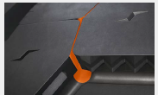SmartFlex AH51:

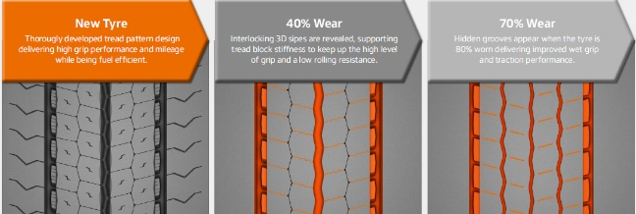

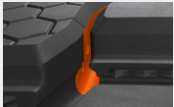SmartFlex DH51:

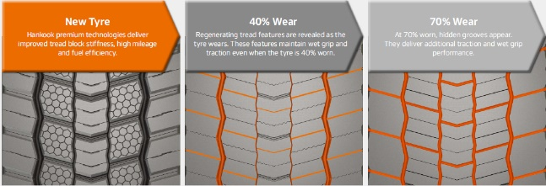

***Three-dimension sipe (AH51/DH51)***

* Zigzag interlocking sipes extending to the base of the tread reduce block movement in the tyre contact pattern
* Delivers high traction and braking performance throughout the whole tyre life
* Improved overall mileage

SmartFlex AH51:

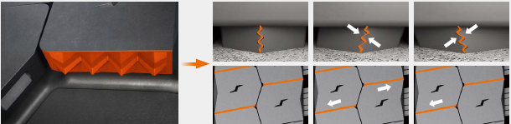

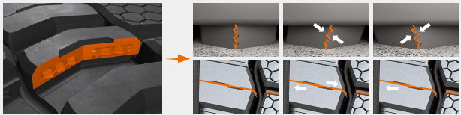SmartFlex DH51:

***Optimised tread-block size and Tread Wear Equalisation Step (T.W.E.S.), AH51***

* Delivers increased tread-block stiffness
* Ensures even wear across the entire width of the tyre
* Improves mileage and rolling resistance

Ein Bild, das Text, Tastatur enthält.

***Performance diagram (AH51)\****

* Premium materials, design and tread technologies deliver significant gains in tyre performance

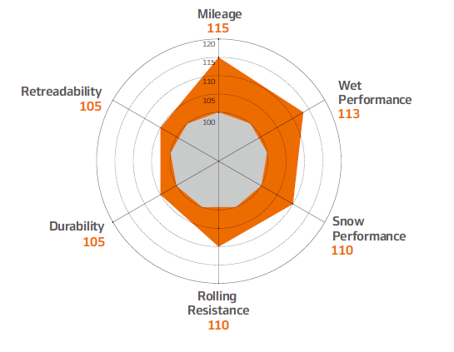

*compared to predecessors

***Wide tread block (DH51)***

* Increases tread width and reduced channels from five to four mean increased tyre contact area
* Improved traction performance
* Increased mileage, improved traction and reduced rolling resistance

Ein Bild, das Text, Tastatur, drinnen enthält.

***Horn-shaped self-regenerating sipes (DH51)***

* Full-depth sipes and regenerating tread groove
* Enhanced water evacuation and tread-block cooling
* Improved milage and traction

Ein Bild, das Text enthält.

***Performance diagram (DH51*)***

* Premium materials, designs and tread technologies deliver significant gains in tyre performances

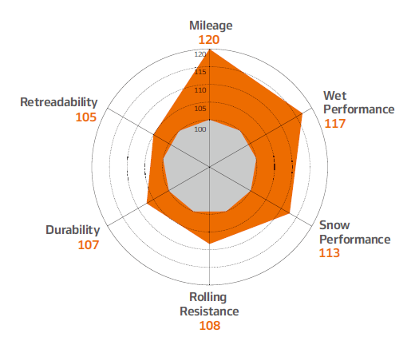

*compared to predecessors

***Test results: Comparison with worn tyre***

* Hankook premium tyre technologies deliver benchmark grip and safety in all conditions – from the first to last millimetre of tread.
* Shorter braking distance and safer driving

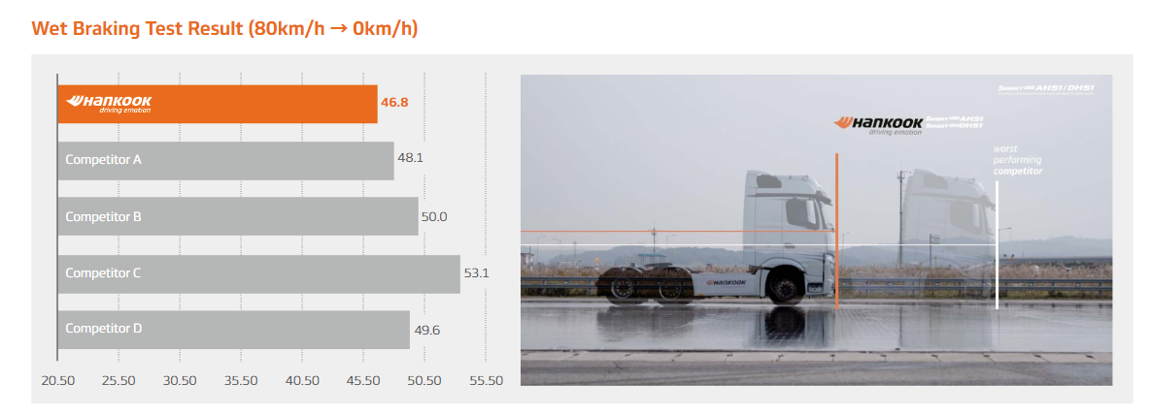

Tyre size: 315/70R22.5

Location: Korea automobile testing & research institute proving ground

Vehicle: Mercedes Benz Actros 25-ton tractor

80 km/h to 0 km/h – 5 mm tread depth remaining

# **Hankook and Vaculug partner up for Hankook’s retreading business in UK and Ireland**

* **Hankook’s Alphatread retread brand will be manufactured by Vaculug**
* **Five year contract ensures consistent supply and quality for Hankook’s customers**
* **Sustainable initiative to increase tyre life and avoid unnecessary waste**

Hankook continues to focus on its significant retreading business for commercial vehicle tyres by expanding its own retread brand “Hankook Alphatread”. Together with Vaculug, Hankook has signed a five-year agreement. Vaculug, one of Europe’s largest independent retread producers, will manufacture Hankook’s Alphatread retread brand in the UK. Vaculug will also work with Hankook product as a premium fitment for all its fleets.

“To offer our fleet and dealer partners a cost effective and ecological solution, Hankook continuously invests in its range and volumes of production of premium Alphatread hot-cured tyres. Our new partnership with Vaculug will support our mission to offer attractive and sustainable products. This new agreement also ensures maximum value for our fleet customers,” says Guy Heywood, Vice President Marketing Truck and Bus tyres, Hankook Tire Europe.

On behalf of Vaculug, Jorge Crespo, Managing Director, commented “We are very proud of our association with Hankook and look forward to growing this relationship to new heights. While this agreement is only for an initial period of five years, we as a family have had a relationship with Hankook that goes back over four decades. We look forward to building on that partnership where the next generation of both Vaculug and Hankook help the environment through more sustainable initiatives such as this one.”

The Hankook SmartLife Solutions concept demonstrates the advantages of a hot retread for fleet companies. All Hankook commercial vehicle tyres are designed in such a way that they can be regrooved, while the high-quality carcass can be retreaded several times. These features allow fleet companies to be able to achieve significant economic benefits: 5-9 mm of additional base rubber under the tread delivers up to 25% more mileage after regrooving. Hankook Alphatread hot retreads can deliver up to 100% of the mileage achieved with a new tyre and equivalent performance for around 60% of the cost. If the regrooving and retreading process is continued in line with the Hankook SmartLife Solutions concept, the service life of a new tyre can be increased to 250%. As well as these financial benefits, there are also various benefits for the environment. One of them is the fact that around 70% of the raw materials used in new tyres can be saved during retreading.

Hankook ‘alphatread’ for the UK market:  
Bead-to-bead retread truck tyre range

* **‘alphatread’ is the environmentally conscious bead to bead retread truck tyre range from premium tyre maker Hankook Tyre UK**
* **The ‘alphatread’ line-up designed for medium haul purposes consists of sizes for the drive axle position together with a corresponding trailer tyre size**
* **It aims to meet customer demands for reducing fleets running costs by providing a ‘cradle to grave’ tyre solution**

The ever-increasing demands in the area of environmental friendliness and continued pressure upon fleets to reduce their running costs have led to the development of the Hankook ‘alphatread’ range. The premium manufacturer’s retread truck tyre line has been specifically designed to maximise mileage as the casings of Hankook’s 1st life A1 grade tyres are used to mirror Hankook’s existing tyre patterns to produce the alphatread tyre. For the time being the products are available in the UK market in two drive axle sizes and a corresponding trailer size.

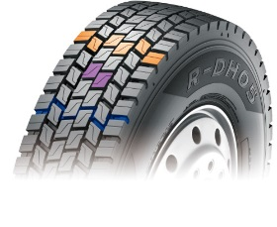The Hankook alphatread R-DH05 is a drive axle tyre for medium haul, available in three sizes 295/80R22.5, 315/80R22.5 and now the 315/70 R22.5. With its wide outline and a unique compound, the R-DH05 provides excellent wet and dry performance, driving stability and long-lasting wear. While the extra wide tread and deep grooves ensure high mileage, the optimised block shape provides block rigidity also under heavy loads for an outstanding traction and tread stability. Its lateral oriented tread design with high density grooves help to provide excellent traction in all weather conditions.

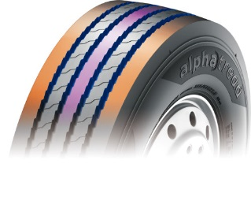The Hankook alphatread R-TH22 sized 385/65R22.5 is the corresponding trailer tyre for medium haul purposes. It provides a 5 rib tread design and a so called cool running compound for optimum performance. Optimised zigzag grooves care for stone ejection and crack prevention. The wide, solid shoulder area provides a higher mileage and helps to prevent belt separation. Its massive kerfless centre rib enhances free-rolling on axle thus increasing the trailer’s riding stability.

Hankook’s alphatread tyres contribute to the environment by using significantly less raw material as well as energy during manufacturing.

**Current sizes of the Hankook alphatread line-up:**

|  |  |  |  |  |  |  |
| --- | --- | --- | --- | --- | --- | --- |
| **Tread** | **Size** | **LI** | **Regrooving depth** | **Snow flake** | **M+S** | **Availability** |
| **R-DH05** | 295/80R22.5 | 152/148K | 3.0 mm |  | 🗹 | 🗹 |
| 315/80R22.5 | 154/150K | 3.0 mm |  | 🗹 | 🗹 |
| 315/70R22.5 | 154/150K | 3.0 mm |  | 🗹 | 🗹 |
| **R-TH22** | 385/65R22.5 | 160J | 3.0 mm |  |  | 🗹 |
| **R-TH31** | 385/65R22.5 | 160K | 3.0 mm | 🗹 | 🗹 | From Q3 2022 |

**Hankook's all-year truck tyres SmartFlex AH35 and SmartFlex DH35 for regional traffic**

* **With the steering axle tyre SmartFlex AH35 and the drive axle tyre SmartFlex DH35, premium tyre maker Hankook has an all-year truck tyre for regional traffic**
* **The all-year tyres, winners of the Red Dot Design Award in 2016, have particularly high traction on account of special Multi-3D sipes**

With the SmartFlex AH35 and SmartFlex DH35, fleets and forwarding agents benefit from a low-fuel, high-mileage and high-traction all-year tyre solution for the steering and drive axles. It is also possible to fit SmartFlex AH35 to all axles. In 2016, they were presented with the Red Dot Design Award. Whilst the SmartFlex AH31 and SmartFlex DH31 are intended mainly for larger wheel sizes such as 22.5 inch, the SmartFlex AH35 and its counterpart SmartFlex DH35 for the drive axle are designated to the smaller 17.5/19.5 inch sizes.

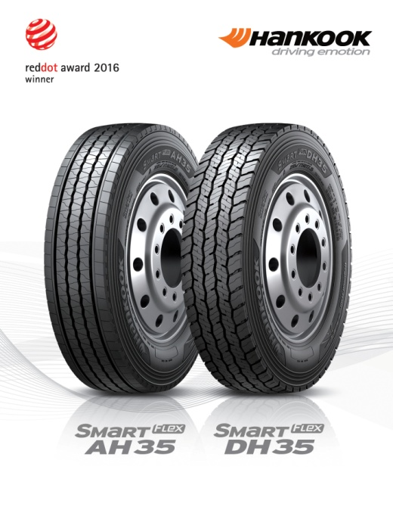The Multi-3D sipes anchored in the tread of the SmartFlex AH35 guarantee outstanding traction. The mixture of straight and wave-shaped grooves improves water drainage and prevents hydroplaning long-term. Without losing sight of the summer properties, the M+S marking and the 3PMFS symbol (snowflake) indicate that the tyre is also perfectly equipped for all wintry weather conditions such as slush, ice and snow. The rigidity of the tread blocks promotes particularly fuel-efficient driving. Equally, the special tread design supports even tyre wear so that the Total Cost of Ownership for fleet and forwarding agent companies can be reduced long term in terms of service life. The high mileage and performance of the tyre are guaranteed by a wide contact area.

Just like the steering axle tyre, the drive axle tyre SmartFlex DH35 has M+S marking and the snowflake symbol. In addition, the tyre also has a wide contact area with four zigzag groove lines over the whole tread surface, enhancing mileage and driving performance under different road and traffic conditions. Furthermore, the 3D sipes ensure high traction and low rolling resistance. The innovative tread sipe design supports low rolling resistance and tyre traction for the drive axle in road traffic.

###

*Available sizes of the SmartFlex AH35/DH35:*

|  |  |  |  |  |  |  |
| --- | --- | --- | --- | --- | --- | --- |
| **Tread** | **Size** | **LI** | **Marking** |  | **M+S** | **Availability** |
| **AH35** | 8.5R17.5 | 121/120L | D/C/W1 67dB | 🗹 | 🗹 | 🗹 |
| 9.5.R17.5 | 129/127L | D/C/W1 67dB | 🗹 | 🗹 | 🗹 |
| 8R19.5 | 117/116L | D/C/W1 71dB | 🗹 | 🗹 | 🗹 |
| 205/75R17.5 | 124/122M | D/C/W1 65dB | 🗹 | 🗹 | 🗹 |
| 215/75R17.5. | 126/124M | D/C/W1 65dB | 🗹 | 🗹 | 🗹 |
| 215/75R17.5. | 128/126M | D/C/W1 65dB | 🗹 | 🗹 | 🗹 |
| 225/75R17.5 | 129/127M | C/C/W1 67dB | 🗹 | 🗹 | 🗹 |
| 235/75R17.5 | 132/130M | C/C/W1 67dB | 🗹 | 🗹 | 🗹 |
| 245/70R17.5 | 136/134M | C/C/W1 67dB | 🗹 | 🗹 | 🗹 |
| 245/70R19.5 | 136/134M | C/C/W1 67dB | 🗹 | 🗹 | 🗹 |
| 265/70R17.5 | 140/138M | C/C/W1 67dB | 🗹 | 🗹 | 🗹 |
| 265/70R19.5 | 140/138M | C/C/W1 67dB | 🗹 | 🗹 | 🗹 |
| 285/70R19.5 | 146/144M | C/C/W1 67dB | 🗹 | 🗹 | 🗹 |
|  | 305/70R19.5 | 148/145M | C/C/W1 71dB | 🗹 | 🗹 | 🗹 |
| **DH 35** | 205/75R17.5 | 124/122M | D/C/W1 66dB | 🗹 | 🗹 | 🗹 |
| 215/75R17.5 | 126/124M | D/C/W1 66dB | 🗹 | 🗹 | 🗹 |
| 225/75R17.5 | 129/127M | D/C/W1 73dB | 🗹 | 🗹 | 🗹 |
| 235/75R17.5 | 132/130M | D/C/W1 73dB | 🗹 | 🗹 | 🗹 |
| 245/70R17.5 | 136/134M | D/C/W1 73dB | 🗹 | 🗹 | 🗹 |
| 8.5R17.5 | 121/120L | D/C/W1 73dB | 🗹 | 🗹 | 🗹 |
| 9.5R17.5 | 129/127L | D/C/W1 73dB | 🗹 | 🗹 | 🗹 |
| 8R17.5 | 117/116L | D/C/W1 73dB | 🗹 | 🗹 | 🗹 |
| 245/70R19.5 | 136/134M | D/C/W1 73dB | 🗹 | 🗹 | 🗹 |
| 265/70R17.5 | 140/138M | D/C/W1 73dB | 🗹 | 🗹 | 🗹 |
| 265/70R19.5 | 140/138M | D/C/W1 73dB | 🗹 | 🗹 | 🗹 |
| 285/70R19.5 | 146/144M | D/C/W1 73dB | 🗹 | 🗹 | 🗹 |
| 305/70R19.5 | 148/145M | D/C/W1 73dB | 🗹 | 🗹 | 🗹 |

**Technical properties of the SmartFlex AH35**

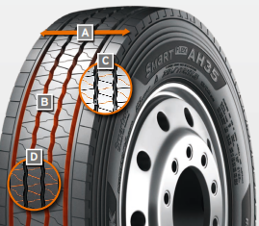

1. ***Wide contact area:***

* The wide contact area guarantees high mileage.

1. ***Four wave-shaped and straight grooves:***

* The combination of four wave-shaped and straight grooves over the whole tread surface on a wide range of different road surfaces guarantees excellent water drainage

1. ***Multi-3D sipe tread:***

* The Multi-3D sipe tread offers outstanding traction and thus promotes improved driving stability.
* The rigidity of the tread blocks and the resulting minimum block movement lead to significant fuel savings.

1. ***Special tread design with “semi-sipes”:***

* Special tread design with “semi sipes” guarantees an even wear pattern over the entire service life

*Wide contact area*

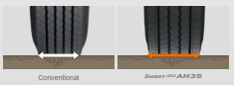

*Multi-3D sipes*

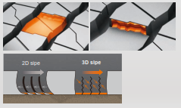

**Technical properties of the SmartFlex DH35**

1. 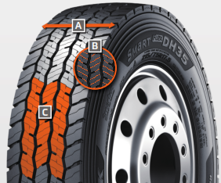***Wide contact area with 4 zigzag grooves:***

* The wide contact area and the 4 all-round zigzag tread grooves ensure high mileage and overall performance.

1. ***Multi-3D sipes:***

* The special tread design with Multi-3D sipes promotes low rolling resistance and outstanding traction.

1. ***Innovative tread design:***

* The special tread design guarantees low rolling resistance and optimum traction under a wide range of different conditions.

**SmartFlex TH31:** **The trailer allrounder**

* **Particularly in changeable weather conditions, Hankook recommends that truck and bus customers use the SmartFlex all-weather tyre line for medium and long haul trips**
* **Commercial vehicle customers can rely in particular on a high level of driving safety as well as the current trend of increased load-bearing capacity for some sizes**

The SmartFlex all-weather tyre line is completed by the corresponding trailer tyre SmartFlex TH31. Its wide, closed shoulder area supports stable straight driving and ensure good lateral stability. Chamfered tread grooves help prevent splintering. Within its successful SmartFlex series, global leading tyre company Hankook has introduced new treads in the truck segment for regional up to long-distance traffic in Europe. The SmartFlex AH51 for the steering axle and the SmartFlex DH51 for the driving axle respectively offer 15 and 20% better mileage in comparison to the previous models. In addition to numerous other features from the Hankook SmartLife concept that include new technologies, such as self-regeneration of tread patterns, will be established within the Hankook truck tyre portfolio.

Whilst the SmartFlex AH51 and SmartFlex DH51 are intended mainly for larger wheel sizes such as 22.5 inch, the SmartFlex AH35 and its counterpart SmartFlex DH35 for the drive axle are designated to the smaller 17.5/19.5 inch sizes.

***Sizes of the SmartFlex tyre line available***

|  |  |  |  |  |  |  |  |
| --- | --- | --- | --- | --- | --- | --- | --- |
| **Tread** | **Size** | **LI** | **Marking** |  | **M+S** | **Availability** | **Remark** |
| **TH31** | 385/65R22.5 | 160K | B/B/W1 69 dB | 🗹 | 🗹 | 🗹 | - |
| 435/50R19.5 | 160J | B/B/W2 73 dB | - | 🗹 | 🗹 | - |
| 455/40R22.5 | 160J | B/B/W1 70 dB | - | - | In production | - |
| 11R22.5 | 148/145J | C/C/W1 70 dB | - | 🗹 | 🗹 | - |
| 275/70R22.5 | 152/148J | C/C/W1 69 dB | - | 🗹 | 🗹 | - |
| 385/55R22.5 | 160K (158L) | B/C/W2 73 dB | 🗹 | 🗹 | 🗹 | - |
| 205/65R17.5 | 129/127J | C/BW1 70 dB | 🗹 | 🗹 | 🗹 | - |
| 215/75R17.5 | 135/133K | C/B/W1 69dB | 🗹 | 🗹 | 🗹 | - |
| 235/75R17.5 | 143/141K | C/B/W1 70 dB | 🗹 | 🗹 | 🗹 | - |
| 245/70R17.5 | 143/141K | C/B/W1 70 dB | 🗹 | 🗹 | 🗹 | - |
| 245/70R19.5 | 141/140J | C/C/W1 69 dB | 🗹 | 🗹 | 🗹 | - |
| 265/70R19.5 | 143/141J | C/C/W1 69 dB | 🗹 | 🗹 | 🗹 | - |
| 9.5R17.5 | 143/141J | C/B/W1 69 dB | 🗹 | 🗹 | 🗹 | - |

**Technical properties of the Hankook SmartFlex all-year tyre line**

**SmartFlex TH 31**

***Truck all-year tyres for the trailer axle for medium to long-haul applications***

1. ***4 zigzag sipes***

* 4 main tread grooves ensure optimum water displacement

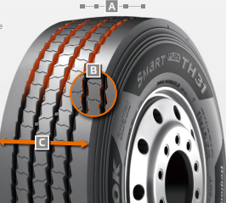

1. ***Chamfered profile block design***

* Chamfered profile blocks sipes help to prevent material splintering

1. ***Extra-wide tread and shoulder area***

* The extra-wide closed shoulder area supports high driving stability and ensures good lateral stability as well as even wear

###

# **Hankook SmartWork DM09: Tough & durable on & off-road performance**

* **The SmartWork DM09 is a commercial vehicle tyre for demanding tasks in the on & off-road segment**
* **This directional drive axle tyre is optimised for heavy loads and high stress and is distinguished by increased resilience against splintering, cuts and tread breaks**
* **The SmartWork DM09 with M+S identification is available in sizes 295/80R22.5 and 315/80R22.5**

High traction even on muddy surfaces: The DM09 has a tread surface that is 5% wider than the previous model. The extra-wide, directional tread design enables improved displacement of mud and water while maintaining an increased ground contact area. The tyre thereby proves itself in difficult terrain thanks to its excellent cross-country mobility and also provides exceptional mileage and grip on dry and wet roads.

Optimised tyre tread for resilience and durability: Thanks to a special block design with a reinforced central bar, the force effect is distributed more evenly during use, the wear characteristics are more consistent and uneven wear out is minimised. Conically designed tread blocks on the outside of the tread surface increase resistance to lateral strains and effectively help prevent damage to the tyre's shoulder or tearing of the block edges. The tread, which is designed to be open right up to the tyre shoulder, also increases the self-cleaning properties.

Mileage and fuel efficiency for operating efficiency - even under intense stress: The innovative Hankook mixing method IMS (Innovative Mixing System) ensures a particularly even distribution of carbon black particles and rubber molecules within the mixtures. Together with longer mixing times at lower temperatures, a significant increase of the bonding rate between the carbon black and rubber molecules can be achieved. As a result, the DM09 generates less heat during the drive, which has a positive effect on the rolling resistance and thereby on fuel consumption as well.

Durable with improved retreadibility properties: The Hankook SCCT technology (Stiffness Control Contour Theory) enables even distribution of tyre pressure even under severe loads. This way the deformation strain that affects the carcass is minimised. This not only positively influences the longevity of the tyre but also performance features like turning and braking characteristics as well as the retreadibility of the DM09.

As a package, the design and technology features of the DM09 turn drive axle tyres into a smart work horse that can do the job right - efficiently, safely and reliably.

###

**Technical characteristics of the Hankook SmartWork DM09:**

*1. Hankook SCCT Technology (Stiffness Control Contour Theory):*

- The even distribution of internal tyre pressure under heavy loads effectively minimises the deformation of the carcass, resulting in improved reconditioning properties, improved performance, optimised braking ability, and a generally higher durability.

*2. Optimised tyre profile:*

- Block design with reinforced central rib for a more even distribution of the forces acting on the tyre

- More uniform abrasion pattern and minimisation of uneven wear.

- High level of grip on loose surfaces and very good self-cleaning properties thanks to the open tyre shoulder design.

- Conical design of the tread blocks on the outer tread area for increased resistance to lateral loads and protection of the block edges in the shoulder area.

*3. Hankook Innovative Mixing System:*

- Particularly homogeneous distribution of soot particles and rubber molecules within the mixtures through longer mixing times at lower temperatures.

- The significantly higher bonding rate between soot and rubber molecules results in lower heat

**First Hankook bus tyre specification**

**for electromotive use**

* **Hankook is presenting the SmartCity AU04+, its first tyre specification for electric buses**
* **To keep battery energy loss to a minimum, the SmartCity AU04+ also stands out on account of its very low rolling resistance**
* **The tread of the AU04+, which has been designed as an all-year tyre, is suitable for all wintry conditions without restriction and bears the snowflake symbol (3PMSF)**

Hankook is expanding its tyre portfolio in the urban/city bus sector and is supplying a city bus tyre in the size 315/60 R 22.5, optimised for electromotive use. The SmartCity AU04+ stands out in particular due to its very low rolling resistance which helps to ease the strain on the energy storage units of electric-powered urban buses. On account of the increased vehicle weight resulting from the battery weight, the tyre not only has a stable carcass but also an increased load capacity of 154/148J (156/152F) which corresponds to a weight of 8 tonnes per axle. The standard load bearing capacity is usually 7 tonnes per axle for this size.

During development of the bus tyre, special attention was paid to a high traction and braking performance, particularly on wet road surfaces. Klaus Krause, head of the European Research and Development Centre, explains: “Unlike conventional combustion engines, an electric motor is able to deliver the full torque immediately. This means the vehicle and the tyres respond faster to speed or the changing road conditions. Consequently, more demands are made on tyres for electric-powered vehicles. The high grip level avoids irregular tyre wear without having to do without optimum mileage.”

The high mileage is guaranteed by the optimised zigzag grooves which ensure higher block rigidity thanks to their modified layout, among other things. The constant starting and stopping in city traffic puts a heavy and irregular load on bus tyres. “For this reason, we have adapted the shoulder width and design for the SmartCity AU04+ to the increased requirements, thus guaranteeing more even wear. The improved molecular structure of the new tread compound makes the tyre much more heat-resistant and is a further contributing factor to a longer service life,” Dipl.-Ing. Klaus Krause adds.

Completely in line with the safety aspect, the SmartCity AU04+ also has a further reinforced sidewall. This protects the tyre from damage following the often-unavoidable contact with the curb in city traffic: “The reinforced sidewall is particularly important for the protection of electric bus tyres, since they accelerate much more quickly on account of the system and also build up a more aggressive contact to curb stones” Klaus Krause explains.

###

*Available sizes of the AU04+*

|  |  |  |  |  |  |  |
| --- | --- | --- | --- | --- | --- | --- |
| **Tread** | **Size** | **LI** | **Marking** | **Snowflake** | **M+S** | **Availability** |
| **AU04+** | 315/60R22.5 | 154/148J (156/152F) | C/B/W1/73dB | 🗹 | 🗹 | 🗹 |
| **AU04+** | 275/70R22.5 | 150/148J  (152/148F) | D/B/W1/67 dB | 🗹 | 🗹 | Phase out end 2022 |
| **AU04+** | 275/70R22.5 | 152/149J | D/B/W1/67 dB | 🗹 | 🗹 | From May 2022 |

**Technical properties of the AU04+**

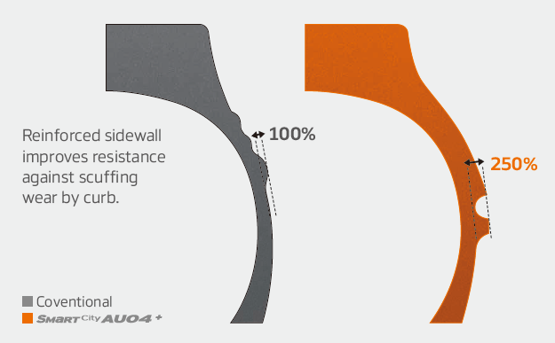

***Wide shoulders and reinforced sidewalls***

* Wide shoulders and reinforced sidewalls ensure   
  excellent wet grip and driving stability
* New shape and position of the sidewall indicator   
  makes determining the tyre condition easier

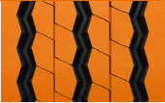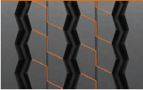***Improved tread design***

* Stabilising 3D tread blocks guarantee improved traction
* Higher mileage through optimised rib spacing
* 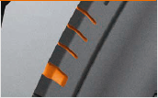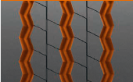Three zigzag grooves guarantee excellent traction, particularly

in the wet

* Adapted shoulder width and removed lugs and ribs ensure more   
  even wear

***Innovative rubber compound***

* Improved chemical structure makes the tyre more heat-resistant

**For even more safety: Hankook reinforced the sidewalls of the bus tyre AU03+ on all axle positions**

* **Hankook’s bus tyre AU03+ was developed particularly with the requirements of stop-and-go traffic in mind, and is especially suitable for use on regular city bus services**
* **The all-year tyre provides an optimum profile especially suitable for city traffic and urban roads and is designed with a high level of safety in mind, whilst being economic and environmentally friendly at the same time**

The sidewalls have been reinforced to guarantee even safer and more efficient use in city traffic, with an even wider and deeper sidewall indicator being incorporated at the same time. The AU03+ is available in size 275/70R22.5 and with M+S marking and the 3PMSF (3 Peak Mountain Snowflake) symbol. In addition to the AU03 +, the AU03 is available in 11R22.5, 275/80R22.5, 245/70R19.5 ,265 / 70R19.5 and 275/70R22.5

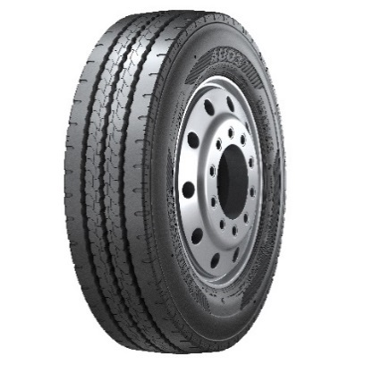

Safety is a fundamental factor that Hankook considers for each of its products. That’s why safety performance with short braking distances and superior wet performance is also a key component of the AU03+. Furthermore, the reinforced sidewall protects the tyre from damages including stone chips and curb contacts.

The profile of Hankook’s AU03+ guarantees excellent traction which is supported through an optimised kerf arrangement without leaving mileage behind.

*Sizes of the AU03+ / AU03 available:*

|  |  |  |  |  |  |  |
| --- | --- | --- | --- | --- | --- | --- |
| **Tread** | **Size** | **LI** | **Marking** | **Snowflake** | **M+S** | **Availability** |
| **AU03+** | 275/70R22.5 | 150/145J  (152/148) | D/C/W1/71dB | 🗹 | 🗹 | 🗹 |
| **AU03** | 245/70R19.5 | 136/134L | D/C W1 71 dB | 🗹 | 🗹 | 🗹 |
| 265/70R19.5 | 140/138M | D/C W1 71 dB | 🗹 | 🗹 | 🗹 |

**###**

**Technical features of the AU03+:**

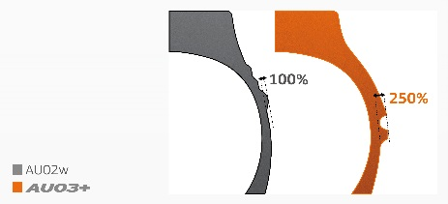***Wide shoulders and reinforced sidewalls***

* The wide shoulder and reinforced sidewalls ensure excellent wet grip, dry grip and driving stability.

***Horizontal kerfs and deep sipes***

* Kerfs incorporated horizontally in the cap rib and a tread with deep sipes guarantee outstanding traction and mileage performance.

***Zigzag grooves***

* Three zigzag tread grooves guarantee excellent lateral guidance and ensure optimum water drainage.

**Hankook light truck tyre Vantra LT:**

**Durable, powerful and fuel-efficient**

* **Hankook presents a modern summer tyre for minibuses, transporters and light trucks with the Vantra LT**
* **The innovative design ensures up to 13% higher fuel efficiency with 12% higher mileage at the same time**

The Hankook Vantra LT is a summer tyre variant for transporters and vans. The light truck tyre was developed in view of the high demands that are placed on passenger and goods transport vehicles in regional traffic. The engineers focused on maximising the mileage, coupled with optimised fuel efficiency by minimising energy losses while driving, for an overall high level of economy. Thanks to many innovative design features, the new Hankook Vantra LT offers not only robustness, mileage and fuel efficiency, but also excellent braking and wet weather performance. It is now available in 49 dimensions.

Frequent use in start/stop traffic can place additional demands on tyres. In commercial passenger and goods transport, the overall cost-effectiveness, i.e. mileage, resistance to external influences and fuel efficiency are the focus of the purchasing decision. At the same time, safety-relevant tyre properties such as wet braking behaviour and track stability must not be neglected. The Hankook Vantra LT offers a variety of new technologies such as the sidewall shield as well as optimised tread block arrangement and structure ("Durable Contact Patch Technology") for improved driving characteristics and safety even at high speeds, in addition to reduced tread wear. The mileage potential of the tyre could therefore be increased by up to 12% compared to its predecessor.

Furthermore, three wide centre grooves in combination with newly developed 3D transverse grooves ensure faster water displacement and significantly reduce the risk of aquaplaning. The innovative tread pattern also guarantees excellent wet braking characteristics while ensuring high traction even in wet conditions and low temperatures. The new and more angular tread of the Vantra LT allows an improved arrangement of the tread grooves. This is particularly beneficial for the stability in the area of the outer tread ribs. In combination with the innovative double steel belt structure of the Vantra LT, a very even ground pressure distribution was achieved. As a result, the Vantra LT delivers significantly increased driving and tracking stability even at higher speeds and loads. In addition, the lower deformation of the tyre reduces rolling resistance, improving the tyre's fuel efficiency by up to 13%.

###

**Technical properties of the Vantra LT**

1. **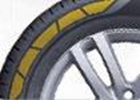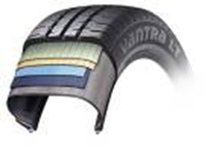*Optimised tyre structure for longer service life and greater safety***

* The double belt structure guarantees consistent performance thanks to the high-strength belt bandages.
* Special core rider for an improved rim seat for optimised driving characteristics.
* Sidewall protector for the prevention of sidewall damage.

1. ***Improved driving characteristics and wet grip***

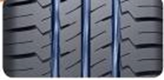

* Three wide circumferential main drainage grooves and 3D transverse grooves for 14% improved aquaplaning performance over conventional treads.
* Innovative tread pattern for high traction and braking performance even in wet, cold weather.

1. ***Improved fuel efficiency & higher mileage***

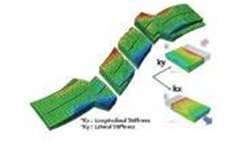

* Up to 12% improved abrasion behaviour due to innovative tread structure and mixing technology.
* Optimised carcass tread for up to 13% more fuel efficiency by minimising energy losses while driving.

1. ***Increased robustness & driving stability***

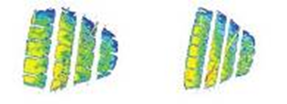

* Angular tread pattern with improved tread groove arrangement for increased stability in the area of the outer tread ribs for increased driving and tracking stability even at higher speeds and loads.

1. ***Available sizes***

* The Vantra LT is available in 49 dimensions in sizes from 12 to 17 inches in the 82 to 60 series and in tread widths from 155 to 235, and is consistently marked with the M+S identifier.

**Hankook presents all-season tread for vans/light trucks**

* **Tyre maker Hankook has expanded its portfolio, adding the Vantra ST AS 2, an all-season to meet the increased demand in this segment in the UK market**

Premium tyre maker Hankook presents the Vantra ST AS 2, an all-season tyre with the 3PMSF symbol. The Vantra ST AS 2 shows its strengths particularly on road surfaces common in urban areas during the cold season and, with its specially developed "Ice-Philic-Technology", ensures increased grip even at lower temperatures.

The tyre structures provide impressive endurance and durability, as well as a wide contact area and long sipes which improve grip and handling performance in all conditions, all year round. The groove and shoulder design enable efficient water drainage for those wetter days and the Vantra ST AS 2 benefits from increased grip in all weather conditions. A wide steel belt layer deigned within the tyre ensures that the Vantra ST AS2 has optimal tread stiffness which also helps to improve handling. Moreover, the side of the tyre has a decoration reinforcing its wall to protect against damage, e.g. when hitting a curb, which can often happen with vans.

This innovation in Hankook’s all-season tyre line-up is available on the UK market in 15 sizes from 14 to 16 inches with tread widths of 185 - 235 mm and aspect ratios of 80 - 60 in the speed indices Q, R, S, T and H.

###

**About Hankook**

Hankook Tire manufactures globally innovative, award-winning radial tyres of proven superior quality for passenger cars, light trucks, SUVs, RVs, trucks, and buses as well as motorsports (circuit racing/rallies).

Aspiring to bring consumers the utmost excellence in product quality, technological excellence and driving satisfaction, Hankook Tire continuously invests in research and development maintaining five R&D centres and eight production facilities around the world. Bespoke tyre solutions for the European markets as well as European Original Equipment according to the requirements of leading premium car manufacturers, are developed in the company’s regional Technical Centre in Hanover/Germany. Production for the European region is taking place in the state-of-the-art manufacturing site in Rácalmás/Hungary which was inaugurated in June 2007 and is continuously being expanded. Currently around 3,000 employees produce up to 19 million tyres a year for passenger cars, SUVs and light trucks.

Hankook Tire’s European headquarters are located in Neu-Isenburg near Frankfurt am Main in Germany. The manufacturer operates further branches in several European countries and sells its products through regional distributors in other local markets. Hankook Tire employs approximately 20,000 people worldwide and are selling their products in over 180 countries. Internationally leading car manufacturers rely on tyres made by Hankook for their original equipment. Approximately 34 percent of the company's global sales are generated within the European and CIS-Region. Hankook Tire has been represented in the renowned Dow Jones Sustainability Index World (DJSI World) since 2016.

For more information, please visit [www.hankooktire-mediacenter.com](http://www.hankooktire-mediacenter.com) or [www.hankooktire.com](http://www.hankooktire.com)

|  |  |  |  |
| --- | --- | --- | --- |
| **Contact:**  **Hankook Tyre UK Ltd** | Fawsley Drive, Heartlands Business Park | Daventry, Nothamptonshire | NN11 8UG | | | |
| **Zoë Baldwin**  Marketing Manager  tel.: +44 (0)1327 304146  mob.: +44 (0) 7948 247048  [zbaldwin@hankooktyres.co.uk](mailto:zbaldwin@hankooktyres.co.uk) |  |  |  |