

Press Kit
Truck Grand Prix
June 29th – July 01st 2018
Nürburgring

Contents

- Hankook strongly represented once again in 2018 ADAC Truck Grand Prix at the Nürburgring
- Hankook truck tyres for construction site use now as Original Equipment on all Scania trucks
- Hankook Supplies Original Equipment Tyres with 38 Sizes to MAN
- Hankook and Schmitz Cargobull – a successful partnership
- Hankook AL10+ e-cube MAX: Low-line sizes for the steering axle
- Hankook Smart Control AW02, DW07 and TW01: Be equipped to face the wintry weather with Hankook
- Hankook SmartFlex AH31, DH31, TH31: All-rounders for all-year tyres
- Hankook SmartTouring AL22 Hankook’s ultra-modern tyre for long-distance coaches
- Hankook SmartTouring DL22: Rounds off the Hankook tyre portfolio for long-distance coaches
- Hankook SmartCity AU04+: Hankook presents its new city bus tyre with an even longer service life
ADAC Truck Grand Prix at the Nürburgring

Hankook is again heavily involved in the Truck Grand Prix from 29 June to 1 July at the Nürburgring. The premium tyre maker is underlining its increasingly important position in the European premium truck segment and as an original fitment supplier to MAN, Mercedes-Benz Trucks, Scania and Schmitz-Cargobull. In addition to its own exclusive customer hospitality area close to the track, Hankook is also showcasing its “Hankook Brand World” on site, presenting a selection of its cutting-edge and high-performance truck and bus tyres to visitors to the paddock. One product highlight is the fuel-saving tyre for the drive axle, DL10+ e-cube MAX, now also available in the low-line size 295/55R22.5.

As in previous years, premium tyre maker Hankook is again involved in the ADAC Truck Grand Prix with a powerful display for its customers at the Nürburgring. On a total area of 500 square metres, the company will be presenting its popular tyre sizes of the e-cube MAX, SmartControl, SmartFlex, SmartCity and SmartTouring product lines in the exclusive hospitality zone and in the Hankook Brand World, which is accessible to all visitors. In addition, the triple European truck racing champion Jochen Hahn will be showcasing selected Hankook truck tyres for his fans outside the team marquee and is also involved in the tyre maker’s event activities on site. “I am looking forward to appearing as a brand ambassador for Hankook again this year. The Hankook truck products have completely convinced me in terms of mileage, fuel efficiency and quality.”

“We have further expanded our fleet and original fitment business in the truck segment since last year, so once again we are providing a strong presence at this year’s Truck Grand Prix.,” explains Manfred Zoni, Hankook’s Truck Sales Director for the German-speaking markets. The product highlights at this year’s event include the fuel-efficient e-cube MAX tyre line for regional and long-haul traffic in the low-line sizes of the 40, 50 and 55 series, and for the first time, the immediately available 295/55R22.5 for the drive axle DL10+ e-cube MAX which is designed especially for the requirements of high-volume transport. With its small diameter, the tyre lowers the coupling height of the tractor engine, increasing the inner load height and allowing full utilisation of the three-metre high loading platform. In addition, the new SmartTouring and SmartCity bus portfolio will be on show at the Hankook presentation area. “Here in the Eifel region we would like to present our customers and visitors with our latest developments and are looking forward to a successful weekend together.”

###

Hankook truck tyres for construction site use
as Original Equipment on all Scania trucks

Premium tyre maker Hankook is now supplying various treads of its SmartWork truck tyre series for use in construction site traffic, to the Swedish commercial vehicles manufacturer Scania as Original Equipment (OE). Seven dimensions for 22.5 and 24 inches are initially listed, which fleet customers and transport companies can now order from the three European Scania plants in Zwolle (Netherlands), Södertälje (Sweden) and Anger (France). The new Scania XT generation of construction vehicles is one of the models to be equipped with Hankook tyres.

Premium tyre maker Hankook is now supplying five additional tyre treads for all Scania models designed for use on construction sites, including their new XT generation of construction vehicles. These are the steering axle tyres SmartWork AM06, SmartWork AM09 and SmartWork AM15+ as well as the SmartWork DM06 and SmartWork DM09 treads for the drive axle.

The commercial vehicle manufacturer is part of the Volkswagen Group and the latest truck OE partner for Hankook. Hankook’s OE business with truck tyres for Scania is currently concentrating on Europe and covers a total of 27 dimensions in the 22.5 and 24 inch range. Alongside truck tyres for construction site use, Hankook is supplying the Swedish commercial vehicle manufacturer with the e-cube MAX, a truck tyre range for long-haul traffic as well as the SmartFlex, an all-year tyre for medium-haul applications. The range has been specially adapted for European conditions, boasting both ecological and economic advantages. Both tyre ranges can also be fitted to Scania buses.

The OE cooperation with Scania is Hankook’s second within the Volkswagen Group in the heavy commercial vehicle segment; Hankook has been supplying various models to MAN Truck & Bus since 2015.

Han-Jun Kim, Head of Hankook Tire Europe commented: “We are looking forward to expanding our cooperation with Scania. We have to rely on maximum durability when designing tyres for construction site traffic; our SmartWork line was able to completely convince the Scania engineers.”

Hankook's range of Original Equipment tyres for Scania:

Tread | Size | LI | Marking |  | M+S | Availability
AM09 | 315/80R22.5 | 156/150K | D/B/W1 67dB | - | ☑ | ☑
AM09 | 13R22.5 | 156/150K | D/C/W1 68dB | - | ☑ | ☑
DM09 | 315/80R22.5 | 156/150K | D/C/W1 70dB | ☑ | ☑ | ☑
DM09 | 13R22.5 | 156/150K | D/C/W2 75dB | ☑ | ☑ | ☑
AM15+ | 385/65R22.5 | 160K (158L) | C/C/W2 74dB | - | ☑ | ☑
AM06 | 325/95R24 | 162/160K | D/C/W1 72dB | - | ☑ | ☑
DM06 | 325/95R24 | 162/160K | D/C/W1 73dB | - | ☑ | ☑
AL10+ | 315/80R22.5 | 156/150L (154/150M) | B/B/W1 70dB | - | - | ☑
AL10+ | 315/70R22.5 | 156/150L | B/B/W1 70dB | - | - | ☑
AL10+ | 315/60R22.5 | 154/148L | C/B/W1 70dB | - | - | ☑
AL10+ | 355/50R22.5 | 156L | C/B/W1 70dB | - | - | ☑
DL10+ | 315/80R22.5 | 156/150L (154/150M) | C/C/W1 73dB | ☑ | ☑ | ☑
DL10+ | 315/70R22.5 | 154/150L (152/148M) | C/C/W1 73dB | ☑ | ☑ | ☑
DL10+ | 315/60R22.5 | 152/148L | C/C/W1 73dB | ☑ | ☑ | ☑
AL10 | 295/60R22.5 | 150/147K  (149/146L) | C/C/W1 70dB | - | - | ☑
AL10 | 295/80R22.5 | 152/148M (154/149L) | C/C/W1 70dB | - | - | ☑
AL10 | 385/55R22.5 | 160K (158L) | B/C/W1 70dB | - | - | ☑
DL10 | 295/80R22.5 | 152/148M | C/C/W2 72dB | - | ☑ | ☑
DL10 | 295/60R22.5 | 150/147K (149/146L) | D/C/W2 75dB | - | ☑ | ☑
AH31 | 295/80R22.5 | 154/149M | C/B/W1 73dB | ☑ | ☑ | ☑
AH31 | 315/70R22.5 | 156/150L | C/B/W1 73dB | ☑ | ☑ | ☑
AH31 | 315/80R22.5 | 156/150L (154/150M) | C/B/W1 73dB | ☑ | ☑ | ☑
AH31 | 385/65R22.5 | 160K | C/B/W1 69dB | ☑ | ☑ | ☑
AH31 | 385/55R22.5 | 160K (158L) | C/B/W1 69dB | ☑ | ☑ | ☑
DH31 | 295/80R22.5 | 152/148M | D/C/W2 75dB | ☑ | ☑ | ☑
DH31 | 315/70R22.5 | 154/150L | D/C/W2 75dB | ☑ | ☑ | ☑
DH31 | 315/80R22.5 | 156/150L (154/150M) | D/C/W2 75dB | ☑ | ☑ | ☑

###

Hankook Supplies Original Equipment Tyres
with 38 Sizes to MAN

Tyre maker Hankook is consistently expanding its Original Equipment commitment in the truck segment and already supplies original equipment tyres in 38 sizes to MAN. The MAN Truck & Bus AG belongs to the Volkswagen Group, one of Hankook's largest OE customers worldwide. The OE business with Hankook truck tyres for MAN covers a total of 38 dimensions in the 17.5, 19.5, 22.5 and 24 inch range. Hankook's Original Equipment range for the bus and truck manufacturer includes the supply of the tyre lines e-cube MAX, SmartFlex and SmartWork for various MAN models to the production facilities of the Munich-based manufacturer in Germany, Austria and Poland. The tyre ranges have been specially adapted for European conditions, boasting both ecological and economic advantages.

Premium tyre maker Hankook is listed as an OE supplier for MAN with 38 dimensions, including the truck tyre ranges e-cube MAX, SmartFlex and SmartWork. The commercial vehicles specialist and the tyre maker have been cooperating since the first quarter of 2015. Han-Jun Kim, Hankook COO for Europe comments: “The expansion of OE business in the commercial vehicles segment with MAN is of great strategic importance to us, as we can now offer further treads and dimensions for light to heavy-duty trucks from MAN.”

The tyres will be fitted to the multi-award-winning MAN vehicle series TGX, TGS, TGM and TGL which are used for national and international long-haul, delivery and construction site traffic. Tyres used include the e-cube MAX line, which is tried-and-trusted for international long-haul traffic, the new SmartFlex all-year tyre range for flexible use between long-haul and delivery traffic, as well as construction site treads from the SmartWork series. Specially adapted for use on vehicles of the EURO 6 emission class, the treads – both as special steering and drive axle versions – score highly for environmental friendliness and mileage. This is also relevant to the TCO (Total Cost of Ownership), important for Original Equipment.

One special feature of the Hankook’s Original Equipment portfolio for MAN are the numerous sizes in the low-line segment; the latest size to be added is 355/50R22.5. With these, the premium tyre maker is demonstrating that its portfolio has already integrated the current market trend, namely the growing importance of low-line sizes in the truck business.

Hankook's range of Original Equipment tyres for MAN:

Tread | Size | Model | LI | Marking |  | M+S | Availability
AL10+ | 315/80R22.5 | TGX | 156/150L (154/150M) | B/B/W1 70dB | - | - | ☑
AL10+ | 315/70R22.5 | TGX | 156/150L | B/B/W1 70dB | - | - | ☑
AL10+ | 315/60R22.5 | TGX | 154/148L | B/C/W1 70dB | - | - | ☑
AL10+ | 295/60R22.5 | TGX | 150/147L | C/B/W1 70dB | - | -
AL10+ | 355/50R22.5 | TGX | 156L | C/B/W2 76dB | - | - | ☑
DL10+ | 315/80R22.5 | TGX | 156/150L (154/150M) | C/C/W2 75dB | ☑ | ☑ | ☑
DL10+ | 315/70R22.5 | TGX | 154/150L  (152/148M) | C/C/W2 75dB | ☑ | ☑ | ☑
DL10+ | 315/60R22.5 | TGX | 152/148L | C/C/W2 75dB | ☑ | ☑ | ☑
DL10+ | 295/60R22.5 | TGX | 150/147L | C/C/W1 73dB | ☑ | ☑
AL10 | 295/60R22.5 | TGX | 150/147K  (149/146L) | C/C/W1 70dB | - | - | ☑
AL10 | 295/80R22.5 | TGX | 152/148M | C/C/W1 70dB | - | - | ☑
AL10 | 385/55R22.5 | TGX | 158L (160K) | B/C/W1 70dB | - | - | ☑
DL10 | 295/80R22.5 | TGX | 152/148M | C/C/W2 75dB | - | ☑ | ☑
DL10 | 295/60R22.5 | TGX | 150/147K (149/146L) | D/C/W2 75dB | - | ☑ | ☑
AH31 | 295/80R22.5 | TGM & TGS | 152/148M | C/B/W1 72dB | ☑ | ☑ | ☑
AH31 | 315/70R22.5 | TGM & TGS | 156/150L | C/B/W2 73dB | ☑ | ☑ | ☑
AH31 | 315/80R22.5 | TGM & TGS | 156/150L  (154/150M) | C/B/W2 73dB | ☑ | ☑ | ☑
AH31 | 385/65R22.5 | TGM & TGS | 160K | C/B/W1 69dB | ☑ | ☑ | ☑
AH31 | 315/60R22.5 | TGM & TGS | 154L | C/B/W1 70dB | ☑ | ☑ | ☑
AH31 | 385/55R22.5 | TGM & TGS | 160K | C/B/W1 69dB | ☑ | ☑ | ☑
DH31 | 295/80R22.5 | TGM & TGS | 152/148M | D/C/W2 75dB | ☑ | ☑ | ☑
DH31 | 315/80R22.5 | TGM & TGS | 156/150L  (154/150M) | D/C/W2 75dB | ☑ | ☑ | ☑
DH31 | 315/70R22.5 | TGM & TGS | 154/150L | D/C/W2 75dB | ☑ | ☑ | ☑
DH31 | 315/60R22.5 | TGM & TGS | 152/148L | D/C/W2 75dB | ☑ | ☑ | ☑
AH35 | 215/75R17.5 | MAN TGL | 128/126M | D/C/W1 65dB | ☑ | ☑ | ☑
AH35 | 235/75R17.5 | MAN TGL | 132/130M | D/C/W1 66dB | ☑ | ☑ | ☑
AH35 | 265/70R19.5 | MAN TGL | 140/138M | C/C/W1 67dB | ☑ | ☑ | ☑
AH35 | 285/70R19.5 | MAN TGL | 145/143M | C/C/W1 67dB | ☑ | ☑ | ☑
DH35 | 215/75R17.5 | MAN TGL | 126/124M | D/C/W1 66dB | ☑ | ☑ | ☑
DH35 | 235/75R17.5 | MAN TGL | 132/130M | D/C/W1 71dB | ☑ | ☑ | ☑
DH35 | 265/70R19.5 | MAN TGL | 140/138M | D/B/W1 73dB | ☑ | ☑ | ☑
DH35 | 285/70R19.5 | MAN TGL | 146/144M | D/B/W1 70dB | ☑ | ☑ | ☑
AM06 | 325/95R24 | MAN TGS | 162/160K | D/C/W2 75dB | - | ☑ | ☑
DM06 | 325/95R24 | MAN TGS | 162/160K | D/B/W1 73dB | - | ☑ | ☑
AM15+ | 385/65R22.5 | MAN TGS | 160K (158L) | C/C/W2 74dB | - | ☑ | ☑
AM09 | 315/80R22.5 | MAN TGS | 156/150K | D/B/W1 67dB | - | ☑ | ☑
AM09 | 13R22.5 | MAN TGS | 156/150K | D/C/W1 68dB | - | ☑ | ☑
DM09 | 315/80R22.5 | MAN TGS | 156/150K | D/C/W1 70dB | - | ☑ | ☑
DM09 | 13R22.5 | MAN TGS | 156/150K | D/C/W2 75dB | - | ☑ | ☑
Hankook and Schmitz Cargobull – a successful partnership

Hankook and the trailer manufacturer Cargobull have been working together successfully since 2013. The Europe-wide cooperation covers original fitment of eleven different trailer models, strategic cooperation in the fleet business and the full-service business. In 2016 the two partners extended their cooperation by three years. Schmitz Cargobull honoured Hankook with the title “Strategic Partner” in 2017 for the successful collaboration.

Premium tyre maker Hankook and Schmitz Cargobull AG, Europe’s leading manufacturer of truck trailers, have been cooperating closely and successfully for five years. Schmitz Cargobull specialises in the production of semitrailers for heavy-duty trucks and sets benchmarks for particularly efficient transport solutions on account of its innovative manufacturing and intelligent production technologies. Premium tyre maker Hankook has been supplying Schmitz Cargobull AG with its complete range of trailer tyres for original fitment for several years now. These state-of-the-art tyres have been adapted for European conditions and are eco-friendly. The range covers the truck trailer tyres of the Hankook e-cube MAX and SmartWork series among others. The original fitment business for national and international heavy-duty traffic with Hankook TBR trailer tyres for Schmitz Cargobull is initially concentrating on the European market and currently covers 10 trailer sizes in the 19.5 and 22.5 inch range, including the mega-trailer size 445/45R19.5, 435/50R19.5 and 455/40R22.5 of the Hankook e-cube family. All Hankook tyres are delivered directly to the production plants of the trailer manufacturer, which is based in Altenberge, Germany.

The long-standing cooperation is concentrating on strategic collaboration in the fleet business on a European level and extending the existing supply contracts in the OE segment. In 2016, and ahead of time, the two partners agreed to extend their cooperation until 2019 and intensify their business relationship. This more intensive collaboration covers the expansion of the full-service range as well as the development of the spare parts business of Hankook trailer tyres through the existing sales cooperation between the Schmitz Cargobull Service Partner network and joint service partner Pneunet.

Manfred Zoni, Truck Sales Director for the German-speaking market, sees lots of potential in an even closer cooperation with Schmitz Cargobull: “Stepping up our partnership with Schmitz Cargobull is of strategic importance to us, particularly since it boosts both our original fitment and spare parts business in the trailer segment.”

Schmitz Cargobull also values the close and reliable collaboration with the premium tyre maker. As a mark of recognition, the company awarded the “Strategic Partnership” prize to Hankook in 2017.

Bernhard Schmitz, Deputy General Manager for Strategic Purchasing at Cargobull, is relying on synergy effects. “Hankook’s strategy supports the Schmitz Cargobull strategy. We are convinced that the long-term collaboration with Hankook will complement our premium products so that we can deliver optimum transport solutions to our customers.”

Hankook's range of original fitment tyres for Schmitz Cargobull

Tread | Size | LI | Marking |  | M+S | Availability
TH22 | 385/55 R22.5 | 160K | B/B/W2 71dB | - | ☑ | ☑
TH22 | 385/65 R22.5 | 160K | C/B/W1 70dB | - | ☑ | ☑
TH22 | 385/65 R22.5 | 164K | C/B/W1 70dB | - | ☑ | ☑
TL10 | 445/45 R19.5 | 160J | B/B/W2 73dB | - | ☑ | ☑
TL10+ | 385/65 R22.5 | 160K | B/B/W1 69dB | - | - | ☑
TL10+ | 385/55 R22.5 | 160K | B/B/W1 70dB | - | - | ☑
TL10+ | 435/50 R19.5 | 160J | B/B/W2 73dB | - | - | ☑
TL10+ | 455/40 R22.5 | 160J | B/B/W2 71dB | - | - | ☑
TW01 | 385/65 R22.5 | 160K | B/C/W1 69dB | ☑ | ☑ | ☑
AW02 | 385/55 R22.5 | 160K | C/C/W1 70dB | ☑ | ☑ | ☑

###

Hankook AL10+ e-cube MAX:
Low-line sizes for the steering axle

In times when the trend is going more and more towards volume transportation, the legally permissible outside height of four metres for commercial vehicles means that fleet operators are quickly reaching their limits. The issues get amplified if the freight forwarder wants to transport heavy standard goods in addition to volume transports. Therefore, premium tyre maker Hankook has now released the AL10+ e-cube MAX long distance tyre for the low-line segment as well. With the dimension of 355/50R22.5, the new low profile tyre for the truck steering axle is designed especially for the requirements of volume transports.

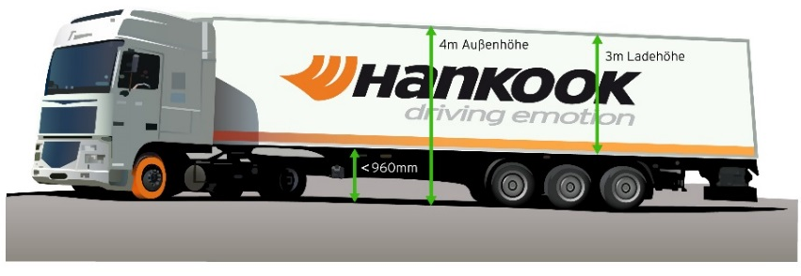
Until now, fleet operators with truck tyres of series 60 to 80 have often not been able to completely utilise the maximum inner load height of three metres without exceeding the legally permissible total height of four metres. Therefore, load capacity is lost, which in turn can result in economic disadvantages. As a consequence, premium tyre maker Hankook is offering its customers a truck tyre for the steering axle in series 50: the AL10+ e-cube MAX was developed in size 355/50R22.5 exclusively for use on jumbo trucks for long distances, and it provides a load index of 156, which means that the axle can be loaded with a weight of up to 8 tons. With its small diameter, it lowers the coupling height of the tractor engine, with the result that the inner load height increases and the three-metre loading platform can be fully utilised thanks to the lower profile tyres.

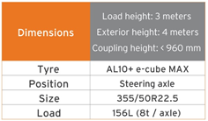
The tyre profile e-cube MAX for commercial vehicles represents maximum cost effectiveness, energy efficiency and environmental friendliness: due to its longitudinal grooved tread with wave structure, the AL10+ e-cube MAX for the steering axle prevents uneven wear. Therefore the AL10+ e-cube MAX guarantees an increased service life. The improved tread compound and high load index of the tyre increase the fuel efficiency while offering higher load capacity at the same time. The linear groove structure supports stable directional stability as well as maximum steering precision and improved water dispersal.

The long distance specialist for the steering axle is supported by its counterpart for the drive axle, the DL10+ e-cube MAX from the same tyre line. Due to its three-dimensional lamellae, it offers drivers outstanding traction, while the extra-wide profile block and deep grooves ensure increased mileage. The block stabilisers of the DL10+ e-cube MAX also contribute to a high service life and low rolling resistance. The e-cube MAX series is completed by the matching trailer tyre TL10+, which is characterised by maximum driving stability and low rolling resistance. Furthermore, the TL10 completes the e-cube package, which is available in sizes 275/70R22.5, 445/65R22.5 and 445/45R19.5.

Sizes of the e-cube MAX tyre line available

Tread | Size | LI | Marking |  | M+S | Availability
AL 10+ | 315/80R22.5 | 156/150L (154/150M) | B/B/W1 70dB | - | - | ☑
AL 10+ | 315/70R22.5 | 156/150L | B/B/W1 70dB | - | - | ☑
AL 10+ | 385/65R22.5 | 160K | B/B/W1 70dB | - | - | ☑
AL 10+ | 295/60/R22.5 | 150/147L | C/B/W1 70dB | - | - | ☑
AL 10+ | 315/60R22.5 | 154/148L | C/B/W1 70dB | - | - | ☑
AL 10+ | 355/50R22.5 | 156L | B/B/W1 70dB | - | - | ☑
DL 10+ | 315/80R22.5 | 156/150L (154/150M) | C/C/W1 73dB | ☑ | ☑ | ☑
DL 10+ | 295/60R22.5 | 150/147K | C/C/W1 73dB | ☑ | ☑ | ☑
DL 10+ | 315/60R22.5 | 152/148L | C/C/W1 73dB | ☑ | ☑ | ☑
DL 10+ | 295/55R22.5 | 147/145K | C/C/W1 73dB | ☑ | ☑ | ☑
DL 10+ | 315/45R22.5 | 147/145L | D/C/W2 75dB | ☑ | ☑ | In production
TL10+ | 215/75R22.5 | 135/133J | C/B/W1 69dB | - | - | ☑
TL10+ | 235/75R22.5 | 143/141J | B/B/W1 69dB | - | - | ☑
TL10+ | 245/70R17.5 | 143/141J (146/146F) | B/B/W1 69dB | - | - | ☑
TL10+ | 265/70R19.5 | 143/141J | B/B/W1 69dB | - | - | ☑
TL10+ | 385/65R22.5 | 160K | B/B/W1 69dB | - | - | ☑
TL10+ | 435/50R19.5 | 160J | B/B/W2 73dB | - | - | ☑
TL10+ | 455/40R22.5 | 160J | B/B/W2 71dB | - | - | ☑

###
Be equipped to face the wintry weather with Hankook

Premium tyre maker Hankook has made preparations for the imminent wintry weather with its range of winter tyres for trucks and buses. Together with the steering and drive axle treads and the trailer tread from the SmartControl series, Hankook offers its customers a complete reliable winter solution which promises top performance on ice and snow.

The SmartControl AW02 is Hankook’s winter specialist for trucks, and can be used both on the steering axle as well as at all other positions. Like all the other treads in the SmartControl range, the tyre, which is suitable for use on all axles, not only impresses with the M+S marking but also verifies its high winter performance with the "Three Peak Mountain Snowflake" (3PMSF) symbol.

The tyre tread of the SmartControl DW07 has been designed especially for snow performance and safety on wintry roads. The tread is exceptionally wide on the Hankook’s truck winter specialist for the drive axle, increasing the contact area between tyre and surface and improving grip and handling. In addition, the tread design with five main drainage grooves improves hydroplaning safety.

The trailer tyre SmartControl TW01, designed as a 5-rib tread, stands out due to its excellent braking performance on wet, snow and ice-covered roads. This is guaranteed due to the inner three ribs with so-called Multi-3D sipes. The 3D sipes also provide the tread blocks with a high degree of stability which results in uniform tread wear and increased mileage and fuel efficiency.

“Particularly as the winter gets under way, drivers and fleets must be equipped to face the toughest of wintry conditions in order to avoid expensive downtimes and arrive safely at their destination. Hankook is extremely well prepared and its complete winter solution SmartControl optimum offers snow traction and safety, while maintaining a high mileage and top braking performance,” says David Thorpe, TBR Sales Manager for the UK market.

Sizes of the SmartControl AW02 available

Tread | Size | LI | Marking |  | M+S | Availability
AW02 | 295/80R22.5 | 154/149M | D/C/W1 70dB | ☑ | ☑ | ☑
AW02 | 315/80R22.5 | 156/150L | D/C/W1 70dB | ☑ | ☑ | ☑
AW02 | 275/70R22.5 | 150/145J (152/148E) | D/C/W1 70dB | ☑ | ☑ | ☑
AW02 | 315/70R22.5 | 154/150L | D/C/W1 70dB | ☑ | ☑ | ☑
AW02 | 385/65R22.5 | 160K | C/C/W1 70dB | ☑ | ☑ | ☑
AW02 | 385/55R22.5 | 160K (158L) | C/C/W1 70dB | ☑ | ☑ | ☑

Sizes of the SmartControl DW07 available

Tread | Size | LI | Marking |  | M+S | Availability
DW07 | 12R22.5 | 152/148L | D/C/W1 72dB | ☑ | ☑ | ☑
DW07 | 275/70R22.5 | 150/145J (152/148E) | D/C/W1 72dB | ☑ | ☑ | ☑
DW07 | 295/80R22.5 | 152/148L | D/C/W1 72dB | ☑ | ☑ | ☑
DW07 | 315/70R22.5 | 154/150L | D/C/W1 72dB | ☑ | ☑ | ☑
DW07 | 315/80R22.5 | 156/150L | D/C/W1 72dB | ☑ | ☑ | ☑

Sizes of the SmartControl TW01 available

Tread | Size | LI | Marking |  | M+S | Availability
TW01 | 385/65R22.5 | 160K(158L) | B/C/W1 69dB | ☑ | ☑ | ☑
TW01 | 385/55R22.5 | 160K | C/C/W1 69dB | ☑ | ☑ | ☑
TW01 | 445/45R19.5 | 160K | C/C/W2 75dB | ☑ | ☑ | ☑

Technical properties of the SmartControl AW02

1. Extra-wide tread and five grooves in zigzag design
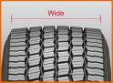
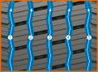

- Larger contact area
- Outstanding handling
- Excellent water drainage

2. 3D sipes, bars between the blocks and half-open shoulder design
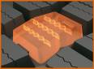
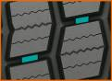
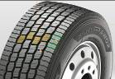

- Even tread wear
- High mileage
- High traction and outstanding handling properties

Technical properties of the SmartControl DW07

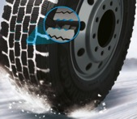
1. Pentagonal block design for optimum grip on snow and ice

- Enlarged pentagonal blocks enable the load to be spread over the whole contact area for optimum winter performance.
- The serrated edges of the tread blocks generate optimum grip on wintry surfaces, high braking and traction performances.

2. 3D sipe technology for driving stability and maximised traction on snow

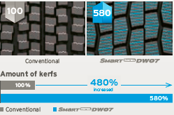
- Significantly larger numbers of 3D sipes for high snow grip and traction over the whole service life.
- Half-open shoulder design for improved traction and cornering on ice and snow-covered roads.

3. Extra-wide tread design for optimised driving stability

- Wider shoulder blocks (+8% compared to the predecessor model) increase mileage by up to 13%.)
- Optimised block design for high traction.

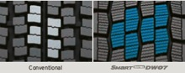

Technical properties of the SmartControl TW01

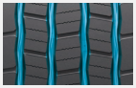
1. Zigzag grooves
- Four zigzag tread grooves guarantee excellent lateral guidance and ensure optimum water drainage.

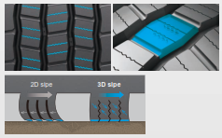

2. Multi-3D sipes
- The Multi-3D sipe tread ensures an outstanding braking performance.
- The stability of the tread blocks and the resulting minimum block movement lead to significant fuel savings.

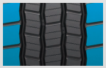
3. Wide shoulders
- The wide shoulders ensure excellent wet grip and driving stability.

###

All-rounders for all-year tyres
Particularly in changeable weather conditions, Hankook recommends that truck and bus customers use the SmartFlex all-weather tyre line for medium and long haul trips. Commercial vehicle customers can rely in particular on a high level of driving safety as well as the current trend of increased load-bearing capacity for some sizes.
Both the steering axle tyres SmartFlex AH31 and the drive axle tyres SmartFlex DH31 have M+S marking and the snowflake (3PMSF) symbol, which means good traction is guaranteed even if drivers should be surprised by wintry road conditions. The Hankook SmartFlex DH31 has a 6-rib tread with special hexagonal tread blocks that guarantees more even wear behaviour and thus a longer tyre service life. Hankook's patented self-cleaning sipes in the middle of each block prevent damage to the block edges and thus guarantee excellent traction throughout the tyre life.

The SmartFlex all-year tyre line is completed by the corresponding trailer tyre SmartFlex TH31, which celebrated its première at the 66th IAA for Commercial Vehicles. Its wide, closed shoulder area supports stable straight driving and ensure good lateral stability. Chamfered tread grooves help prevent splintering.

Whilst the SmartFlex AH31 and SmartFlex DH31 are designated mainly for larger wheel sizes in the 22.5 inch range, SmartFlex AH35 and its drive axle counterpart SmartFlex DH35 is more designated for smaller wheels with 17.5/19.5 inch sizes.

Sizes of the SmartFlex tyre line available

Tread | Size | LI | Marking |  | M+S | Availability | Remark
AH31 | 295/80R22.5 | 152/148M (154M/149L) | C/B/W1 73 dB | ☑ | ☑ | ☑ | -
AH31 | 295/80R22.5 | 154/149M | C/B/W1 73 dB | ☑ | ☑ | ☑ | Tyre with higher load-bearing capacity
AH31 | 315/80R22.5 | 156/150L | C/B/W1 73 dB | ☑ | ☑ | ☑ | -
AH31 | 315/70R22.5 | 156/150L | C/B/W1 73 dB | ☑ | ☑ | ☑ | -
AH31 | 385/65R22.5 | 164K | C/B/W1 69 dB | ☑ | ☑ | ☑ | -
AH31 | 385/65R22.5 | 160K | C/B/W1 69 dB | ☑ | ☑ | ☑ | -
AH31 | 315/60R22.5 | 154/148L | C/B/W1 70 dB | ☑ | ☑ | ☑ | -
AH31 | 385/55R22.5 | 160K | C/B/W1 69 dB | ☑ | ☑ | ☑ | -
AH31 | 355/50R22.5 | 156L | C/B/W1 69 dB | ☑ | ☑ | ☑ | -
DH31 | 295/80R22.5 | 152/148M | D/C/W2 75 dB | ☑ | ☑ | ☑ | -
DH31 | 315/80R22.5 | 156/150L | D/C/W2 75 dB | ☑ | ☑ | ☑ | -
DH31 | 315/70R22.5 | 154/150L | D/C/W2 75 dB | ☑ | ☑ | ☑ | -
DH31 | 295/60R22.5 | 150/147K | D/C/W2 75 dB | ☑ | ☑ | ☑ | -
DH31 | 315/60R22.5 | 152/148L | D/C/W2 75 dB | ☑ | ☑ | ☑ | -
TH31 | 385/65R22.5 | 160K | B/B/W1 69 dB | - | ☑ | ☑ | -
TH31 | 435/50R19.5 | 160J | B/B/W2 | - | ☑ | ☑ | -
TH31 | 455/40R22.5 | 160J |  |  |  | In production | -
Technical properties of the Hankook SmartFlex all-year tyre line

SmartFlex AH 31

Truck all-year tyres for the steering axle for medium to long-haul applications

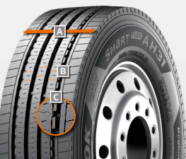
A Extra-wide tread and shoulder area:
- The extra-wide open shoulder area supports a high mileage and traction as well as outstanding handling properties

B Multi-3D sipe treads:
- High traction and mileage with even
wear

C Tread Wear Equalizer Stepper Technology (T.W.E.S.):
- Stabilisers on profile blocks
- Reduction of uneven/one-sided wear

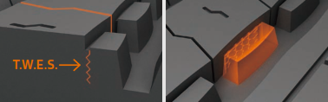
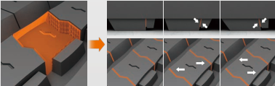

SmartFlex DH 31

Truck all-year tyres for the drive axle for medium to long-haul applications

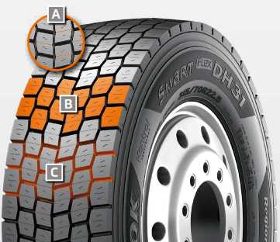
A Multi-3D sipes:
- High traction and mileage with even wear

B 6-rib block tread:
- Sturdy 6-rib block tread with special hexagonal tread blocks

C Self-cleaning sipes:
- Constant traction over the entire service life
- Protection against splintering at the corners of the sipes

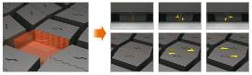
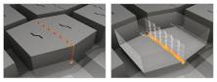

SmartFlex TH 31

Truck all-year tyres for the trailer axle for medium to long-haul applications
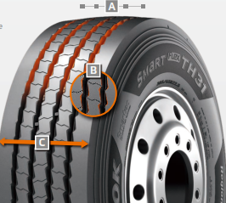

A 4 Zigzag sipes:
- 4 main tread grooves ensure optimum water displacement

B Chamfered profile block design:
- Chamfered profile blocks sipes help to prevent material splintering

C Extra-wide tread and shoulder area:
- The extra-wide closed shoulder area supports high driving stability and ensures good lateral stability as well as even wear

###
SmartTouring is Hankook’s ultra-modern tyre for long-distance coaches

With the SmartTouring AL22, tyre maker Hankook now has a coach tyre for long-distance travel in their portfolio. The company is anticipating that long-distance coach travel will grow in significance, and thus there will be an increasing demand for high-technology coach tyres in this category. The Hankook SmartTouring AL22 can be used on all axle positions and provides maximum ride and rolling comfort, excellent concentricity, a very low rolling noise and, as is customary with Hankook tyres, optimised rolling resistance and low wear for particularly efficient travel.

With the SmartTouring AL22, premium tyre maker Hankook has a state-of-the-art tyre for long-distance coach travel on the European market. This is available in the sizes 295/80R22.5 and 315/80R22.5 and is suitable for all long-distance coach wheels in all axle positions. Klaus Krause, Vice President and Head of the European Development Centre in Hanover, adds: “During development of the SmartTyre line, we focused particularly on ride and rolling comfort as well as on a straight driving performance. The characteristics of the SmartTouring AL22 not only allow maximum travel comfort for passengers, they also maximise driving and handling comfort for the driver on long-distance trips.”
The carcass contour of the SmartTouring AL22 ensures the best suspension properties and contributes to a particularly safe driving style. The longitudinal 5-rib profile with its closed, solid central rib makes an excellent straight driving performance possible at all times. Special Multi-3D sipes guarantee both good traction and an outstanding braking response.
The new bead area guarantees a particularly precise rim joint stiffness, which results in excellent concentricity and travel comfort.
The individual belt layers of the new SmartTouring AL22 are structurally arranged in such a way that significantly less heat is developed in operation compared with conventional tyres. This effect not only reduces rolling resistance, thus economising on fuel, it also considerably extends the service life of the tyre.

Fuel savings through reduced heat development have been achieved not only by the belt structure but also by the tread compound used for the Hankook SmartTouring AL22. Special soot molecules with a larger volume and a particularly stable structure are used for the basic tread rubber in particular, leading to a significant reduction in energy loss during movement. These so-called highly structured carbon molecules also guarantee enhanced abrasion resistance and, in combination with the other technologies, help to increase the mileage of the SmartTouring AL22 compared with conventional products by more than 17 percent.
Available dimensions
Tread | Size | LI | Marking |  | M+S | Availability
AL22 | 295/80R22.5 | 154M | C/B/W1 71dB |  | ☑ | ☑
AL22 | 315/80R22.5 | 156/150L | C/B/W1 71dB |  | ☑ | ☑

Hankook SmartTouring AL22: Technical properties

Longitudinal tread profile with Multi-3D sipes and solid central rib
- High directional stability and comfortable handling response.
- Excellent straight driving.
- Very good braking and traction performance.
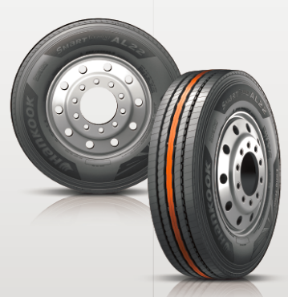
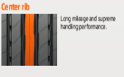

Special brake structure and newly developed bead area
- Reduced heat development.
- High retreadability.
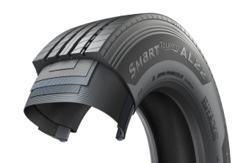

###

Powerful coach range: New SmartTouring DL22 rounds off the Hankook tyre portfolio for long-distance coaches

Premium tyre maker Hankook is launching the new drive axle tyre for long-distance coaches in Europe, SmartTouring DL22. Along with the existing SmartTouring AL22, Hankook now has a complete portfolio of coach tyres available for long-distance routes. The company is responding to the growing importance of travelling long-distance by coach and to the increasing demand for high-tech coach tyres with low rolling noise, a high ride and rolling comfort.

With the introduction of the new SmartTouring DL22, premium tyre maker Hankook now offers a complete portfolio of coach tyres for long-distance routes to its coach fleet customers. The company is responding to the continuing increase in long-distance coach travel by completing its range in the long-distance coach segment with these new tyres for the drive axle.

The SmartTouring DL22 has a particularly low noise level and therefore offers high ride comfort. The special tyre tread design guarantees uniform tyre wear even during permanent use, and makes a high mileage and long service life possible. Like most drive axle tyres from Hankook, the new all-year tyre has the 3PMSF symbol and M+S marking. The 3D sipes arranged in a V-shape make top grip and traction properties possible in the snow and wet, without having a negative effect on the mileage performance. The sipe technology of the SmartTouring DL22 also provides good longitudinal and lateral grip as well as directional and lateral stability. Low rolling resistance on the SmartTouring DL22 makes efficient fuel consumption possible.

Among others the tyre maker still offers the tried-and-trusted city tyre AU03+ in its range for short and medium distances. This model has been specially designed to meet the requirements of stop-and-go traffic in cities as well as on country roads, and is particularly suitable for use on scheduled urban buses. The side walls were recently reinforced to guarantee even safer and more efficient use in city traffic; in addition, an even wider and deeper side wall indicator has been incorporated which protects the tyre from damage, including gravel throw and contact with kerbstones. The all-year tyre is available in size 275/70R22.5 and comes marked with the M+S and 3PMSF symbols (3 Peak Mountain Snowflake).

Sizes of the SmartTouring DL22 available:

Tread | Size | LI | Marking | Snowflake | M+S | Availability
DL22 | 295/80R22.5 | 154/149M | C/C/W1/70dB | ☑ | ☑ | 2nd quarter 2018

Technical properties of the SmartTouring DL22

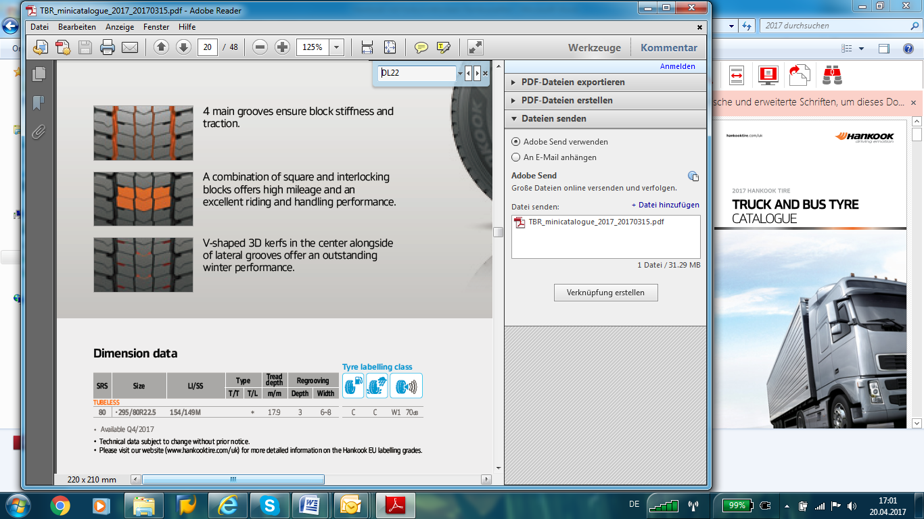
Four main grooves
- The four main grooves guarantee high tread block rigidity and are decisive for the outstanding traction of the SmartTouring DL22.

Arrangement of the tread blocks
- The combination of standard and 3D sipes guarantees a high mileage, high ride comfort and low noise development. This results in reliable longitudinal and lateral grip and excellent directional stability.

V-shaped 3D sipes
- The 3D sipes arranged in a V-shape offer an outstanding winter performance.

###
Hankook presents its new city bus tyre SmartCity AU04+ with an even longer service life

In the stop-and-go business of city traffic bus tyres must be able to withstand a heavy load and guarantee safe and efficient use at the same time. With the SmartCity AU04+ Hankook is launching the ideal city bus tyre on the market. The improved tread of the all-season tyre ensures as low and as even a wear as possible. The innovative tread compound and new tyre structure guarantee high safety and make efficient and eco-friendly use in city traffic a reality. Thus Hankook has a comprehensive range of city bus tyres available, comprising the AU03, AU03+ and the new SmartCity AU04+.

Premium tyre maker Hankook is extending its range for city buses by a new tyre line: SmartCity AU04+. The bus tyre for city traffic impresses through efficient fuel consumption and maximum wear resistance. The tread design has been adapted. An improved rib spacing, stabilising 3D tread blocks and optimised zigzag grooves ensure outstanding traction without restricting mileage. The constant starting and stopping in city traffic puts a heavy and irregular load on bus tyres. “For this reason, Hankook has adapted the shoulder width and design for the SmartCity AU04+, thus guaranteeing more even wear. The improved structure of the new tread compound makes the tyre much more heat-resistant, thus reducing wear and make a longer service life possible“, adds Dipl.-Ing. Klaus Krause, Hankook’s Vice President and Head of the European Technical Center in Hanover.

The safety aspect is a major factor for Hankook during tyre development. The entire city tyre range from Hankook implements this claim. Like the AU03+, the SmartCity AU04+ is characterised by a reinforced sidewall. This protects the tyre from damage following contact with kerbstones. In addition, all three city bus tyre models have impressive brake distance values; the AU04+ stands out particularly through its excellent behaviour in wet road conditions due to the improved sipe arrangement. The deep sidewall indicator on the SmartCity AU04+ makes it easier to determine the tyre condition and thus supports timely damage prevention.

The SmartCity AU04+ is available in size 275/70R22.5 and has the M+S marking as well as the 3PMSF symbol (3 Peak Mountain Snowflake).

Available sizes of the AU04+ / AU03+ and AU03:

Tread | Size | LI | Marking | Snowflake | M+S | Availability
AU04+ | 275/70R22.5 | 150/145J | D/B/W1/67 dB | ☑ | ☑ | ☑
AU03+ | 275/70R22.5 | 150/145J  (152/148) | D/C/W1/71 dB | ☑ | ☑ | ☑
AU03 | 11R22.5 | 148/145J | C/B W1 71 dB | - | ☑ | ☑
AU03 | 275/80R22.5 | 149/146J | D/C W1 71 dB | - | ☑ | ☑
AU03 | 295/80R22.5 | 152/148J | C/C W1 71 dB | ☑ | ☑ | ☑
AU03 | 245/70R19.5 | 136/134L | D/C W1 71 dB | ☑ | ☑ | ☑
AU03 | 265/70R19.5 | 104/138M | D/C W1 71 dB | ☑ | ☑ | ☑

Technical features of the Hankook AU04+

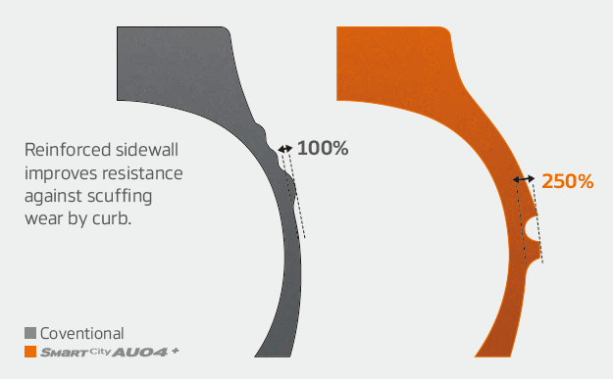
Wide shoulders and reinforced sidewalls
- Wide shoulders and reinforced sidewalls ensure excellent wet grip, grip and driving stability.
- New shape and position of the sidewall indicator makes determining the tyre condition easier.

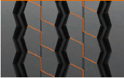
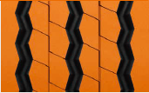
Improved tread design
- Stabilising 3D tread blocks guarantee improved traction
- Longer service life through optimised rib spacing
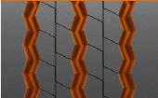
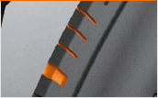
- Three zigzag grooves guarantee excellent traction, particularly under wet conditions
- Adapted should width and removed lugs and ribs ensure more even wear

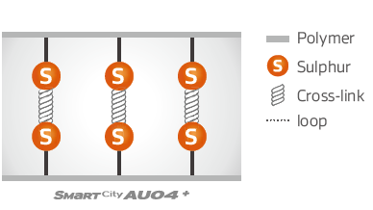
Innovative rubber compound
- Improved chemical structure makes the tyre more heat-resistant

# # #

About Hankook

Hankook Tire manufactures globally innovative, award winning radial tyres of proven superior quality for passenger cars, light trucks, SUVs, RVs, trucks, and buses as well as motorsports (circuit racing/rallies).
Aspiring to bring consumers the utmost excellence in product quality, technological excellence and driving satisfaction, Hankook Tire continuously invests in research and development maintaining five R&D centres and eight production facilities around the world. Bespoke tyre solutions for the European markets as well as European Original Equipment according to the requirements of leading premium car manufacturers, are developed in the company’s regional Technical Centre in Hanover/Germany. Production for the European region is taking place in the state-of-the-art manufacturing site in Rácalmás/Hungary which was inaugurated in June 2007 and is continuously being expanded. Currently around 3,000 employees produce up to 19 million tyres a year for passenger cars, SUVs and light trucks.

Hankook Tire’s European headquarters are located in Neu-Isenburg near Frankfurt am Main in Germany. The manufacturer operates further branches in Czech Republic, France, Germany, Hungary, Italy, the Netherlands, Poland, Russia, Spain, Sweden, Turkey, UK and Ukraine. Hankook products are sold directly through regional distributors in other local markets. Hankook Tire employs approximately 22,000 people worldwide and are selling their products in over 180 countries. Internationally leading car manufacturers rely on tyres made by Hankook for their original equipment. Approximately 30 percent of the company's global sales are generated within the European and CIS-Region. Hankook Tire has been represented in the renowned Dow Jones Sustainability Index World (DJSI World) since 2016.

For more information please visit www.hankooktire-mediacenter.com or www.hankooktire.com

European Media contacts:
Hankook Tire Europe GmbH | Corporate Communications Europe/CIS
Siemensstr. 14, 63263 Neu-Isenburg | Germany

Anna Pasternak, PR Manager
LT and Truck & Bus Tyres, Intl. Motorsports, CSR
Tel.: +49 (0) 6102 8149 – 173
Mobile: +49 151 65641014
a.pasternak@hankookreifen.de

Sabine Riedel, PR Manager
LT and Truck & Bus Tyres, Hankook Media Center, SNS, Corporate
Tel.: +49 (0) 6102 8149 – 174
Mobile: +49 160 2545318
s.riedel@hankookreifen.de

