

**Press Kit**

**“The Tire Cologne“ Cologne 2018**

**Contents**

* **Hankook at Tire Cologne 2018:** World premières and smart tyre solutions
* **Hankook Tire Acquires High-tech Digital Prototype Company Model Solution**

**Summer tyres**

* **Hankook Ventus Prime³:** 1st place in Auto Bild summer tyre test 2018
* **The Hankook KINERGY ECO²:** Economical summer tyres for Europe’s
* **Hankook Ventus S1 evo²:** Achieved “outstanding” test result

**Hankook Ventus S1 evo² SUV:** Rated “outstanding” by AUTO BILD Allrad

**Winter- Allseason tyres**

* **Hankook presents its new all-weather tyre Kinergy 4S²**
* **Hankook UHP Premium winter tyres: Optimised driving during cold season; including SEALGUARD® technology; Run-flat OE**
* **Winter i*cept RS²: Very good test results!**

**Truck tyres**

* **Hankook presents its new city bus tyre SmartCity AU04+ with an even longer service life**
* **Hankook AL10+ e-cube MAX:** Low-line sizes for the steering axle
* **All-rounders for all-year tyres**
* **Winner of the Red Dot Design Award: Hankook's all-year truck tyres SmartFlex AH35 and SmartFlex DH35 for regional traffic**

**Images:**

You will find further picture material for any of the press releases on our Hankook Mediacenter Website: <https://www.hankooktire-mediacenter.com/tire-cologne-2018>

**Hankook at Tire Cologne 2018:**

**World premières and smart tyre solutions**

**At Tire Cologne from 29th May to 1st June 2018 Hankook is presenting several world premières alongside current tyre exhibits from the passenger car, SUV, bus and truck line-ups. In Hall 6.1, Stand no. A050, the world première of a completely newly developed passenger car all-weather tyre will be just one product visitors can expect to see in the 400 square metres of exhibition space. In addition, the premium tyre maker will be using the trade fair presentation to focus on the current winner of the major Auto Bild summer tyre test 2018, the Ventus Prime³, which completes the exhibition portfolio alongside other premières in the truck and bus tyre segment.**

***Neu-Isenburg/ Köln, Deutschland, 29. Mai 2018***– Premium tyre maker Hankook is presenting its comprehensive portfolio for the European market at the specialist tyre trade fair Tire Cologne from 29th May to 1st June and introducing a completely newly developed all-weather tyre for passenger cars in Hall 6.1, Stand A050. The brand new all-rounder created in Hankook’s European development centre will continue the long tradition of success of Hankook products in this market segment.

At the new trade fair for tyres and wheels, the focus in the passenger car portfolio ranging from the classic summer Ultra-High-Performance (UHP) products to the current winter tyre range will be on the tried-and-trusted UHP flagship series Ventus S1 evo² as well as on the Ventus Prime³, the winner of the major summer tyre test 2018 carried out by Auto Bild. Hankook’s premium comfort summer tyre was developed with a balanced blend of power, comfort, safety and eco-friendliness and was able to prove its performance impressively for the second time compared with more than 50 brands, in what is probably the largest independent product test in the world. In addition to solutions for private transport, visitors to the Hankook stand can also take a look at the comprehensive tyre range for trucks and buses, including the new SmartCity AU04+, which is supplementing the brand’s range of bus tyres. It goes without saying that the stand will include a show car, and the tyre maker is bringing along a special treat this year – the current project vehicle Eibach Audi RS5, for which Hankook is the official partner, supplying suitable Ventus S1 evo² 20-inch tyres.

Trade fair visitors will also able to see the technological excellence of the brand for themselves. With its home-made premium technologies SEALGUARD® and HRS®, Hankook is showcasing state-of-the-art tyre solutions for the further enhancement of safety and comfort. The special SEALGUARD® sealing material is being used for the original fitment of several VW vehicles, can seal punctures up to a diameter of 5 mm in the area of the tyre tread and allow you to drive on safely without replacing the tyre. The HRS® (Hankook Runflat System) is also successful in original fitment and is being fitted on the current 7 Series BMW among others as both summer and winter tyres. The tyre maker is dedicating part of the 400 m² exhibition area to its second brand, Laufenn.

**Hankook Tire Acquires**

**High-tech Digital Prototype Company Model Solution**

**Hankook Tire secures its competitiveness in the 4th industrial revolution by diversifying its business model. Through active mergers and acquisitions of companies with advanced technology and design capabilities like Model Solution, Hankook establishes a new growth engine.**

On 10th May, premium tyre maker Hankook announced the acquisition of a 75 per cent equity stake of Model Solution Ltd; a high-tech digital prototype company for 68.6 billion KRW (approximately 53.5 million Euro).

The tyre maker plans to incorporate Model Solution as an affiliate company. Hankook Tire’s share of 75 per cent in Model Solution will consist of a 51per cent stake from the UK electronics company Laird and a 24 per cent stake from the global private equity firm Crescendo Equity Partners.

The high-tech digital prototype company Model Solution, founded in 1993, designs and manufactures prototypes and molds for IT equipment such as electronic and medical devices. In 2007, the company started to work in the field of prototype solution services and is currently serving 420 clients worldwide.

Possessing the best technical and design skills in the field, Model Solution provides first-class design and prototyping support. Moreover, through constantly developing high-tech skills such as 3D-printing, the company is leading the prototype industry.

This acquisition is part of Hankook Tire’s plans to strengthen its investment in promising technologies. Through active mergers and acquisitions of high-tech corporations, the tyre maker aims to secure a new growth engine. Furthermore, the synergy effect with existing cooperations can be maximised by bringing together Model Solution’s expertise and the processing techniques of Hankook Tire’s affiliate M&K Technology, a super-size mold equipment company.

Along with the takeover, Hankook Tire aims to solidify its new growth focussing on technology, brand and network in order to increase quality and strengthen its competitiveness.

**Hankook is convincing in independent product tests:**

**1st place in Auto Bild summer tyre test 2018**

**The Hankook Ventus Prime³ is the winner of the large-scale summer tyre test 2018 conducted by German automobile consumer magazine Auto Bild. Decisive factors included the best overall braking performance from all 51 examined tyre brands. The German automobile club ADAC also awarded the best mark "Good" to Hankook’s premium comfort tyre in its latest summer tyre test. The Hankook Ventus Prime³ was developed to provide an ideal blend of performance, comfort, safety and environmental friendliness. It is available on the market in more than 90 sizes for an extremely broad spectrum ranging from compact cars to luxury limousines.**

The Hankook Ventus Prime³ has confirmed its top performance once again in independent product tests1). Following its excellent victory in the tyre test conducted by Europe’s largest automobile consumer magazine Auto Bild in its debut season in spring 2016 and further international top placings in 2017, the comfort-champion of the successful Hankook Ventus product family has repeated its success this year again in tests by the specialist automotive press. After the renowned ADAC had awarded the Ventus Prime³ the top overall mark "Good" (best mark in the test) in its 2018 summer tyre test and praised the tyre for its outstanding braking performance as "very balanced tyre with top marks on dry roads and good in the wet", the Auto Bild followed suit. In probably the largest-scale tyre test involving 51 products2) including all the top brands, it was crowned the winner for the second time since 2016. The crucial factors included the best braking performance as a combination of wet and dry braking distance out of all brands – probably the most important safety feature for all car drivers. Auto Bild editors testified that the Hankook pattern to be the test winner with outstanding driving characteristics on wet and dry roads, precise steering behaviour, short wet and dry braking distance along with pleasant ride comfort amongst other things.

The Hankook Ventus Prime3 was developed to provide an ideal blend of performance, comfort, safety and environmental friendliness. The very good braking performance on wet surfaces was a key task for Hankook engineers during development. To achieve this, Ventus Prime³ uses a high-grip silica tread compound and a new compounding technology which provides better distribution of polymers and fillers in the tread compound. This improved both wet braking performance and rolling resistance. The effective contact surface between the tyre and the road was increased by using a specially designed, asymmetrical tread. Along with a high tread stiffness in both radial and lateral directions, and in conjunction with special “hybrid hardness” tread ribs with different hardness levels at the outer and inner shoulder areas, the Ventus Prime³ provides an exceptional dry performance. The very good dry braking performance is achieved applying chamfered tread block edges across the entire tread surface and being able to enlarge the tyre's contact surface during braking.

Newly-developed, functionalised polymers with a high molecular weight in the tread compound of the Ventus Prime³ increase its wear-resistance. The tyre is equipped with a highly-modern, lightweight, and especially sturdy Rayon carcass and a wide steel belt package including a jointless bandage and high-strength bead fillers. Besides improving handling, this ensures precise steering feedback and great control, even at high speeds. Thanks to an improved pitch design and the optimised angle of lateral profiling, as well as a sidewall optimised for air resistance, Hankook's development engineers were able to further reduce the noise level of the tyres, once again improving the tyre's comfort features.

The Hankook Ventus Prime³ is market available in more than 90 sizes with tread widths from 195 to 245 for the series 65 to 40 and speed indices H-W (210 - 270 km/h) for an extremely wide spectrum of passenger cars ranging from compact cars to luxury limousines.

1) Test results of Hankook Ventus Prime³ published in German automotive media:

Magazine: Tested Size: Test Result: Edition:

Auto Bild 205/55 R 16 91 V "exemplary/best in test" 12/2016

Auto Zeitung 215/55 R 17 94 W "highly recommended" 06/2017

Auto Bild 225/50 R 17 98 W "exemplary" 11/2017

ADAC Motorwelt 205/55 R 16 91 V „good" 03/2018

Auto Bild 195/65 R 15 91 V "exemplary/best in test" 10/2018

2) 51 Tyre patterns pre-tested (wet/dry braking), 20 best braking patterns (combined) continued in main test.

**Technical features of the Hankook Ventus Prime³**

1. *Improved performance on dry roads*

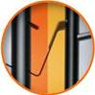

- Increased profile block stiffness in both radial and lateral directions.

- Tyre contact area increased by ten percent.

- Different hardness levels on the outer ribs, and a massive

outer shoulder block for improved curve stability.

- Longitudinally oriented tread design for outstanding directional stability, even at

high speeds.

- Chamfered profile block edges broaden the contact surface while braking:

dry braking power improved by three percent.

- Light, yet highly sturdy Rayon carcass and extremely strong

bead filler for better handling characteristics and precise steering feedback.

2. *Improved performance on wet roads*

- Four wide main tread grooves for especially fast drainage.



- Newly developed, high-grip tread blend and new compounding technology

for an improved distribution of polymers and fillers; eight percent

better wet braking performance.

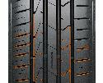

3. *Reduced noise production and higher comfort*

- Innovative pitch design and newly developed technology to position the tread

grooves in order to reduce noise production on the tread, even with

continued use.

- Stable, single-strand bead wire for excellent concentricity / driving comfort.

- Air resistance optimised side wall design to reduce air vortices

and vibrations at high speeds.

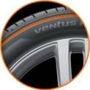

4. *Lower rolling resistance and less tyre wear*

- High-grip silica blend reduces rolling resistance.

- Polymers with high molecular weights in the tread compound:

wear performance improved by nine percent.

- Visual Alignment Indicator System on the outer tyre shoulder allows drivers to

easily check for uneven wear caused by poor body alignment.



5.  *Line-Up*

- The Ventus Prime³ is primarily produced in Hankook’s highly modern European production facility in Hungary, and is available in 107 sizes from 15 to 19 inches, with tread surface widths of 185 to 245 mm, aspect ratios of 65 to 40, and is available in speed classes H, V, W and Y.

**The Hankook KINERGY ECO²: Economical summer tyres for Europe’s small, compact and mid-range vehicles**

**Hankook’s latest Kinergy generation - the exceptionally eco-friendly and economical KINERGY ECO² summer tyre was developed with the needs of modern small, compact and mid-range vehicles in mind. Like its predecessor, which received many outstanding reviews from independent institutions, the development engineers focussed not only on driving safety and economy with a low rolling resistance and high mileage, but also particularly on rolling and noise comfort. The KINERGY ECO² is available from Spring 2018, initially in 52 sizes from 13 to 16 inches, with tread surface widths of 145 to 215 mm in aspect ratios of 55 to 80 and the speed classes T, H and V.**

In the portfolio of premium tyre maker Hankook, KINERGY represents the exceptionally economic summer tyre for vehicles from micro-car/small car to the lower mid-range. Due to the increasing electrification of smaller vehicle classes, accompanied by further urbanisation and shortage of space for traffic, the company envisages an increasing market for these vehicle segments and appropriate tyres. Alongside pure economic efficiency they also offer optimised traction and braking performances as well as noise comfort, and are therefore suitable for future generations of electric vehicles with their high torques and very low drive noise levels.

KINERGY is short for Kinetic Energy (from the Greek Kinesis = movement), in other words ‘the energy an object contains due to its movement’. It corresponds to the work that must be done to move the object from rest to its current movement. With the new Hankook tyre, this is much lower than with conventional tyres of this class. The suffix ECO provides orientation for consumers as it is widely understood to be a synonym both for ecology and economy, combining the eco-friendly an economical fuel-saving characteristics of the tyre for the benefit of both nature and consumers’ wallets. The first KINERGY ECO generation, which was launched in 2011, received many independent international awards1. The new KINERGY ECO² is retaining these positive characteristics whilst being further improved. Optimisation of braking performance in the wet was a focus during development of the latest additions to the KINERGY family. A high-grip silica tread compound in conjunction with the compounding technology already used for the company’s performance products provides much better distribution of polymers and fillers in the tread compound. This has improved both wet braking performance and reduced rolling resistance even further. In addition, three linear grooves make fast drainage possible and also increase vehicle control on wet roads.

By using a newly designed, asymmetrical tread, the actual contact surface between the tyre and the road was optimised compared with its predecessor’s profile. Along with the improved tread stiffness in both radial and lateral directions, as well as the massive outer tyre shoulder, the KINERGY ECO² provides more driving stability and a significantly better dry performance. The dry braking performance of the tyre was also improved by four percent. This was made possible by applying chamfered tread block edges across the entire tread surface, which immediately increased the contact surface during braking. Newly-developed polymers with a high molecular weight in the tread compound of the KINERGY ECO² increase its wear-resistance by four percent.

Thanks to an improved pitch design, the noise development of the tyre particularly at country road speed has been further reduced, improving the comfort features even further. By using the latest Hankook design technology when positioning the tread grooves, development engineers were able to achieve a significant reduction in the noise level of the tread, even with improved tyre life. Like all current Hankook products, the KINERGY ECO² has a Visual Alignment Indicator System (VAI) on both tyre shoulders, which allows drivers to check the basic body alignment easily and conveniently.

1 International test results determined by independent institutions for the Hankook KINERGY ECO of the 1st generation:

|  |  |  |  |  |
| --- | --- | --- | --- | --- |
| **Medium:** | **Country:** | **Year:** | **Tyre size:** | **Overall rating:** |
| ADAC/OEAMTC/TCS | Germany/Austria/Switzerland | 2016 | 185/65 R 15 H | Good (best mark in the test) |
| ACE/GTUE | Germany | 2016 | 195/65 R 15 V | Highly recommended |
| Auto Review | Russia | 2016 | 185/65 R 15 H | Best in test |
| Auto Bild | Germany | 2015 | 185/60 R 15 H | Exemplary |
| ADAC/OEAMTC/TCS | Germany/Austria/Switzerland | 2015 | 185/60 R 14 H | Good (best mark in the test) |
| ADAC/OEAMTC/TCS | Germany/Austria/Switzerland | 2014 | 175/65 R 14 T  195/65 R 15 V | Good (best mark in the test)  Good (best mark in the test) |
| L'Argus | France | 2012 | 205/55 R 16 V | Best in test |
| ACE/GTUE | Germany | 2012 | 205/55 R 16 V | Price/performance winner |
| Za Rulem | Russia | 2012 | 185/60 R 14 H | Good |

**Technical characteristics of Hankook KINERGY ECO²**

1. *Improved performance on dry roads:*

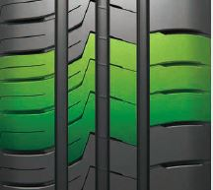

- Increased profile block stiffness in both radial and lateral directions.

- Optimised tyre contact surface and asymmetrical tread.

- Massive outer shoulder blocks for improved curve stability.

- Chamfered block edges broaden the contact surface while braking:   
Dry braking improved by four percent.

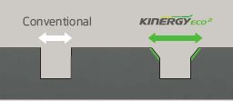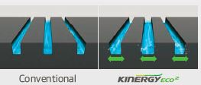

1. *Better wet performance:*

- 3 linear optimally positioned main tread grooves for especially fast drainage.

- Newly developed, high-grip silica tread compound and new compounding technology for an improved distribution of polymers and fillers, resulting in a higher wet braking performance.

*3.*  *Reduced noise emissions and higher comfort:*

- Innovative pitch design and new design technology for positioning the tread grooves: reduction of noise development on the tread, even with continued use.

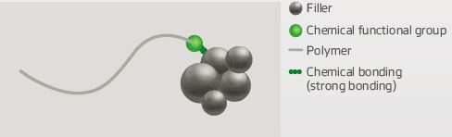

1. *Lower rolling resistance and less tyre wear:*

*-* High-grip silica compound reduces rolling resistance at the same time.

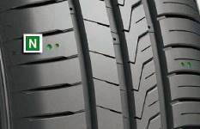

- Polymers with high molecular weights in the tread compound

for improved wear performance (four percent better).

- Visual Alignment Indicator System on the tyre shoulder blocks allows to easily check for uneven wear caused by poor body alignment.

*5.* *Line-up:*

The KINERGY ECO² is primarily produced in Hankook’s high end production facility in Hungary and will be available on the market from Spring 2018 in 52 sizes from 13 to 16 inches, with tread surface widths of 145 to 215 mm in aspect ratios of 55 to 80 and speed classes T, H and V.

* **Hankook Ventus S1 evo²: once again “outstanding”**

**test result in Auto Bild sportscars 2018 summer tyre test as well as a “recommendable” by auto motor sport**

* **Hankook Ventus S1 evo² SUV: also rated “outstanding” by AUTO BILD Allrad (4-wheel drive)**

**Hankook Tire’s UHP flagship Ventus S1 evo² has been rated ‘outstanding’ the third time in a row in the 2018 German Auto Bild Sportscars UHP Summer Tyre Test, keeping its title since 2016. The testers emphasize in particular its exemplary performance and short braking distances on wet and dry roads as well as the very good price performance.**

With new top-test results premium tyre maker Hankook continues the success-story of its flagship tyre Ventus S1 evo2 by achieving ‘outstanding’ for the third time in a row as test result in the UHP Summer Tyre Test by the renowned German automobile magazine Auto Bild Sportcars in size 235/35 (FA) and 265/35 (RA) R19 93/98Y (Auto Bild Sportscars 04/2018). The magazine Auto Motor Sport reached a similar conclusion when testing size 245/45 R18 Y. Hankooks Ventus S1 evo² is named recommendable” and the Testers emphasize the harmonic and well-balanced driving characteristics (auto motor sport 07/2017). Also awarded “outstanding” is the SUV-version Ventus S1 evo² SUV by Auto Bild Allrad, the 4-wheel drive magazine tested summer tyres in size 235/50 R19 (Auto Bild Allrad 04/2017). The UHP-SUV tyre has recently been chosen as original fitment with Sound absorber® technology by Audi for the Q7 and SQ7 TDI, the strongest Diesel-SUV on the market in size 285/35 R 22 106 Y XL. Rising demands in refitting business show that customers have discovered the impressive 22-rim tyre with interior-noise-reduction as a sporty, attractive as well as comfortable choice.

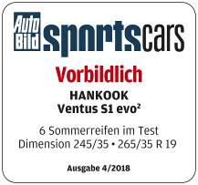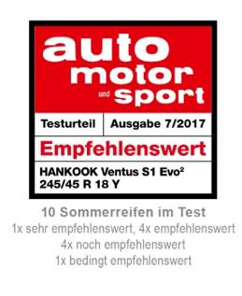

The tyre tests of the renowned automotive magazines reflect various performance aspects including handling and braking on both dry and wet roads, as well as noise level and rolling resistance. During the tests, the Ventus S1 evo² and Ventus S1 evo² SUV showed an overall very strong performance.

Equipped with sophisticated DTM technology, the Hankook Ventus S1 evo² has repeatedly been recognised by premium automakers including Audi, BMW, Mercedes Benz and the Volkswagen Group, for its successful combination of performance, durability, comfort and energy efficiency.

The tyre’s asymmetric tread design provides an increased water drainage performance whilst dispersing friction heat. It also guarantees a precise and comfortable driving experience with reduced noise and vibration.

Han Jun Kim, COO for Europe at Hankook, explains: “We are extremely pleased with these excellent test results for our UHP flagship models of the Ventus S1 evo² range. Regularly achieving such results in independent tyre tests gives proof that our continuous commitment to technology advancement results in products that deliver the best possible driving experience at all times for our customers.”

**Technical Characteristics of the Hankook Ventus S1 evo²/ S1 evo² SUV**

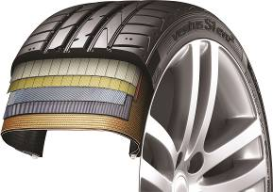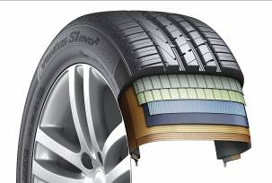

1. *DTM-engineered Multi-Tread-Radius Rayon carcass for*

*equal ground contact pressure through ideal tyre footprint*

* Outstanding high-speed driving performance and straight stability.
* Perfect balance in both wet and dry conditions.
* Increased performance especially in lateral hydroplaning.
* High driving comfort combined with a low rolling noise.
* Double-layer rayon carcass for SUV version

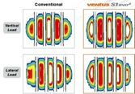

1. *DTM-inspired triple layered block design for superior traction*

* The staircase arrangement of the outer rib blocks is designed to increase the tyre contact patch with the surface as the tyre wear progresses, ensuring a consistently high traction performance throughout the tyre-lifecycle.

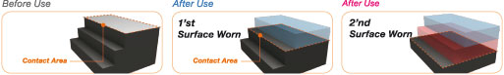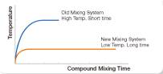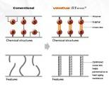

1. *Tread compound of the latest generation for reduced rolling resistance, dynamic handling characteristics and a high wet braking performance*

* The extension of mixing times at reduced temperature significantly increases the binding speed and makes more specific cross-linking between carbon and rubber molecules possible for reduced heat development during driving, which in turn improves handling characteristics while at the same time reducing rolling resistance, tread wear and thermal ageing.
* New styrene polymer enhances the tyre’s wet braking performance.

1. *More stabling handling behaviour through improved heat regulation*

* Surface-enlarging cooling fins in the ground of the tyre grooves provide a permanent heat reduction for a more stable handling performance.
* Double-step dimples at outer block edges generate micro cooling turbulences.

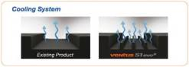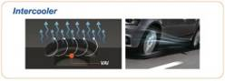

* Side walls with an aerodynamic design reduce rolling noise and vibration level for increased driving comfort.

*5. Line-up* Ventus S1 evo²/ S1 evo² SUV:

- Available in 165 sizes (including all specifications) from 16 to 22 inches, with tread

surface widths of 205 to 315 mm, aspect ratios of 65 to 30, in speed classes, W, Y and (Y).

**Hankook presents its new all-weather tyre Kinergy 4S²**

**A reliable performance 365 days a year without changing tyres – this is what the latest generation of Hankook all-weather tyres has been developed for. With more than 20 years of experience in the all-weather tyre product category, the tyre maker is one of the pioneers in this field. The entire know-how of the Hankook engineers has been incorporated in the development of the Kinergy 4S², which has been specially designed for European road conditions. With its new V-shaped tread pattern and a state-of-the-art tread mixture made of natural oil components, the new Kinergy 4S² guarantees stable driving and braking behaviour all year round across the different temperature ranges that regularly occur in Europe. On its market launch in June 2018, it will be available in 17 popular sizes from 14 to 17 inches. By the end of the year, the line-up will be expanded by a further 43 sizes up to 20 inches.**

With the Kinergy 4S² all-weather specialist, which has been completely redeveloped for no less than its fifth generation, premium tyre maker Hankook is specifically targeting quality- and cost-conscious drivers who prefer not have to change their tyres every six months but who do not want to go without balanced performance and safety. In order to be equipped for all weathers and temperatures, the new Kinergy 4S² offers specially balanced and constant performance features across all seasons. This is made possible by a directional tread being used for Hankook all-weather tyres for the first time, combined with a particularly innovative polymer silica tread mixture.

This makes the product an attractive alternative when it comes to ensuring legally compliant year-round mobility, particularly as weather conditions in Europe become increasingly changeable, as well as for use in more urban traffic. Thanks to the snowflake marking (3PMSF), which has been binding for winter tyres in Europe since January 2018, the tyre can be used all year round even in countries with situational or static winter tyre requirements.

As Dipl.-Ing. Klaus Krause, head of the Hankook European Development Centre in Hanover, emphasises, “Our team of engineers was able to fall back on more than twenty years of expertise in the field of all-weather tyres for the Kinergy 4S². The result is a completely new product which makes a particularly stable performance available with the aid of an innovative tyre compound and the special tread design, independently of weather conditions and temperatures.”

As an all-weather tyre, the Kinergy 4S² is a real all-rounder and combines crucial summer and winter tyre properties without temperature-related performance losses. It is extremely reliable in wet and dry conditions as well as on snow.

The directional tread is one of the factors that ensures safe driving on wet roads. The V-shaped interleaved tread blocks guarantee high driving stability. They are divided by extra-wide two-level grooves which disperse water ideally to the side even in heavy rain. The drainage system prevents hydro planning and even discharges slush out of the tread effectively. These tread characteristics are supported by the newly developed tyre mixture from a high-density silica polymer compound which ensures very good wet grip on nano level thanks to a high share of natural renewable raw materials among other factors.

The same combination of natural and synthetic high-tech ingredients also has a positive effect on the dry performance of the Kinergy 4S². For the new all-weather tyre, Hankook’s compound experts have achieved a high rigidity, extra stability round bends and improved steering precision on dry roads as well as high grip independently of the temperature. This high rigidity is guaranteed by the solid block structure and its special layout. Thus the Hankook engineers ensure that the braking distances remain short even on dry roads and at higher temperatures, and the tyre shoulder offers the necessary footing, benefiting dry handling properties as a whole.

In addition, the variation in block layout, which has a zigzag pattern in the centre of the tread, results in a reduction in noise level compared to the predecessor tread. Functionalised polymers ensure a high-density compound with silica structures. Thus elasticity is retained while rolling resistance is reduced and the tyre’s natural aging process is slowed down by the stable chemical composition of the individual constituents. This also has a positive effect on mileage. The Kinergy 4S² is particularly resilient and has a long service life and good operating efficiency thanks to reduced abrasion.

With all-weather tyres it is important that the tyre compound remains elastic and does not harden at low temperatures. This is the only way the tyre’s contact surface can retain the crucial number of contact points with the road to ensure the necessary grip for safe driving even at temperatures below freezing. Fine 3D sipes in the centre tread block increase the surface area and ensure optimum grip in the snow. The special 3D wave layout keeps the Kinergy 4S² stable and ensures short braking distances during braking actions not only in the winter, it also reduces wear on the sipes under greater loads on the tyre at high temperatures as well. An optimised tread surface with V-shaped crosswise grooves also enables controlled handling and good lateral stability on snowy roads.

Special winter tread wear indicators (WTWI) incorporated into the tread grooves at regular intervals also make it quick and easy for drivers to check whether the tread meets the minimum depth requirements for winter tyres.

At market launch in June 2018, the Hankook Kinergy 4S² line-up will initially have 17 sizes available from 14 to 17 inches in the 45 to 65 series and tread widths from 175 to 255 with speed ratings T, H and V, W. From the second half of 2018 the line-up will be expanded to 64 sizes from 14 to 20 inches, some of which will be up to speed index Y.

**Hankook UHP Premium winter tyres:**

* **Optimised driving during the cold season**
* **Also with Hankook SEALGUARD® technology**
* **Run-flat original equipment on premium vehicles**

**Winter i*cept evo² and Winter i*cept evo² SUV with new sizes and even more models as run-flat version. The premium winter tyres of the i*cept evo family, which have been released in a number of sizes for up to 270 km/h, is rounded off with various new sizes for sporty cars and SUVs, run-flat sizes for premium original equipment and includes a SEALGUARD® version. The ultra-high-performance winter profiles i*cept evo, i*cept evo² and i*cept evo² SUV, which are optimised for winter conditions in Central and Western Europe, are provided with functional full-silica compounds and are already being fitted as original equipment on the new BMW 7 series. The asymmetric tread design used for all three versions ensures sporty yet comfortable handling on wet and dry roads as well as good traction and braking performance on snow-covered ground.**

The ultra-high-performance winter profile which is optimised for winter conditions in Central and Western Europe and available for SUV and passenger cars, has been extended by further sizes for the coming winter season.In line with the continually increasing sales figures for SUVs, Hankook is boosting the line-up of its UHP winter tyre Winter i*cept evo² SUV by further sizes and also offering two new run-flat versions which offer drivers additional safety. The sizes 255/55R18V XL HRS (Hankook Run-flat System) and 255/50R19V XL HRS have been optimised for the requirements of sporty SUVs which want to be able to drive safely at speeds of up to 240 km/h with their winter tyres too.

The passenger car version of the tyre, the Winter i*cept evo², is also being offered in new run-flat sizes and the 20-inch version popular with premium vehicles. The newly available run-flat sizes 225/55R16H HRS and 245/45R17V XL HRS make sure you can reach the next repair garage safely even with a damaged tyre, without having to compromise on comfort and handling.

The i*cept evo series is offered in the run-flat versions with reinforced side walls for various BMW models among others. Thus, the Hankook Winter i*cept evo in the size 245/50 R18 HRS (Hankook Runflat System) has been fitted as original equipment to the BMW 7 series.

In the standard version, size 365/40R20W XL has been added, which is particularly suitable for the stylish equipping of sporty saloons and is approved for speeds up to 270 km/h. In addition, the Hankook SEALGUARD® technology is available in a number of sizes e.g. for the VW models Passat and Touran. The special SEALGUARD® sealing material seals punctures up to a diameter of 5 mm in the area of the tyre tread. This means that journeys can be continued with no problems even in the case of damage caused by puncture. Additionally, vehicles that are equipped with self-sealing tyres no longer need to carry spare tyres. In addition to their safety advantages, products equipped with Hankook SEALGUARD® technology offer particularly comfortable driving pleasure, as the tyres essentially have the same structure as the models without this technology.

Snow, ice, frost, heavy rain or wet leaves often produce dangerous road conditions in winter. The Hankook winter profiles i*cept evo, i*cept evo² and i*cept evo²SUV are therefore meeting these challenges with maximum-grip tread compounds and optimised design functions. Among other things, a highly dispersible nano-silica compound is used, which prevents hardening of the tyre at low temperatures and thus ensures better grip on wintry and wet roads through greater elasticity of the tyre contact area. The contact area of the tyre has been further improved thanks to further optimisation of the tyre profile, which likewise has a positive effect on grip in snow and rain and moreover ensures improved hydroplaning performance.

The outside of the traditionally asymmetric profile of the Hankook UHP profiles ensures improved snow handling and increased traction performance, whilst the inside guarantees optimised braking performance on snow, slush and wet roads. The snow traction performance is aided by an increased number of profile block edges, which effectively “grip” into the snow. By minimising block movement and wear, specially developed 3D sipes applied to the entire tread area ensure additional driving stability as well as improving the general handling properties with the aid of maximised edge effects. The transverse profiling arranged at an optimised angle on the inside of the profile likewise improves performance on snow-covered roads.

The two wide main drainage grooves offer 30 % greater volume for particularly efficient drainage of water or snow slush. In conjunction with the wide design of the tyre shoulder and the optimised cubic block design, a reinforced sidewall and bead area ensure direct steering response as well as improved cornering grip and optimised handling performance on dry roads too.

Both the Hankook winter tyre models i*cept evo, i*cept evo² and i*cept evo² SUV as well as the Hankook SEALGUARD® system are manufactured predominantly in the modern European production plants of Hankook in Hungary.

The **Hankook Winter i*cept evo** is available in the sizes 205/ 50 R15 H, 205/ 60 R15 H and 205 45 R17V HRS4 as run-flat tyre with reinforced side wall to fit many BMW models. The BMW 7 is factory fitted with the Hankook Winter i*cept evo 245/50 R18 100 H RSC among others.

The **Hankook Winter i*cept evo²** is available in a total of 156 sizes (including **SUV**, run-flat & Sealguard) from 15 - 21 inches with tread widths of 195 - 315 mm and aspect ratios of 75 - 30 in the speed indices H, T, V and W, mainly as designs with increased load capacity (Extra-Load ‒ XL).

**Technical Characteristics of the Hankook Premium Winter Treads**

**i*cept evo, i*cept evo² and i*cept evo² SUV**

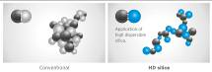

*1. Highly dispersible nano-silica tread compound*

* Improved wet traction,

snow and ice performance.

*2. Double functional, asymmetrical performance tread*



* The outer tread with its compact shoulder profile

offer better handling performance on dry roads.

* The inner tread surface increases braking power and traction

on wet and snowy streets.

* Especially efficient water and slush removal.



*3. 3D-sipes across the entire tread surface*

* Optimised driving stability in dry or wet conditions

and better winter performance through minimised block movement.

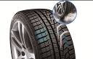

*4. Lateral grooves on the inside of the profile act like ice axes*

* Improved snow traction

through optimised angular arrangement of the lateral grooves.

*5. HRS (Hankook Runflat System) technology*

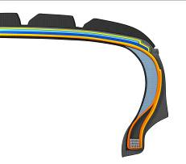

* Side wall reinforced tyres with run-flat features.
* Available in different sizes including for many

BMW models in the i*cept evo tread.

*6. Hankook SEALGUARD® technology*

* The SEALGUARD® tyre contains a viscous material with which

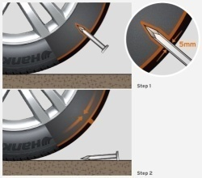

the interior of the tyre is coated from shoulder to shoulder.

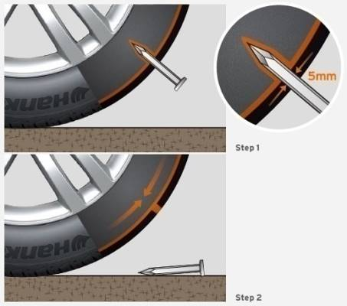

* In case of a puncture, holes with a diameter of up to

5 mm are immediately sealed off by the Hankook SEALGUARD® technology.

* Available in various sizes, including for VW Passat and Touran

in the i*cept evo² tread.

*7. Double-layer carcass*

* Extremely even ground pressure distribution through ideal

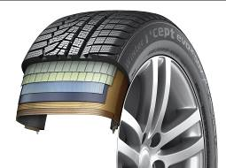

tyre contact surface.

* Outstanding driving stability, especially for

high-power, heavy vehicles

* Available in a variety of dimensions made especially for the

demands of modern sports utility vehicles

in the i*cept evo² SUV profile.

**Winter i*cept RS²: Very good test results!**

**The Hankook Winter i*cept RS² is “highly recommendable”, according to the editors of the Auto Zeitung in their winter tyre test. The very good snow performance and an outstanding price-performance ratio have convinced Auto Bild in previous years as well. Besides strong performance in the safety-related criteria in wet, snowy, and dry road conditions, the Winter i*cept RS² beat 50 competitors in terms of mileage too and has been awarded the title of “Eco Master”.**

“Aspects such as fuel efficiency and the sparing handling of resources are becoming increasingly important for tyre buyers, too,” explains Tony Lee, Hankook’s Vice President of Marketing and Sales for Europe. “Our current winter tread shows that these days modern, high-performance winter tyres can also meet customers’ requirements in terms of sustainability and environmental compatibility. We are extremely pleased with the independent test results and the related evaluations for our Hankook Winter i*cept RS².”

Developed to deliver balanced performance in all wintry driving conditions, the Hankook Winter i*cept RS2 comes equipped with a special nano-sized, high dispersible silica compound, resistant to hardening in low temperatures, and a new solution-styrene butadiene rubber The compound ensures the tread remains elastic even at low temperatures, thus providing excellent traction and braking power by increasing the tyre’s contact area, in particular in the cool temperatures and wet roads typical during the colder seasons. The increased void volume of the tyre tread, designed using Hankook Aqua-Slant technology, is achieved through the highly effective interaction between two longitudinal wide grooves on the tread. This offers especially efficient water and slush displacement.

The directional V-shaped tread design of Hankook's Winter i*cept RS² features 28% more pitches as well as increased groove and block edge length. Enhanced traction on snow covered surfaces is the result of the tread design which effectively bites into the snow. Moreover, the corrugated 3D sipes applied throughout the tyre tread increase traction and braking performance on all smooth surfaces. In addition they improve driving stability in wintry conditions by minimising block movement, abrasion and enhancing the overall handling performance through maximised edge effects. They also improve driving and lateral stability in all road conditions which occur during the cold season by optimising the general handling performance through maximised edge effects and minimising inner block movements, which also has a positive effect on the tyre’s wear behaviour.

Further improvements to the tyre contour have resulted in an even more homogeneous distribution of the bearing load and an increase in the contact surface of the Winter i*cept RS2 by up to five percent compared with conventional products which has further enhanced the braking performance on both wet and dry roads. The stiffer sidewall and bead area of the tyre ensures more direct steering reactions and improved steering feedback and a more precise lateral stability on dry roads as well. The Winter i*cept RS² is available for vehicles from city runabouts through compact and medium-size cars to estates and people carriers.

**Technical Characteristics of the Hankook Winter i*cept RS2**

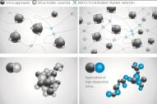

1. *New high-dispersible nano silica tread compound for improved winter performance*

* Improved wet traction, snow and ice performance.

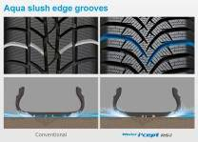

1. *Aqua slush edge grooves for improved wet performance*

* Water and slush are effectively drained away to reduce the risk of aquaplaning and improve wet braking performance.
* Significantly increased traction on snowy and slushy roads.

1. *3D sipes*



* Enhanced driving stability and improved winter performance through minimised block movement.

1. *Grip claw technology and increased pitch number for improved snow traction*



* 3D sharp edges improve traction on snow covered roads.
* 28% increase of pitch sequence for high snow grip and increased

traction performance.

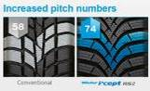

*5. Available sizes:*

* The Hankook Winter i*cept RS2 is available in 62 dimensions from 13 – 17 inches, in tread widths of 135 - 225 mm with aspect ratios from 45 - 80 in speed indices H and T.

**Hankook presents its new city bus tyre SmartCity AU04+ with an even longer service life**

**In the stop-and-go business of city traffic bus tyres must be able to withstand a heavy load and guarantee safe and efficient use at the same time. With the SmartCity AU04+ Hankook is launching the ideal city bus tyre on the market. The improved tread of the all-season tyre ensures as low and as even a wear as possible. The innovative tread compound and new tyre structure guarantee high safety and make efficient and eco-friendly use in city traffic a reality. Thus Hankook has a comprehensive range of city bus tyres available, comprising the AU03, AU03+ and the new SmartCity AU04+.**

Premium tyre maker Hankook is extending its range for city buses by a new tyre line: SmartCity AU04+. The bus tyre for city traffic impresses through efficient fuel consumption and maximum wear resistance. The tread design has been adapted. An improved rib spacing, stabilising 3D tread blocks and optimised zigzag grooves ensure outstanding traction without restricting mileage. The constant starting and stopping in city traffic puts a heavy and irregular load on bus tyres. “For this reason, Hankook has adapted the shoulder width and design for the SmartCity AU04+, thus guaranteeing more even wear. The improved structure of the new tread compound makes the tyre much more heat-resistant, thus reducing wear and make a longer service life possible“, adds Dipl.-Ing. Klaus Krause, Hankook’s Vice President and Head of the European Technical Center in Hanover.

The safety aspect is a major factor for Hankook during tyre development. The entire city tyre range from Hankook implements this claim. Like the AU03+, the SmartCity AU04+ is characterised by a reinforced sidewall. This protects the tyre from damage following contact with kerbstones. In addition, all three city bus tyre models have impressive brake distance values; the AU04+ stands out particularly through its excellent behaviour in wet road conditions due to the improved sipe arrangement. The deep sidewall indicator on the SmartCity AU04+ makes it easier to determine the tyre condition and thus supports timely damage prevention.

The SmartCity AU04+ is available in size 275/70R22.5 and has the M+S marking as well as the 3PMSF symbol (3 Peak Mountain Snowflake).

*Available sizes of the AU04+ / AU03+ and AU03:*

|  |  |  |  |  |  |  |
| --- | --- | --- | --- | --- | --- | --- |
| **Tread** | **Size** | **LI** | **Marking** | **Snowflake** | **M+S** | **Availability** |
| **AU04+** | 275/70R22.5 | 150/145J | D/B/W1/67 dB | ☑ | ☑ | ☑ |
| **AU03+** | 275/70R22.5 | 150/145J  (152/148) | D/C/W1/71 dB | ☑ | ☑ | ☑ |
| **AU03** | 11R22.5 | 148/145J | C/B W1 71 dB | - | ☑ | ☑ |
| 275/80R22.5 | 149/146J | D/C W1 71 dB | - | ☑ | ☑ |
| 295/80R22.5 | 152/148J | C/C W1 71 dB | ☑ | ☑ | ☑ |
| 245/70R19.5 | 136/134L | D/C W1 71 dB | ☑ | ☑ | ☑ |
| 265/70R19.5 | 104/138M | D/C W1 71 dB | ☑ | ☑ | ☑ |

**Technical features of the Hankook AU04+**

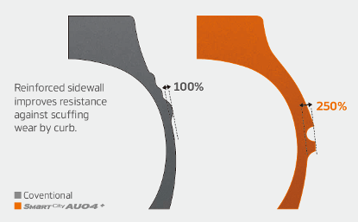

***Wide shoulders and reinforced sidewalls***

* Wide shoulders and reinforced sidewalls ensure excellent wet grip, grip and driving stability.
* New shape and position of the sidewall indicator makes determining the tyre condition easier.

***Improved tread design***

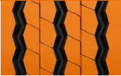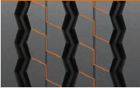

* Stabilising 3D tread blocks guarantee improved traction
* Longer service life through optimised rib spacing
* Three zigzag grooves guarantee excellent traction, particularly under wet conditions

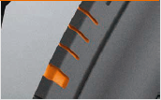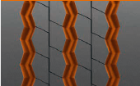

* Adapted should width and removed lugs and ribs ensure more even wear

***Innovative rubber compound***

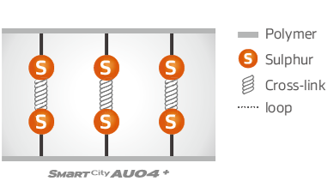

* Improved chemical structure makes the tyre more heat-resistant

**Hankook AL10+ e-cube MAX:**

**Low-line sizes for the steering axle**

**In times when the trend is going more and more towards volume transportation, the legally permissible outside height of four metres for commercial vehicles means that fleet operators are quickly reaching their limits. The issues get amplified if the freight forwarder wants to transport heavy standard goods in addition to volume transports. Therefore, premium tyre maker Hankook has now released the AL10+ e-cube MAX long distance tyre for the low-line segment as well. With the dimension of 355/50R22.5, the new low profile tyre for the truck steering axle is designed especially for the requirements of volume transports.**

Until now, fleet operators with truck tyres of series 60 to 80 have often not been able to completely utilise the maximum inner load height of three metres without exceeding the legally permissible total height of four metres. Therefore, load capacity is lost, which in turn can result in economic disadvantages. As a consequence, premium tyre maker Hankook is offering its customers a truck tyre for the steering axle in series 50: the AL10+ e-cube MAX was developed in size 355/50R22.5 exclusively for use on jumbo trucks for long distances, and it provides a load index of 156, which means that the axle can be loaded with a weight of up to 8 tons. With its small diameter, it lowers the coupling height of the tractor engine, with the result that the inner load height increases and the three-metre loading platform can be fully utilised thanks to the lower profile tyres.

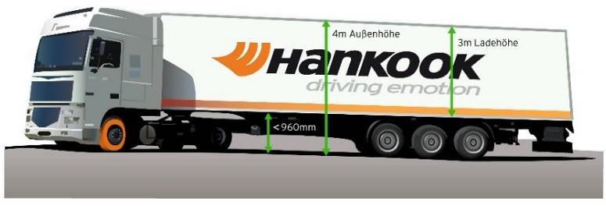

The tyre profile e-cube MAX for commercial vehicles represents maximum cost effectiveness, energy efficiency and environmental friendliness: due to its longitudinal grooved tread with wave structure, the AL10+ e-cube MAX for the steering axle prevents uneven wear. Therefore the AL10+ e-cube MAX guarantees an increased service life. The improved tread compound and high load index of the tyre increase the fuel efficiency while offering higher load capacity at the same time. The linear groove structure supports stable directional stability as well as maximum steering precision and improved water dispersal.

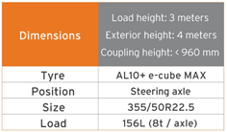

The long distance specialist for the steering axle is supported by its counterpart for the drive axle, the DL10+ e-cube MAX from the same tyre line. Due to its three-dimensional lamellae, it offers drivers outstanding traction, while the extra-wide profile block and deep grooves ensure increased mileage. The block stabilisers of the DL10+ e-cube MAX also contribute to a high service life and low rolling resistance. The e-cube MAX series is completed by the matching trailer tyre TL10+, which is characterised by maximum driving stability and low rolling resistance. Furthermore, the TL10 completes the e-cube package, which is available in sizes 275/70R22.5, 445/65R22.5 and 445/45R19.5.

*Sizes of the e-cube MAX tyre line available*

|  |  |  |  |  |  |  |
| --- | --- | --- | --- | --- | --- | --- |
| **Tread** | **Size** | **LI** | **Marking** |  | **M+S** | **Availability** |
| **AL 10+** | 315/80R22.5 | 156/150L (154/150M) | B/B/W1 70dB | - | - | 🗹 |
| 315/70R22.5 | 156/150L | B/B/W1 70dB | - | - | 🗹 |
| 385/65R22.5 | 160K | B/B/W1 70dB | - | - | 🗹 |
| 295/60/R22.5 | 150/147L | C/B/W1 70dB | - | - | 🗹 |
| 315/60R22.5 | 154/148L | C/B/W1 70dB | - | - | 🗹 |
| 355/50R22.5 | 156L | B/B/W1 70dB | - | - | 🗹 |
| **DL 10+** | 315/80R22.5 | 156/150L (154/150M) | C/C/W1 73dB | 🗹 | 🗹 | 🗹 |
|  |  |  |  |  |  |
| 295/60R22.5 | 150/147K | C/C/W1 73dB | 🗹 | 🗹 | 🗹 |
| 315/60R22.5 | 152/148L | C/C/W1 73dB | 🗹 | 🗹 | 🗹 |
| 295/55R22.5 | 147/145K | C/C/W1 73dB | 🗹 | 🗹 | 🗹 |
| 315/45R22.5 | 147/145L | D/C/W2 75dB | 🗹 | 🗹 | In production |
| **TL10+** | 215/75R22.5 | 135/133J | C/B/W1 69dB | - | - | 🗹 |
| 235/75R22.5 | 143/141J | B/B/W1 69dB | - | - | 🗹 |
| 245/70R17.5 | 143/141J (146/146F) | B/B/W1 69dB | - | - | 🗹 |
| 265/70R19.5 | 143/141J | B/B/W1 69dB | - | - | 🗹 |
|  |  |  |  |  |  |
| 385/65R22.5 | 160K | B/B/W1 69dB | - | - | 🗹 |
| 435/50R19.5 | 160J | B/B/W2 73dB | - | - | 🗹 |
| 455/40R22.5 | 160J | B/B/W2 71dB | - | - | 🗹 |

**All-rounders for all-year tyres**

**Particularly in changeable weather conditions, Hankook recommends that truck and bus customers use the SmartFlex all-weather tyre line for medium and long haul trips. Commercial vehicle customers can rely in particular on a high level of driving safety as well as the current trend of increased load-bearing capacity for some sizes.**

Both the steering axle tyres SmartFlex AH31 and the drive axle tyres SmartFlex DH31 have M+S marking and the snowflake (3PMSF) symbol, which means good traction is guaranteed even if drivers should be surprised by wintry road conditions. The Hankook SmartFlex DH31 has a 6-rib tread with special hexagonal tread blocks that guarantees more even wear behaviour and thus a longer tyre service life. Hankook's patented self-cleaning sipes in the middle of each block prevent damage to the block edges and thus guarantee excellent traction throughout the tyre life.

The SmartFlex all-year tyre line is completed by the corresponding trailer tyre SmartFlex TH31, which celebrated its première at the 66th IAA for Commercial Vehicles. Its wide, closed shoulder area supports stable straight driving and ensure good lateral stability. Chamfered tread grooves help prevent splintering.

Whilst the SmartFlex AH31 and SmartFlex DH31 are designated mainly for larger wheel sizes in the 22.5 inch range, SmartFlex AH35 and its drive axle counterpart SmartFlex DH35 is more designated for smaller wheels with 17.5/19.5 inch sizes.

*Sizes of the SmartFlex tyre line available*

|  |  |  |  |  |  |  |  |
| --- | --- | --- | --- | --- | --- | --- | --- |
| **Tread** | **Size** | **LI** | **Marking** |  | **M+S** | **Availability** | **Remark** |
| **AH31** | 295/80R22.5 | 152/148M (154M/149L) | C/B/W1 73 dB | 🗹 | 🗹 | 🗹 | - |
| 295/80R22.5 | 154/149M | C/B/W1 73 dB | 🗹 | 🗹 | 🗹 | Tyre with higher load-bearing capacity |
| 315/80R22.5 | 156/150L | C/B/W1 73 dB | 🗹 | 🗹 | 🗹 | - |
| 315/70R22.5 | 156/150L | C/B/W1 73 dB | 🗹 | 🗹 | 🗹 | - |
| 385/65R22.5 | 164K | C/B/W1 69 dB | 🗹 | 🗹 | 🗹 | - |
| 385/65R22.5 | 160K | C/B/W1 69 dB | 🗹 | 🗹 | 🗹 | - |
| 315/60R22.5 | 154/148L | C/B/W1 70 dB | 🗹 | 🗹 | 🗹 | - |
| 385/55R22.5 | 160K | C/B/W1 69 dB | 🗹 | 🗹 | 🗹 | - |
| 355/50R22.5 | 156L | C/B/W1 69 dB | 🗹 | 🗹 | 🗹 | - |
| **DH31** | 295/80R22.5 | 152/148M | D/C/W2 75 dB | 🗹 | 🗹 | 🗹 | - |
| 315/80R22.5 | 156/150L | D/C/W2 75 dB | 🗹 | 🗹 | 🗹 | - |
| 315/70R22.5 | 154/150L | D/C/W2 75 dB | 🗹 | 🗹 | 🗹 | - |
| 295/60R22.5 | 150/147K | D/C/W2 75 dB | 🗹 | 🗹 | 🗹 | - |
| 315/60R22.5 | 152/148L | D/C/W2 75 dB | 🗹 | 🗹 | 🗹 | - |
| **TH31** | 385/65R22.5 | 160K | B/B/W1 69 dB | - | 🗹 | In production | - |
| 435/50R19.5 | 160J | B/B/W2 | - | 🗹 | In production | - |
| 455/40R22.5 | 160J |  |  |  | In production | - |

**Technical properties of the Hankook SmartFlex all-year tyre line**

**SmartFlex AH 31**

***Truck all-year tyres for the steering axle for medium to long-haul applications***

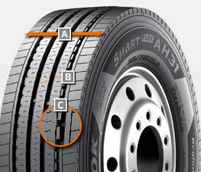

***A Extra-wide tread and shoulder area:***

* The extra-wide open shoulder area supports a high mileage and traction as well as outstanding handling properties

***B Multi-3D sipe treads:***

* High traction and mileage with even

wear

***C Tread Wear Equalizer Stepper Technology (T.W.E.S.):***

* Stabilisers on profile blocks
* Reduction of uneven/one-sided wear

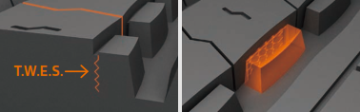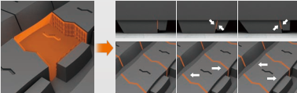

**SmartFlex DH 31**

***Truck all-year tyres for the drive axle for medium to long-haul applications***

***A Multi-3D sipes:***

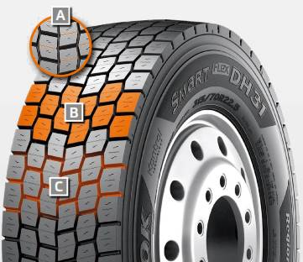

* High traction and mileage with even wear

***B 6-rib block tread:***

* Sturdy 6-rib block tread with special hexagonal tread blocks

***C Self-cleaning sipes:***

* Constant traction over the entire service life
* Protection against splintering at the corners of the sipes

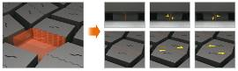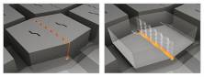

**SmartFlex TH 31**

***Truck all-year tyres for the trailer axle for medium to long-haul applications***

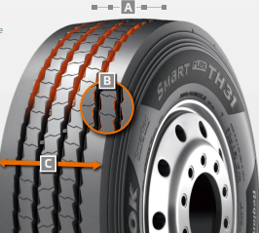

***A 4 Zigzag sipes:***

* 4 main tread grooves ensure optimum water displacement

***B Chamfered profile block design:***

* Chamfered profile blocks sipes help to prevent material splintering

***C Extra-wide tread and shoulder area:***

* The extra-wide closed shoulder area supports high driving stability and ensures good lateral stability as well as even wear

**Winner of the Red Dot Design Award: Hankook's all-year truck tyres SmartFlex AH35 and SmartFlex DH35 for regional traffic**

**With the steering axle tyre SmartFlex AH35 and the drive axle tyre SmartFlex DH35, premium tyre maker Hankook has an all-year truck tyre for regional traffic. The all-year tyres, winners of the Red Dot Design Award in 2016, have particularly high traction on account of special Multi-3D sipes. In addition, the rigid tread blocks with minimum block movement promote fuel-efficient driving.**

With the SmartFlex AH35 and SmartFlex DH35, fleets and forwarding agents benefit from a low-fuel, high-mileage and high-traction all-year tyre solution for the steering and drive axles. It is also possible to fit SmartFlex AH35 to all axles. In 2016, they were presented with the Red Dot Design Award. Whilst the SmartFlex AH31 and SmartFlex DH31 are intended mainly for larger wheel sizes such as 22.5 inch, the SmartFlex AH35 and its counterpart SmartFlex DH35 for the drive axle are designated to the smaller 17.5/19.5 inch sizes.

The Multi-3D sipes anchored in the tread of the SmartFlex AH35 guarantee outstanding traction. The mixture of straight and wave-shaped grooves improves water drainage and prevents hydroplaning long-term. Without losing sight of the summer properties, the M+S marking and the 3PMFS symbol (snowflake) indicate that the tyre is also perfectly equipped for all wintry weather conditions such as slush, ice and snow. The rigidity of the tread blocks promotes particularly fuel-efficient driving. Equally, the special tread design supports even tyre wear so that the Total Cost of Ownership for fleet and forwarding agent companies can be reduced long term in terms of service life. The high mileage and performance of the tyre are guaranteed by a wide contact area.

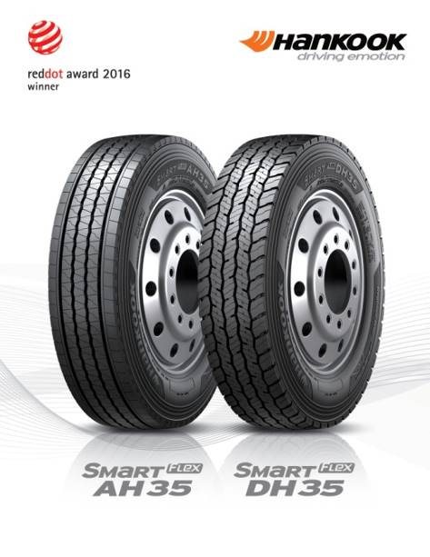

Just like the steering axle tyre, the drive axle tyre SmartFlex DH35 has M+S marking and the snowflake symbol. In addition, the tyre also has a wide contact area with four zigzag groove lines over the whole tread surface, enhancing mileage and driving performance under different road and traffic conditions. Furthermore, the 3D sipes ensure high traction and low rolling resistance. The innovative tread sipe design supports low rolling resistance and tyre traction for the drive axle in road traffic.

*Sizes of the SmartFlex tyre line available*

|  |  |  |  |  |  |  |
| --- | --- | --- | --- | --- | --- | --- |
| **Tread** | **Size** | **LI** | **Marking** |  | **M+S** | **Availability** |
| **AH35** | 8.5R17.5 | 121/120L | D/C/W1 67dB | 🗹 | 🗹 | 🗹 |
| 9.5.R17.5 | 131/129L | D/C/W1 67dB | 🗹 | 🗹 | 🗹 |
| 8R19.5 | 124/122L | D/C/W1 67dB | 🗹 | 🗹 | 🗹 |
| 205/75R17.5 | 124/122M | D/C/W1 65dB | 🗹 | 🗹 | 🗹 |
| 215/75R17.5. | 126/124M | D/C/W1 65dB | 🗹 | 🗹 | 🗹 |
| 215/75R17.5. | 128/124M | D/C/W1 65dB | 🗹 | 🗹 | 🗹 |
| 225/75R17.5 | 129/127M | C/C/W1 67dB | 🗹 | 🗹 | 🗹 |
| 235/75R17.5 | 132/130M | C/C/W1 69dB | 🗹 | 🗹 | 🗹 |
| 245/70R17.5 | 136/134M | C/C/W1 69dB | 🗹 | 🗹 | 🗹 |
| 245/70R19.5 | 136/134M | C/C/W1 67dB | 🗹 | 🗹 | 🗹 |
| 265/70R17.5 | 140/136M | C/C/W1 65dB | 🗹 | 🗹 | 🗹 |
| 265/70R19.5 | 140/138M | C/C/W1 67dB | 🗹 | 🗹 | 🗹 |
| 285/70R19.5 | 146/144M | C/C/W1 67dB | 🗹 | 🗹 | 🗹 |
|  | 305/70R19.5 | 148/145M | C/C/W1 65dB | 🗹 | 🗹 | 🗹 |
| **DH 35** | 205/75R17.5 | 124/122M | D/C/W1 66dB | 🗹 | 🗹 | 🗹 |
| 215/75R17.5 | 126/124M | D/C/W1 66dB | 🗹 | 🗹 | 🗹 |
| 225/75R17.5 | 129/127M | D/C/W1 73dB | 🗹 | 🗹 | 🗹 |
| 235/75R17.5 | 132/130M | D/C/W1 73dB | 🗹 | 🗹 | 🗹 |
| 245/70R17.5 | 136/134M | D/C/W1 73dB | 🗹 | 🗹 | 🗹 |
| 8.5R17.5 | 121/120L | D/C/W1 73dB | 🗹 | 🗹 | 🗹 |
| 9.5R17.5 | 131/129L | D/C/W1 73dB | 🗹 | 🗹 | 🗹 |
| 245/70R19.5 | 136/134M | D/C/W1 73dB | 🗹 | 🗹 | 🗹 |
| 265/70R17.5 | 139/136M | D/C/W1 73dB | 🗹 | 🗹 | 🗹 |
| 265/70R19.5 | 140/138M | D/B/W1 73dB | 🗹 | 🗹 | 🗹 |
| 285/70R19.5 | 146/144M | D/B/W1 73dB | 🗹 | 🗹 | 🗹 |
| 305/70R19.5 | 148/145M | D/B/W1 73dB | 🗹 | 🗹 | 🗹 |

**Technical properties of the SmartFlex AH35**

***A Wide contact area:***

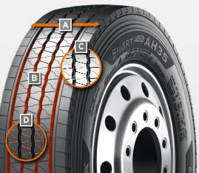

The wide contact area guarantees high mileage.

***B Four wave-shaped and straight grooves:***

The combination of four wave-shaped and straight grooves over the whole tread surface on a wide range of different road surfaces guarantees excellent water drainage

***C Multi-3D sipe tread:***

The Multi-3D sipe tread offers outstanding traction and thus promotes improved driving stability.

The rigidity of the tread blocks and the resulting minimum block movement lead to significant fuel savings.

***D Special tread design with “semi-sipes”***

Special tread design with “semi sipes” guarantees an even wear pattern over the entire service life

*Wide contact area*

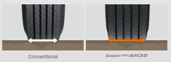

*Multi-3D sipes*

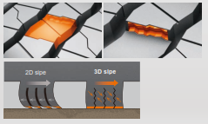

**Technical properties of the SmartFlex DH35**

***A Wide contact area with 4 zigzag grooves:***

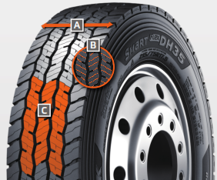

The wide contact area and the 4 all-round zigzag tread grooves ensure high mileage and overall performance.

***B Multi-3D sipes:***

The special tread design with Multi-3D sipes promotes low rolling resistance and outstanding traction.

***C Innovative tread design:***

The special tread design guarantees low rolling resistance and optimum traction under a wide range of different conditions.

*Wide contact area*



**About Hankook Tire**

Hankook Tire manufactures globally innovative, award winning radial tyres of proven superior quality for passenger cars, light trucks, SUVs, RVs, trucks, and buses as well as motorsports (circuit racing/rallies).

Aspiring to bring consumers the utmost excellence in product quality, technological excellence and driving satisfaction, Hankook Tire continuously invests in research and development maintaining five R&D centres and eight production facilities around the world. Bespoke tyre solutions for the European markets as well as European Original Equipment according to the requirements of leading premium car manufacturers, are developed in the company’s regional Technical Centre in Hanover/Germany. Production for the European region is taking place in the state-of-the-art manufacturing site in Rácalmás/Hungary which was inaugurated in June 2007 and is continuously being expanded. Currently around 3,000 employees produce up to 19 million tyres a year for passenger cars, SUVs and light trucks.

Hankook Tire’s European headquarters are located in Neu-Isenburg near Frankfurt am Main in Germany. The manufacturer operates further branches in Czech Republic, France, Germany, Hungary, Italy, the Netherlands, Poland, Russia, Spain, Sweden, Turkey, UK and Ukraine. Hankook products are sold directly through regional distributors in other local markets. Hankook Tire employs approximately 22,000 people worldwide and are selling their products in over 180 countries. Internationally leading car manufacturers rely on tyres made by Hankook for their original equipment. Approximately 30 percent of the company's global sales are generated within the European and CIS-Region. Hankook Tire has been represented in the renowned Dow Jones Sustainability Index World (DJSI World) since 2016.

For more information please visit [www.hankooktire-mediacenter.com](https://www.hankooktire-mediacenter.com/index.php?id=8&L=0&flt=5) or [www.hankooktire.com](http://www.hankooktire.com)

**Media-Contact:**

**Hankook Tire Europe GmbH | Corporate Communications Europe/CIS**

**Siemensstr. 14, 63263 Neu-Isenburg | Germany**

Felix Kinzer, Director

Corporate/Finance/Investor Relations, Magazine Tyre Testing, Crisis Comm. & CSR/Corporate Philanthropy

Tel.: +49 (0) 61 02 8149 – 170

f.kinzer@hankookreifen.de

Larissa Büsch, PR Manager

PCR/SUV, Media Events PCR/ SUV, Football/ Sport Sponsoring & Magazine Tyre Testing

Tel.: +49 (0) 6102 8149 – 171

l.buesch@hankookreifen.de

Yara Willems, Public Relations

PCR/SUV, Motorsport, Budget & Media Events

Tel.: +49 (0) 6102 8149 – 172

y.willems@hankookreifen.de

Anna Pasternak, PR Manager

TBR/LT, Motorsport, CSR/Corporate Philanthropy & Media Events TBR/ LT

Tel.: +49 (0) 6102 8149 – 173

a.pasternak@hankookreifen.de

Sabine Riedel, PR Manager

TBR/LT, Corporate/ Finance, Social Media & Media Website

Tel.: +49 (0) 6102 8149 – 174

s.riedel@hankookreifen.de