

Press Kit
International Motor Show
Frankfurt 2017

Contents
- Tyre maker Hankook presents pioneering tyre development at IAA 2017

Summer tyres

- The new Hankook KINERGY ECO²

- Hankook further develops silent technology “sound absorber®”

- Hankook UHP Flagship Tyre Ventus S1 evo² as OE on the new Audi RS 5

- Hankook supplies UHP Tyres with advanced “sound absorber®” Technology for the new Opel Insignia

- Hankook Ventus S1 evo²: Achieved “outstanding” test result

Hankook Ventus S1 evo² SUV: Rated “outstanding” by AUTO BILD Allrad

- Hankook Ventus Prime³: Premium comfort-tyre gains awards in 2017

Winter- Allseason tyres

- Hankook Kinergy 4S all-season tyre: 365 days of balanced performance

- Hankook UHP Premium winter tyres: Optimised driving during cold season; including SEALGUARD® technology; Run-flat OE

- Winter i*cept RS²: Very good test results!

Motorsport

- Hankook equips a new customer-racing model from BMW Motorsport

- New generation of Hankook racing tyres for the DTM 2017 season

Concept tyres

- New Volkswagen I.D. Crozz II fitted with Hankook concept tyres

- Hankook Tire showcases award winning futuristic concept tyre

- Innovated driving: 360-degree rotating “Ball Pin Tyre”

Images:

You will find further picture material for any of the press releases on our Hankook Mediacenter Website (also for the new Hankook concept tyres on Volkswagen I.D. Crozz II):
www.hankooktire-mediacenter.com/iaa2017
Tyre maker Hankook presents pioneering tyre development at the IAA 2017

Tyre maker Hankook is exhibiting at the IAA in Frankfurt again in 2017. In line with the “Future Now” motto of this year’s show, the company will present the tyre technologies of tomorrow at its fair booth. Alongside design ideas for the mobility concepts of the future, the focus is on innovations in premium original fitment tyres and the current winter tyre line-up.

Neu-Isenburg, Germany, 12th September 2017 – In accordance with this year’s “Future Now” motto, Hankook presents numerous future-oriented innovations at the IAA 2017. The premium tyre maker exhibits in Hall 8, Booth C26. Hankook has become an increasingly established name in the European tyre market as original equipment supplier for leading car manufacturers such as Audi, BMW, Ford, Mercedes-Benz, Opel, Porsche and VW. The company’s growth is also reflected in the opening of the new development centre in Korea, the “Technodome” and the company’s own European testing ground for winter tyres in Finland, the “Technotrac”.

In accordance with this year’s IAA motto, Hankook’s booth focuses on the latest trends and developments in the market. Alongside the presentation of a new summer product, the latest line-up in winter tyres is shown. This includes the eco-friendly high-performance winter tyre series i*cept which has been extended by several sizes; this winter tyres series has been developed using a special silica compound for central and western European conditions.

Visitors to the Hankook booth can also experience “Future Now” in the Next Driving Lab simulator. The driving experience features the futuristic concept tyre “Ball Pin Tyre”, and can be simulated on a large screen with an interactive 360-degree view.

“We are experiencing the future of driving today. The IAA is the ideal platform for current developments and progress in the automotive sector. For Hankook as a tyre maker in the premium segment, it is the best opportunity to present the technical highlights of global R&D activities and demonstrate the increasing development of the company,” explains Ho-Youl Pae, COO for Europe.

Once again, the latest concept tyres Flexup, Shiftrac and Autobine – created in cooperation with design students at the University of Cincinnati – will be on display. These tyres make ideas of the future tangible: they climb steps, change lane without changing direction and extend a vehicle’s tyre equipment automatically if more people have to be transported.

On the 14th and 15th September, information regarding career opportunities at the development centre in Hanover and the European headquarters in Neu-Isenburg will be available on the booth. Short interviews with department heads and human resources will be possible.

Visitors to the Hankook booth can additionally look forward to interviews and autographs with football players from Champions League Team Borussia Dortmund, popular TV presenter Sidney Hoffmann from German automobile TV Show PS Profis, and the current DTM drivers.

The new Hankook KINERGY ECO²: Economical summer tyres for Europe’s small, compact and mid-range vehicles
Hankook’s latest Kinergy generation - the exceptionally eco-friendly and economical KINERGY ECO² summer tyre was developed with the needs of modern small, compact and mid-range vehicles in mind. Like its predecessor, which received many outstanding reviews from independent institutions, the development engineers focussed not only on driving safety and economy with a low rolling resistance and high mileage, but also particularly on rolling and noise comfort. The new KINERGY ECO² will be available from Spring 2018, initially in 52 sizes from 13 to 16 inches, with tread surface widths of 145 to 215 mm in aspect ratios of 55 to 80 and the speed classes T, H and V.

In the portfolio of premium tyre maker Hankook, KINERGY represents the exceptionally economic summer tyre for vehicles from micro-car/small car to the lower mid-range. Due to the increasing electrification of smaller vehicle classes, accompanied by further urbanisation and shortage of space for traffic, the company envisages an increasing market for these vehicle segments and appropriate tyres. Alongside pure economic efficiency they also offer optimised traction and braking performances as well as noise comfort, and are therefore suitable for future generations of electric vehicles with their high torques and very low drive noise levels.
KINERGY is short for Kinetic Energy (from the Greek Kinesis = movement), in other words ‘the energy an object contains due to its movement’. It corresponds to the work that must be done to move the object from rest to its current movement. With the new Hankook tyre, this is much lower than with conventional tyres of this class. The suffix ECO provides orientation for consumers as it is widely understood to be a synonym both for ecology and economy, combining the eco-friendly an economical fuel-saving characteristics of the tyre for the benefit of both nature and consumers’ wallets. The first KINERGY ECO generation, which was launched in 2011, received many independent international awards¹. The new KINERGY ECO² is retaining these positive characteristics whilst being further improved. Optimisation of braking performance in the wet was a focus during development of the latest additions to the KINERGY family. A high-grip silica tread compound in conjunction with the compounding technology already used for the company’s performance products provides much better distribution of polymers and fillers in the tread compound. This has improved both wet braking performance and reduced rolling resistance even further. In addition, three linear grooves make fast drainage possible and also increase vehicle control on wet roads.

By using a newly designed, asymmetrical tread, the actual contact surface between the tyre and the road was optimised compared with its predecessor’s profile. Along with the improved tread stiffness in both radial and lateral directions, as well as the massive outer tyre shoulder, the KINERGY ECO² provides more driving stability and a significantly better dry performance. The dry braking performance of the tyre was also improved by four percent. This was made possible by applying chamfered tread block edges across the entire tread surface, which immediately increased the contact surface during braking. Newly-developed polymers with a high molecular weight in the tread compound of the KINERGY ECO² increase its wear-resistance by four percent.

Thanks to an improved pitch design, the noise development of the tyre particularly at country road speed has been further reduced, improving the comfort features even further. By using the latest Hankook design technology when positioning the tread grooves, development engineers were able to achieve a significant reduction in the noise level of the tread, even with improved tyre life. Like all current Hankook products, the KINERGY ECO² has a Visual Alignment Indicator System (VAI) on both tyre shoulders, which allows drivers to check the basic body alignment easily and conveniently.
¹ International test results determined by independent institutions for the Hankook KINERGY ECO of the 1st generation:

Medium: | Country: | Year: | Tyre size: | Overall rating:
ADAC/OEAMTC/TCS | Germany/Austria/Switzerland | 2016 | 185/65 R 15 H | Good (best mark in the test)
ACE/GTUE | Germany | 2016 | 195/65 R 15 V | Highly recommended
Auto Review | Russia | 2016 | 185/65 R 15 H | Best in test
Auto Bild | Germany | 2015 | 185/60 R 15 H | Exemplary
ADAC/OEAMTC/TCS | Germany/Austria/Switzerland | 2015 | 185/60 R 14 H | Good (best mark in the test)
ADAC/OEAMTC/TCS | Germany/Austria/Switzerland | 2014 | 175/65 R 14 T  195/65 R 15 V | Good (best mark in the test)  Good (best mark in the test)
L'Argus | France | 2012 | 205/55 R 16 V | Best in test
ACE/GTUE | Germany | 2012 | 205/55 R 16 V | Price/performance winner
Za Rulem | Russia | 2012 | 185/60 R 14 H | Good

Technical characteristics of Hankook KINERGY ECO²

- Improved performance on dry roads:
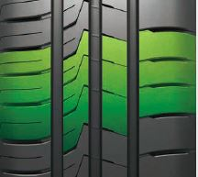
- Increased profile block stiffness in both radial and lateral directions.
- Optimised tyre contact surface and asymmetrical tread.
- Massive outer shoulder blocks for improved curve stability.
- Chamfered block edges broaden the contact surface while braking:
Dry braking improved by four percent.
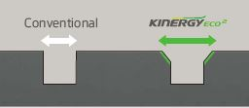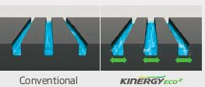

- Better wet performance:
- 3 linear optimally positioned main tread grooves for especially fast drainage.
- Newly developed, high-grip silica tread compound and new compounding technology for an improved distribution of polymers and fillers, resulting in a higher wet braking performance.

3. Reduced noise emissions and higher comfort:
- Innovative pitch design and new design technology for positioning the tread grooves: reduction of noise development on the tread, even with continued use.


- Lower rolling resistance and less tyre wear:
- High-grip silica compound reduces rolling resistance at the same time.
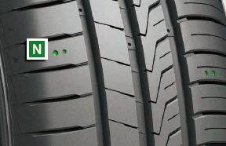
- Polymers with high molecular weights in the tread compound
for improved wear performance (four percent better).
- Visual Alignment Indicator System on the tyre shoulder blocks allows to easily check for uneven wear caused by poor body alignment.

5. Line-up:
The KINERGY ECO² is primarily produced in Hankook’s high end production facility in Hungary and will be available on the market from Spring 2018 in 52 sizes from 13 to 16 inches, with tread surface widths of 145 to 215 mm in aspect ratios of 55 to 80 and speed classes T, H and V.
Hankook further develops technology “sound absorber®”: focus on weight, process optimisation & top speed use

Hankook’s “sound absorber®” technology is already being successfully fitted as original equipment on premium SUVs and high-powered sport coupés. The patented sound absorbing technology has now been updated. The acoustic foam used is no longer being fixed in place with a full-surface coating of the company's own Sealguard material. Instead a new, specialised heat-resistant silicone-based glue, that only requires a partial coverage to achieve the same effect, is being applied. This updated adhesion process in conjunction with the newly developed and advanced lighter-weight acoustic foam, allows the second generation “sound absorber®” to offer a considerable weight optimisation. This means a labour intensive manufacturing process is no longer necessary, thus allowing larger production volumes to be achieved through fully automated production. Consequently, Hankook’s “sound absorber®” tyres will not be limited to luxury and premium class vehicles in the future; they will also become increasingly viable options for upper medium-class models. Tyres equipped with this technology significantly reduce system-related cavity vibrations which, at certain speeds, are audible inside the car.

Premium tyre maker Hankook has been delivering silent tyres as original equipment to car manufacturers since 2016. The “sound absorber®” technology has already been used across a variety of vehicle classes; from the performance focused Audi RS5 Coupé and the luxurious Audi Q7/SQ7 SUV, to spacious mid-class saloons and estate cars such as the new Opel/Vauxhall Insignia. With this technology, Hankook significantly reduces a car's interior noise caused by tyre cavity vibrations, and thus helps to create a more comfortable and luxurious driving experience. Every car can benefit as Hankook continues to develop this technology.

The Hankook “sound absorber®” tyres are equipped with a special polyurethane foam inlay sheet which is attached to the inside of the tyre during the manufacturing process. This helps to reduce unpleasant system-related resonances/droning frequencies which are produced at certain speeds during normal driving. The noise level peak value inside the vehicle drops considerably when “sound absorber®” tyres are used. This can be as much as 5 to 7 dB(A). Light weight, sporty ultra-high-performance tyres with a low aspect ratio but large resonant cavities tend to benefit most from this technology. Previously the acoustic foam used has been fixed in place using a thin layer of the company’s own Sealguard material, applied all over in a labour intensive process. As the “sound absorber®” technology has developed, the foam application has been integrated into the fully automated tyre manufacturing process. A new, lighter-weight foam material has also been developed for this purpose. In addition, the Sealguard material has been replaced by a silicone-based glue that only needs to partially cover the inside of the tyre, instead of the full-surface application previously used. This not only significantly reduces weight but enhances the heat-resistance properties of the new technology, resulting in improved load-bearing capacity and durability, particularly under full load conditions and at top speeds.

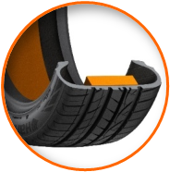
®

Hankook’ “sound absorber®” technology for the Ventus S1 evo²:
- Patented technology for noise reduction on the interior.
- Reduces resonances produced in the tyre cavity
thanks to a special, lightweight foam insert.
- The tyre’s driving characteristics remain unchanged.

Hankook UHP Flagship Tyre Ventus S1 evo² as Original Fitment on the new Audi RS 5 Coupé

The ultra-high-performance tyres from Hankook have already proved themselves on many Audi models. Like its brother model TT RS, the latest Audi RS5 Coupé will now also be leaving the factory fitted with Hankook tyres. In the spirit of the high performance Gran Turismo tradition, the Ventus S1 evo² tyres for the new Audi RS 5 Coupé provide both sportiness and comfort, and are thus an ideal match for the current top model in the A5 family. Both the standard 19-inch and the optional 20-inch versions of the Ventus S1 evo² are equipped with Hankooks own noise-reducing “sound absorber®” technology.

Premium tyre maker Hankook to supply original fitment tyres for the Audi RS 5 Coupé in 19- and 20-inch sizes. Hankook premiered as original equipment manufacturer for an RS model in 2016, fitting the high-performance two-seater Audi Sport TT RS with S1 evo² tyres on 19-inch wheels. The RS 5 Coupé is the first Audi RS-model to use the car makers new design philosophy, which is exclusively reserved for this line, and with its newly developed V6 biturbo engine combining an apparent contradiction: performance with efficiency. These characteristics are precisely what make the Audi RS 5 Coupé so unique – despite its high level of sportiness, it always remains suitable for everyday use. This premise applies for the tyres, too. During development, care had to be taken that the focus on sportiness was not achieved at the expense of comfort, and that good grip did not lead to a compromise on durability. This is all achieved by the Hankook Ventus S1 evo², which is fitted in sizes 265/35 R 19 98 Y XL (standard) and 275/30 R 20 97Y XL (optional) as original fitment tyres all round and equipped with the company’s new “sound absorber®” technology.

With each RS model, Audi Sport GmbH ensures that not only roadworthiness is guaranteed, but that sportiness is not only in the name either. In terms of the tyre approval procedure, this means that the road tyres have to survive ten laps of the iconic “Nordschleife” track at the German Nürburgring circuit in such a way that they can then drive just as safely back into the city for a shopping trip. Here, Hankook’s flagship tyre was able to demonstrate not only its sportiness, but its durability and reliability as well. The innovative DTM inspired 3-layer block design, with its special staircase arrangement of the outer rib blocks, thus ensures an evenly gripping tyre contact area even as tyre wear progresses, thereby guaranteeing very good traction performance throughout the entire lifetime of the tyre.

Short braking distances and an above-average performance in the wet ensure that drivers can completely rely on their tyres at all times. The sophisticated technology of the Ventus S1 evo² with its multiple tread radius and rayon carcass provides maximum tread contact, even if evasive action should suddenly become necessary in city traffic on wet roads or if hard braking is required on the motorway. The advanced styrene-polymer-silica mixture used for the tread compound comes into play here, optimising wet grip significantly.

Driving comfort in particular is further enhanced by Hankook’s own “sound absorber®” technology. This technology is already being used for the tyres on the current Audi Q7 and SQ7, and significantly reduces cavity noise. This reduction of that noise typical of sporty, low aspect ratio tyres at higher speeds was a pivotal aspect and a focal point of the development work to provide a top performing yet pleasant driving experience. The Hankook engineers adapted the company’s own silent tyre technology “sound absorber®” to date used on powerful large SUVs, and now to their passenger car flagship model, the Ventus S1 evo².
With this, Audi has chosen a tyre that combines sporty and dynamic driving with a high level of comfort.

Hankook supplies UHP Tyres with advanced “sound absorber®” Technology for the new Opel/Vauxhall Insignia

Car maker Opel/Vauxhall has chosen Hankook’s ultra-high-performance tyre Ventus S1 evo² as original fitment for the new Opel Insignia. The sporty and comfortable high-end 18 inch tyre with the latest Hankook “sound absorber®” technology is being factory fitted on the second Opel Insignia generation.

Premium tyre maker Hankook is supplying original fitment tyres both for the Opel Insignia Grand Sport saloon and for the Sports Tourer estate models. One of the ex works tyre options for the 2017 model is the ultra-high-performance tyre Ventus S1 evo² in size 245/45 R18 96W, which already comes with the advanced Hankook “sound absorber®” technology.

The sporty and elegant Opel/Vauxhall flagship with up to 260hp under the bonnet, stands for driving pleasure without compromising comfort. To match the new sportiness of the Opel Insignia Hankook engineers have developed a tyre that befits the characteristics of the car in every aspect. The optimised high-grip silica tread compound guarantees reduced rolling resistance and therefore contributes to an improved ecological footprint. The sophisticated technology of the tyre with its lightweight carcass provides maximum tread contact under all conditions. The innovative, DTM-inspired 3-layer block design with its special staircase arrangement of the outer rib blocks also ensures an evenly gripping tyre contact area throughout the entire tyre lifetime, thereby guaranteeing very good traction and braking performance on both wet and dry roads.

In order to further optimise cavity noise and improve the comfort characteristics of the Opel Insignia even further, the Hankook developers adapted the company’s own silent tyre “sound absorber®” technology. With this, a special polyurethane foam inlay sheet which prevents cavity noise is applied to the inside of the tread.

Opel/Vauxhall has chosen the Ventus S1 evo² as a tyre combining high suspension comfort, a very low rolling noise and reduced rolling resistance. As always with Hankook, the focus was on safety features during development therefore the tyre has wider tread grooves leading to enhanced aquaplaning characteristics as well as a high grip on both wet and dry roads.

- Hankook Ventus S1 evo²: achieved “outstanding”

test result in Auto Bild sportscars 2017 summer tyre test as well as a “recommendable” by auto motor sport
- Hankook Ventus S1 evo² SUV: also rated “outstanding” by AUTO BILD Allrad (4-wheel drive)

Hankook Tire’s UHP flagship Ventus S1 evo² is again rated ‘outstanding’ in the 2017 German Auto Bild Sportscars UHP Summer Tyre Test, keeping its 2016 title and is recognised as price-performance winner. The testers emphasize in particular its exemplary performance in handling and its good grip on wet and dry roads.

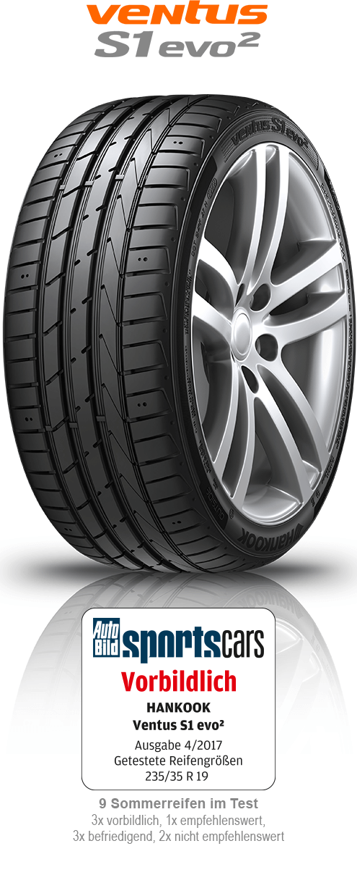
With two top-test results premium tyre maker Hankook adds to the success-story of its flagship tyre Ventus S1 evo² by achieving another ‘outstanding’ test result in the UHP Summer Tyre Test by the renowned German automobile magazine Auto Bild Sportcars in size 235/35 R19 91Y (Auto Bild Sportscars 07/2017). The magazine Auto Motor Sport reached a similar conclusion when testing size 245/45 R18 Y. Hankooks Ventus S1 evo² is named “recommendable” and the Testers emphasize the harmonic and well-balanced driving characteristics (auto motor sport 07/2017). Also awarded “outstanding” is the SUV-version Ventus S1 evo² SUV by Auto Bild Allrad, the 4-wheel drive magazine tested summer tyres in size 235/50 R19 (Auto Bild Allrad 04/2017). The UHP-SUV tyre has recently been chosen as original fitment with Sound absorber® technology by Audi for the Q7 and SQ7 TDI, the strongest Diesel-SUV on the market in size 285/35 R 22 106 Y XL. Rising demands in refitting business show that customers have discovered the impressive 22-rim tyre with interior-noise-reduction as a sporty, attractive as well as comfortable choice.
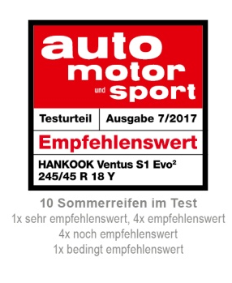
The tyre tests of the renowned automotive magazines reflect various performance aspects including handling and braking on both dry and wet roads, as well as noise level and rolling resistance. During the tests, the Ventus S1 evo² and Ventus S1 evo² SUV showed an overall very strong performance.

Equipped with sophisticated DTM technology, the Hankook Ventus S1 evo² has repeatedly been recognised by premium automakers including Audi, BMW, Mercedes Benz and the Volkswagen Group, for its successful combination of performance, durability, comfort and energy efficiency.

The tyre’s asymmetric tread design provides an increased water drainage performance whilst dispersing friction heat. It also guarantees a precise and comfortable driving experience with reduced noise and vibration.

Ho-Youl Pae, COO for Europe at Hankook, explains: “We are extremely pleased with these excellent test results for our UHP flagship models of the Ventus S1 evo² range. Regularly achieving such results in independent tyre tests gives proof that our continuous commitment to technology advancement results in products that deliver the best possible driving experience at all times for our customers.”

Technical Characteristics of the Hankook Ventus S1 evo²/ S1 evo² SUV

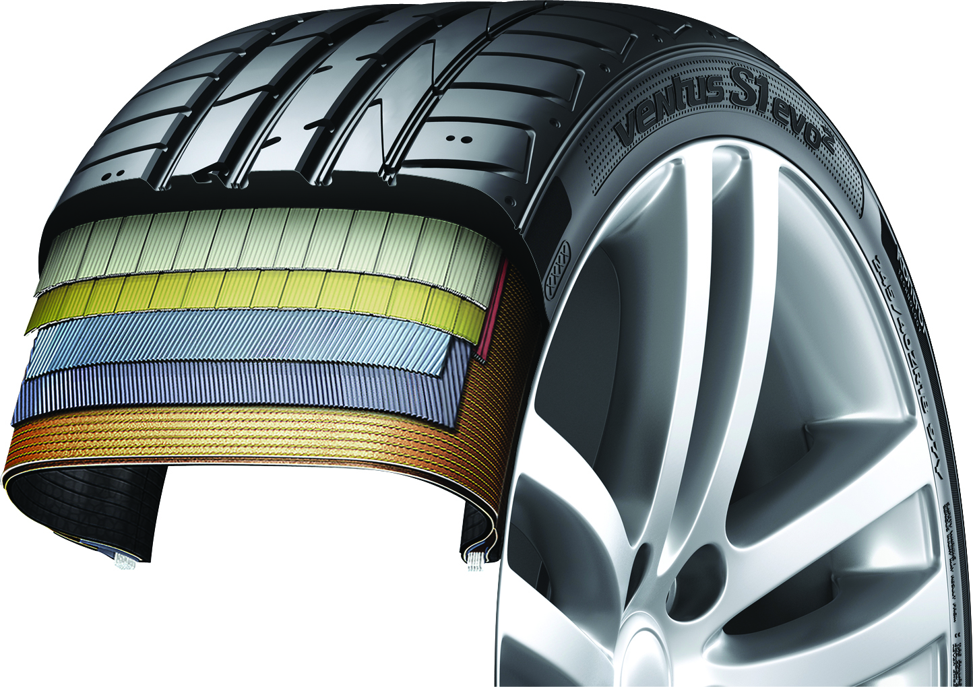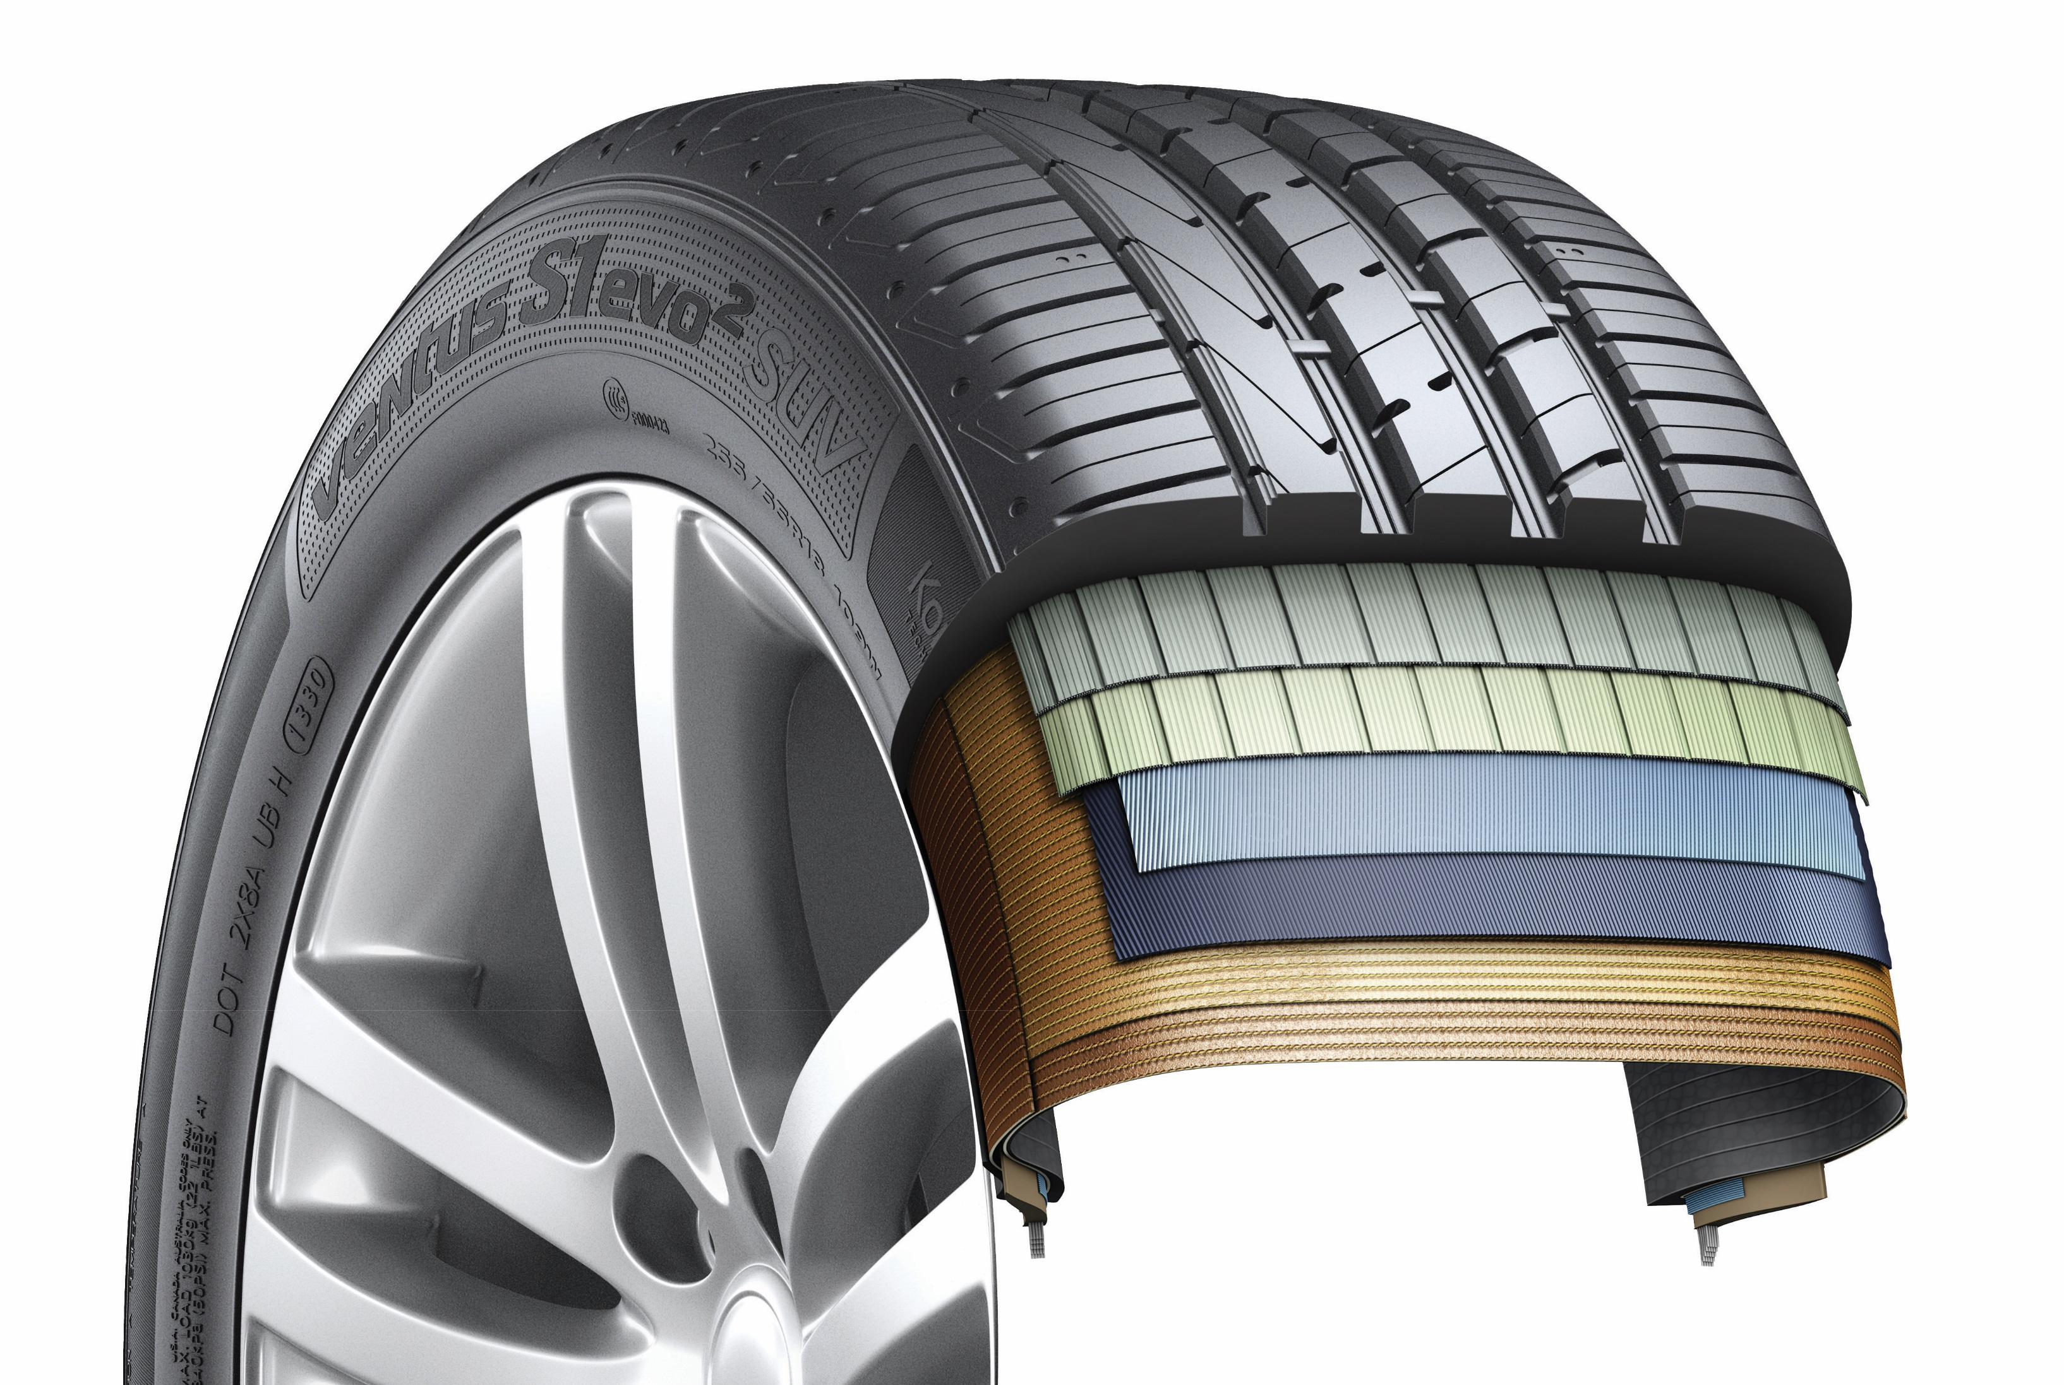
- DTM-engineered Multi-Tread-Radius Rayon carcass for
equal ground contact pressure through ideal tyre footprint
- Outstanding high-speed driving performance and straight stability.
- Perfect balance in both wet and dry conditions.
- Increased performance especially in lateral hydroplaning.
- High driving comfort combined with a low rolling noise.
- Double-layer rayon carcass for SUV version
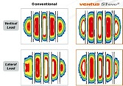

- DTM-inspired triple layered block design for superior traction
- The staircase arrangement of the outer rib blocks is designed to increase the tyre contact patch with the surface as the tyre wear progresses, ensuring a consistently high traction performance throughout the tyre-lifecycle.

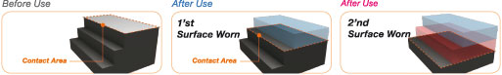
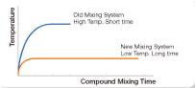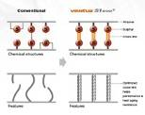
- Tread compound of the latest generation for reduced rolling resistance, dynamic handling characteristics and a high wet braking performance
- The extension of mixing times at reduced temperature significantly increases the binding speed and makes more specific cross-linking between carbon and rubber molecules possible for reduced heat development during driving, which in turn improves handling characteristics while at the same time reducing rolling resistance, tread wear and thermal ageing.
- New styrene polymer enhances the tyre’s wet braking performance.

- More stabling handling behaviour through improved heat regulation
- Surface-enlarging cooling fins in the ground of the tyre grooves provide a permanent heat reduction for a more stable handling performance.
- Double-step dimples at outer block edges generate micro cooling turbulences.
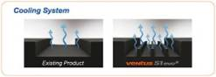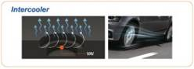
- Side walls with an aerodynamic design reduce rolling noise and vibration level for increased driving comfort.

5. Line-up Ventus S1 evo²/ S1 evo² SUV:
- Available in 165 sizes (including all specifications) from 16 to 22 inches, with tread
surface widths of 205 to 315 mm, aspect ratios of 65 to 30, in speed classes, W, Y and (Y).

Hankook Ventus Prime³ gains more awards in 2017
The comfort-champion of the successful Ventus product family for premium performance passenger car tyres was developed to provide an ideal blend of performance, safety, comfort, and environmental friendliness. Scoring first test wins directly after its market launch in 2016 the Ventus prime³ was nominated again in 2017 in the summer tyre test by the magazine AUTO BILD as ‘outstanding’ in size 225/50 R17 W/Y (Auto Bild 10/2017). The German car magazine Auto Zeitung produced a similar result when testing summer tyres in size 215/55 R17 94W, rating Hankook’s comfort-tyre as “very recommendable” (Autozeitung 07/2017). The line-up of the traditionally extremely diversified range of premium comfort tyres is available in numerous new sizes from 15 to 19 inches in both standard and run-flat versions.
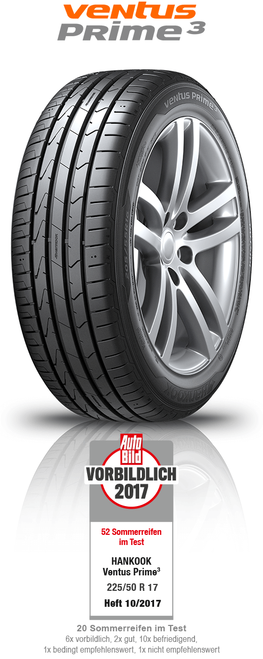
The ideal mix of performance, safety, comfort and environmental friendliness of the Ventus Prime³ continues on its road to success. which is why Hankook has once again extended its range for comfort-oriented saloons in the current season. The previous line-up for the aftermarket has been supplemented by a further 32 dimensions, from 195/60R15H to 225/55R19V. The particularly outstanding features of the tyres are their high level of comfort and especially good braking performance. The new dimensions also include two sizes with the Hankook Runflat system (HRS), 205/60R16V and 205/55R16W. With run-flat tyres, a car can drive at up to 80 km/h even if the tyre pressure has dropped following damage (breakdown).

A new, high-grip silica tread compound and an improved compounding technology which provides much more even distribution of polymers and fillers in the tread compound improve braking performance of the Ventus Prime³ on wet surfaces. This allows the tyres to achieve both wet braking performance improved by around eight percent and reducing of rolling resistance. In addition, the four wide profiled grooves ensure fast drainage, which improves vehicle control on wet roads and helps reduce the danger of aquaplaning. The depth of the individual profiled grooves also depends on their position on the tyre, in order to counteract the classic conflict between wet and dry driving characteristics in the Ventus Prime³. The current generation of the Ventus Prime³ also made another developmental leap when it comes to dry handling. By using a newly designed, asymmetrical tread, the actual contact surface between the tyre and the road was increased by ten percent. Along with the improved tread stiffness in both radial and lateral directions, and in conjunction with new “hybrid hardness” pattern ribs (different hardness levels on the outside and inside) and a massive outer tyre shoulder, the Ventus Prime³ provides significantly better dry performance. The dry braking performance of the tyre was also improved by three percent, whilst the traction was optimised, for instance, by applying chamfered profile block edges distributed across the entire tread surface, increasing the contact surface during braking.

Newly-developed, functionalised polymers with a high molecular weight in the tread blend of the Ventus Prime³ increase its wear-resistance by nine percent. The tyre is equipped with a highly-modern, lightweight, and especially sturdy Rayon carcass and a wide steel belt including a wrapped bandage and high-strength bead filler. Besides improving handling, this ensures precise steering feedback and great control, even at high speeds. Thanks to an improved pitch design and the optimised angle of lateral profiling, as well as a sidewall optimised for air resistance, developers were able to further develop the noise level of the tyres, once again improving the outstanding comfort features of the Ventus Prime³. By using a new technology when positioning the profile grooves, development engineers at Hankook were able to achieve a significant reduction in the noise level of the tread, even with improved tyre life.
Technical features of the Hankook Ventus Prime³

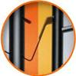
- Improved performance on dry roads
- Increased profile block stiffness in both radial and lateral directions.
- Tyre contact area increased by ten percent.
- Different hardness levels on the outer ribs, and a massive
outer shoulder block for improved curve stability.
- Longitudinally oriented tread design for outstanding directional stability, even at
high speeds.
- Chamfered profile block edges broaden the contact surface while braking:
dry braking power improved by three percent.
- Light, yet highly sturdy Rayon carcass and extremely strong
bead filler for better handling characteristics and precise steering feedback.

2. Improved performance on wet roads

- Four wide main tread grooves for especially fast drainage.
- Newly developed, high-grip tread blend and new compounding technology
for an improved distribution of polymers and fillers; eight percent
better wet braking performance.

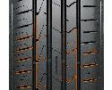
3. Reduced noise production and higher comfort
- Innovative pitch design and newly developed technology to position the tread
grooves in order to reduce noise production on the tread, even with
continued use.
- Stable, single-strand bead wire for excellent concentricity / driving comfort.
- Air resistance optimised side wall design to reduce air vortices
and vibrations at high speeds.
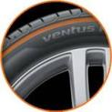

4. Lower rolling resistance and less tyre wear
- High-grip silica blend reduces rolling resistance.
- Polymers with high molecular weights in the tread compound:
wear performance improved by nine percent.
- Visual Alignment Indicator System on the outer tyre shoulder allows drivers to
easily check for uneven wear caused by poor body alignment.


5. Line-Up
- The Ventus Prime³ is primarily produced in Hankook’s highly modern European production facility in Hungary, and is available in 107 sizes from 15 to 19 inches, with tread surface widths of 185 to 245 mm, aspect ratios of 65 to 40, and is available in speed classes H, V, W and Y.

Hankook Kinergy 4S all-season tyre:
365 days of balanced performance for Europe’s roads

With the Kinergy 4S, tyre maker Hankook offers an all-weather specialist developed for European road conditions that features balanced performance and safety through all seasons.
Representing the fourth generation of all-season tyres from Hankook, the Kinergy 4S is geared toward continuing to offer drivers in Europe an alternative that features balanced performance and safety through all seasons, including climate change and future legal requirements. The tyre’s asymmetrical tread combines summer properties related to performance and safety on its block-tread outer side and tested suitability for winter conditions on the inner side, which features 3D sipes. The Kinergy 4S is offered in many popular sizes from 14 to 18 inches and is available as original equipment on the Audi Models TT, A1 and A4.

With the Kinergy 4S (4S - Four Seasons) all-season tyre, premium maker Hankook is continuing to gear its activities toward quality-conscious, ecology-minded drivers who prefer not to change their tyres every six months, but do not want to – or have to – go without balanced performance and safety. The Kinergy 4S is distinguished by its especially harmonious performance features across all seasons. This makes the tyre an attractive alternative when it comes to ensuring legally compliant year-round mobility as weather conditions in Europe become increasingly changeable. The tyre can be used all year round even in countries with seasonal winter tyre requirements, as it bears the M+S and snowflake symbols (which will be required for winter tyres in Europe, as elsewhere, starting in 2018). A true all-weather specialist, the Kinergy 4S combines the advantages of a summer tyre – short braking distances and good driving characteristics on both wet and dry surfaces at higher temperatures – with the benefits of a winter tyre, especially in the areas of traction and braking performance under cold conditions or with moderate snowfall. With their asymmetrical tread configuration, the current generation of Hankook all-season tyres adopts major design elements from its successful predecessor type, but the tyres have been fully redesigned, as the name also indicates.

The “summer shoulder” of the Kinergy 4S has been given a larger block structure in combination with stepped tie bars between the blocks, aligning it in particular to the more stringent requirements that apply when driving in dry conditions at higher temperatures. Its five-rib tread design also offers excellent stability. Special summer sipes on the outer tread blocks deliver better steering precision even when driving briskly on a dry surface. At the same time, the extra-wide belt package and highly dispersed silica tread compound for maximum bonding of silica and rubber make the tyre especially durable and reduce wear, extending the tyre’s lifespan and boosting cost-effectiveness. In combination with four main grooves of which the outer one comes in slanted design, this ensures optimum drainage, shedding water (or even slush) from the tread with high efficiency and effectively guarding against hydro- or slush planning.

The tyre’s inner tread has a winter design, with a higher number of sipes and blocks providing secure braking abilities in fall or winter weather conditions. An optimised tread surface with V-shaped crosswise grooves also enables controlled handling on snowy roads. Winter tread wear indicators incorporated into the tread grooves at regular intervals also make it quick and easy for drivers to check whether the tread meets the minimum depth requirements for winter tyres. Hankook is one of the first manufacturers to have recognised the potential of all-season tyres for the European market, and has been deliberately advancing its development efforts in this segment since the 1990s.

Technical Characteristics of the Hankook Kinergy 4S

1. Improved combination of summer and winter properties:
- Two differently designed types of sipes provide improved winter performance on the inner side (blue) and strong summer performance (green) on dry and wet surfaces on the tyre’s outer side at the same time.
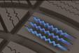
- Hankook’s 3D sipe system to enhance block stiffness provides optimum support for driving even under tough road conditions, and reduces wear.

2. Improved wet grip and a reduced wear:

- EA highly dispersed Nano Silica mixture enables more even molecular bonding for improved performance on wet roads, a reduced wear and an improved rolling resistance (4 per cent shorter wet braking distance).

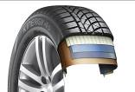
- Optimised tyre structure for a 6 per cent improved wet/ dry handling
and lateral stability:
- The wide tread belt package in combination with a jointless full cover reinforced belt and a high hardness bead filler provide improved handling, lateral stability and steering response for an overall more precise driving in summer.

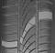
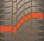
4. Safe driving and cornering in winter
- Ice axe inspired V-shaped lateral grooves offer
effective interlocking of the tread with the ground.
- A larger number of tread blocks with a wider design, combined
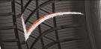
with highly dense self-locking sipes, increases the contact area between
the sipe and the road, giving the tyre better grip on road surfaces under winter conditions (10 per cent shorter snow braking distance) and an increased traction.

5. Line-Up:
- The Hankook Kinergy 4S line-up is available in a total of 83 sizes from 13 to 18
inches in series 80 to 40 and tread widths from 135 to 255 in the
speed ratings T, H and V, W, partially also as extra-load versions.

Hankook UHP Premium winter tyres:
- Optimised driving during the cold season
- Also with Hankook SEALGUARD® technology
- Run-flat original equipment on premium vehicles

Winter i*cept evo² and Winter i*cept evo² SUV with new sizes and even more models as run-flat version. The premium winter tyres of the i*cept evo family, which have been released in a number of sizes for up to 270 km/h, is rounded off with various new sizes for sporty cars and SUVs, run-flat sizes for premium original equipment and includes a SEALGUARD® version. The ultra-high-performance winter profiles i*cept evo, i*cept evo² and i*cept evo² SUV, which are optimised for winter conditions in Central and Western Europe, are provided with functional full-silica compounds and are already being fitted as original equipment on the new BMW 7 series. The asymmetric tread design used for all three versions ensures sporty yet comfortable handling on wet and dry roads as well as good traction and braking performance on snow-covered ground.

The ultra-high-performance winter profile which is optimised for winter conditions in Central and Western Europe and available for SUV and passenger cars, has been extended by further sizes for the coming winter season.In line with the continually increasing sales figures for SUVs, Hankook is boosting the line-up of its UHP winter tyre Winter i*cept evo² SUV by further sizes and also offering two new run-flat versions which offer drivers additional safety. The sizes 255/55R18V XL HRS (Hankook Run-flat System) and 255/50R19V XL HRS have been optimised for the requirements of sporty SUVs which want to be able to drive safely at speeds of up to 240 km/h with their winter tyres too.

The passenger car version of the tyre, the Winter i*cept evo², is also being offered in new run-flat sizes and the 20-inch version popular with premium vehicles. The newly available run-flat sizes 225/55R16H HRS and 245/45R17V XL HRS make sure you can reach the next repair garage safely even with a damaged tyre, without having to compromise on comfort and handling.

The i*cept evo series is offered in the run-flat versions with reinforced side walls for various BMW models among others. Thus, the Hankook Winter i*cept evo in the size 245/50 R18 HRS (Hankook Runflat System) has been fitted as original equipment to the BMW 7 series.

In the standard version, size 365/40R20W XL has been added, which is particularly suitable for the stylish equipping of sporty saloons and is approved for speeds up to 270 km/h. In addition, the Hankook SEALGUARD® technology is available in a number of sizes e.g. for the VW models Passat and Touran. The special SEALGUARD® sealing material seals punctures up to a diameter of 5 mm in the area of the tyre tread. This means that journeys can be continued with no problems even in the case of damage caused by puncture. Additionally, vehicles that are equipped with self-sealing tyres no longer need to carry spare tyres. In addition to their safety advantages, products equipped with Hankook SEALGUARD® technology offer particularly comfortable driving pleasure, as the tyres essentially have the same structure as the models without this technology.

Snow, ice, frost, heavy rain or wet leaves often produce dangerous road conditions in winter. The Hankook winter profiles i*cept evo, i*cept evo² and i*cept evo² SUV are therefore meeting these challenges with maximum-grip tread compounds and optimised design functions. Among other things, a highly dispersible nano-silica compound is used, which prevents hardening of the tyre at low temperatures and thus ensures better grip on wintry and wet roads through greater elasticity of the tyre contact area. The contact area of the tyre has been further improved thanks to further optimisation of the tyre profile, which likewise has a positive effect on grip in snow and rain and moreover ensures improved hydroplaning performance.

The outside of the traditionally asymmetric profile of the Hankook UHP profiles ensures improved snow handling and increased traction performance, whilst the inside guarantees optimised braking performance on snow, slush and wet roads. The snow traction performance is aided by an increased number of profile block edges, which effectively “grip” into the snow. By minimising block movement and wear, specially developed 3D sipes applied to the entire tread area ensure additional driving stability as well as improving the general handling properties with the aid of maximised edge effects. The transverse profiling arranged at an optimised angle on the inside of the profile likewise improves performance on snow-covered roads.

The two wide main drainage grooves offer 30 % greater volume for particularly efficient drainage of water or snow slush. In conjunction with the wide design of the tyre shoulder and the optimised cubic block design, a reinforced sidewall and bead area ensure direct steering response as well as improved cornering grip and optimised handling performance on dry roads too.

Both the Hankook winter tyre models i*cept evo, i*cept evo² and i*cept evo² SUV as well as the Hankook SEALGUARD® system are manufactured predominantly in the modern European production plants of Hankook in Hungary.

The Hankook Winter i*cept evo is available in the sizes 205/ 50 R15 H, 205/ 60 R15 H and 205 45 R17V HRS4 as run-flat tyre with reinforced side wall to fit many BMW models. The BMW 7 is factory fitted with the Hankook Winter i*cept evo 245/50 R18 100 H RSC among others.

The Hankook Winter i*cept evo² is available in a total of 156 sizes (including SUV, run-flat & Sealguard) from 15 - 21 inches with tread widths of 195 - 315 mm and aspect ratios of 75 - 30 in the speed indices H, T, V and W, mainly as designs with increased load capacity (Extra-Load ‒ XL).

Technical Characteristics of the Hankook Premium Winter Treads
i*cept evo, i*cept evo² and i*cept evo² SUV
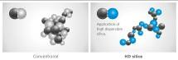
1. Highly dispersible nano-silica tread compound
- Improved wet traction,
snow and ice performance.


2. Double functional, asymmetrical performance tread
- The outer tread with its compact shoulder profile
offer better handling performance on dry roads.
- The inner tread surface increases braking power and traction
on wet and snowy streets.
- Especially efficient water and slush removal.


3. 3D-sipes across the entire tread surface
- Optimised driving stability in dry or wet conditions
and better winter performance through minimised block movement.

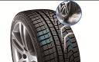
4. Lateral grooves on the inside of the profile act like ice axes
- Improved snow traction
through optimised angular arrangement of the lateral grooves.

5. HRS (Hankook Runflat System) technology
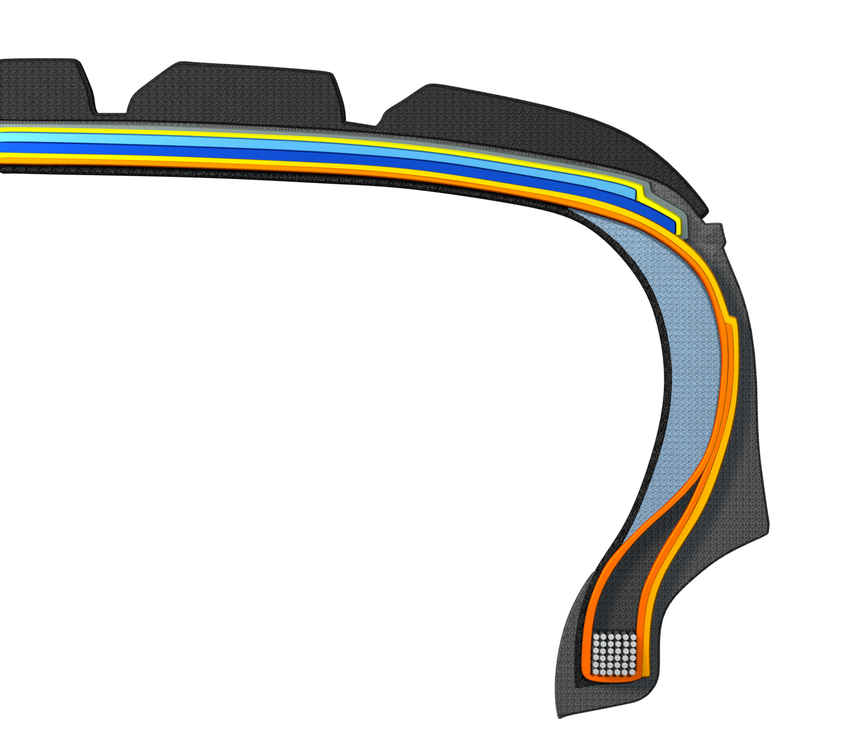
- Side wall reinforced tyres with run-flat features.
- Available in different sizes including for many
BMW models in the i*cept evo tread.

6. Hankook SEALGUARD® technology
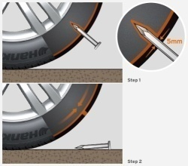
- The SEALGUARD® tyre contains a viscous material with which
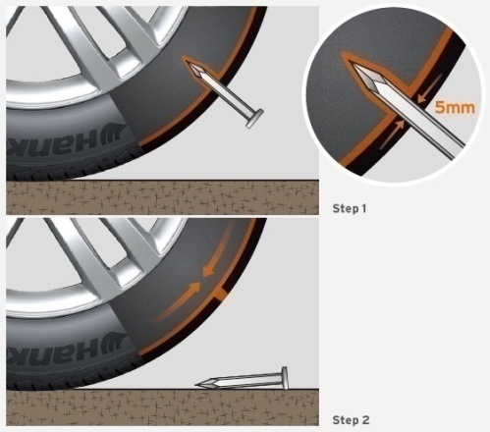
the interior of the tyre is coated from shoulder to shoulder.
- In case of a puncture, holes with a diameter of up to
5 mm are immediately sealed off by the Hankook SEALGUARD® technology.
- Available in various sizes, including for VW Passat and Touran
in the i*cept evo² tread.

7. Double-layer carcass
- Extremely even ground pressure distribution through ideal
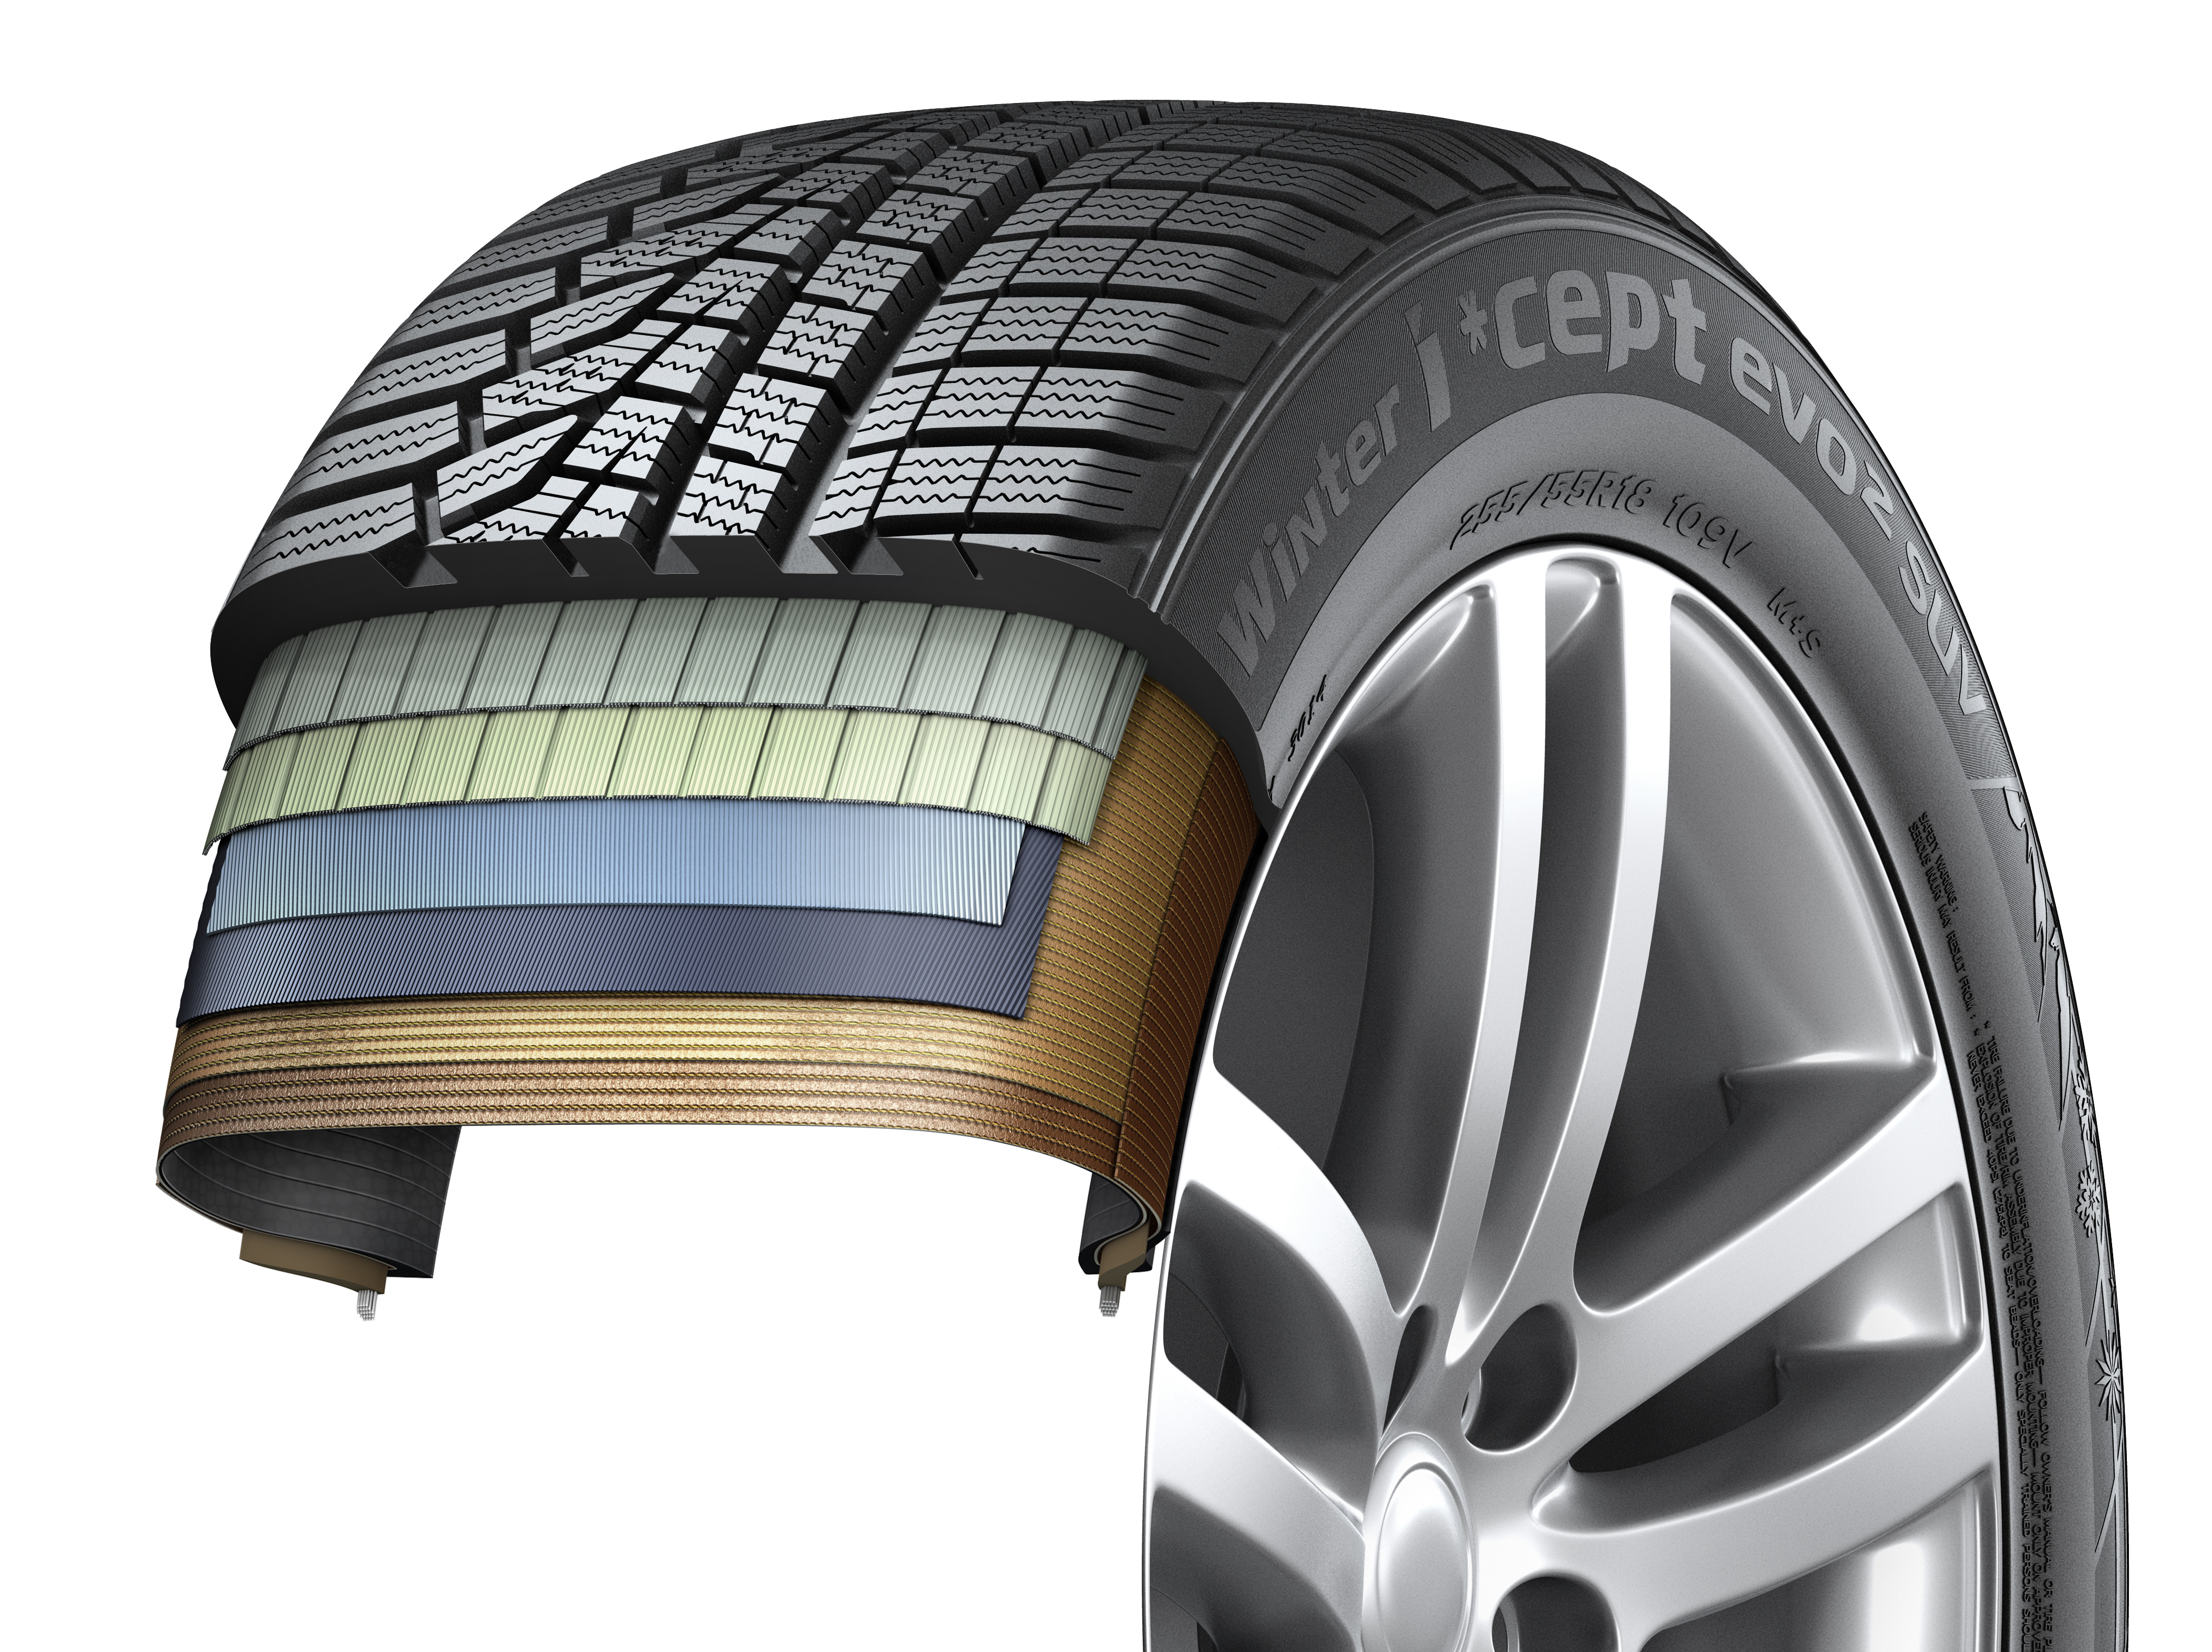
tyre contact surface.
- Outstanding driving stability, especially for
high-power, heavy vehicles
- Available in a variety of dimensions made especially for the
demands of modern sports utility vehicles
in the i*cept evo² SUV profile.

Winter i*cept RS²: Very good test results!

The Hankook Winter i*cept RS² is “highly recommendable”, according to the editors of the Auto Zeitung in their winter tyre test. The very good snow performance and an outstanding price-performance ratio of size 205/55 has once again impressed reviewers. Auto Bild emphasised; fuel-saving thanks to low rolling resistance as well as achieving high mileage, the Winter i*cept RS² is economical and safe. Besides strong performance in the safety-related criteria in wet, snowy, and dry road conditions, the Winter i*cept RS² beat 50 competitors in terms of mileage too and took the title of “Eco Master”.

As well as offering a strong performance in all safety-related criteria necessary in the cold season, the current generation of winter tyres from premium tyre maker Hankook is also extremely economical. This was rated as “highly recommendable” by the Auto Zeitung (Auto Zeitung issue 21/16 13 tyre treads of different makes, tested in size 205/55 R 16 on a VW Golf).The Hankook Winter i*cept RS² was able to beat off the competition once again in a test of winter tyres carried out by Auto Bild and was crowned “Eco-Master 2015” (Auto Bild issue no. 40 dated 2 October 2015, 50 tyre profiles of all makes, tested in size 185/60 R 15 T on a VW Polo). “Aspects such as fuel efficiency and the sparing handling of resources are becoming increasingly important for tyre buyers, too,” explains Tony Lee, Hankook’s Vice President of Marketing and Sales for Europe. “Our current winter tread shows that these days modern, high-performance winter tyres can also meet customers’ requirements in terms of sustainability and environmental compatibility. We are extremely pleased with the independent test results and the related evaluations for our Hankook Winter i*cept RS².”
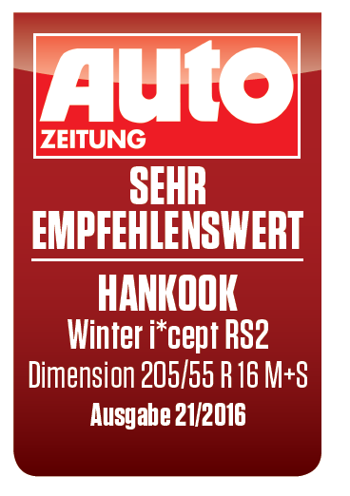

Developed to deliver balanced performance in all wintry driving conditions, the Hankook Winter i*cept RS² comes equipped with a special nano-sized, high dispersible silica compound, resistant to hardening in low temperatures, and a new solution-styrene butadiene rubber The compound ensures the tread remains elastic even at low temperatures, thus providing excellent traction and braking power by increasing the tyre’s contact area, in particular in the cool temperatures and wet roads typical during the colder seasons. The increased void volume of the tyre tread, designed using Hankook Aqua-Slant technology, is achieved through the highly effective interaction between two longitudinal wide grooves on the tread. This offers especially efficient water and slush displacement.

The directional V-shaped tread design of Hankook's Winter i*cept RS² features 28% more pitches as well as increased groove and block edge length. Enhanced traction on snow covered surfaces is the result of the tread design which effectively bites into the snow. Moreover, the corrugated 3D sipes applied throughout the tyre tread increase traction and braking performance on all smooth surfaces. In addition they improve driving stability in wintry conditions by minimising block movement, abrasion and enhancing the overall handling performance through maximised edge effects. They also improve driving and lateral stability in all road conditions which occur during the cold season by optimising the general handling performance through maximised edge effects and minimising inner block movements, which also has a positive effect on the tyre’s wear behaviour.

Further improvements to the tyre contour have resulted in an even more homogeneous distribution of the bearing load and an increase in the contact surface of the Winter i*cept RS² by up to five percent compared with conventional products which has further enhanced the braking performance on both wet and dry roads. The stiffer sidewall and bead area of the tyre ensures more direct steering reactions and improved steering feedback and a more precise lateral stability on dry roads as well. The Winter i*cept RS² is available for vehicles from city runabouts through compact and medium-size cars to estates and people carriers.

Technical Characteristics of the Hankook Winter i*cept RS²
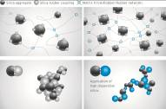
- New high-dispersible nano silica tread compound for improved winter performance
- Improved wet traction, snow and ice performance.

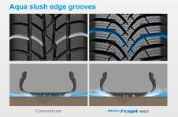

- Aqua slush edge grooves for improved wet performance
- Water and slush are effectively drained away to reduce the risk of aquaplaning and improve wet braking performance.
- Significantly increased traction on snowy and slushy roads.

- 3D sipes
- Enhanced driving stability and improved winter performance through minimised block movement.


- Grip claw technology and increased pitch number for improved snow traction
- 3D sharp edges improve traction on snow covered roads.
- 28% increase of pitch sequence for high snow grip and increased
traction performance.
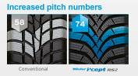

5. Available sizes:
- The Hankook Winter i*cept RS² is available in 62 dimensions from 13 – 17 inches, in tread widths of 135 - 225 mm with aspect ratios from 45 - 80 in speed indices H and T.

Hankook equips a new customer-racing model
from BMW Motorsport

Tyre maker Hankook is supplying the tyres for the new BMW M4 GT4. The customer racing models from the Munich-based premium car manufacturer will be exclusively fitted with Hankook race tyres and will be sold to motorsport enthusiasts in customer racing teams all over the world. The powerful new racing car fulfilled all expectations with a class victory on its debut during the 24H race at the Nürburgring. From 2018 onwards, Hankook is equipping a customer racing model from BMW motor racing alongside the BMW teams in the DTM for the first time

Hankook will be supplying its Ventus Race racing tyres in the size 300/660 R 18 on 11 x 18-inch wheels exclusively to international customers for the new BMW M4 GT4 in future. Exclusively equipped with Hankook racing tyres, it passed its official "baptism by fire" at the 45th ADAC Zurich 24H race from 26 to 28 May at the Nürburgring. During the iconic endurance race in the "Green Hell", the new customer sport racing car from BMW Motorsport gave a clear indication of its potential by winning its class. With the successful BMW M4 Coupé and its famous three-litre twin-turbo straight-six-cylinder engine as a basis, the new 431 hp M4 GT4 has also had its weight optimised in comparison to the series model by the use of lightweight carbon in the hood and doors. In addition, it has been supplemented by a special front splitter and an adjustable rear wing.

“The start of the sales phase represents the achievement of a further milestone with the BMW M4 GT4,” says BMW Motorsport Director Jens Marquardt. “We look forward to seeing the vehicle racing successfully at the hands of our customer racing teams 2018. We are relying on Hankook performance and expertise here, too. We offer our customers a fully developed and reliable GT4 vehicle which brings to bear the entire BMW motorsport know-how coupled with the powerful basis of the BMW M4 Coupé. Development of the BMW M4 GT4 focussed on mileage performance, cost efficiency and maintenance friendliness.”

“We are really looking forward to entering the world of BMW customer racing as a tyre supplier to the new M4 GT4. Successful cooperation with BMW Motorsport on a top international level in the DTM provided the ideal basis for this. Equipping this vehicle is a further success for us in international motorsport,” says Manfred Sandbichler, Hankook Motorsport Director in Europe.

New generation of Hankook racing tyres
in the DTM 2017 season

Tyre maker Hankook has launched a new generation of tyres for the DTM 2017 season. Preferred by the drivers, the new DTM slicks of the Ventus Race generate more grip in their optimum condition than the previous version. And, as requested by the vehicle manufacturers and organisers, they wear more quickly and heavily depending on use, which significantly influences lap times. This will increase race excitement.

For the current season in what is probably the world’s most successful touring car series, premium tyre maker Hankook introduced a completely new generation of slicks to the racetrack. The new Ventus Race, which is now the fourth DTM version, generates more grip than its predecessor despite unchanged dimensions (FA: 300/680 R 18, RA: 320/710 R 18). At the same time, particularly when pushed hard, it wears somewhat more quickly and heavily than last year’s model, which has a significant influence on lap times, depending on driving style.

Hankook, the exclusive DTM tyre partner has thus fulfilled a request by the three vehicle manufacturers Audi, BMW and Mercedes Benz as well as the DTM organiser ITR e.V., who expected the new tyres to lead to even more exciting races and significantly more overtaking manoeuvres. The season races to date have already shown that lap times can increase by several seconds as tread wear progresses and depending on how aggressive the driving style is, which promises very exciting racing, and demands more tactical skills from the drivers. The changes only affect dry tyres; the DTM rain tyre variant, the Ventus Race Rain, will remain unchanged for the 2017 season.

“There is no doubt that the DTM is one of the most technically demanding racing series in the world, so our development engineers have had some hard nuts to crack with the DTM racing tyres,” Manfred Sandbichler, Hankook’s Motorsport Director, explains. “As in the past, we have done a good job fulfilling the 2017 specification, as the exciting season shows.”

Thomas Baltes, the racing engineer responsible for the DTM at Hankook, explains: “The new DTM slicks are a completely new development, although the sizes remain the same. With the fourth generation of Ventus Race tyres, the focus is back on the “tyre whisperers” among the DTM drivers. Those drivers and their engineers who manage to run the tyres in particularly well, in order to get them to their optimum temperature window as quickly as possible but without too much aggression, have a significant advantage in 2017. The treatment of the tyres during qualifying also has more influence on the performance during the subsequent race than has previously been the case.”

Another alteration for 2017 prohibits the slicks being pre-heated. Thus, drivers must drive intelligently, particularly at the start and during the first laps after a pit stop, to get the tyres up to working temperature as quickly as possible.

Visionary new electric drive concept vehicle Volkswagen I.D. Crozz II is fitted with concept tyres from Hankook

Like the Volkswagen I.D. and the I.D. Buzz, the latest electric drive concept vehicle from Volkswagen, the I.D. Crozz II, is also fitted with concept tyres from Hankook. The tyre was developed according to the specifications from the Volkswagen Group exclusively for the new electric crossover, which is currently being presented at the IAA in Frankfurt. The zero emissions vehicles Volkswagen I.D., I.D. Buzz and I.D. Crozz II with Hankook concept tyres can be seen on the Volkswagen fair stand at the IAA, in Hall 3, Stand A02.

A new concept tyre from premium tyre maker Hankook will be showcased on the new electric drive concept vehicle from Volkswagen, the I.D. Crozz II, at the IAA in Frankfurt. The four-door vehicle with all-wheel drive is the first electrically driven Crossover Utility Vehicle (CUV) from Volkswagen – a mixture between Coupé and SUV. Following the world première of the concept car in Shanghai in April, the company is presenting a new version of the I.D. Crozz at the IAA. Like the Volkswagen I.D. and the I.D. Buzz, the latest generation from the Volkswagen Group is also equipped with Hankook tyres. With the concept tyre for the Volkswagen I.D. Crozz II, Hankook is again presenting an interpretation of innovative tyres for the electric vehicles of the future. The anthracite colour of the tyre blends in perfectly with the avant-garde design of the vehicle. The colouring is made with a special tread and side wall compound which contains white filler materials rather than soot. An inlay on the tyre side wall adapted to the tyre design provides a visual contrast and contributes to the harmonious interplay between wheel and tyre.

One special feature is that the concept tyre for the Volkswagen I.D. Crozz II got its special tread from a heated mould, just like conventional road tyres, and so the production process can be automated for the most part, which provides completely new opportunities. Up until now, the usual procedure for concept tyres has been to cut the tread painstakingly by hand into a blank tyre similar to a slick following vulcanisation. With the tyre for the I.D. Crozz II, only the inlay on the side wall was attached by hand.

The dimensions of the concept tyre correspond to size 245/45R21 in conventional tyres (I.D.: 215/45R20, I.D. Buzz: 235/45R22). The diameter, which is large compared to the tyre width, makes for a slim, high silhouette. This results in a lower drag coeffieient in relation to the contact area compared with conventional tyre dimensions, promoting optimum energy efficiency in conjunction with a lower rolling resistance. In addition, the large diameter results in less deformation and reshaping of the tyre, which has a positive effect on the rolling resistance. The size of the contact area, which is important for brake performance, traction and lateral stability, is relatively large despite the small tyre width, so that no compromises have to be made in terms of tyre performance in conjunction with the high-grip tread compound.

“We are very pleased to have implemented such a project together with Volkswagen. With the development of electric vehicles, the demands made on tyres will change in future, too. The rolling noise will play a more major role due to the lack of engine noise, and rolling resistance will have to be reduced even further to cut energy losses.” predicts Dipl.-Ing. Klaus Krause, head of the Hankook Europe Technical Centre in Hanover. “Nevertheless,” Krause continues, “future generations of Hankook tyres will still offer the same high safety as before.” Coloured tyres such as those on the Volkswagen I.D., the I.D. Buzz or the I.D. Crozz II are currently not competitive for cost reasons, but this does not mean they have to be reserved for concept cars: “Visual aspects can favour coloured tyres by all means. They can emphasise a vehicle's character and offer buyers further customising options for for their vehicles. Today's electric vehicle concepts show what can be possible in future.”

Hankook Tire showcases award winning

futuristic concept tyres

At the IAA 2017 in Frankfurt, premium tyre maker Hankook showcases innovative concept tyres inspired by future mobility. The five futuristic concept tyres Magfloat, Flexup, i-Play, Shiftrac and Autobine are designed by students at the University of Cincinnati to showcase Hankook’s cutting edge technology.

Global tyre company Hankook brings futuristic concept tyres to the 2017 IAA in Frankfurt. Each of the five concept tyres reflects Hankook’s design philosophy to develop innovative technology that will affect the future of driving. The tyres were designed in line with the theme ‘Connect to the Connected World’, where the company aims to predict mobility changes in future mega cities and present a vision of future mobility with tyres. This includes car sharing, autonomous driving and connected cars. Hankook Tire’s 2016 Design Innovation – the company’s exclusive sponsorship program for the world’s leading design universities - collaborated with the University of Cincinnati to design the five futuristic concept tyres. Featured are ‘Magfloat’ for flexible single user mobility based on magnetic field extensions, ‘Flexup’ for single user mobility that can freely ascend stairs and ‘iPlay’, a two wheel single user mobility. The ‘Shiftrac’ allows for strong cornering whilst the ‘Autobine’ can attach and detach the tyres from the body according to the number of passengers. “The IAA is a great venue for showcasing our innovative concept tyres because it is where the best in the industry come together,” said Mr. Seung Hwa Suh, Vice Chairman & CEO of Hankook Tire and added, “We are pleased to be leading the future mobility trend and look forward to revealing our futuristic concept tyres. Hankook Tire will continue to do its best to lead the tyre industry with our global top-tier technology.” Hankook’s concept tyres have been continuously recognized for design excellence with leading global design awards. In 2015 and 2016, the Boostrac, HyBlade and Alpike were awarded at the Red Dot Luminary, iF Gold and IDEA Awards, followed by the Flexup and Shiftrac which received bronze and finalist awards at the 2017 IDEA Awards.

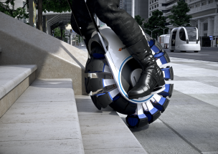
Hankook Tire – Flexup
[Can be used on stairs and speed bumps (0~35km/h)]
Futuristic single user mobility which can freely move within complicated cities and access stairs and speed bumps through a principle of divided treads that expand and contract.

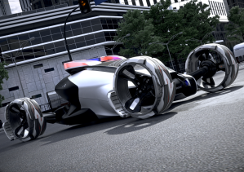
Hankook Tire – Shiftrac
[Strong cornering through skating principle]
The divided treads, with the skating principle provides maximum cornering performance. They are tyre concepts for special vehicles such as police cars in mega cities that are becoming increasingly sophisticated and dense.

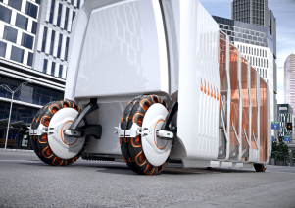
Hankook Tire – Autobine
[Expansion in accordance to number of passengers / Tyre detachment and attachment]
Wheels and tyres with their own power source that attach and detach according to the weight of the vehicle. It is an autonomous bus concept (Driverless Public Transportation) that has an applied Self-Contained Drone concept.

Innovated driving: 360-degree rotating “Ball Pin Tyre”

At this year’s IAA in Frankfurt, premium tyre maker Hankook is showcasing another progressive driving innovation as part of its “The Next Driving Lab” campaign: a 360-degree rotating “Ball Pin Tyre”.
Hankook presents “The Next Driving Lab” campaign, showcasing its 360-degree rotating “Ball Pin Tyre” at this year’s IAA in Frankfurt. As the 3rd project from “The Next Driving Lab”, Hankook Tire aims to use the most advanced technology to deliver a futuristic driving experience. The campaign began in 2013 and continues to highlight the company’s longstanding commitment to progressive, forward-thinking innovation.
The “Ball Pin Tyre” is a unique future-oriented tyre capable of moving in a full 360-degree circle, meaning right angle turns and zigzag driving is possible.
To help the “Ball Pin Tyre” achieve the full potential of its futuristic technology, Hankook Tire has installed an advanced gyroscope and a three omni-wheel system to the vehicle. The gyroscope and gyro-sensor measure and detect three-dimensional angles on the vehicle in order to maintain perfect balance between the body and the tyre. In addition, the precision control of the three omni-wheel system gives drivers the freedom to drive flexibly at any speed.
“With The Next Driving Lab campaign, Hankook Tire hopes to shed new light on our long-term commitment to leading the driving industry into the future by developing innovative, boundary-pushing technology,” said Mr. Seung Hwa Suh, Vice Chairman & CEO of Hankook Tire.
The Next Driving Lab campaign was launched in 2013 with the unveiling of Hankook Tire’s Digital Creative Car on the streets of Seoul, Korea. The campaign’s next venture was the Mind Reading Tyre showpiece, which featured a tyre capable of responding to brainwave commands. Hankook Tire’s official video on the 3rd project from The Next Driving Lab campaign, the “Ball Pin Tyre”, can be found on the company’s official web page (http://www.hankooktire.com) or YouTube page (https://www.youtube.com/watch?v=dTz-jszAkQ4&list=PLEB24B2655ECD46D6).

About Hankook Tire

Hankook Tire is one of the global top 5 companies in the mass production of tyres and manufactures innovative, award winning radial tyres of proven superior quality for passenger cars, light trucks, SUVs, RVs, trucks and buses as well as motorsports (circuit racing/rallies).

Hankook continues to invest in research and development so that we can always offer our customers the highest level of quality, combined with technological excellence. At a total of five development centres and seven large scale factories around the world, the company develops and produces tyre solutions specially tailored to the requirements and needs of regional markets. Bespoke tyre solutions for the European markets as well as European Original Equipment according to the requirements of leading premium car manufacturers are developed in the company’s regional Technical Centre in Hanover/Germany. Production for the European region is taking place in the state-of-the-art manufacturing site in Rácalmás/Hungary which was inaugurated in June 2007 and is continuously being expanded. Currently more than 3,000 employees produce up to 19 million tyres a year for passenger cars, SUVs and light trucks.

Hankook Tire’s European headquarters are located in Neu-Isenburg near Frankfurt am Main in Germany. The manufacturer operates further branches in Germany, UK, France, Italy, Spain, the Netherlands, Hungary, Czech Republic, Russia, Turkey, Sweden and Poland. Hankook products are sold directly through regional distributors in other local markets. Hankook Tire employ more than 22,000 people worldwide and are selling their products in over 180 countries. Internationally leading car manufacturers rely on tyres made by Hankook for their original equipment. Approximately 30 percent of the company's global sales are generated within the European and CIS-Region.

For more information please visit www.hankooktire-mediacenter.com or www.hankooktire.com

Media-Contact:
Hankook Tire Europe GmbH | Corporate Communications Europe/CIS
Siemensstr. 14, 63263 Neu-Isenburg | Germany

Felix Kinzer, Director
Corporate/Finance/Investor Relations, Magazine Tyre Testing, Crisis Comm. & CSR/Corporate Philanthropy
Tel.: +49 (0) 61 02 8149 – 170
f.kinzer@hankookreifen.de

Larissa Büsch, PR Manager
PCR/SUV, Media Events PCR/ SUV, Football/ Sport Sponsoring & Magazine Tyre Testing
Tel.: +49 (0) 6102 8149 – 171
l.buesch@hankookreifen.de

Yara Willems, Public Relations
PCR/SUV, Motorsport, Budget & Media Events
Tel.: +49 (0) 6102 8149 – 172
y.willems@hankookreifen.de

Anna Pasternak, PR Manager
TBR/LT, Motorsport, CSR/Corporate Philanthropy & Media Events TBR/ LT
Tel.: +49 (0) 6102 8149 – 173
a.pasternak@hankookreifen.de

Sabine Riedel, PR Manager
TBR/LT, Corporate/ Finance, Social Media & Media Website
Tel.: +49 (0) 6102 8149 – 174
s.riedel@hankookreifen.de

