

Press Kit for
Commercial Vehicle Show
Birmingham 2017

Contents

- Hankook presents new tyres at the 2017 Commercial Vehicle Show
- Hankook is Original Equipment Supplier for Scania
- Hankook Supplies Original Equipment Tyres with 36 Sizes to MAN
- Hankook Tire Expands Original Fitment Supply Volume to include Additional Sizes for Premium Trucks
- Hankook and Schmitz Cargobull AG to intensify their strategic cooperation
- SmartTouring is Hankook’s ultra-modern tyre for long-distance coaches
- Winner of the Red Dot Design Award: Hankook's all-year truck tyres SmartFlex AH35 and SmartFlex DH35 for regional traffic
- All-rounders for all-year tyres
- Hankook AU03+: For even more safety: Hankook is reinforcing the sidewalls of the bus tyre AU03+ on all axle positions
- Hankook AL10+ e-cube MAX: Low-line sizes for the steering axle
- Hankook light truck tyre Vantra LT: Energy efficient, safe and exceptionally durable
- Hankook SmartWork: Sturdy and durable for on and off-road
- Hankook TH22: Trailer tyres for low-bed truck transport
- Hankook ‘alphatread’: Bead-to-bead retread truck tyre range

Hankook presents new tyres at the
2017 Commercial Vehicle Show
Once again, this year Hankook Tyre UK will be exhibiting at the Commercial Vehicle Show from 25th to 27th April in Birmingham’s National Exhibition Centre – the largest and most comprehensive road transport and commercial vehicle event in the UK. In Hall 5, Stand 5C60, the premium tyre maker will be presenting a comprehensive range of commercial vehicle tyres including the new all-season trailer tyre SmartFlex TH31 and, for long-distance coach travel, the new SmartTouring AL22.
Birmingham, UK, 25th April 2017 – Hankook Tyre UK will be presenting their expanding portfolio of commercial vehicle tyres at the Commercial Vehicle Show in Birmingham. Taking place on the 25th-27th April 2017 at the National Exhibition Centre (NEC), Hankook will be located in Hall 5, stand number 5C60 where the stand shall feature a launch of the tyre manufacturers new all-season trailer tyre SmartFlex TH31 displayed in size 385/65 R22.5. Alongside the new addition to the SmartFlex range, the existing SmartWork series that is likewise selected as Original Equipment for MAN, Mercedes-Benz Truck and Scania vehicles will be presented. Besides the coach tyre for long-distance SmartTouring AL22 will be presented for the very first time on the UK market, which had been a product premiere at the IAA Commercial Vehicle Show 2016.

The SmartFlex TH31 is an all-year tyre for medium to long haul applications. It offers four main tread grooves to ensure optimum water displacement, a chamfered profile block design to prevent material splintering and extra-wide closed shoulder area which supports high driving stability and ensures good lateral stability as well as even wear. The new Hankook SmartTouring AL22, a new high-technology coach tyre for long-distance travel will also be presented to the UK market for the first time at the Show. The AL22 can be used on all axle positions and provides maximum ride and rolling comfort, excellent concentricity, a very low rolling noise and, as is customary with Hankook tyres, optimised rolling resistance and low wear for particularly efficient travel.

New for 2017, the Hankook stand will be featuring a ‘Wheel of Fortune’ which visitors can spin to win Hankook goodies as well as the opportunity to gain free entry to a draw to win 2 tickets to a 2017/18 Real Madrid home game including flights and hotel stay! The winner shall be announced after the exhibition ends.
Hankook Tyre UK looks forward to welcoming fans and the exhibition audience to the Hankook fair stand (Hall 5, Stand 5C60) between 8.30 am and 5.00 pm from 25th to 27th April.

###

Hankook is Original Equipment Supplier for Scania

Tyre maker Hankook has been the OE supplier for various Scania heavy-goods trucks and buses since 2016. Scania, based in Södertälje in Sweden, is a part of Volkswagen Truck & Bus GmbH - one of the world’s leading manufacturers of trucks and buses for heavy transport applications. Scania is also leading provider of industrial and marine engines. Service-related products account for a growing proportion of the company’s operations, assuring Scania customers of cost-effective transport solutions and maximum uptime. Scania also offers financial services. Since the end of 2016, Hankook has been supplying the truck tyre line e-cube MAX for long-haul traffic, as well as the SmartFlex, an all-year tyre for medium-haul applications, for the optimised Scania Euro-6 models. These tyres are environmentally friendly and economical, and have been adapted for European road conditions. From the end of 2017 onwards, the truck tyre line for construction site use SmartWork will also be fitted in all three European Scania plants.

Premium tyre maker Hankook has been Original Equipment Manufacturer to Scania, among others, since 2016. The Swedish commercial vehicles manufacturer is part of the Volkswagen Group, one of Hankook’s largest OE customers world-wide. Hankook’s OE business with truck tyres for Scania will focus on Europe and currently covers 18 dimensions in the 22.5 inch range. The OE cooperation with Scania is Hankook’s second within the Volkswagen Group in the heavy commercial vehicles segment; Hankook has already been supplying different models within this segment to the MAN Truck & Bus GmbH since 2015.

“The cooperation with Scania in the original equipment segment is real proof of the quality of our products, since the e-cube MAX, SmartFlex and SmartWork lines were all able to meet the stringent specifications of the Scania engineers particularly in terms of performance, efficiency and sustainability,” says Ho-Youl Pae, COO for Europe at Hankook.

All Scania truck and bus model ranges being produced in Europe are to be fitted with Hankook tyres. Tyres to be used include the e-cube MAX line for international long-haul traffic, a series which has been optimized for rolling resistance, and the new SmartFlex all-year tyre range, designed for flexible use between long-haul and delivery traffic. Construction site and offroad treads from the SmartWork series will also be introduced. Specially adapted for use on vehicles of the EURO 6 emissions class, the designated treads for the steering and drive axle score particularly well for environmental friendliness and service life – important aspects of TCO (Total Cost of Ownership) in the commercial vehicles OE business.

Tread | Size | LI | Marking |  | M+S | Availability
AL10+ | 315/80R22.5 | 156/150L (154/150M) | B/B/W1 70dB | - | - | ☑
AL10+ | 315/70R22.5 | 156/150L | B/B/W1 70dB | - | - | ☑
AL10+ | 315/60R22.5 | 154/148L | C/B/W1 70dB | - | - | ☑
DL10+ | 315/80R22.5 | 156/150L (154/150M) | C/C/W1 73dB | ☑ | ☑ | ☑
DL10+ | 315/70R22.5 | 154/150L | C/C/W1 73dB | ☑ | ☑ | ☑
DL10+ | 315/60R22.5 | 152/148L | C/C/W1 73dB | ☑ | ☑ | ☑
AL10 | 295/60R22.5 | 150/147K  (149/146L) | C/C/W1 70dB | - | - | ☑
AL10 | 295/80R22.5 | 152/148M (154/149L) | C/C/W1 70dB | - | - | ☑
AL10 | 385/55R22.5 | 158L (160K) | B/C/W1 70dB | - | - | ☑
DL10 | 295/80R22.5 | 152/148M | C/C/W2 75dB | - | ☑ | ☑
DL10 | 295/60R22.5 | 150/147K (149/146L) | D/C/W2 75dB | - | ☑ | ☑
AH31 | 295/80R22.5 | 152/148M | C/B/W1 73dB | ☑ | ☑ | ☑
AH31 | 315/70R22.5 | 156/150L | C/B/W1 67dB | ☑ | ☑ | ☑
AH31 | 315/80R22.5 | 156/150L | C/B/W1 73dB | ☑ | ☑ | ☑
DH31 | 295/80R22.5 | 152/148M | D/C/W2 75dB | ☑ | ☑ | ☑
DH31 | 315/80R22.5 | 156/150L | D/C/W2 75dB | ☑ | ☑ | ☑
DH31 | 315/70R22.5 | 154/150L | D/C/W2 75dB | ☑ | ☑ | ☑
AH15 | 385/65R22.5 | 160K | C/B/W1 70dB | - | - | ☑

###

Hankook Supplies Original Equipment Tyres with 36 Sizes to MAN

Tyre maker Hankook is consistently expanding its Original Equipment commitment in the truck segment and already supply original equipment tyres in 36 sizes to MAN. The MAN Truck & Bus AG belongs to the Volkswagen Group, one of Hankook's largest OE customers worldwide. The OE business with Hankook truck tyres for MAN covers a total of 36 dimensions in the 17.5, 19.5, 22.5 and 24 inch range. Hankook's Original Equipment range for the bus and truck manufacturer includes the supply of the tyre lines e-cube MAX, SmartFlex and SmartWork for various MAN models to the production facilities of the Munich-based manufacturer in Germany, Austria and Poland. The tyre ranges have been specially adapted for European conditions, boasting both ecological and economic advantages.

Premium tyre maker Hankook is listed as an OE supplier for MAN with 36 dimensions, including the truck tyre ranges e-cube MAX, SmartFlex and SmartWork. The commercial vehicles specialist and the tyre maker have been cooperating since the first quarter of 2015. Ho-Youl Pae, Hankook COO for Europe comments: “The expansion of OE business in the commercial vehicles segment with MAN is of great strategic importance to us, as we can now offer further treads and dimensions for light to medium-duty trucks from MAN.”

The tyres will be fitted to the multi-award-winning MAN vehicle series TGX, TGS, TGM and TGL which are used for national and international long-haul, delivery and construction site traffic. Tyres used include the e-cube MAX line, which is tried-and-trusted for international long-haul traffic, the new SmartFlex all-year tyre range for flexible use between long-haul and delivery traffic, as well as construction site treads from the SmartWork series. Specially adapted for use on vehicles of the EURO 6 emission class, the treads – both as special steering and drive axle versions – score highly for environmental friendliness and mileage. This is also relevant to the TCO (Total Cost of Ownership), important for Original Equipment.

One special feature of the Hankook’s Original Equipment portfolio for MAN are the numerous sizes in the low-line segment; the latest size to be added is 355/50R22.5. With these, the premium tyre maker is demonstrating that its portfolio has already integrated the current market trend, namely the growing importance of low-line sizes in the truck business.

Hankook's range of Original Equipment tyres for MAN:

Tread | Size | Model | LI | Marking |  | M+S | Availability
AL10+ | 315/80R22.5 | TGX | 156/150L (154/150M) | B/B/W1 70dB | - | - | þ
AL10+ | 315/70R22.5 | TGX | 156/150L | B/B/W1 70dB | - | - | þ
AL10+ | 315/60R22.5 | TGX | 154/148L | C/B/W1 70dB | - | - | þ
AL10+ | 355/50R22.5 | TGX | 156L | C/B/W2 76dB | - | - | þ
DL10+ | 315/80R22.5 | TGX | 156/150L (154/150M) | C/C/W2 75dB | þ | þ | þ
DL10+ | 315/70R22.5 | TGX | 154/150L  (152/148M) | C/C/W2 75dB | þ | þ | þ
DL10+ | 315/60R22.5 | TGX | 152/148L | C/C/W2 75dB | þ | þ | þ
AL10 | 295/60R22.5 | TGX | 150/147K  (149/146L) | C/C/W1 70dB | - | - | þ
AL10 | 295/80R22.5 | TGX | 152/148M | C/C/W1 70dB | - | - | þ
AL10 | 385/55R22.5 | TGX | 158L (160K) | B/C/W1 70dB | - | - | þ
DL10 | 295/80R22.5 | TGX | 152/148M | C/C/W2 75dB | - | þ | þ
DL10 | 295/60R22.5 | TGX | 150/147K (149/146L) | D/C/W2 75dB | - | þ | þ
AH31 | 295/80R22.5 | TGM & TGS | 152/148M | C/B/W1 72dB | þ | þ | þ
AH31 | 315/70R22.5 | TGM & TGS | 156/150L | C/B/W2 73dB | þ | þ | þ
AH31 | 315/80R22.5 | TGM & TGS | 156/150L  (154/150M) | C/B/W2 73dB | þ | þ | þ
AH31 | 385/65R22.5 | TGM & TGS | 160K | C/B/W1 69dB | þ | þ | þ
AH31 | 315/60R22.5 | TGM & TGS | 154L | C/B/W1 75dB | þ | þ | þ
DH31 | 295/80R22.5 | TGM & TGS | 152/148M | D/C/W2 75dB | þ | þ | þ
DH31 | 315/80R22.5 | TGM & TGS | 156/150L  (154/150M) | D/C/W2 75dB | þ | þ | þ
DH31 | 315/70R22.5 | TGM & TGS | 154/150L | D/C/W2 75dB | þ | þ | þ
DH31 | 315/60R22.5 | TGM & TGS | 154/148L  (152/148L) | D/C/W2 75dB | þ | þ | þ
AH11 | 215/75R17.5 | MAN TGL | 128/126M | D/C/W1 67dB | - | - | þ
AH11 | 235/75R17.5 | MAN TGL | 132/130M | D/C/W1 67dB | - | - | þ
AH11 | 265/70R19.5 | MAN TGL | 140/138M | C/C/W1 67dB | - | - | þ
AH11 | 285/70R19.5 | MAN TGL | 145/143M | C/B/W1 67dB | - | - | þ
DH05+ | 215/75R17.5 | MAN TGL | 126/124M | D/C/W1 67dB | - | þ | þ
DH05+ | 235/75R17.5 | MAN TGL | 132/130M | E/B/W2 75dB | - | þ | þ
DH05+ | 265/70R19.5 | MAN TGL | 140/138M | D/B/W2 75dB | - | þ | þ
DH05+ | 285/70R19.5 | MAN TGL | 145/143M | D/C/W2 75dB | - | þ | þ
AM06 | 325/95R24 | MAN TGS | 162/160K | D/C/W2 72dB | - | þ | þ
DM06 | 325/95R24 | MAN TGS | 162/160K | D/B/W1 67dB | - | þ | þ
AM15+ | 385/65R22.5 | MAN TGS | 158L | D/C/W2 73dB | - | þ | þ
AM09 | 315/80R22.5 | MAN TGS | 156/150K | D/C/W1 70dB | - | þ | þ
AM09 | 13R22.5 | MAN TGS | 156/150K | D/C/W2 74dB | - | þ | þ
DM09 | 315/80R22.5 | MAN TGS | 156/150K | D/C/W1 68dB | - | þ | þ
DM09 | 13R22.5 | MAN TGS | 156/150K | D/C/W2 75dB | - | þ | þ

Hankook Tire Expands Original Fitment Supply Volume to include Additional Sizes for Premium Trucks

Hankook supplies 42 sizes of its premium truck tyres as Original Equipment to the European market, including for the complete Mercedes-Benz Actros family and Atego model ranges. Just recently, Hankook also become the standard equipment supplier for the steering and drive axles for the Mercedes-Benz Actros family in the low-line size 315/60R22.5 as well. This refers to the SmartFlex product line. Overall, the Hankook portfolio for Daimler includes the e-cube MAX, SmartFlex and SmartWork tyre families. The range of sizes available from Hankook for the commercial vehicle segment at Daimler AG has more than quadrupled since the cooperation for Original Equipment for Europe began in 2014.

Premium tyre maker Hankook is continually expanding its original equipment (OE) portfolio in the heavy commercial vehicle (HCV) and medium duty segment as part of its existing OE agreements for Mercedes-Benz truck model range: Actros, Antos, Arocs, Axor, Econic and Atego and equips the premium commercial vehicle manufacturer with no less than 42 sizes in Europe alone. The tyre maker’s latest original equipment portfolio includes among others the Hankook treads AL10+ e-cube MAX and DL10+ e-cube MAX, as well as the SmartFlex AH31 and SmartFlex DH31, all of which have been specially developed for the European market. Just recently, Hankook also became the standard equipment supplier for the Mercedes-Benz Actros family both with the SmartFlex AH31 tread for the steering axle and the SmartFlex DH31 tyre for the drive axle in the low-line size 315/60R22.5. The tyre maker is thus following the steadily growing market demand for commercial vehicle tyres in the low-line segment.

In addition, Hankook supplies multiple options for 22.5 inch tyres, the top-selling standard wheel size for heavy duty trucks in Europe, as well as for commercial vehicle tyres in the 17.5 and 19.5 inch sizes. Extending the OE fitment of the most-demanded heavy duty and medium duty trucks further strengthens the Hankook brand in a highly competitive market and is yet another milestone in the company’s endeavour for sustainable growth in the TBR business. Since the start of their original equipment business with Daimler AG, Hankook has expanded its portfolio for the Stuttgart-based truck and bus manufacturer to include more than 42 dimensions.

The e-cube MAX AL10+ (all position long haul) utilises linear grooves with waved walls to prevent uneven wear, enhancing durability and providing improved long-term fuel efficiency. The improved tread compound and high load index of the AL10+ increases fuel efficiency whilst simultaneously increasing load capacity. The e-cube MAX DL10+ (drive axle long haul) offers drivers excellent traction with three-dimensional kerfs and superior long mileage performance with extra-wide tread blocks and deep grooves. The block supporter also provides the DL10+ with boosted longevity and low rolling resistance. Both of these treads will be supplied in three sizes: 315/80R22.5, 315/70R22.5 and 315/60R22.5.

The SmartFlex AH31 is an all-season TBR tyre well-suited for variable road conditions, providing even wear and long mileage performance with significantly lower rolling resistance. The revolutionary drive axle tyre SmartFlex DH31 is perfectly matched for a number of different applications with its cutting-edge technology providing excellent traction in a number of different operating conditions. These include regional, long-haul and winter conditions due to the 3PMSF (Three Peak Mountain Snowflake), and also guarantee high mileage durability. The SmartFlex AH31 and SmartFlex DH31 will be available as original equipment in four sizes: 295/80R22.5, 315/60R22.5, 315/70R22.5 and 315/80R22.5.

Hankook original equipment for Mercedes-Benz trucks:

Tread | Size | Model | LI | Marking |  | M+S | Availability
Smart Flex AH31 | 295/80R22.5 | Actros, Antos, Arocs, Axor and Econic | 152/148M  (154/149L) | C/B/W1 72dB | þ | þ | þ
Smart Flex AH31 | 315/60R22.5 | Actros, Antos, Arocs, Axor and Econic | 160K(158L) | C/B/W1 70dB | þ | þ | þ
Smart Flex AH31 | 315/70R22.5 | Actros, Antos, Arocs, Axor and Econic | 156/150L | C/B/W2 73dB | þ | þ | þ
Smart Flex AH31 | 315/80R22.5 | Actros, Antos, Arocs, Axor and Econic | 156/150L (154/150M) | C/B/W2 73dB | þ | þ | þ
Smart Flex  DH31 | 295/80R22.5 | Actros, Antos, Arocs, Axor and Econic | 152/148M | D/C/W2 75dB | þ | þ | þ
Smart Flex  DH31 | 315/80R22.5 | Actros, Antos, Arocs, Axor and Econic | 156/150L | D/C/W2 75dB | þ | þ | þ
Smart Flex  DH31 | 315/60R22.5 | Actros, Antos, Arocs, Axor and Econic | 152/148 L | D/C/W2 75dB | - | þ | þ
Smart Flex  DH31 | 315/70R22.5 | Actros, Antos, Arocs, Axor and Econic | 154/150L | D/C/W2 75dB | þ | þ | þ
AL10+  e-cube MAX | 315/80R22.5 | Actros, Antos, Arocs, Axor and Econic | 156/150L (154/150M) | B/B/W1 70dB | - |  | þ
AL10+  e-cube MAX | 315/70R22.5 | Actros, Antos, Arocs, Axor and Econic | 156/150L | B/B/W1 70dB | - | - | þ
AL10+  e-cube MAX | 315/60R22.5 | Actros, Antos, Arocs, Axor and Econic | 154/148L | C/B/W1 70dB | - | - | þ
DL10+  e-cube MAX | 315/80R22.5 | Actros, Antos, Arocs, Axor and Econic | 156/150L (154/150M) | C/C/W1 73dB | þ | þ | þ
DL10+  e-cube MAX | 315/70R22.5 | Actros, Antos, Arocs, Axor and Econic | 154/150L | C/C/W1 73dB | þ | þ | þ
DL10+  e-cube MAX | 315/60R22.5 | Actros, Antos, Arocs, Axor and Econic | 152/148L | C/C/W1 73dB | þ | þ | þ
AL 10  e-cube | 295/80R22.5 | Actros, Antos, Arocs, Axor and Econic | 152/148 (154/149L) | C/C/W1 70dB | - | - | þ
AL 10  e-cube | 385/55R22.5 | Actros, Antos, Arocs, Axor and Econic | 158L (160J) | B/C/W1 70dB | - | - | þ
DL 10  e-cube | 295/80R22.5 | Actros, Antos, Arocs, Axor and Econic | 152/148M | C/C/W2 75dB | - | þ | þ
AH15 | 385/65R22.5 | Actros, Antos, Arocs, Axor and Econic | 158L (160K) | C/B/W1 70dB | - | - | þ
AH11 | 215/75R17.5 | Atego | 126/124M | D/C/W1 67dB | - | - | þ
AH11 | 235/75R17.5 | Atego | 136/134M | D/C/W1 67dB | - | - | þ
AH11 | 245/70R19.5 | Atego | 140/138M | C/C/W1 67dB | - | - | þ
AH11 | 285/70R19.5 | Atego | 145/143M | C/B/W1 67dB | - | - | þ
AH11 | 265/70R19.5 | Atego | 140/138M | C/C/W1 67dB | - | - | þ
DH05+ | 215/75R17.5 | Atego | 126/124M | D/B/W1 70dB | þ |  | þ
DH05+ | 235/75R17.5 | Atego | 132/130M | D/B/W1 70dB | þ |  | þ
DH05+ | 245/70R17.5 | Atego | 136/134M | D/B/W1 70dB | þ |  | þ
DH05+ | 265/70R19.5 | Atego | 140/138M | E/B/W1 70dB | þ |  | þ
DH05+ | 285/70R19.5 | Atego | 145/143M | D/B/W1 70dB | þ |  | þ
DH05W | 245/70R19.5 | Atego | 136/134M | D/C/W1 70dB | - | þ | þ
AM06 | 10R22.5 | Atego | 144/142K | C/B/W2 72dB | - | - | þ
AM06 | 11R22.5 | Atego | 148/145K | D/B/W2 72dB | - | - | þ
AM06 | 12R22.5 | Actros, Arocs and Axor | 125/148K | D/C/W2 72dB | - | - | þ
AM06 | 13R22.5 | Actros, Arocs and Axor | 154/150K (156/150G) | D/C/W2 72dB | - | - | þ
AM06 | 315/80R22.5 | Actros Antos, Arocs, Axor and Econic | 156/150K | D/C/W1 72dB | - | - | þ
AH22+ | 245/70R17.5 | Atego | 136/134M | D/C/W1 70dB | - | - | þ
TH22 | 215/75R17.5 | Actros  (leading axle) | 135/133J | D/B/W1 70dB | - | þ | þ
SmartWork AM15 | 385/65R22.5 | Actros, Antos, Arocs, Axor and Econic | 160K (160J) | D/C/W2 74dB | - | þ | þ
SmartWork AM15 | 275/70R22.5 | Atego | 148/145K | D/B/W2 74dB | - | þ | þ
DM03 | 315/80R22.5 | Actros, Antos, Arocs, Axor and Econic | 154/150M (156L) | D/B/W2 76dB | - | þ | þ
DM03 | 13R22.5 | Actros, Arocs and Axor | 154/150K | D/C/W2 76dB | - | þ | þ
DM03 | 12R22.5 | Actros, Arocs and Axor | 152 / 148 K | D/C/W2 76dB | - | þ | -
DM03 | 11R22.5 | Atego | 148/145K | D/C/W2 76dB | - | þ | þ

Hankook and Schmitz Cargobull AG
to intensify their strategic cooperation

At the last IAA for Commercial Vehicles, Hankook and Schmitz Cargobull agreed an early extension to their partnership. This includes expanding the existing supply contracts in the OE segment, strategic cooperation on a European level in the fleet business as well as developing the spare parts business of Hankook trailer tyres through the existing sales cooperation between the Schmitz Cargobull Service Partner network and its mutual service partner Pneunet. Hankook has been equipping Schmitz Cargobull trailer models since 2013 and currently offers 11 different sizes for the original equipment business.The two companies have been collaborating in the full-service business since the beginning of 2015 and are also concentrating on the European market.

Premium tyre maker Hankook and Schmitz Cargobull AG, Europe's leading manufacturer of truck trailers, have extended their cooperation earlier than planned until 2019 during the last IAA for Commercial Vehicles in Hanover. The innovative manufacturing and intelligent production technologies used by the company, which specialises in the production of semitrailers for heavy-duty trucks, set benchmarks for especially efficient transport solutions. Hankook TBR trailer tyres have been available at Schmitz Cargobull as original fitment tyres for years as premium products for all trailer types. The cooperation announced at the IAA includes extending the existing supply contracts in the OE segment, increasing the strategic cooperation on a European level in the fleet business, expanding the full-service range as well as developing the spare parts business of Hankook trailer tyres through the existing sales cooperation between the Schmitz Cargobull Service Partner network and joint service partner Pneunet. This cooperation offers the trailer manufacturer's contract customers full-service concepts, including standardised conditions both for tyres as well as for tyre services and tyre management in the vehicle fleet. It also covers tyre changes due to wear, punctures, deadline monitoring and fleet checks (air pressure adjustments). In addition, comprehensive cost and mileage analyses can be made available to fleet operators.

Tony Lee, Vice President for Sales and Marketing of Hankook Tire Europe agrees: “Stepping up our partnership with Schmitz Cargobull is of strategic importance to us, particularly since it boosts both our OE and spare parts business in the trailer segment.”

“The further, long-term extension of the strategic partnership with Hankook is the right logical step for us, since Hankook's strategy effectively supports the Schmitz Cargobull strategy,” says Bernhard Schmitz, shareholder and Deputy General Manager - Purchasing. “We feel that the long-term cooperation with Hankook will complement our premium products so that we can deliver optimum transport solutions to our customers.”

Premium tyre maker Hankook supplies Schmitz Cargobull AG with its complete range of state-of-the-art trailer tyres for original fitment. These have been adapted for European conditions, are particularly eco-friendly and economic, and include the Hankook ranges e-cube MAX and SmartWork. The original fitment business for national and international heavy duty traffic with Hankook TBR trailer tyres for Schmitz Cargobull is initially concentrating on the European market and currently covers 11 trailer sizes in the 19.5 and 22.5 inch range, including the mega-trailer sizes 445/45R19.5, 435/50R19.5 and 455/40R22.5 of the Hankook e-cube family. All Hankook tyres are delivered directly to the production plants of the trailer manufacturer, which is based in Altenberge in North Rhine-Westphalia.
SmartTouring is Hankook’s ultra-modern tyre for long-distance coaches

With the SmartTouring AL22, tyre maker Hankook now has a coach tyre for long-distance travel in their portfolio. The company is anticipating that long-distance coach travel will grow in significance, and thus there will be an increasing demand for high-technology coach tyres in this category. The Hankook SmartTouring AL22 can be used on all axle positions and provides maximum ride and rolling comfort, excellent concentricity, a very low rolling noise and, as is customary with Hankook tyres, optimised rolling resistance and low wear for particularly efficient travel.

With the SmartTouring AL22, premium tyre maker Hankook has a state-of-the-art tyre for long-distance coach travel on the European market. This will be available in the sizes 295/80R22.5 and 315/80R22.5 from June 2017 and is suitable for all long-distance coach wheels in all axle positions. Klaus Krause, Vice President and Head of the European Development Centre in Hanover, adds: “During development of the SmartTouring line, we focused particularly on ride and rolling comfort as well as on a straight driving performance. The characteristics of the SmartTouring AL22 not only allow maximum travel comfort for passengers, they also maximise driving and handling comfort for the driver on long-distance trips.”
The carcass contour of the SmartTouring AL22 ensures the best suspension properties and contributes to a particularly safe driving style. The longitudinal 5-rib profile with its closed, solid central rib makes an excellent straight driving performance possible at all times. Special Multi-3D sipes guarantee both good traction and an outstanding braking response.
The new bead area guarantees a particularly precise rim joint stiffness, which results in excellent concentricity and travel comfort.
The individual belt layers of the new SmartTouring AL22 are structurally arranged in such a way that significantly less heat is developed in operation compared with conventional tyres. This effect not only reduces rolling resistance, thus economising on fuel, it also considerably extends the service life of the tyre.

Fuel savings through reduced heat development have been achieved not only by the belt structure but also by the tread compound used for the Hankook SmartTouring AL22. Special soot molecules with a larger volume and a particularly stable structure are used for the basic tread rubber in particular, leading to a significant reduction in energy loss during movement. These so-called highly structured carbon molecules also guarantee enhanced abrasion resistance and, in combination with the other technologies, help to increase the mileage of the SmartTouring AL22 compared with conventional products by more than 17 percent.

Available dimensions
Tread | Size | LI | Marking |  | M+S | Availability
AL22 | 295/80R22.5 | 154M | C/B/W1 71dB |  | ☑ | ☑
AL22 | 315/80R22.5 | 156/150L | C/B/W1 71dB |  | ☑ | In production

Hankook SmartTouring AL22: Technical properties

Longitudinal tread profile with Multi-3D sipes and solid central rib
- High directional stability and comfortable handling response.
- Excellent straight driving.
- Very good braking and traction performance.
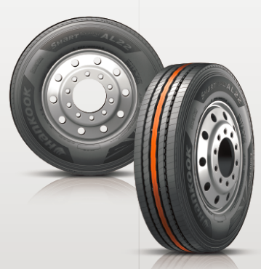
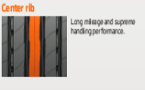

Special brake structure and newly developed bead area
- Reduced heat development.
- High retreadability.
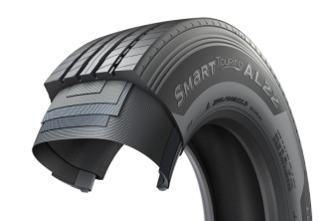

New tyre compound with highly structured soot molecules:
- Low rolling resistance and reduced fuel consumption.
- Increased abrasion resistance, up to 17% increase in mileage
compared with conventional products.



###

Winner of the Red Dot Design Award: Hankook's all-year truck tyres SmartFlex AH35 and SmartFlex DH35 for regional traffic

With the steering axle tyre SmartFlex AH35 and the drive axle tyre SmartFlex DH35, premium tyre maker Hankook has an all-year truck tyre for regional traffic. The all-year tyres, winners of the Red Dot Design Award in 2016, have particularly high traction on account of special Multi-3D sipes. In addition, the rigid tread blocks with minimum block movement promote fuel-efficient driving.

With the SmartFlex AH35 and SmartFlex DH35, fleets and forwarding agents benefit from a low-fuel, high-mileage and high-traction all-year tyre solution for the steering and drive axles. It is also possible to fit SmartFlex AH35 to all axles. In 2016, they were presented with the Red Dot Design Award. Whilst the SmartFlex AH31 and SmartFlex DH31 are intended mainly for larger wheel sizes such as 22.5 inch, the SmartFlex AH35 and its counterpart SmartFlex DH35 for the drive axle are designated to the smaller 17.5/19.5 inch sizes.
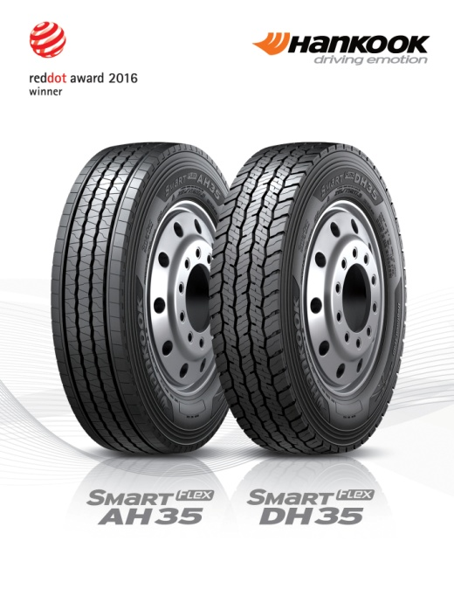
The Multi-3D sipes anchored in the tread of the SmartFlex AH35 guarantee outstanding traction. The mixture of straight and wave-shaped grooves improves water drainage and prevents hydroplaning long-term. Without losing sight of the summer properties, the M+S marking and the 3PMFS symbol (snowflake) indicate that the tyre is also perfectly equipped for all wintry weather conditions such as slush, ice and snow. The rigidity of the tread blocks promotes particularly fuel-efficient driving. Equally, the special tread design supports even tyre wear so that the Total Cost of Ownership for fleet and forwarding agent companies can be reduced long term in terms of service life. The high mileage and performance of the tyre are guaranteed by a wide contact area.
Just like the steering axle tyre, the drive axle tyre SmartFlex DH35 has M+S marking and the snowflake symbol. In addition, the tyre also has a wide contact area with four zigzag groove lines over the whole tread surface, enhancing mileage and driving performance under different road and traffic conditions. Furthermore, the 3D sipes ensure high traction and low rolling resistance. The innovative tread sipe design supports low rolling resistance and tyre traction for the drive axle in road traffic.

Sizes of the SmartFlex tyre line available

Tread | Size | LI | Marking |  | M+S | Availability
AH35 | 8.5R17.5 | 121/120L | D/C/W1 67dB | ☑ | ☑ | ☑
AH35 | 9.5.R17.5 | 131/129L | D/C/W1 67dB | ☑ | ☑ | ☑
AH35 | 8R19.5 | 124/122L | D/C/W1 67dB | ☑ | ☑ | ☑
AH35 | 205/75R17.5 | 124/122M | D/C/W1 65dB | ☑ | ☑ | ☑
AH35 | 215/75R17.5. | 126/124M | D/C/W1 65dB | ☑ | ☑ | ☑
AH35 | 225/75R17.5 | 129/127M | C/C/W1 67dB | ☑ | ☑ | ☑
AH35 | 235/75R17.5 | 132/130M | C/C/W1 69dB | ☑ | ☑ | ☑
AH35 | 245/70R17.5 | 136/134M | C/C/W1 69dB | ☑ | ☑ | ☑
AH35 | 245/70R19.5 | 136/134M | C/C/W1 67dB | ☑ | ☑ | ☑
AH35 | 265/70R17.5 | 140/136M | C/C/W1 65dB | ☑ | ☑ | ☑
AH35 | 265/70R19.5 | 140/138M | C/C/W1 67dB | ☑ | ☑ | ☑
AH35 | 285/70R19.5 | 146/144M | C/C/W1 67dB | ☑ | ☑ | ☑
 | 305/70R19.5 | 148/145M | C/C/W1 65dB | ☑ | ☑ | ☑
DH 35 | 205/75R17.5 | 124/122M | D/C/W1 66dB | ☑ | ☑ | ☑
DH 35 | 215/75R17.5 | 126/124M | D/C/W1 66dB | ☑ | ☑ | ☑
DH 35 | 225/75R17.5 | 129/127M | D/C/W1 73dB | ☑ | ☑ | ☑
DH 35 | 235/75R17.5 | 132/130M | D/C/W1 73dB | ☑ | ☑ | ☑
DH 35 | 245/70R17.5 | 136/134M | D/C/W1 73dB | ☑ | ☑ | ☑
DH 35 | 8.5R17.5 | 121/120L | D/C/W1 73dB | ☑ | ☑ | ☑
DH 35 | 9.5R17.5 | 131/129L | D/C/W1 73dB | ☑ | ☑ | ☑
DH 35 | 245/70R19.5 | 136/134M | D/C/W1 73dB | ☑ | ☑ | ☑
DH 35 | 265/70R17.5 | 139/136M | D/C/W1 73dB | ☑ | ☑ | ☑
DH 35 | 265/70R19.5 | 140/138M | D/B/W1 73dB | ☑ | ☑ | ☑
DH 35 | 285/70R19.5 | 146/144M | D/B/W1 73dB | ☑ | ☑ | ☑
DH 35 | 305/70R19.5 | 148/145M | D/B/W1 73dB | ☑ | ☑ | ☑

Technical properties of the SmartFlex AH35

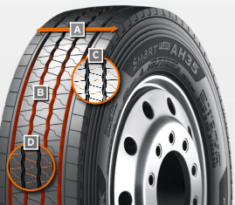
A Wide contact area:
The wide contact area guarantees high mileage.

B Four wave-shaped and straight grooves:
The combination of four wave-shaped and straight grooves over the whole tread surface on a wide range of different road surfaces guarantees excellent water drainage

C Multi-3D sipe tread:
The Multi-3D sipe tread offers outstanding traction and thus promotes improved driving stability.
The rigidity of the tread blocks and the resulting minimum block movement lead to significant fuel savings.

D Special tread design with “semi-sipes”
Special tread design with “semi sipes” guarantees an even wear pattern over the entire service life

Wide contact area
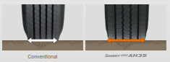

Multi-3D sipes
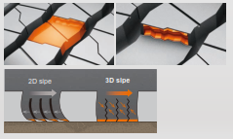

Technical properties of the SmartFlex DH35

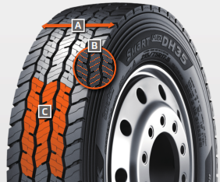
A Wide contact area with 4 zigzag grooves:
The wide contact area and the 4 all-round zigzag tread grooves ensure high mileage and overall performance.

B Multi-3D sipes:
The special tread design with Multi-3D sipes promotes low rolling resistance and outstanding traction.

C Innovative tread design:
The special tread design guarantees low rolling resistance and optimum traction under a wide range of different conditions.

All-rounders for all-year tyres
Particularly in changeable weather conditions, Hankook recommends that truck and bus customers use the SmartFlex all-weather tyre line for medium and long haul trips. Commercial vehicle customers can rely in particular on a high level of driving safety as well as the current trend of increased load-bearing capacity for some sizes.
Both the steering axle tyres SmartFlex AH31 and the drive axle tyres SmartFlex DH31 have M+S marking and the snowflake (3PMSF) symbol, which means good traction is guaranteed even if drivers should be surprised by wintry road conditions. The Hankook SmartFlex DH31 has a 6-rib tread with special hexagonal tread blocks that guarantees more even wear behaviour and thus a longer tyre service life. Hankook's patented self-cleaning sipes in the middle of each block prevent damage to the block edges and thus guarantee excellent traction throughout the tyre life.

The SmartFlex all-year tyre line is completed by the corresponding trailer tyre SmartFlex TH31, which celebrated its première at the 66th IAA for Commercial Vehicles. Its wide, closed shoulder area supports stable straight driving and ensure good lateral stability. Chamfered tread grooves help prevent splintering.

Whilst the SmartFlex AH31 and SmartFlex DH31 are designated mainly for larger wheel sizes in the 22.5 inch range, SmartFlex AH35 and its drive axle counterpart SmartFlex DH35 is more designated for smaller wheels with 17.5/19.5 inch sizes.

Sizes of the SmartFlex tyre line available

Tread | Size | LI | Marking |  | M+S | Availability | Remark
AH31 | 295/80R22.5 | 152/148M (154M/149L) | C/B/W1 73 dB | ☑ | ☑ | ☑ | -
AH31 | 295/80R22.5 | 154/149M | C/B/W1 73 dB | ☑ | ☑ | ☑ | Tyre with higher load-bearing capacity
AH31 | 315/80R22.5 | 156/150L | C/B/W1 73 dB | ☑ | ☑ | ☑ | -
AH31 | 315/70R22.5 | 156/150L | C/B/W1 73 dB | ☑ | ☑ | ☑ | -
AH31 | 385/65R22.5 | 164K | C/B/W1 69 dB | ☑ | ☑ | ☑ | -
AH31 | 385/65R22.5 | 160K | C/B/W1 69 dB | ☑ | ☑ | ☑ | -
AH31 | 315/60R22.5 | 154/148L | C/B/W1 70 dB | ☑ | ☑ | ☑ | -
AH31 | 385/55R22.5 | 160K | C/B/W1 69 dB | ☑ | ☑ | ☑ | -
AH31 | 355/50R22.5 | 156L | C/B/W1 69 dB | ☑ | ☑ | In production | -
DH31 | 295/80R22.5 | 152/148M | D/C/W2 75 dB | ☑ | ☑ | ☑ | -
DH31 | 315/80R22.5 | 156/150L | D/C/W2 75 dB | ☑ | ☑ | ☑ | -
DH31 | 315/70R22.5 | 154/150L | D/C/W2 75 dB | ☑ | ☑ | ☑ | -
DH31 | 295/60R22.5 | 150/147K | D/C/W2 75 dB | ☑ | ☑ | ☑ | -
DH31 | 315/60R22.5 | 152/148L | D/C/W2 75 dB | ☑ | ☑ | ☑ | -
TH31 | 385/65R22.5 | 160K | B/B/W1 69 dB | - | ☑ | In production | -
TH31 | 435/50R19.5 | 160J | B/B/W2 | - | ☑ | In production | -
TH31 | 455/45R22.5 | 160K | C/B/W1 70 dB | - | ☑ | In production | -

SmartFlex AH 31

Truck all-year tyres for the steering axle for medium to long-haul applications

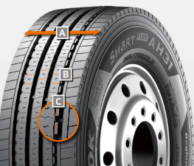
A Extra-wide tread and shoulder area:
- The extra-wide open shoulder area supports a high mileage and traction as well as outstanding handling properties

B Multi-3D sipe treads:
- High traction and mileage with even wear

C Tread Wear Equalizer Stepper Technology (T.W.E.S.):
- Stabilisers on profile blocks
- Reduction of uneven/one-sided wear

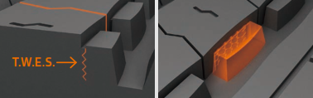
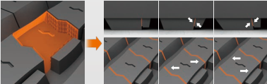

SmartFlex DH 31

Truck all-year tyres for the drive axle for medium to long-haul applications

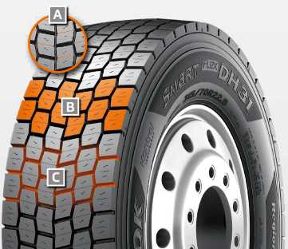
A Multi-3D sipes:
- High traction and mileage with even wear

B 6-rib block tread
- Sturdy 6-rib block tread with special hexagonal tread blocks

C Self-cleaning sipes
- Constant traction over the entire service life
- Protection against splintering at the corners of the sipes

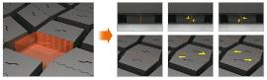
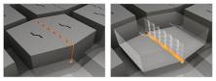

SmartFlex TH 31

Truck all-year tyres for the trailer axle for medium to long-haul applications
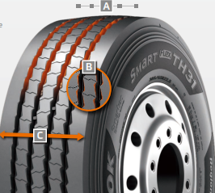

A 4 Zigzag sipes:
- 4 main tread grooves ensure optimum water displacement

B Chamfered profile block design:
- Chamfered profile blocks sipes help to prevent material splintering

C Extra-wide tread and shoulder area:
- The extra-wide closed shoulder area supports high driving stability and ensures good lateral stability as well as even wear

###

For even more safety: Hankook is reinforcing the sidewalls of the bus tyre AU03+ on all axle positions
Hankook’s bus tyre AU03+ was developed particularly with the requirements of stop-and-go traffic in mind, and is especially suitable for use on regular city bus services. The all-year tyre provides an optimum profile especially suitable for city traffic and urban roads and is designed with a high level of safety in mind, whilst being economic and environmentally friendly at the same time.

The sidewalls have recently been reinforced to guarantee even safer and more efficient use in city traffic, with an even wider and deeper sidewall indicator being incorporated at the same time. The AU03+ is available in size 275/70R22.5 and with M+S marking and the 3PMSF (3 Peak Mountain Snowflake) symbol.

Safety is a fundamental factor that Hankook considers for each of its products. That’s why safety performance with short braking distances and superior wet performance is also a key component of the AU03+. Furthermore, the reinforced sidewall protects the tyre from damages including stone chips and curb contacts.

The profile of Hankook’s AU03+ guarantees excellent traction which is supported through an optimised kerf arrangement without leaving mileage behind.
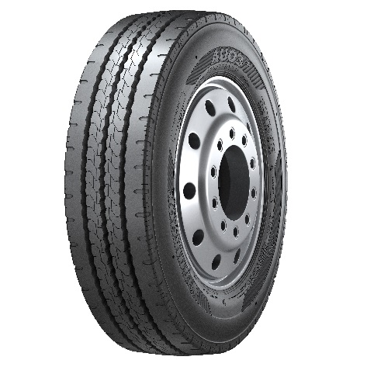
The innovative Hankook mixing method IMS (Innovative Mixing System) ensures a particularly even distribution of carbon black particles and rubber molecules within the mixtures. Together with longer mixing times at lower temperatures, a significant increase of the bonding rate between the carbon black and rubber molecules can be achieved. As a result, the AU03+ generates less heat during the drive, which has a positive effect on the rolling resistance and thereby on fuel consumption as well.

Sizes of the AU03+ available:

Tread | Size | LI | Marking | Snowflake | M+S | Availability
AU03+ | 275/70R22.5 | 150/145J | D/C/W1/71 dB | ☑ | ☑ | ☑

Technical features of the AU03+:

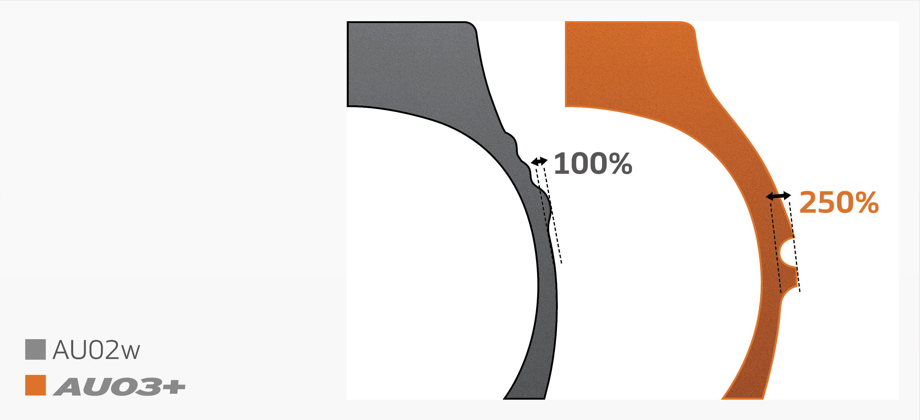
Wide shoulder and reinforced sidewalls
- The wide shoulder and reinforced sidewalls ensure excellent wet grip, dry grip and driving stability.


Horizontal kerfs and deep sipes
- Kerfs incorporated horizontally in the cap rib and a tread with deep sipes guarantee outstanding traction and mileage performance.


Zigzag groooves
- Four zigzag tread grooves guarantee excellent lateral guidance and ensure optimum water drainage.

###

Hankook AL10+ e-cube MAX:
Low-line sizes for the steering axle

In times when the trend is going more and more towards volume transportation, the legally permissible outside height of four metres for commercial vehicles means that fleet operators are quickly reaching their limits. The issues get amplified if the freight forwarder wants to transport heavy standard goods in addition to volume transports. Therefore, premium tyre maker Hankook has now released the AL10+ e-cube MAX long distance tyre for the low-line segment as well. With the dimension of 355/50R22.5, the new low profile tyre for the truck steering axle is designed especially for the requirements of volume transports.

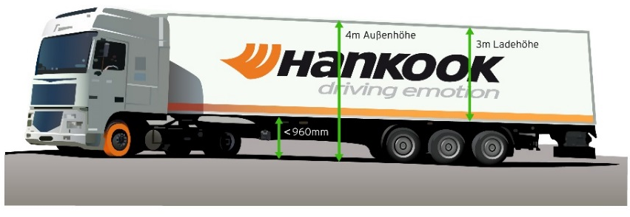
Until now, fleet operators with truck tyres of series 60 to 80 have often not been able to completely utilise the maximum inner load height of three metres without exceeding the legally permissible total height of four metres. Therefore, load capacity is lost, which in turn can result in economic disadvantages. As a consequence, premium tyre maker Hankook is offering its customers a truck tyre for the steering axle in series 50: the AL10+ e-cube MAX was developed in size 355/50R22.5 exclusively for use on jumbo trucks for long distances, and it provides a load index of 156, which means that the axle can be loaded with a weight of up to 8 tons. With its small diameter, it lowers the coupling height of the tractor engine, with the result that the inner load height increases and the three-metre loading platform can be fully utilised thanks to the lower profile tyres.

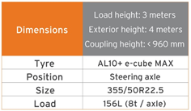
The tyre profile e-cube MAX for commercial vehicles represents maximum cost effectiveness, energy efficiency and environmental friendliness: due to its longitudinal grooved tread with wave structure, the AL10+ e-cube MAX for the steering axle prevents uneven wear. Therefore the AL10+ e-cube MAX guarantees an increased service life. The improved tread compound and high load index of the tyre increase the fuel efficiency while offering higher load capacity at the same time. The linear groove structure supports stable directional stability as well as maximum steering precision and improved water dispersal.

The long distance specialist for the steering axle is supported by its counterpart for the drive axle, the DL10+ e-cube MAX from the same tyre line. Due to its three-dimensional lamellae, it offers drivers outstanding traction, while the extra-wide profile block and deep grooves ensure increased mileage. The block stabilisers of the DL10+ e-cube MAX also contribute to a high service life and low rolling resistance. The e-cube MAX series is completed by the matching trailer tyre TL10+, which is characterised by maximum driving stability and low rolling resistance.

Sizes of the e-cube MAX tyre line available

Tread | Size | LI | Marking |  | M+S | Availability
AL 10+ | 315/80R22.5 | 156/150L (154/150M) | B/B/W1 70dB | - | - | ☑
AL 10+ | 315/70R22.5 | 156/150L | B/B/W1 70dB | - | - | ☑
AL 10+ | 385/65R22.5 | 160K | B/B/W1 70dB | - | - | ☑
AL 10+ | 295/60/R22.5 | 150/147L | C/B/W1 70dB | - | - | ☑
AL 10+ | 315/60R22.5 | 154/148L | C/B/W1 70dB | - | - | ☑
AL 10+ | 355/50R22.5 | 156L | B/B/W1 70dB | - | - | ☑
DL 10+ | 315/80R22.5 | 156/150L (154/150M) | C/C/W1 73dB | ☑ | ☑ | ☑
DL 10+ | 315/70R22.5 | 154/150L | C/C/W1 73dB | ☑ | ☑ | ☑
DL 10+ | 295/60R22.5 | 150/147K | C/C/W1 73dB | ☑ | ☑ | ☑
DL 10+ | 315/60R22.5 | 152/148L | C/C/W1 73dB | ☑ | ☑ | ☑
DL 10+ | 295/55R22.5 | 147/145K | C/C/W1 73dB | ☑ | ☑ | In production
DL 10+ | 315/45R22.5 | 147/145L | D/C/W2 75dB | ☑ | ☑ | In production
TL10+ | 215/75R22.5 | 135/133J | C/B/W1 69dB | - | - | ☑
TL10+ | 235/75R22.5 | 143/141J | B/B/W1 69dB | - | - | ☑
TL10+ | 245/70R17.5 | 143/141J (146/146F) | B/B/W1 69dB | - | - | ☑
TL10+ | 265/70R19.5 | 143/141J | B/B/W1 69dB | - | - | ☑
TL10+ | 385/55R22.5 | 160K(158L) | B/B/W1 70dB | - | - | ☑
TL10+ | 385/65R22.5 | 160K | B/B/W1 69dB | - | - | ☑
TL10+ | 435/50R19.5 | 160J | B/B/W2 73dB | - | - | ☑
TL10+ | 455/40R22.5 | 160J | B/B/W2 71dB | - | - | ☑

1. Optimised tread compound

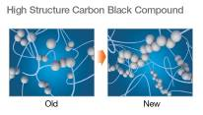
- “Low hysteresis” tread compound reduces rolling resistance:
High molecular weight rubbers with very long-chain molecules, which have a lower tendency of branching and thus fewer free chain ends, are processed at reduced temperatures and extended mixing periods in Hankook's innovative mixture process IMS (Innovative Mixing System). This results in a significant increase in the connection rate between the carbon black and rubber molecules and a much more consistent distribution within the mixture.

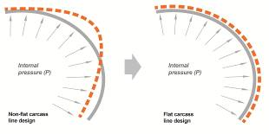
2.Stiffness Control Contour Theory (SCCT)
- Patented Hankook design technology for the even distribution of pressure inside the tyre and increased stability as well as movement in the tyre
- High carcass durability and economy, improved retreadability

###

Hankook light truck tyre Vantra LT:
Energy efficient, safe and exceptionally durable

Hankook presents the Vantra LT, the Summer tyre for commercial vans and transporters. The innovative design features improves fuel efficiency by up to 13 % while reducing wear by 12 % for extended mileage. Designed specifically for the high demands placed on passenger and goods transport vehicles ensuring optimised durability and reduced breaking distances.
Hankook Tire introduce the Vantra LT designed for commercial vans and transporters. The light truck tyre was developed in view of the high demands that are placed on passenger and goods transport vehicles in regional traffic. Durability, fuel efficiency and mileage played a key role during development as well as safety-related driving characteristics such as short breaking distances and superior wet performance. The new Vantra LT is now available in 36 dimensions.

Frequent use in start/stop traffic places special demands on tyres: a long service-life with high economic efficiency to maximise mileage and robustness against external influences are important while safety performance is playing a key role as well. The Hankook Vantra LT’s innovative design features such as a sidewall protect shield and optimised groove location with durable contact patch technology enable increased performance and assure safety at high speeds whilst at the same time reduce tread wear and improve the tyre’s fuel efficiency by up to 13 per cent versus its predecessor. In addition, 3-channel wide central grooves and 3D lateral grooves enable fast water dispersion to reduce hydroplaning and guarantee superior performance in wet and even cold weather conditions.

Hankook Vantra LT’s footprint is designed to improve durability by applying square shape contact patch technology that allows for an optimised groove position, increasing stability in the outer grounding footprint area. In combination with the tyre’s innovative reinforced belt structure featuring a double steel belt this allows a more even distribution of the ground pressure resulting in an improved wear performance of up to 12%. In addition, the reduced tyre deformation results in a lowered rolling resistance, resulting in higher fuel efficiency and thus heightened cost-effectiveness – a key factor for tyres used for start/stop traffic. The additionally applied sidewall protect shield effectively helps to prevent sidewall damage.

The innovative pattern not only guarantees superior wet braking performance and effectively prevents hydroplaning but also improves fuel efficiency by minimising energy loss while driving. The Vantra LT’s optimised block stiffness further improves the tyre’s handling performance in wet, dry and even cold weather conditions without sacrificing block strength. The running smoothness of the tyre – and thus control and driving comfort – is perceptibly greater as well.

Technical features of the Vantra LT

- Optimised interior structure ensures durability and safety
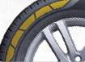
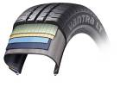
The reinforced belt structure of the Vantra LT ensures durable performance by applying a reinforced belt layer and double steel belt. In combination with special bead filler for enhanced rim joint stiffness also handling performance is improved. The tyre’s Sidewall Protect Shield prevents sidewall damage under low-pressure conditions.

- Increased handling and wet performance
3-channel wide grooves in combination with 3D lateral grooves reduce the risk of hydroplaning and ensure increased performance and safety at higher speed as well as enhanced wet and cold weather
performance without sacrificing block strength. The Vantra LT’s innovative new straight main grove improves hydroplaning performance by up to 14% by ensuring better water runoff.
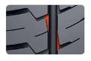
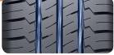

- Improved wear performance, fuel efficiency and extended mileage
By applying an optimised structure with innovative compound technology the wear performance has improvement of up to 12% compared to a conventional tyre. In addition an optimised carcass profile allows for up to 13 % improved fuel efficiency by minimising energy loss in driving.
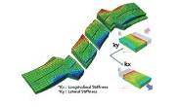

- Increased durabilty and driving stability
The Vantra LT’s square shape contact patch improves the tyre’s durability while the optimised groove position ensures additional stability in the outer grounding footprint area.

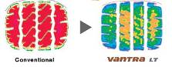
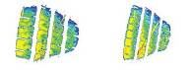

- Available sizes
The Vantra LT is available in 36 dimensions in sizes from 13 to 16 inches in series 82 to 60 and cover tread width from 155 to 235 all marked M+S.

###

Hankook SmartWork: Sturdy and durable for on and off-road

Hankook's truck range for use on construction sites, comprising of the tyres SmartWork AM09, SmartWork AM15/AM15+ for the steering axle, the SmartWork DM09 for the drive axle and the SmartWork TM15 for the trailer, was developed especially for the demanding tasks in the on- and off-road segment. All the tyres have been designed for heavy weights and high loads, and stand out on account of their high resistance to splintering, cuts and tread breaks. Other convincing features include their self-cleaning function and an extremely sturdy carcass structure.

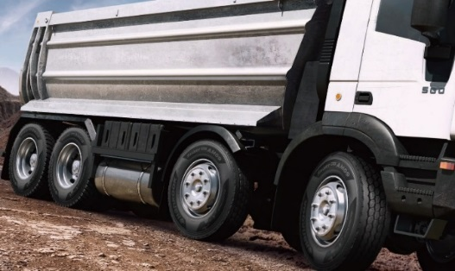
The SmartWork AM09 for the steering axle is suitable for construction site vehicles which are more frequently used on roads. Its polygonal tread blocks ensure excellent traction and outstanding braking performance even on muddy roads. Both the extra-wide tread design and the closed shoulder area provide the SmartWork AM09 with a high degree of driving stability. Special rubber blocks in the profile grooves prevent stones from becoming lodged. The SmartWork AM15/AM15+ is also suitable for the steering axle, but has been designed especially for off-road use. Its extra-wide tread blocks guarantee optimum traction on uneven surfaces like those typical of construction sites. Its open shoulder area with tie-bar also contributes to this. Extra-wide tread grooves prevent gravel becoming lodged in the tread.

The SmartWork DM09 is available for the drive axle. The directional tread design enables improved displacement of mud and water. The interblock tie-bar at the centre of the SmartWork DM09 guarantees outstanding straight driving performance and impact dispersion for blocks, thereby improving longevity. Chamfered tread blocks on the outside of the tread surface increase resistance to lateral strains and effectively help prevent damage to the tyre's shoulder or tearing of the block edges.

The trailer tyre SmartWork TM15 included in the line has particularly high traction thanks to its high groove width. In addition, the trailer tyre stands out on account of very good water repulsion. Thanks to their M+S marking, all the treads of the SmartWork series can be utilised on and off-road all year round even in wintry conditions.

As with other tyre ranges from Hankook, the SmartWork line also features the Hankook SCCT technology (Stiffness Control Contour Theory): this enables the particularly even distribution of the tyre pressure even under heavy loads. This way the deformation strain that affects the carcass is minimised. This not only positively influences the longevity of the tyre but also performance features like braking characteristics and the retreadability of the tyres.

Sizes of the SmartWork line available

Tread | Size | LI | Marking |  | M+S | Availability
AM09 | 10R22.5 | 144/142K | C/B/W1 70dB | - | ☑ | ☑
AM09 | 11R22.5 | 148/145K | D/B/W1 67dB | - | ☑ | ☑
AM09 | 12R22.5 | 152/149K | D/B/W1 69dB | - | ☑ | ☑
AM09 | 13R22.5 | 156/150K | D/C/W1 70dB | - | ☑ | ☑
AM09 | 295/80R22.5 | 152/148K (154/150J) | C/B/W1 67dB | - | ☑ | ☑
AM09 | 315/80R22.5 | 156/150K | D/B/W1 67dB | - | ☑ | ☑
DM09 | 11R22.5 | 148/145K | E/C/W1 70dB | - | ☑ | ☑
DM09 | 13R22.5 | 156/150K | D/C/W2 75dB | - | ☑ | ☑
DM09 | 1200R20 | 154/150K | E/C/W2 75dB | - | ☑ | ☑
DM09 | 295/80R22.5 | 152/148K | E/B/W1 70dB | - | ☑ | ☑
DM09 | 315/80R22.5 | 156/150K | D/C/W1 70dB | - | ☑ | ☑
AM15 | 265/70R19.5 | 143/141J | D/B/W2 74dB | - | ☑ | ☑
AM15 | 275/70R22.5 | 148/145K | D/B/W2 74dB | - | ☑ | ☑
AM15 | 385/65R22.5 | 160K/(158L) | D/C/W2 74dB | - | ☑ | ☑
AM15 | 425/65R22.5 | 165K | C/C/W2 75dB | - | ☑ | ☑
 | 445/65R22.5 | 169K | C/C/W2 75dB | - | ☑ | ☑
AM15+ | 385/65R22.5 | 160K/(158L) | D/C/W2 74dB | - | ☑ | ☑
TM15 | 385/65R22.5 | 160K/158L | D/C/W1 69dB | - | ☑ | ☑

Technical properties of the Hankook SmartWork AM09

- Wider zigzag grooves for high traction and optimised braking performance:
- Four extra-wide tread grooves in a zigzag design guarantee the right grip both on tarmac roads and off-road.
- Excellent displacement of mud and water.
- Additional pimples in the grooves support the tyre's self-cleaning function.

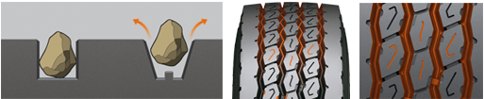

- Polygonal, stepped blocks for a more pronounced edge effect:
- Special notches on the individual tread blocks for particularly good grip.
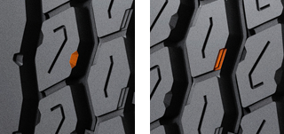
- Shorten braking distance.
- Enhance off-road traction.

- Closed shoulder design increases the tyre's driving stability:
- Improved resistance against forces acting at the side.
- Protection against damage to the block edges.
- Shoulder lugs help to produce less heat while driving.

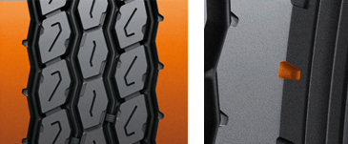

Technical properties of the Hankook SmartWork AM15/AM15+

- Optimised tread blocks
- Bars between the tread blocks stabilise the tyre.
- The optimised contact area prevents uneven wear.
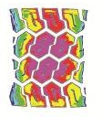
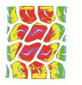

Old AM15

- Particularly wide and deep grooves for better traction and to prevent stone damage
- Grooves ideally displace water and guarantee an extremely high mileage.
- Ribs within the grooves prevent stones becoming lodged in the tread.

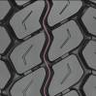
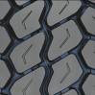
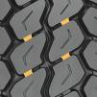

- Innovative rubber compound reduces heat development
- Specially developed mixing method slows wear and increases mileage.
- Retreading is made easier and the tyre can be used again more quickly.

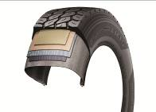

Technical properties of the Hankook SmartWork DM09

1. Hankook SCCT technology (Stiffness Control Contour Theory):
- The particularly even distribution of tyre pressure even under heavy loads effectively minimises the deformation load acting on the carcass, resulting in optimal retreadability, cornering and braking characteristics, short braking distances as well as generally higher durability.

2. Optimised tyre tread:
- Block design with reinforced central rib for more even distribution of the forces acting in
use.
- More uniform abrasion pattern and minimisation of uneven wear.
- High grip on loose surfaces and very good self-cleaning properties thanks to the open
tyre shoulder design.
- Conical tread blocks on the outer side of the tread for increased resistance
to side loads and protection of the block edges in the shoulder area
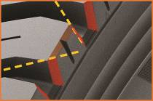

3. Hankook Innovative Mixing System:
- Especially even distribution of the carbon black particles and rubber molecules within the compounds thanks to longer mixing times at reduced temperatures.
- The significantly increased bonding rate between the carbon black and rubber molecules results in lower heat development during driving for less rolling resistance and fuel consumption.
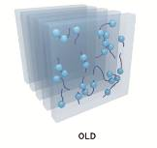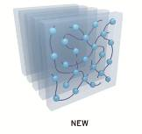
Technical properties of the Hankook SmartWork TM15

Optimised tyre tread:
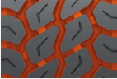
- Wide tread grooves ensure high traction

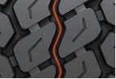
- Sipes in the centre of the three tread grooves prevent stones becoming lodge in the tread

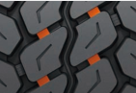

- Bars between the tread blocks increase their rigidity, thus promoting more even wear

###

Hankook TH22: Trailer tyres for low-bed truck transport

The TH22 is Hankook's trailer specialist when it comes to transporting heavy loads in regional traffic, along country roads for example. Because alongside the standard sizes, the TH22 is available in smaller sizes which can then be fitted to low-bed trucks, making maximum loading volume possible.

The Hankook TH22 is the successful trailer tyre from the premium tyre maker for regional and delivery traffic, which was launched in 2011. The TH22 is available in standard sizes 385/65R22.5, 425/65R22.5 and 385/55R22.5 and also in smaller sizes sizes especially for use on low-bed trailers.

The profile and carcass design of the Hankook TH22 trailer tyre optimises wear resistance as well as rolling resistance. The smaller sizes have a closed 4-rib block profile with extra-broad, solid shoulder ribs which was especially developed for low rolling resistance and good lateral stability. At the same time, the tread design supports even wear and 10 percent higher mileage than its predecessor. Wave-shaped tread sipes and transverse sipes right down to the base of the groove additionally provide for effective water displacement, making the TH22 a true all-round talent when it comes to handling. The large sizes have the same characteristics, the only difference being that the block profile is made up of five ribs.

With the TH22 Hankook is also relying on the patented IMS solution (Innovative Mixing System), which is used in many truck tyre ranges in the premium tyre maker's portfolio. Rubbers with particularly long-chain molecules are used for production. This results in significantly cooler operation and significantly increased mileage.

The low design height ensures maximum loading volume and, coupled with the high load-bearing capacity, makes the Hankook TH22 in the sizes 205/65R17.5 and 215/75R17.5 particularly suitable for low-bed trailer heavy-duty transport on country roads, such as car, construction vehicle or construction element transport.

Available sizes of the TH22

Tread | Size | LI | Marking |  | M+S | Availability
TH22 | 9.5R17.5 | 143/141J | D/B/W1 70dB | - | ☑ | ☑
TH22 | 11R22.5 | 148/146L | C/B/W1 70dB | - | ☑ | ☑
TH22 | 215/75R17.5 | 135/133J | D/B/W1 70dB | - | ☑ | ☑
TH22 | 235/75R17.5 | 143/141J | C/B/W1 70dB | - | ☑ | ☑
TH22 | 245/70R17.5 | 143/141J (146/146F) | C/B/W1 70dB | - | ☑ | ☑
TH22 | 245/70R19.5 | 141/140J | C/B/W1 67dB | - | ☑ | ☑
TH22 | 265/70R19.5 | 143/141J | C/B/W1 70dB | - | ☑ | ☑
TH22 | 285/70R19.5 | 150/148J | C/B/W1 70dB | - | ☑ | ☑
TH22 | 205/65R17.5 | 132F |  | - | ☑ | In production
TH22 | 385/65R22.5 | 164K (160K) | C/B/W1 70dB | - | ☑ | ☑
TH22 | 425/65R22.5 | 165K | B/B/W1 71dB | - | ☑ | ☑
TH22 | 385/55R22.5 | 160K (158L) | B/B/W1 71dB | - | ☑ | ☑

Technical properties of the Hankook TH22

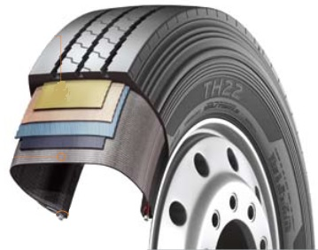

1. Tyre design
- Belt structure: Less belt deformation guarantees very
low rolling resistance
- Carcass structure: The wider carcass profile with reinforced
belt cord guarantees
excellent durability
- Bead structure: Reinforced bead structure ensures a long service life
even at high load weights

2. Tread design
- Optimised zigzag rib design for good self-cleaning
- Wide and firm shoulder package for improved mileage and even wear
- Solid, continuous centre rib improves rolling characteristics and lateral stability

###

Hankook ‘alphatread’:
Bead-to-bead retread truck tyre range

‘alphatread’ is the environmentally conscious bead to bead retread truck tyre range from premium tyre maker Hankook. The ‘alphatread’ line-up designed for medium haul purposes consists of sizes for the drive axle position together with a corresponding trailer tyre size. It aims to meet customer demands for reducing fleets running costs by providing a ‘cradle to grave’ tyre solution.

The ever increasing demands in the area of environmental friendliness and continued pressure upon fleets to reduce their running costs have led to the development of the Hankook ‘alphatread’ range. The premium manufacturer’s retread truck tyre line has been specifically designed to maximise mileage as the casings of Hankook’s 1st life A1 grade tyres are used to mirror Hankook’s existing tyre patterns to produce the alphatread tyre. For the time being the products are available in the UK market in two drive axle sizes and a corresponding trailer size.

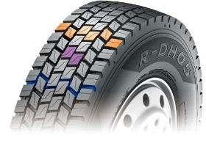
The Hankook alphatread R-DH05 is a drive axle tyre for medium haul, available in three sizes 295/80R22.5, 315/80R22.5 and now the 315/70 R22.5. With its wide outline and a unique compound the R-DH05 provides excellent wet and dry performance, driving stability and long lasting wear. While the extra wide tread and deep grooves ensure high mileage, the optimised block shape provides block rigidity also under heavy loads for an outstanding traction and tread stability. Its lateral oriented tread design with high density grooves help to provide excellent traction in all weather conditions.

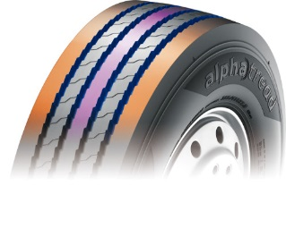
The Hankook alphatread R-TH22 sized 385/65R22.5 is the corresponding trailer tyre for medium haul purposes. It provides a 5 rib tread design and a so called cool running compound for optimum performance. Optimised zigzag grooves care for stone ejection and crack prevention. The wide, solid shoulder area provides a higher mileage and helps to prevent belt separation. Its massive kerfless centre rib enhances free-rolling on axle thus increasing the trailer’s riding stability.

Hankook’s alphatread tyres contribute to the environment by using significantly less raw material as well as energy during manufacturing.

Current sizes of the Hankook alphatread line-up:

Tread | Size | LI | Regrooving depth | Snow flake | M+S | Availability
R-DH05 | 295/80R22.5 | 152/148K | 3.0 mm |  | ☑ | ☑
R-DH05 | 315/80R22.5 | 154/150K | 3.0 mm |  | ☑ | ☑
R-DH05 | 315/70R22.5 | 154/150K | 3.0 mm |  | ☑ | ☑
R-TH22 | 385/65R22.5 | 160J | 3.0 mm |  |  | ☑

###

About Hankook

Hankook Tire is one of the global top 5 companies in the mass production of tyres and manufactures innovative, award winning radial tyres of proven superior quality for passenger cars, light trucks, SUVs, RVs, trucks and buses as well as motorsports (circuit racing/rallies). Hankook continues to invest in research and development so that we can always offer our customers the highest level of quality, combined with technological excellence. At a total of five development centers and seven large scale factories around the world, the company develops and produces tyre solutions specially tailored to the requirements and needs of regional markets. Bespoke tyre solutions for the European markets as well as European Original Equipment according to the requirements of leading premium car manufacturers, are developed in the company’s regional Technical Centre in Hanover/Germany. Production for the European region is taking place in the state-of-the-art manufacturing site in Rácalmás/Hungary which was inaugurated in June 2007 and is continuously being expanded. Currently more than 3,000 employees produce up to 19 million tyres a year for passenger cars, SUVs and light trucks.

Hankook Tire’s European headquarters are located in Neu-Isenburg near Frankfurt am Main in Germany. The manufacturer operates further branches in Germany, UK, France, Italy, Spain, the Netherlands, Hungary, Czech Republic, Russia, Turkey, Sweden and Poland. Hankook products are sold directly through regional distributors in other local markets. Hankook Tire employs more than 22,000 people worldwide and are selling their products in over 180 countries. Internationally leading car manufacturers rely on tyres made by Hankook for their original equipment. Approximately 30 percent of the company's global sales are generated within the European and CIS-Region.

For more information please visit www.hankooktire-mediacenter.com

Media contact UK:
Hankook Tyre UK Ltd, Fawsley Drive, Heartlands Business Park, Daventry, Northamptonshire NN11 8UG

Zoë Baldwin, Marketing Communication Manager
Tel.: +44 (0) 1327 304 146
zbaldwin@hankooktyres.co.uk

European Media contacts:
Hankook Tire Europe GmbH | Corporate Communications Europe/CIS
Siemensstr. 5a, 63263 Neu-Isenburg | Germany

Anna Pasternak, PR Manager
LT and Truck & Bus Tyres, Intl. Motorsports, CSR
Tel.: +49 (0) 6102 8149 – 173
Mobile: +49 151 65641014
a.pasternak@hankookreifen.de

Sabine Riedel, Public Relations
LT and Truck & Bus Tyres, Hankook Media Center, SNS, Corporate
Tel.: +49 (0) 6102 8149 – 174
Mobile: +49 160 2545318
s.riedel@hankookreifen.de

