****

**Press Kit**

**AutoZum 2017**

**Content**

* **Hankook with extensive tyre portfolio at the AutoZum 2017**
* **Hankook Silent Technology “Sound Absorber” as Original Fitment on Audi Q7 models including the all new SQ7 TDI**
* **Hankook UHP Premium winter tyres:** Optimised driving during the cold

season; Now also with Hankook SEALGUARD® technology; Run-flat original

equipment on premium vehicles

* **Hankook Winter i\*cept RS2:** Very good test results!
* **Hankook Ventus Prime³:** Premium comfort tyre for Europe is Auto Bild

test winner

* **Hankook Ventus S1 evo2:** “Outstanding” in Auto Bild sportscars Summer Tyre Test
* **Hankook Ventus V12 evo² :** Performance, design and environmental

excellence combined in one wide tyre

* **Hankook Tire presents design innovation trough collaboration with Virbram®**
* **Hankook is Original Equipment Supplier for Scania**
* **Hankook Supplies Original Equipment Tyres with 36 Sizes to MAN**
* **Hankook Tire Expands Original Fitment Supply Volume to include Additional Sizes for Premium Trucks**
* **Hankook and Schmitz Cargobull AG to intensify their strategic cooperation**
* **Hankook AL10+ e-cube MAX:** Low-line sizes for the steering axle
* **Hankook SmartFlex AH31/DH3/TH31:** All-rounders for all-year tyres
* **Hankook TH22:** Trailer tyres for low-bed truck transport

**Hankook with extensive tyre portfolio**

**at the AutoZum 2017**

**Between 18th and 21st January 2017 premium tyre maker Hankook will be taking part at the AutoZum in Salzburg for the third consecutive time. Visitors to the fair can look forward to the innovative tyre technology Sound Absorber® and a broad portfolio of car and lorry tyres as well as an original DTM vehicle belonging to BMW driver Bruno Spengler at the Hankook stand 1201 in hall 10.**

***Germany, Neu-Isenburg, 18th January 2017*** – From ultra-high performance (UHP) classics, lorry tyres through to innovative concept tyres: Premium tyre maker Hankook will again be displaying a great line-up at this year’s AutoZum in Salzburg, with the objective of strengthening its position in the Austrian spare tyre market. “This fair is an important meeting point for the industry in terms of new products and innovations, and it also offers us an excellent opportunity to increase and consolidate our sale contacts in Austria,” says Tassilo Rodlauer, head of sales Austria at Hankook Reifen Deutschland GmbH.

Tyre maker Hankook based near Frankfurt a.M., which has a development centre in Hanover and a high-end production facility in Hungary, has continuously expanded its position as an established original equipment supplier to European automobile manufacturers over the past year recording continuous growth, not only in Austria. “We are very pleased that more and more customers in Austria and also in Switzerland, are turning to Hankook’s premium products and that the perception of the brand image is continuously growing there,” says Claus Gömmel, head of sales for southern Germany, Austria and Switzerland.

The Hankook car tyre products displayed at the fair will also feature the comfort summer tyres Ventus Prime³ which were graded as ‘exemplary’ and were the winners of the Auto Bild test, and also Hankook’s UHP flagship product for the European market, the Ventus S1 evo2. One display features a cross section of the Ventus S1 evo2 SUV with Sound Absorber® tyre technology that was part of the original equipment on the Audi models Q7 and SQ7. This display explains to visitors how interior noises created when vehicles are on the move can be effectively reduced. Trade visitors from the HGV sector can look forward to the Hankook SmartFlex family, in particular a fuel-efficient all-season tyre solution for lorries.

In addition to innovative concept tyres developed in cooperation with the Italian shoe sole manufacturer Vibram®, a further highlight at the Hankook stand will be an original DTM vehicle from original equipment partner BMW and the DTM-Champion 2012, Bruno Spengler. Hankook has been the exclusive tyre partner to the successful German Touring Car Masters (DTM) since 2011.

###

**Hankook Silent Technology “Sound Absorber” as Original Fitment on Audi Q7 models including the all new SQ7 TDI**

**Hankook ultra-high performance tyres have once more been chosen as original fitment from premium car manufacturer Audi AG. The company’s new ‘sound absorber’ will be applied to its flagship tyre Hankook Ventus S1 evo2 SUV for the first time ever and shall be applied as a factory fitment in the 22 inch on the Audi Q7 model range including the all new Audi SQ7 TDI. The tyres were chosen by Audi AG for their successful combination of performance and comfort features.**

Hankook Tire will be supplying original fitment tyres for the Audi Q7 range including the recently launched all new Audi SQ7 TDI. The first S-edition of the premium car makers’ Audi Q7 model is the strongest Diesel-SUV on the market and incorporates a variety of cutting-edge technologies, some of them applied for the first time in automobile history. Together with its Q7 sister models, the SQ7 TDI will optionally be equipped amongst others with the tyre maker’s ultra-high performance tyre Ventus S1 evo² SUV in size 285/35 R 22 106 Y XL all round, containing Hankook’s new ‘sound absorber’-technology.

To fully match with Audi AG’s requirements for their premium SUV range, Hankook engineers developed an ultra-high performance pattern without sacrificing the necessary comfort characteristics that are mandatory for this class of luxury vehicles. As an increased cavity noise is typical for light weight low aspect ratio tyres, its reduction was a pivotal aspect and a focal point of the development work to provide a top performing yet pleasant driving experience.

The Hankook engineers adapted the company’s own silent tyre technology ‘sound absorber’ to their flagship model Ventus S1 evo² SUV. A special noise absorbing polyurethane foam inlay sheet is applied to the inside of the tyres and is then bonded by a thin layer of Hankook’s Sealguard material. With the Hankook Ventus S1 evo2 SUV, Audi has chosen a tyre that combines sporty and dynamic driving performance with high suspension comfort, very low rolling noise and reduced rolling resistance. The safety features including wet grip for example, have also been specially adapted to meet the demands of drivers of high performing premium SUVs.

With the sophisticated technology of the Ventus S1 evo² SUV with its multiple tread radius and double-layer rayon carcass provides maximum tread contact under all conditions. The tyre not only impresses from outstanding aquaplaning behaviour but also with optimum road contact for perfect balance under both wet and dry conditions. Driving control and safety at high speeds are also improved significantly. The innovative DTM inspired 3-layer block design, with its special staircase arrangement of the outer rib blocks, ensures an evenly gripping tyre contact area even as tyre wear progresses thereby guaranteeing very good traction performance throughout the entire lifetime of the tyre.

A state-of-the-art high-grip styrene-polymer-silica mixture not only enables optimised wet grip, but also reduced rolling resistance for more environmental compatibility. Thanks to improved wear and heat-ageing resistance, it also contributes to higher mileage and thereby to the economy of the tyre. The refined cooling system of the tyre also enables faster heat discharge for stable handling features and an overall longer tyre lifetime.

**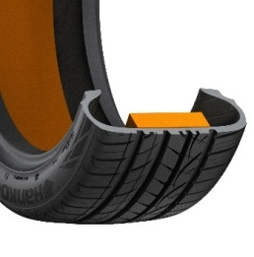Hankook ®**

**Hankook’s sound absorber ® technology for the Ventus S1evo 2SUV:**

* Sound absorber ®: Hankook’s patented technology for noise reduction.
* Reduces interior noise through a specialised, lightweight foam layer.
* The tyre’s driving characteristics remain unchanged.

**Hankook UHP Premium winter tyres:**

* **Optimised driving during the cold season**
* **Now also with Hankook SEALGUARD® technology**
* **Run-flat original equipment on premium vehicles**

**Hankook is applying further upgrades to its ultra high performance winter tyres in the ongoing season. The premium winter tyres of the i\*cept evo family, which have been released in a number of sizes for up to 270 km/h, is rounded off with various new sizes for sporty cars and SUVs, run-flat sizes for premium original equipment and, for the first time, includes a SEALGUARD® version. The ultra high performance winter profiles i\*cept evo, i\*cept evo² and i\*cept evo² SUV, which are optimised for winter conditions in Central and Western Europe, are provided with functional full-silica compounds and are already being fitted as original equipment on the new BMW 7 series. The asymmetric tread design used for all three versions ensures sporty yet comfortable handling on wet and dry roads as well as good traction and braking performance on snow-covered ground.**

Premium tyre maker Hankook is continuing to expand the line-up of its current ultra high performance (UHP) winter tyre specialist. Developed in order to guarantee more safety with continued high performance and superior comfort through the increasing changeable weather conditions in the cold season, the winter tyres of the i\*cept evo family have been tailored specifically for upper mid-range vehicles through to luxury saloons and sports cars. Furthermore, the Winter i\*cept evo² is also available in an SUV version, which has been adapted to meet the special requirements of the popular Sports Utility Vehicle category with its double-layer carcass.

In addition, the Hankook SEALGUARD® technology is being used for the first time in a number of sizes in the current winter season, e.g. for the VW models Passat and Touran. The special SEALGUARD® sealing material seals punctures up to a diameter of 5 mm in the area of the tyre tread. This means that journeys can be continued with no problems even in the case of damage caused by puncture. Additionally vehicles that are equipped with self-sealing tyres no longer need to carry spare tyres. This makes more space available in the vehicle, saves weight and eliminates inconvenient wheel changing at the side of the road. In addition to their safety advantages, products equipped with Hankook SEALGUARD® technology offer particularly comfortable driving pleasure, as the tyres essentially have the same structure as the models without this technology.

Hankook Winter i\*cept evo tyres are also available in various dimensions as run-flat versions with reinforced sidewall for many BMW vehicles amongst others. Thus the Hankook Winter i\*cept evo in the size 245/50 R18 HRS (Hankook Runflat System) has been fitted as original equipment to the BMW 7 series.

Snow, ice, frost, heavy rain or wet leaves often produce dangerous road conditions in winter. The Hankook winter profiles i\*cept evo, i\*cept evo² and i\*cept evo²SUV are therefore meeting these challenges with maximum-grip tread compounds and optimised design functions. Among other things, a highly dispersible nano-silica compound is used, which prevents hardening of the tyre at low temperatures and thus ensures better grip on wintry and wet roads through greater elasticity of the tyre contact area. The contact area of the tyre has been further improved thanks to further optimisation of the tyre profile, which likewise has a positive effect on grip in snow and rain and moreover ensures improved hydroplaning performance.

The outside of the traditionally asymmetric profile of the Hankook UHP profiles ensures improved snow handling and increased traction performance, whilst the inside guarantees optimised braking performance on snow, slush and wet roads. The snow traction performance is aided by an increased number of profile block edges, which effectively “grip” into the snow. By minimising block movement and wear, specially developed 3D sipes applied to the entire tread area ensure additional driving stability as well as improving the general handling properties with the aid of maximised edge effects. The transverse profiling arranged at an optimised angle on the inside of the profile likewise improves performance on snow-covered roads.

The two wide main drainage grooves offer 30 % greater volume for particularly efficient drainage of water or snow slush. With the Hankook Winter i\*cept evo², they aid grip in the snow and hydroplaning performance for a safer driving experience on wet and slushy roads. In conjunction with the wide design of the tyre shoulder and the optimised cubic block design, a reinforced sidewall and bead area ensure direct steering response as well as improved cornering grip and optimised handling performance on dry roads too.

Both the Hankook winter tyre models i\*cept evo, i\*cept evo² and i\*cept evo² SUV as well as the Hankook SEALGUARD® system are manufactured predominantly in the modern European production plants of Hankook in Hungary. The various i\*cept evo versions are available in a total of 155 different dimensions for upper mid-range vehicles through to luxury saloons, sports cars and all popular SUVs.

The **Hankook Winter i\*cept evo** is supplied in 25 dimensions from 15 - 18 inches with tread widths of 185 - 265 mm and aspect ratios of 75 - 45 in the speed indices H and V, some with **HRS** (Hankook Runflat System) as sidewall-reinforced run-flat tyres suitable for many BMW models.

The **Hankook Winter i\*cept evo²** is available in a total of 87 sizes from 15 - 20 inches with tread widths of 195 - 295 mm and aspect ratios of 60 - 30 in the speed indices H, V and W, mainly as designs with increased load capacity (Extra-Load ‒ XL). The Hankook **SEALGUARD®** technology is being offered for the winter season 2016 initially for the tread Winter i\*cept evo² in the sizes 215/60 R 16 H and 215/55 R 17 V for the Volkswagen models Passat and Touran amongst others.

The **Hankook Winter i\*cept evo² SUV** is available in 37 sizes from 16 – 21 inches with tread widths of 215 – 315 mm and aspect ratios of 70 – 35 in the speed indices T to W.

**Technical Characteristics of the Hankook Premium Winter Treads i\*cept evo, i\*cept evo² and i\*cept evo² SUV:**

**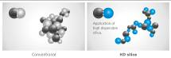**

1. *High-dispersible nano silica ~~t~~read compound*

* Improved wet traction, snow and ice performance.

*2. Double functional, asymmetrical performance tread*

* The outer tread and its compact shoulder profile offer better handling performance on dry roads.
* The inner tread surface increases braking power and traction on wet and snowy streets.
* Especially efficient water and slush removal.

**w320_F_kerf**

*3. 3D-sipesacross the entire tread surface*

* Optimised driving stability in dry or wet conditions, and better winter performance through minimised block movement.

*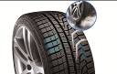*

*4. Lateral grooves on the inside of the profile act like ice axes*

* Improved snow traction through optimised angular arrangement of the lateral grooves.

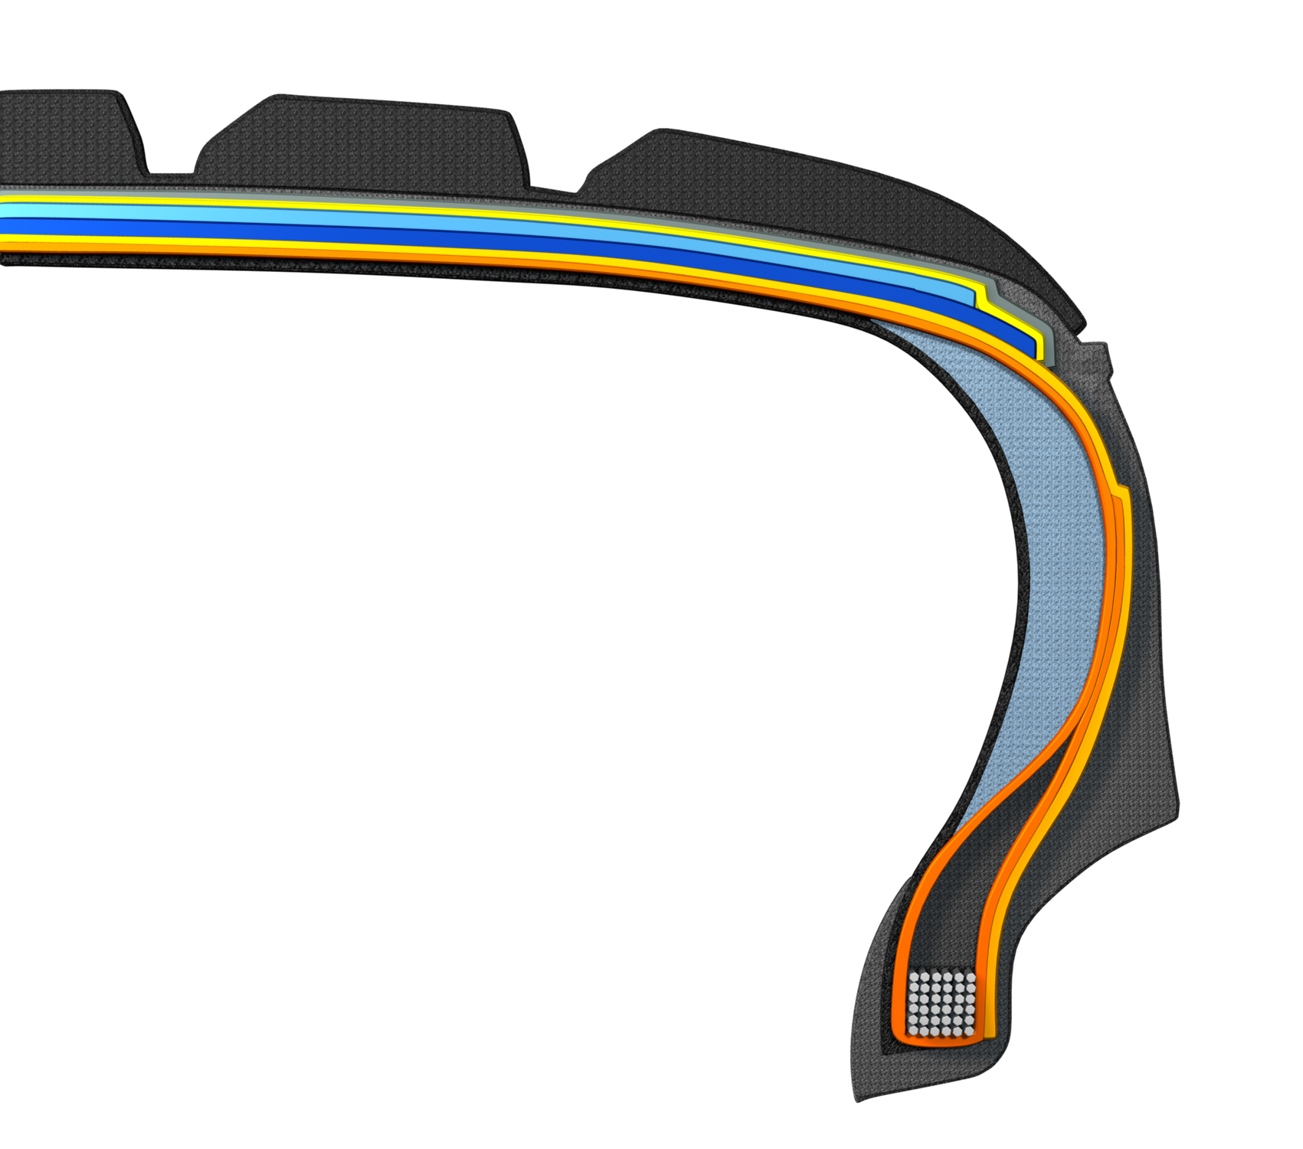

*5. HRS (Hankook Runflat System) technology*

* Side wall reinforced tyres with run-flat features.
* Available in various sizes, including for many BMW models, in the i\*cept evo tread.

*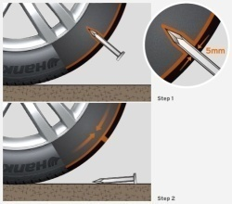6. Hankook SEALGUARD®t echnology*

* SEALGUARD® tyres contain a viscous material with which the interior of

the tire is coated shoulder to shoulder.

* In case of a puncture, holes with a diameter of up to 5 mm are immediately

sealed off by the Hankook SEALGUARD® technology.

* Available in various sizes, including for VW Passat and Touran

in the i\*cept evo² tread.

*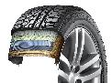7. Double-layer carcass*

* Especially even ground pressure distribution through ideal tyre contact surface.
* Outstanding driving stability, especially for high-power, heavy vehicles
* Available in a variety of dimensions, made especially for the demands of modern sports utility vehicles.

###

**Winter i\*cept RS2: Very good test results!**

**The Hankook Winter i\*cept RS² is “highly recommendable”, according to the editors of the Auto Zeitung in their current winter tyre test. The very good snow performance and an outstanding price-performance ratio of size 205/55 has once again impressed reviewers. Auto Bild emphasised; fuel-saving thanks to low rolling resistance as well as achieving high mileage, the Winter i\*cept RS² is economical and safe. Besides strong performance in the safety-related criteria in wet, snowy, and dry road conditions, the Winter i\*cept RS² beat 50 competitors in terms of mileage too and took the title of “Eco Master”.**

“Aspects such as fuel efficiency and the sparing handling of resources are becoming increasingly important for tyre buyers, too,” explains Tony Lee, Hankook’s Vice President of Marketing and Sales for Europe. “Our current winter tread shows that these days modern, high-performance winter tyres can also meet customers’ requirements in terms of sustainability and environmental compatibility. We are extremely pleased with the independent test results and the related evaluations for our Hankook Winter i\*cept RS²“

Developed to deliver balanced performance in all wintery driving conditions, the Hankook Winter i\*cept RS2 comes equipped with a special nano-sized, high dispersible silica compound, resistant to hardening in low temperatures, and a new solution-styrene butadiene rubber. The compound ensures the tread stays elastic even at very low temperatures, thus providing excellent traction and braking power by increasing the tyre’s contact area, in particular in the cool temperatures and wet roads typical during the colder seasons. The increased void volume of the tyre tread, designed using Hankook Aqua-Slant technology, is achieved through the highly effective interaction between two longitudinal wide grooves on the tread. This offers especially efficient water and slush displacement.

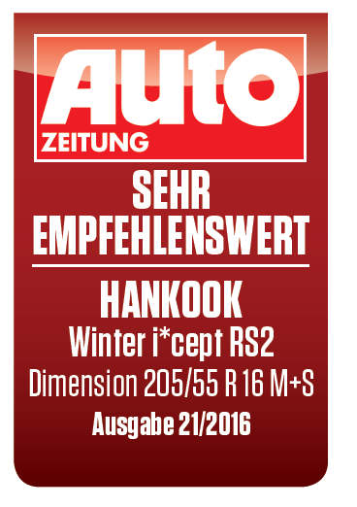

The directional V-shaped tread design of Hankook's Winter i\*cept RS2 features 28% more pitches as well as increased groove and block edge length. Enhanced traction on snow covered surfaces is the result of the tread design which effectively bites into the snow. Moreover, the corrugated 3D sipes applied throughout the tyre tread increase traction and braking performance on all smooth surfaces. In addition they improve driving stability in wintery conditions by minimising block movement, abrasion and enhancing the overall handling performance through maximised edge effects. Special ice slits and grip claw 3D edges make for further improved cornering performance and snow traction.

Further improvements to the structure of the i\*cept RS2 have resulted in an even load distribution and a footprint increase of up to 5% compared to conventional products which has further enhanced the braking performance on both wet and dry roads. The stiffer sidewall and bead area of the tyre ensures more direct steering reactions and improved steering feedback and a more precise lateral stability on dry roads as well.

**Technical Characteristics of the Hankook Winter i\*cept RS2**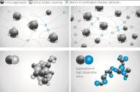**­­­­­­­:**

1. *New high-dispersible nano silica ~~t~~read compound for improved winter performance*

* Improved wet traction, snow and ice performance.

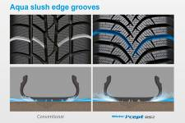

1. *Aqua slush edge grooves for improved wet performance*

* Water and slush are effectively drained away to reduce the risk of aquaplaning and improve wet braking performance.
* Significantly increased traction on snowy and slushy roads.

1. *3D sipes*

* w320_F_kerfEnhanced driving stability and improved winter performance through

minimised block movement.



1. *Grip claw technology and increased pitch number for improved snow traction*

* 3D sharp edges improve traction on snow covered roads.
* 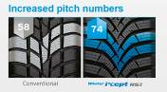28% increase of pitch sequence for high snow grip and increased traction

performance.

1. *Available sizes:*

* The Hankook Winter i\*cept RS2 is available in42 dimensions from 13 – 17 inches, in tread widths of 135 – 225 mm with aspect ratios from 45 – 80 series in speed indexes H and T.

\* Evaluations by Auto Bild no. 40 dated 2 October 2015, 50 tyre treads from all brands, tested on a VW Polo in size 185/60 R 15 T; award: Eco Master, and Auto Zeitung 21/16 13 tyre treads from various brands, tested on a VW Golf in size 205/55 R 16; result: “Highly recommended”.

###

**Hankook Ventus Prime³: Premium comfort tyre for Europe is Auto Bild test winner**

**The newest model in the successful Ventus product family for premium performance passenger car tyres was developed to provide an ideal blend of performance, safety, comfort, and environmental friendliness. It was nominated in March 2016 in the summer tyre test by the magazine AUTO BILD as the test winner among 50 other brands in size 205/55R16V (22/03/2016). Besides its fuel efficiency, the tyre stood out by providing the best driving characteristics in its class on wet and dry streets.**

Premium tyre maker Hankook is introducing its new Ventus Prime³ for the European market. The tyre was developed with a focus on providing a balanced blend of performance, comfort, safety, and environmental friendliness, and is the newest premium comfort flagship in the successful Ventus product series offered by the company. Drivers benefit from well-designed driving characteristics, including even better braking performance on both wet and dry streets.

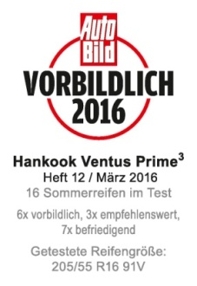Improving braking performance on wet surfaces was a key task for Hankook engineers in developing the next generation of Ventus Prime products. To do so, Ventus Prime³uses a new, high-grip silica tread compound and a new compounding technology which provides much better distribution of polymers and fillers in the tread compound. This allows the tyres to achieve both wet braking performance improved by around eight percent and reducing of rolling resistance. In addition, the four wide profiled grooves ensure fast drainage, which improves vehicle control on wet streets and helps reduce the danger of aquaplaning. The depth of the individual profiled grooves also depends on their position on the tyre, in order to counteract the classic conflict between wet and dry driving

characteristics in the Ventus Prime³.

The new Ventus Prime³also made another developmental leap when it comes to dry handling. By using a newly designed, asymmetrical tread, the actual contact surface between the tyre and the street was increased by ten percent. Along with the improved tread stiffness in both radial and lateral directions, and in conjunction with new “hybrid hardness” pattern ribs (different hardness levels on the outside and inside) and a massive outer tyre shoulder, the Ventus Prime³provides significantly better dry performance. The dry braking performance of the tyre was also improved by three percent, whilst the traction was optimised, for instance, by applying chamfered profile block edges distributed across the entire tread surface, increasing the contact surface during braking.

Newly-developed, functionalised polymers with a high molecular weight in the tread blend of the Ventus Prime³increase its wear-resistance by nine percent. The tyre is equipped with a highly-modern, lightweight, and especially sturdy Rayon carcass and a wide steel belt including a wrapped bandage and high-strength bead filler. Besides improving handling, this ensures precise steering feedback and great control, even at high speeds. Thanks to an improved pitch design and the optimised angle of lateral profiling, as well as a sidewall optimised for air resistance, developers were able to further develop the noise level of the tyres, once again improving the outstanding comfort features of the Ventus Prime³. By using a new technology when positioning the profile grooves, development engineers at Hankook were able to achieve a significant reduction in the noise level of the tread, even with improved tyre life.

**Technical features of the Hankook Ventus Prime³:**

1. 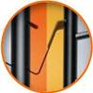*Improved performance on dry streets*

- Increased profile block stiffness in both radial and lateral directions.

- Tyre contact area increased by ten percent.

- Different hardness levels on the outer ribs, and a massive outer shoulder block for improved curve stability.

- Longitudinally oriented tread design for outstanding directional stability, even at high speeds.

- Chamfered profile block edges broaden the contact surface while braking:

dry braking power improved by three percent.

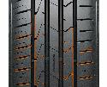- Light, yet highly sturdy Rayon carcass and extremely strong bead

filler for better handling characteristics and precise steering feedback.

2. *Improved performance on wet streets*

- Four wide main tread grooves for especially fast drainage.

- Newly developed, high-grip tread blend and new compounding technology for an improved distribution of polymers and fillers; eight percent better wet braking performance.

*3. Reduced noise production and high comfort*

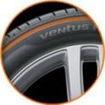- Innovative pitch design and newly developed technology to position the tread grooves in order to reduce noise production on the tread, even with continued use.

- Stable, single-strand bead wire for excellent concentricity / driving comfort.

- Air resistance optimised side wall design to reduce air vortices and vibrations at

high speeds.

*4. Low rolling resistance and less tyre wear*

- High-grip silica blend reduces rolling resistance.

- Polymers with high molecular weights in the tread compound:

- Wear performance improved by nine percent.

- Visual Alignment Indicator System on the outer tyre shoulder allows drivers to

easily check for uneven wear caused by poor body alignment

*5. Line-Up*

- The Ventus Prime³ is primarily produced in Hankook’s highly modern

European production facility in Hungary, and is available in 50 sizes from

15 to 18 inches, with tread surface widths of 185 to 245 mm, aspect ratios

of 65 to 40, and is available in speed classes H, V, W, and Y.

###

**Hankook achieved “Outstanding” in Auto Bild Sportscars Magazine’s 2016 UHP Summer Tyre Test**

**Hankook Tire’s UHP flagship Ventus S1 evo² is rated ‘outstanding’ in the 2016 German Auto Bild Sportscars UHP Summer Tyre Test and is recognised in particular for its exemplary wet performance in the braking, handling and hydroplaning categories.**

Premium tyre maker Hankook achieved an ‘outstanding’ test result with its UHP flagship tyre Ventus S1 evo² in the 2016 UHP Summer Tyre Test by the renowned German automobile magazine Auto Bild Sportcars. The magazine put six leading tyre brands in the dimensions 255/35 R 20 (front axle) and 295/30 R 20 (rear axle) to the test on a Jaguar F-Type. Hankooks’ Ventus S1 evo² achieved the best test result of ‘outstanding’ and was recognised in particular for its wet performance, sharing an excellent overall result and test win with another European Premium brand.

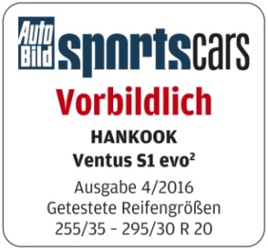

The 2016 Auto Bild Sportscars tyre test reflects various performance aspects including handling and braking on both dry and wet roads, as well as noise level and rolling resistance. During the test, the Ventus S1 evo² showed an overall very strong performance during the handling, braking distances, and hydroplaning as well as noise and rolling resistance tests. It is thus following in the footsteps of its predecessor model Ventus S1 evo, which received the “Outstanding” award from Auto Bild Sportscars in 2015. The UHP wide tyre received special recognition for

its balanced, performance, low rolling resistance and convincing braking qualities

in the wet.

Equipped with sophisticated DTM technology, the Hankook Ventus S1 evo² has repeatedly been recognised by premium automakers including Audi, BMW, Mercedes Benz and the Volkswagen Group, for its successful combination of performance, durability, comfort and energy efficiency. The tyre was particularly recognised by the testers for its exemplary performance on wet roads, scoring category wins in the hydroplaning, wet circle and wet braking tests.

The tyre’s asymmetric tread design provides an increased water drainage performance whilst dispersing friction heat. It also guarantees a precise and comfortable driving experience with reduced noise and vibration.

Ho-Youl Pae, COO for Europe at Hankook, explains: “We are extremely pleased with this excellent test result for our UHP flagship model Ventus S1 evo². Regularly achieving such results in independent tyre tests gives proof that our continuous commitment to technology advancement results in products that deliver the best possible driving experience at all times for our customers.”

**Technical Characteristics of the Hankook Ventus S1 evo²:**

*1. DTM-engineered Multi Tread Radius for equal ground contact pressure through ideal tyre footprint*

* Outstanding high speed driving performance and straight stability.
* Perfect balance in both wet and dry conditions.
* Increased performance especially in lateral hydroplaning.

*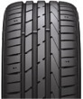 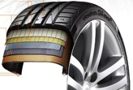* *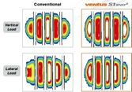*

*2. DTM-inspired triple layered block design for superior traction*

* 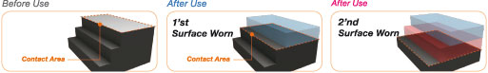The staircase arrangement of the outer rib blocks is designed to increase the tyre contact patch with the surface as the tyre wear progresses, ensuring a consistently high traction performance throughout the tyre-lifecycle.

*3. Improved Compound Technology for improved wet braking performance & reduced rolling resistance*

* High Styrene Polymer enhances the tyre’s wet braking performance.
* 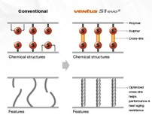An optimised cross-linking system helps to improve the tyre’s wear performance.

*4. Advanced Cooling System with Intercoolers for improved heat regulation*

* Surface enlarging cooling fins in the ground of tyre grooves provide a permanent heat reduction providing

a more stable handling performance.

* Double step dimples at outer block edges generate micro cooling turbulences thus reducing heat in

the tyre’s shoulder part.

* Rectangular dimples-design minimises noise and vibration level for increased driving-comfort.

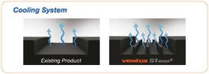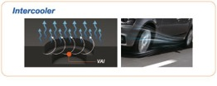

###

Hankook Ventus V12 evo²:

Performance, design and environmental excellence

combined in one wide tyre

**With the new Ventus V12 evo², tyre maker Hankook presents a new performance and design oriented refitting wide tyre for sports-style inspired drivers. The elegant, directional design of the tread with 3D block structure and aerodynamically optimised sidewall combines style and excellent drive performance with very low rolling noise and reduced rolling resistance. As of the market launch, the Ventus V12 evo²is available in 25 refitting sizes ranging from 16 to 19 inches.**

Premium tyre maker Hankook offers the Ventus V12 evo² as a high-performing wide tyre specially developed for the European market and the retrofitting/tuning segment.

The flow-optimised, directional tread consists of the 3D block structure, already known from the predecessor model, which has been enhanced for excellent water channeling. The tyre contour in the Multi-Tread-Radius Technology, derived from the manufacturer's successful involvement with motor sports, in combination with the extremely stiff yet lightweight steel cord material of the belt layer, also guarantees the best possible tyre contact area under extreme stress, for example high cornering speeds.

With the usage of a high traction nano-silica tread compound in combination with the optimisation of tread block stiffness along the entire tread width, braking distances of both dry and wet braking is shortened by 4 to 5 percent. The high traction styrene polymer formula in the rubber compound enables improved wet performance while rolling resistance is reduced for maximised environmental excellence.

A refined cooling system of surface-enlarged fins anchored in the base of the tread grooves enable faster heat dissipation for more stable handling characteristics and longer tyre durability. In order to make the driving experience even more comfortable, like its "big" brother Ventus S1 evo², the new Ventus V12 evo² is also equipped with an aerodynamic shaped wing that further reduces tyre noise and highlights the sports-look of the tyre.

The Ventus V12 evo² is manufactured mainly in the company's state-of-the-art European factory in Hungary and is available in 25 dimensions from 15 to 19 inches with tread widths of 195 to 255 mm in the 30 to 50 series.

**Technical characteristics of the Hankook Ventus V12 evo²:**

*Improved handling characteristics*

* Motor sports tyre contour and extremely stiff, ultra-lightweight belt layer for optimum power transmission.
* Surface enlarged cooling fins in the tread base of the main grooves provide continuous heat reduction for more stable handling performance.

*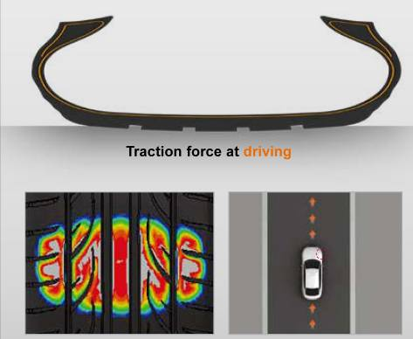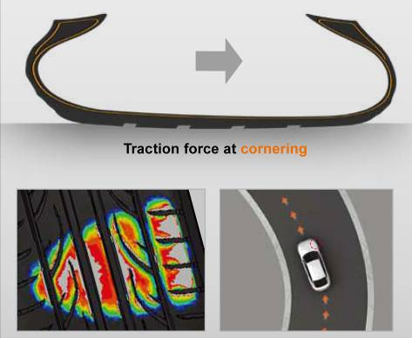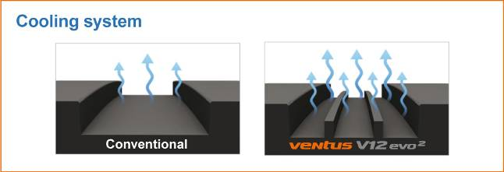*

*Secure water channelling on wet streets*

* The flow optimised tread grooves channel water optimally and quickly.

*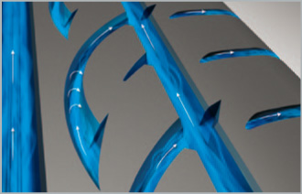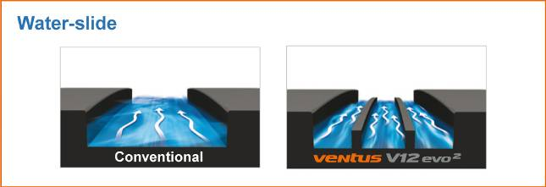*

*Reduced noise development*

* Elaborate 5-pitch design and special block edges minimise rolling noise.
* The dimple sidewall design reduces noise and vibrations at high speeds.

*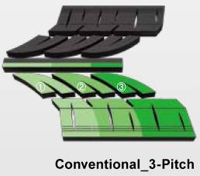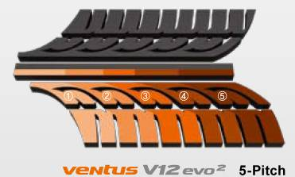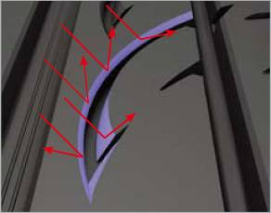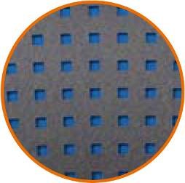*

*Improved rolling resistance*

* New styrene polymer compound technology.

*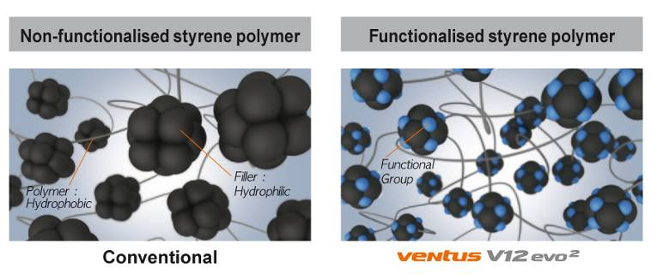*

*Line-Up*

* The line-up is available in sizes 16 to 19 inches covering the 30 to 50 series with tread widths of 195 to 255 in speed indices from V to Y.

###

**Hankook Tire presents design innovation trough collaboration with Vibram®**

**A cross-industry collaboration between Hankook Tire and Vibram® leads to mutually inspired progressive innovation. The combination of Hankook’s advanced technologies and Vibram®’s hyper-functional outsole designs creates innovative off-road tire and shoe concepts**

Hankook Tire’s strategic partnership with Vibram®, the premium outsole company, has enabled the development of futuristic concept tyres and shoes in a cross-industry collaboration. By combining the two companies’ significant technological strengths and authentic styles, the collaboration has pushed the

boundaries of performance in both industries.

In many ways, Hankook and Vibram® are a natural fit for one another. They both have over 70 years of growth and success under their belt, they boast global distribution networks, and they have consistently garnered recognition for innovation in their respective fields. And, of course, both companies specialize in providing superior traction. With their impressive R&D backgrounds in developing high quality materials, the two companies have continually set new yardsticks in performance and design.

Hankook has now utilized Vibram®’s hyper-functional design for its latest concept tyres, while simultaneously enabling Vibram® to integrate cutting-edge tyre technologies into its footwear offerings. In total, five products are being unveiled. Hankook Tire is releasing two off-road concept tyres, the *DynaMIX* and *DynaSYNC*, and Vibram® is releasing three concept shoes, the *DynaTREK*, *DynaSTRYKE BKL*, and *Omnifuse*. The shoes will serve as successors to Vibram®’s wildly popular *Vibram FiveFingers®* lineup.

Hankook Tire’s *DynaMIX* and *DynaSYNC* were inspired by the flexible blocks found on the outer soles of Vibram®’s hiking shoes. These blocks are designed to change their contact positions in response to variations in ground surface. The use of different layer structures also allows for multiple style choices.

*DynaMIX* tires take advantage of Vibram®’s Ultra-light 3D Cocoon Technology. Multi-direction geometric dimensional blocks serve to protect the tyres from road impacts. At the same time, traction, block stability and flexibility are improved while sidewall weights are reduced. The *DynaMIX*’s three-dimensional tread pattern excels in tough off-road conditions. The texture and design of particular tread blocks in the pattern have been tailored to maximise overall performance. The glitter surface of the tyre is polished, which enhances handling and wet performance, while at the same time promoting greater control at faster speeds. And finally, the geometric sidewalls integrate Hankook’s wet-tech holes, enabling the sidewalls to achieve greater flexibility and disperse shocks.

*DynaSYNC* features Vibram®’s iconic Carrarmato lugs design on its tread pattern to improve traction in mountainous terrain. The honeycomb structure grooves that prevents puncture or tyre chips due to gravel or stones. This improves shock absorption and provides powerful and safe handling. And the sidewall comes in a variety of color compounds, allowing car owners to match the tyres to their car’s body color. Its dual-layered sidewall structure prevent cracking by enhancing block stiffness and reducing severe deformations during cornering and high-speed maneuvers.

Vibram®’s *DynaTREK* and *DynaSTRYKE BKL* concept shoes are paired with the *DynaMIX* and *DynaSYNC* concept tyres, respectively, as sister products. The *DynaTREK* boasts a high performance outdoor/hiking outsole, and it uses the same Ultra-light 3D Cocoon Technology found in the *DynaMIX* to provide enhanced protection and shock absorption. It also sports the *DynaMIX*’s center stripe around the entire sole, highlighting the collaboration story between the two brands. The *DynaSTRYKE BKL* reflects the performance attributes of the *DynaSYNC*. The Megagrip rubber outsole and the interlocking lugs provide unparalleled winter running performance in a Vibram *FiveFingers®* shoe. Moreover, thermochromatic pigment applied to the *DynaSTRYKE BKL* induces a subzero appearance with the color shifting at the toes. Finally, the *Omnifuse* adapts motifs from conventional tyre products.

“This joint project fits ideally with our ongoing commitment to investing in technological innovations and performance-oriented designs. Moreover, from a macro-perspective, the project reflects Hankook’s longstanding core company value – progressive innovation. This momentum will be carried forward in the future as the company continues to take an authentic, meaningful approach to meeting the challenges of future driving experience.” said Mr. Ho Youl Pae, Head of Hankook Tire Europe.

###

**Hankook is Original Equipment Supplier for Scania**

**Tyre maker Hankook has been the OE supplier for various Scania heavy-goods trucks and buses since November 2016. Scania, based in Södertälje in Sweden, is a part of Volkswagen Truck & Bus GmbH - one of the world’s leading manufacturers of trucks and buses for heavy transport applications. Scania is also leading provider of industrial and marine engines. Service-related products account for a growing proportion of the company’s operations, assuring Scania customers of cost-effective transport solutions and maximum uptime. Scania also offers financial services. Since November 2016, Hankook has been supplying tyres to the production locations of the commercial vehicle manufacturer in Sweden. The equipment provided will include the truck tyre line e-cube MAX for long-haul traffic, as well as the SmartFlex, an all-year tyre for medium-haul applications suitable for the recently optimized Scania Euro 6 model among others. From the end of 2017 onwards, the truck tyre line for construction site use SmartWork will also be added.**

Premium tyre maker Hankook has been Original Equipment Manufacturer to Scania, among others, since November 2016. Scania is part of the Volkswagen Group, one of Hankook’s largest OE customers world-wide. Hankook’s OE business with truck tyres for Scania will focus on Europe and initially covers 18 dimensions in the 22.5 inch range. The new OE cooperation with Scania is Hankook’s second within the Volkswagen Group in the heavy commercial vehicles segment; Hankook has already been supplying various models within this segment to the MAN Truck & Bus GmbH since 2015.

“The cooperation with Scania in the original equipment segment is real proof of the quality of our products, since the e-cube MAX, SmartFlex and SmartWork lines were all able to meet the stringent specifications of the Scania engineers particularly in terms of performance, efficiency and sustainability,” says Ho-Youl Pae, COO for Europe at Hankook.

All Scania truck and bus model ranges being produced in Europe will be equipped. Tyres to be used include the e-cube MAX line for international long-haul traffic, a series which has been optimized for rolling resistance, and the new SmartFlex all-year tyre range, designed for flexible use between long-haul and delivery traffic. Construction site and offroad treads from the SmartWork series will also be introduced. Specially adapted for use on vehicles of the EURO 6 emissions class, the designated treads for the steering and drive axle score particularly well for environmental friendliness and service life – important aspects of TCO (Total Cost of Ownership) in the commercial vehicles OE business.

|  |  |  |  |  |  |  |
| --- | --- | --- | --- | --- | --- | --- |
| **Tread** | **Size** | **LI** | **Marking** |  | **M+S** | **Availability** |
| **AL10+** | 315/80R22.5 | 156/150L (154/150M) | B/B/W1 70dB | - | - | 🗹 |
| 315/70R22.5 | 156/150L | B/B/W1 70dB | - | - | 🗹 |
| 315/60R22.5 | 154/148L | C/B/W1 70dB | - | - | 🗹 |
| **DL10+** | 315/80R22.5 | 156/150L (154/150M) | C/C/W1 73dB | 🗹 | 🗹 | 🗹 |
| 315/70R22.5 | 154/150L | C/C/W1 73dB | 🗹 | 🗹 | 🗹 |
| 315/60R22.5 | 152/148L | C/C/W1 73dB | 🗹 | 🗹 | 🗹 |
| **AL10** | 295/60R22.5 | 150/147K  (149/146L) | C/C/W1 70dB | - | - | 🗹 |
| 295/80R22.5 | 152/148M (154/149L) | C/C/W1 70dB | - | - | 🗹 |
| 385/55R22.5 | 158L (160K) | B/C/W1 70dB | - | - | 🗹 |
| **DL10** | 295/80R22.5 | 152/148M | C/C/W2 75dB | - | 🗹 | 🗹 |
| 295/60R22.5 | 150/147K (149/146L) | D/C/W2 75dB | - | 🗹 | 🗹 |
| **AH31** | 295/80R22.5 | 152/148M | C/B/W1 73dB | 🗹 | 🗹 | 🗹 |
| 315/70R22.5 | 156/150L | C/B/W1 67dB | 🗹 | 🗹 | 🗹 |
| 315/80R22.5 | 156/150L | C/B/W1 73dB | 🗹 | 🗹 | 🗹 |
| **DH31** | 295/80R22.5 | 152/148M | D/C/W2 75dB | 🗹 | 🗹 | 🗹 |
| 315/80R22.5 | 156/150L | D/C/W2 75dB | 🗹 | 🗹 | 🗹 |
| 315/70R22.5 | 154/150L | D/C/W2 75dB | 🗹 | 🗹 | 🗹 |
| **AH15** | 385/65R22.5 | 160K | C/B/W1 70dB | - | - | 🗹 |

**###**

**Hankook Supplies Original Equipment Tyres**

**with 36 Sizes to MAN**

**Tyre maker Hankook already supplies Original Equipment for various MAN long-haul trucks. The MAN Truck & Bus AG belongs to the Volkswagen Group, one of Hankook's largest OE customers worldwide. The OE business with Hankook truck tyres for MAN covers a total of 36 dimensions in the 17.5, 19.5, 22.5 and 24 inch range. Hankook's Original Equipment portfolio for the bus and truck manufacturer includes the supply of the tyre ranges e-cube MAX, SmartFlex and SmartWork for various MAN models to the production facilities of the Munich-based manufacturer in Germany, Austria and Poland. The tyre ranges have been specially adapted for European conditions, boasting both ecological and economic advantages.**

Premium tyre maker Hankook is listed as an OE supplier for MAN with 36 dimensions, including the truck tyre ranges e-cube MAX, SmartFlex and SmartWork. The commercial vehicles specialist and the tyre maker have been cooperating since the first quarter of 2015. Ho-Youl Pae, Hankook COO for Europe comments: “The expansion of OE business in the commercial vehicles segment with MAN is of great strategic importance to us, as we can now offer further treads and dimensions for light to medium-duty trucks from MAN.”

The tyres will be fitted to the multi-award-winning MAN vehicle series TGX, TGS, TGM and TGL which are used for national and international long-haul, delivery and construction site traffic. Tyres used include the e-cube MAX line, which is tried-and-trusted for international long-haul traffic, the new SmartFlex all-year tyre range for flexible use between long-haul and delivery traffic, as well as construction site treads from the SmartWork series. Specially adapted for use on vehicles of the EURO 6 emission class, the treads – both as special steering and drive axle versions – score highly for environmental friendliness and mileage. This is also relevant to the TCO (Total Cost of Ownership), important for Original Equipment.

One special feature of Hankook's OE tyre portfolio for MAN are the new sizes in the low-line segment. With these, the premium tyre maker is demonstrating that its portfolio has already integrated the current market trend, namely the growing importance of low-line sizes in the truck business.

*Hankook's range of Original Equipment tyres for MAN:*

|  |  |  |  |  |  |  |  |
| --- | --- | --- | --- | --- | --- | --- | --- |
| **Tread** | **Size** | **Model** | **LI** | **Marking** |  | **M+S** | **Availability** |
| **AL10+** | 315/80R22.5 | TGX | 156/150L (154/150M) | B/B/W1 70dB | - | - | 🗹 |
| 315/70R22.5 | TGX | 156/150L | B/B/W1 70dB | - | - | 🗹 |
| 315/60R22.5 | TGX | 154/148L | C/B/W1 70dB | - | - | 🗹 |
| 355/50R22.5 | TGX | 156L | C/B/W2 76dB | - | - | 🗹 |
| **DL10+** | 315/80R22.5 | TGX | 156/150L (154/150M) | C/C/W2 75dB | 🗹 | 🗹 | 🗹 |
| 315/70R22.5 | TGX | 154/150L  (152/148M) | C/C/W2 75dB | 🗹 | 🗹 | 🗹 |
| 315/60R22.5 | TGX | 152/148L | C/C/W2 75dB | 🗹 | 🗹 | 🗹 |
| **AL10** | 295/60R22.5 | TGX | 150/147K  (149/146L) | C/C/W1 70dB | - | - | 🗹 |
| 295/80R22.5 | TGX | 152/148M | C/C/W1 70dB | - | - | 🗹 |
| 385/55R22.5 | TGX | 158L (160K) | B/C/W1 70dB | - | - | 🗹 |
| **DL10** | 295/80R22.5 | TGX | 152/148M | C/C/W2 75dB | - | 🗹 | 🗹 |
| 295/60R22.5 | TGX | 150/147K (149/146L) | D/C/W2 75dB | - | 🗹 | 🗹 |
| **AH31** | 295/80R22.5 | TGM & TGS | 152/148M | C/B/W1 72dB | 🗹 | 🗹 | 🗹 |
| 315/70R22.5 | TGM & TGS | 156/150L | C/B/W2 73dB | 🗹 | 🗹 | 🗹 |
| 315/80R22.5 | TGM & TGS | 156/150L  (154/150M) | C/B/W2 73dB | 🗹 | 🗹 | 🗹 |
| 385/65R22.5 | TGM & TGS | 160K | C/B/W1 69dB | 🗹 | 🗹 | 🗹 |
| 315/60R22.5 | TGM & TGS | 154L | C/B/W1 75dB | 🗹 | 🗹 | 🗹 |
| **DH31** | 295/80R22.5 | TGM & TGS | 152/148M | D/C/W2 75dB | 🗹 | 🗹 | 🗹 |
| 315/80R22.5 | TGM & TGS | 156/150L  (154/150M) | D/C/W2 75dB | 🗹 | 🗹 | 🗹 |
| 315/70R22.5 | TGM & TGS | 154/150L | D/C/W2 75dB | 🗹 | 🗹 | 🗹 |
| 315/60R22.5 | TGM & TGS | 154/148L  (152/148L) | D/C/W2 75dB | 🗹 | 🗹 | 🗹 |
| **AH11** | 215/75R17.5 | MAN TGL | 128/126M | D/C/W1 67dB | - | - | 🗹 |
| 235/75R17.5 | MAN TGL | 132/130M | D/C/W1 67dB | - | - | 🗹 |
| 265/70R19.5 | MAN TGL | 140/138M | C/C/W1 67dB | - | - | 🗹 |
| 285/70R19.5 | MAN TGL | 145/143M | C/B/W1 67dB | - | - | 🗹 |
| **DH05+** | 215/75R17.5 | MAN TGL | 126/124M | D/C/W1 67dB | - | 🗹 | 🗹 |
| 235/75R17.5 | MAN TGL | 132/130M | E/B/W2 75dB | - | 🗹 | 🗹 |
| 265/70R19.5 | MAN TGL | 140/138M | D/B/W2 75dB | - | 🗹 | 🗹 |
| 285/70R19.5 | MAN TGL | 145/143M | D/C/W2 75dB | - | 🗹 | 🗹 |
| **AM06** | 325/95R24 | MAN TGS | 162/160K | D/C/W2 72dB | - | 🗹 | 🗹 |
| **DM06** | 325/95R24 | MAN TGS | 162/160K | D/B/W1 67dB | - | 🗹 | 🗹 |
| **AM15+** | 385/65R22.5 | MAN TGS | 158L | D/C/W2 73dB | - | 🗹 | 🗹 |
| **AM09** | 315/80R22.5 | MAN TGS | 156/150K | D/C/W1 70dB | - | 🗹 | 🗹 |
| 13R22.5 | MAN TGS | 156/150K | D/C/W2 74dB | - | 🗹 | 🗹 |
| **DM09** | 315/80R22.5 | MAN TGS | 156/150K | D/C/W1 68dB | - | 🗹 | 🗹 |
| 13R22.5 | MAN TGS | 156/150K | D/C/W2 75dB | - | 🗹 | 🗹 |

**###**

**Hankook Tire Expands Original Fitment Supply Volume to include Additional Sizes for Premium Trucks**

**Hankook supplies more than 42 sizes of its premium truck tyres as Original Equipment to the European market, including for the complete Mercedes-Benz Actros and Atego model range. The Hankook portfolio for Daimler includes the e-cube MAX, SmartFlex and SmartWork series. This means that Hankook has almost doubled its range of dimensions in OE business with Daimler AG trucks since the cooperation started in 2014.**

Hankook further expands its original equipment (OE) portfolio in the heavy commercial vehicle (HCV) and medium duty segment as part of its existing OE agreements for Mercedes-Benz truck model range: Actros, Antos, Arocs, Axor, Econic and Atego. The tyre maker’s latest original equipment line-up includes among other the Hankook treads AL10+ e-cube MAX and DL10+ e-cube MAX, as well as the SmartFlex AH31 and SmartFlex DH31, all of which have been specially developed for the European market. Since the start of their original equipment business with Daimler AG, Hankook has expanded its portfolio for the Stuttgart-based truck and bus manufacturer to include more than 42 dimensions.

Hankook supplies multiple options for 22.5 inch tyres, the top-selling standard wheel size for heavy duty trucks in Europe, as well as for commercial vehicle tyres in the 17.5 and 19.5 inch sizes. Extending the OE fitment of the most-demanded heavy duty and medium duty trucks further strengthens the Hankook brand in a highly competitive market and is yet another milestone in the company’s endeavour for sustainable growth in the TBR business.

The e-cube MAX AL10+ (all position long haul) utilises linear grooves with waved walls to prevent uneven wear, enhancing durability and providing improved long-term fuel efficiency. The improved tread compound and high load index of the AL10+ increases fuel efficiency whilst simultaneously increasing load capacity. The e-cube MAX DL10+ (drive axle long haul) offers drivers excellent traction with three-dimensional kerfs and superior long mileage performance with extra-wide tread blocks and deep grooves. The block supporter also provides the DL10+ with boosted longevity and low rolling resistance. Both of these treads will be supplied in three sizes: 315/80R22.5, 315/70R22.5 and 315/60R22.5.

The SmartFlex AH31 is an all-season TBR tyre well-suited for variable road conditions, providing even wear and long mileage performance with significantly lower rolling resistance. The revolutionary drive axle tyre SmartFlex DH31 is perfectly matched for a number of different applications with its cutting-edge technology providing excellent traction in a number of different operating conditions. These include regional, long-haul and winter conditions due to the 3PMSF (Three Peak Mountain Snowflake), and also guarantee high mileage durability. The SmartFlex AH31 and SmartFlex DH31 will be available as original equipment in four sizes: 295/80R22.5, 315/60R22.5, 315/70R22.5 and 315/80R22.5.

In 2014, Hankook Tire was selected as an OE supplier for Mercedes-Benz medium duty ‘Atego’ trucks and the heavy duty model range ‘Actros’. Based on its position as a strategic partner for leading automakers like Mercedes-Benz, Hankook Tire has built a reputation for global top-tier technology and quality products in the TBR segments.

*Hankook original equipment for Mercedes-Benz trucks:*

|  |  |  |  |  |  |  |  |
| --- | --- | --- | --- | --- | --- | --- | --- |
| **Tread** | **Size** | **Model** | **LI** | **Marking** |  | **M+S** | **Availability** |
| **Smart Flex AH31** | 295/80R22.5 | Actros, Antos, Arocs, Axor and Econic | 152/148M  (154/149L) | C/B/W1 72dB | 🗹 | 🗹 | 🗹 |
| 315/60R22.5 | Actros, Antos, Arocs, Axor and Econic | 160K(158L) | C/B/W1 70dB | 🗹 | 🗹 | 🗹 |
| 315/70R22.5 | Actros, Antos, Arocs, Axor and Econic | 156/150L | C/B/W2 73dB | 🗹 | 🗹 | 🗹 |
| 315/80R22.5 | Actros, Antos, Arocs, Axor and Econic | 156/150L (154/150M) | C/B/W2 73dB | 🗹 | 🗹 | 🗹 |
| **Smart Flex**  **DH31** | 295/80R22.5 | Actros, Antos, Arocs, Axor and Econic | 152/148M | D/C/W2 75dB | 🗹 | 🗹 | 🗹 |
| 315/80R22.5 | Actros, Antos, Arocs, Axor and Econic | 156/150L | D/C/W2 75dB | 🗹 | 🗹 | 🗹 |
| 315/60R22.5 | Actros, Antos, Arocs, Axor and Econic | 152/148 L | D/C/W2 75dB | - | 🗹 | 🗹 |
| 315/70R22.5 | Actros, Antos, Arocs, Axor and Econic | 154/150L | D/C/W2 75dB | 🗹 | 🗹 | 🗹 |
| **AL10+**  **e-cube MAX** | 315/80R22.5 | Actros, Antos, Arocs, Axor and Econic | 156/150L (154/150M) | B/B/W1 70dB | - |  | 🗹 |
| 315/70R22.5 | Actros, Antos, Arocs, Axor and Econic | 156/150L | B/B/W1 70dB | - | - | 🗹 |
| 315/60R22.5 | Actros, Antos, Arocs, Axor and Econic | 154/148L | C/B/W1 70dB | - | - | 🗹 |
| **DL10+**  **e-cube MAX** | 315/80R22.5 | Actros, Antos, Arocs, Axor and Econic | 156/150L (154/150M) | C/C/W1 73dB | 🗹 | 🗹 | 🗹 |
| 315/70R22.5 | Actros, Antos, Arocs, Axor and Econic | 154/150L | C/C/W1 73dB | 🗹 | 🗹 | 🗹 |
| 315/60R22.5 | Actros, Antos, Arocs, Axor and Econic | 152/148L | C/C/W1 73dB | 🗹 | 🗹 | 🗹 |
| **AL 10**  **e-cube** | 295/80R22.5 | Actros, Antos, Arocs, Axor and Econic | 152/148 (154/149L) | C/C/W1 70dB | - | - | 🗹 |
| 385/55R22.5 | Actros, Antos, Arocs, Axor and Econic | 158L (160J) | B/C/W1 70dB | - | - | 🗹 |
| **DL 10**  **e-cube** | 295/80R22.5 | Actros, Antos, Arocs, Axor and Econic | 152/148M | C/C/W2 75dB | - | 🗹 | 🗹 |
| **AH15** | 385/65R22.5 | Actros, Antos, Arocs, Axor and Econic | 158L (160K) | C/B/W1 70dB | - | - | 🗹 |
| **AH11** | 215/75R17.5 | Atego | 126/124M | D/C/W1 67dB | - | - | 🗹 |
| 235/75R17.5 | Atego | 136/134M | D/C/W1 67dB | - | - | 🗹 |
| 245/70R19.5 | Atego | 140/138M | C/C/W1 67dB | - | - | 🗹 |
| 285/70R19.5 | Atego | 145/143M | C/B/W1 67dB | - | - | 🗹 |
| 265/70R19.5 | Atego | 140/138M | C/C/W1 67dB | - | - | 🗹 |
| **DH05+** | 215/75R17.5 | Atego | 126/124M | D/B/W1 70dB | 🗹 |  | 🗹 |
| 235/75R17.5 | Atego | 132/130M | D/B/W1 70dB | 🗹 |  | 🗹 |
| 245/70R17.5 | Atego | 136/134M | D/B/W1 70dB | 🗹 |  | 🗹 |
| 265/70R19.5 | Atego | 140/138M | E/B/W1 70dB | 🗹 |  | 🗹 |
| 285/70R19.5 | Atego | 145/143M | D/B/W1 70dB | 🗹 |  | 🗹 |
| **DH05W** | 245/70R19.5 | Atego | 136/134M | D/C/W1 70dB | - | 🗹 | 🗹 |
| **AM06** | 10R22.5 | Atego | 144/142K | C/B/W2 72dB | - | - | 🗹 |
| 11R22.5 | Atego | 148/145K | D/B/W2 72dB | - | - | 🗹 |
| 12R22.5 | Actros, Arocs and Axor | 125/148K | D/C/W2 72dB | - | - | 🗹 |
| 13R22.5 | Actros, Arocs and Axor | 154/150K (156/150G) | D/C/W2 72dB | - | - | 🗹 |
| 315/80R22.5 | Actros Antos, Arocs, Axor and Econic | 156/150K | D/C/W1 72dB | - | - | 🗹 |
| **AH22+** | 245/70R17.5 | Atego | 136/134M | D/C/W1 70dB | - | - | 🗹 |
| **TH22** | 215/75R17.5 | Actros  (leading axle) | 135/133J | D/B/W1 70dB | - | 🗹 | 🗹 |
| **SmartWork AM15** | 385/65R22.5 | Actros, Antos, Arocs, Axor and Econic | 160K (160J) | D/C/W2 74dB | - | 🗹 | 🗹 |
| 275/70R22.5 | Atego | 148/145K | D/B/W2 74dB | - | 🗹 | 🗹 |
| **DM03** | 315/80R22.5 | Actros, Antos, Arocs, Axor and Econic | 154/150M (156L) | D/B/W2 76dB | - | 🗹 | 🗹 |
| 13R22.5 | Actros, Arocs and Axor | 154/150K | D/C/W2 76dB | - | 🗹 | 🗹 |
| 12R22.5 | Actros, Arocs and Axor | 152 / 148 K | D/C/W2 76dB | - | 🗹 | - |
| 11R22.5 | Atego | 148/145K | D/C/W2 76dB | - | 🗹 | 🗹 |

**###**

**###**

**Hankook and Schmitz Cargobull AG**

**to intensify their strategic cooperation**

**At the last IAA for Commercial Vehicles, Hankook and Schmitz Cargobull agreed an early extension to their partnership. This includes expanding the existing supply contracts in the OE segment, strategic cooperation on a European level in the fleet business as well as developing the spare parts business of Hankook trailer tyres through the existing sales cooperation between the Schmitz Cargobull Service Partner network and its mutual service partner Pneunet. Hankook has been equipping Schmitz Cargobull trailer models since 2013 and currently offers 11 different sizes for the original equipment business.The two companies have been collaborating in the full-service business since the beginning of 2015 and are also concentrating on the European market.**

Premium tyre maker Hankook and Schmitz Cargobull AG, Europe's leading manufacturer of truck trailers, have extended their cooperation earlier than planned until 2019 during the last IAA for Commercial Vehicles in Hanover. The innovative manufacturing and intelligent production technologies used by the company, which specialises in the production of semitrailers for heavy-duty trucks, set benchmarks for especially efficient transport solutions. Hankook TBR trailer tyres have been available at Schmitz Cargobull as original fitment tyres for years as premium products for all trailer types. The cooperation announced at the IAA includes extending the existing supply contracts in the OE segment, increasing the strategic cooperation on a European level in the fleet business, expanding the full-service range as well as developing the spare parts business of Hankook trailer tyres through the existing sales cooperation between the Schmitz Cargobull Service Partner network and joint service partner Pneunet. This cooperation offers the trailer manufacturer's contract customers full-service concepts, including standardised conditions both for tyres as well as for tyre services and tyre management in the vehicle fleet. It also covers tyre changes due to wear, punctures, deadline monitoring and fleet checks (air pressure adjustments). In addition, comprehensive cost and mileage analyses can be made available to fleet operators.

Tony Lee, Vice President for Sales and Marketing of Hankook Tire Europe agrees: “Stepping up our partnership with Schmitz Cargobull is of strategic importance to us, particularly since it boosts both our OE and spare parts business in the trailer segment.”

“The further, long-term extension of the strategic partnership with Hankook is the right logical step for us, since Hankook's strategy effectively supports the Schmitz Cargobull strategy,” says Bernhard Schmitz, shareholder and Deputy General Manager - Purchasing. “We feel that the long-term cooperation with Hankook will complement our premium products so that we can deliver optimum transport solutions to our customers.”

Premium tyre maker Hankook supplies Schmitz Cargobull AG with its complete range of state-of-the-art trailer tyres for original fitment. These have been adapted for European conditions, are particularly eco-friendly and economic, and include the Hankook ranges e-cube MAX and SmartWork. The original fitment business for national and international heavy duty traffic with Hankook TBR trailer tyres for Schmitz Cargobull is initially concentrating on the European market and currently covers 11 trailer sizes in the 19.5 and 22.5 inch range, including the mega-trailer sizes 445/45R19.5, 435/50R19.5 and 455/40R22.5 of the Hankook e-cube family. All Hankook tyres are delivered directly to the production plants of the trailer manufacturer, which is based in Altenberge in North Rhine-Westphalia.

**Hankook AL10+ e-cube MAX:**

**Low-line sizes for the steering axle**

**In times when the trend is going more and more towards volume transportation, the legally permissible outside height of four metres for commercial vehicles means that fleet operators are quickly reaching their limits. The issues get amplified if the freight forwarder wants to transport heavy standard goods in addition to volume transports. In this case, the standard sizes 295/60 or 315/60 quickly reach the load capacity limit. Therefore, premium tyre maker Hankook has released the AL10+ e-cube MAX long distance tyre for the low-line segment. With the dimension of 355/50R22.5, the new low profile tyre for the truck steering axle is designed especially for the requirements of volume transports.**

***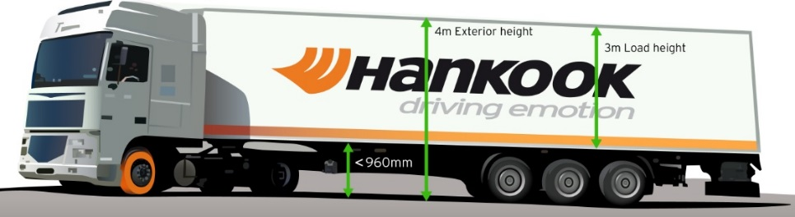***Until now, fleet operators with truck tyres of series 60 to 80 have often not been able to completely utilise the maximum inner load height of three metres without exceeding the legally permissible total height of four metres. Therefore, load capacity is lost, which in turn can result in economic disadvantages. As a consequence and following the market trend, premium tyre maker Hankook is offering its customers a truck tyre for the steering axle in series 50: the AL10+ e-cube MAX was developed in size 355/50R22.5 exclusively for use on jumbo trucks for long distances, and it provides a load index of 156, which means that the axle can be loaded with a weight of up to 8 tons. With its smaller diameter, it lowers the coupling height of the tractor engine, with the result that the inner load height increases and the three-metre loading platform can be fully utilised thanks to the lower profile tyres.

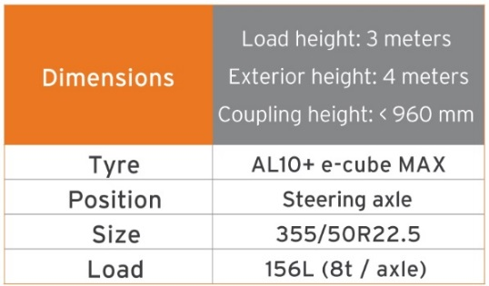

The tyre profile e-cube MAX for commercial vehicles represents maximum cost effectiveness, energy efficiency and environmental friendliness: due to its longitudinal grooved tread with wave structure, the AL10+ e-cube MAX for the steering axle prevents uneven wear. Therefore, the tyre guarantees an increased service life. The improved tyre tread and the high load index of the AL10+ e-cube MAX increases the fuel efficiency while offering higher load capacity at the same time. The linear groove structure supports stable directional stability as well as maximum steering precision and improved water dispersal.

The long distance specialist for the steering axle is supported by the DL10+ e-cube MAX for the drive axle. Due to its three-dimensional lamellae, it offers drivers outstanding traction, while the extra-wide profile block and deep grooves ensure increased mileage. The block stabilisers of the DL10+ e-cube MAX also contribute to a high service life and low rolling resistance. The e-cube MAX series is completed by the matching trailer tyre TL10+, which is characterised by maximum driving stability and low rolling resistance.

*Sizes of the e-cube MAX tyre line available*

|  |  |  |  |  |  |  |
| --- | --- | --- | --- | --- | --- | --- |
| **Tread** | **Size** | **LI** | **Marking** |  | **M+S** | **Availability** |
| **AL 10+** | 315/80R22.5 | 156/150L (154/150M) | B/B/W1 70dB | - | - | ☑ |
| 315/70R22.5 | 156/150L | B/B/W1 70dB | - | - | ☑ |
| 385/65R22.5 | 160K | B/B/W1 70dB | - | - | ☑ |
| 295/60/R22.5 | 150/147L | C/B/W1 70dB | - | - | ☑ |
| 315/60R22.5 | 154/148L | C/B/W1 70dB | - | - | ☑ |
| 355/50R22.5 | 156L | C/B/W1 70dB | - | - | ☑ |
| **DL 10+** | 315/80R22.5 | 156/150L (154/150 M) | C/C/W1 73dB | ☑ | ☑ | ☑ |
| 315/70R22.5 | 154/150L | C/C/W1 73dB | ☑ | ☑ | ☑ |
| 295/60R22.5 | 150/147K | C/C/W1 73dB | ☑ | ☑ | ☑ |
| 315/60R22.5 | 152/148L | C/C/W1 73dB | ☑ | ☑ | ☑ |
| 295/55R22.5 | 147/145K | C/C/W1 73dB | ☑ | ☑ | In production |
| 315/45R22.5 | 147/145L | D/C/W2 75dB | ☑ | ☑ | In production |
| **TL10+** | 215/75R22.5 | 135/133J | C/B/W1 71dB | - | - | ☑ |
| 235/75R22.5 | 143/141J | B/B/W1 69dB | - | - | ☑ |
| 245/70R17.5 | 143/141J (146/146F) | B/B/W1 69dB | - | - | ☑ |
| 265/70R19.5 | 143/141J | B/B/W1 69dB | - | - | ☑ |
| 385/55R22.5 | 160K(158L) | B/B/W1 70 dB | - | - | ☑ |
| 385/65R22.5 | 160K | B/B/W1 69 dB | - | - | ☑ |
| 435/50R19.5 | 160J | B/B/W2 73 dB | - | - | ☑ |
| 455/40R22.5 | 160J | B/B/W2 71 dB | - | - | ☑ |

**Technical properties of the e-cube MAX range**

*1. Optimised tread compound*

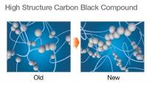- “Low hysteresis” tread compound reduces rolling resistance:

High molecular weight rubbers with very long-chain molecules, which have a lower tendency of branching and thus fewer free chain ends, are processed at reduced temperatures and extended mixing periods in Hankook's innovative mixture process IMS (Innovative Mixing System). This results in a significant increase in the connection rate between the carbon black and rubber molecules and a much more consistent distribution within the mixture.

- Reduction of the loss of energy caused by heat development.

*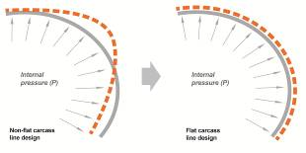2.Stiffness Control Contour Theory (SCCT)*

* Patented Hankook design technology for the even distribution of pressure inside the tyre and increased stability as well as movement in the tyre.
* High carcass durability and economy, improved retreadability.

**###**

**All-rounders for all-year tyres**

**Particularly in changeable weather conditions, Hankook recommends that truck and bus customers use the SmartFlex all-weather tyre line for medium and long haul trips. Commercial vehicle customers can rely in particular on a high level of driving safety as well as the current trend of increased load-bearing capacity for some sizes.**

Both the steering axle tyres SmartFlex AH31 and the drive axle tyres SmartFlex DH31 have M+S marking and the snowflake (3PMSF) symbol, which means good traction is guaranteed even if drivers should be surprised by wintry road conditions. The SmartFlex AH31 tyre, winner of the iF Design Award in 2015, has a special tyre profile with decisive safety functions which promotes water drainage in particular and should thus help to prevent potential hydroplaning. The operating costs incurred by fleet operators can also be reduced through the use of the SmartFlex all-season range because irregular wear is avoided on the steering axle thanks to the so-called Tread Wear Equalised Stepper technology used for the SmartFlex AH31, small stabilising blocks on the outside of ribs 2 and 4.

The counterpart for the drive axle is the Hankook SmartFlex DH31. Its 6-rib tread with special hexagonal tread blocks guarantees more even wear behaviour and thus a longer tyre service life. Hankook's patented self-cleaning sipes in the middle of each block prevent damage to the block edges and thus guarantee excellent traction throughout the tyre life.

The SmartFlex all-year tyre line is completed by the corresponding trailer tyre SmartFlex TH31, which celebrated its premieres at the 2016 IAA for Commercial Vehicles. Its wide, closed shoulder area supports stable straight driving and ensures good lateral stability. Chamfered tread grooves help prevent splintering.

Whilst the SmartFlex AH31 and SmartFlex DH31 are designated mainly for larger wheel sizes in the 22.5 inch range, SmartFlex AH35 and its drive axle counterpart SmartFlex DH35 is more designated for smaller wheels with 17.5/19.5 inch sizes.

*Sizes of the SmartFlex tyre line available*

|  |  |  |  |  |  |  |  |
| --- | --- | --- | --- | --- | --- | --- | --- |
| **Tread** | **Size** | **LI** | **Marking** |  | **M+S** | **Availability** | **Remark** |
| **AH31** | 295/80R22.5 | 152/148M (154M/149L) | C/B/W1 73dB | ☑ | ☑ | ☑ | - |
| 295/80R22.5 | 154/149M | C/B/W1 73dB | ☑ | ☑ | ☑ | Tyre with higher load-bearing capacity, mainly for truck use |
| 315/80R22.5 | 156/150L | C/B/W1 73dB | ☑ | ☑ | ☑ | - |
| 315/70R22.5 | 156/150L | C/B/W1 73dB | ☑ | ☑ | ☑ | - |
| 385/65R22.5 | 164K | C/B/W1 69dB | ☑ | ☑ | ☑ | - |
| 385/65R22.5 | 160K | C/B/W1 69dB | ☑ | ☑ | ☑ | - |
| 315/60R22.5 | 154/148L | C/B/W1 70dB | ☑ | ☑ | ☑ | - |
| 385/55R22.5 | 160K | C/B/W1 69dB | ☑ | ☑ | ☑ | - |
| **DH31** | 295/80R22.5 | 152/148M | D/C/W2 75dB | ☑ | ☑ | ☑ | - |
| 315/80R22.5 | 156/150L | D/C/W2 75dB | ☑ | ☑ | ☑ | - |
| 315/70R22.5 | 154/150L | D/C/W2 75dB | ☑ | ☑ | ☑ | - |
| 295/60R22.5 | 150/147K | D/C/W2 75dB | ☑ | ☑ | ☑ | - |
| 315/60R22.5 | 152/148L | D/C/W2 75dB | ☑ | ☑ | ☑ | - |
| **TH31** | 385/65R22.5 | 160K | B/B/W1 69dB | - | ☑ | In production | - |

**Technical properties of the Hankook SmartFlex all-year tyre line**

**SmartFlex DH 31**

*Truck all-year tyres for the drive axle for medium to long-haul applications*

*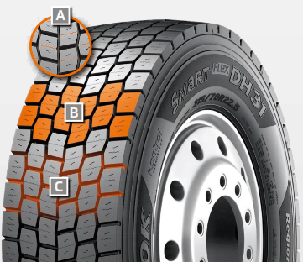A Multi-3D sipes:*

* High traction and mileage with even wear

*B 6-rib block tread:*

* Sturdy 6-rib block tread with special hexagonal tread blocks

*C Self-cleaning sipes:*

* Constant traction over the entire service life
* Protection against splintering at the corners of the sipes

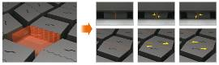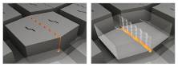

**###**

**Hankook TH22: Trailer tyres for low-bed truck transport**

**The TH22 is Hankook's trailer specialist when it comes to transporting heavy loads in regional traffic, along country roads for example. Because alongside the standard sizes, the TH22 is available in smaller sizes which can then be fitted to low-bed trucks, making maximum loading volume possible.**

The Hankook TH22 is the successful trailer tyre from the premium tyre maker for regional and shuttle traffic, which was launched in 2011. The TH22 is available in standard sizes 235/75R17.5, 245/70R17.5 and 265/70R19.5 and also in smaller sizes especially for use on low-bed trailers.

The profile and carcass design of the Hankook TH22 trailer tyre optimises wear resistance as well as rolling resistance. The closed 4-rib block profile with extra-broad, solid shoulder ribs was especially developed for low rolling resistance and good lateral stability. At the same time, the tread design supports even wear and 10 percent higher mileage than its predecessor. Wave-shaped tread sipes and transverse sipes right down to the base of the groove additionally provide for effective water displacement, making the TH22 a true all-round talent when it comes to handling.

With the TH22 Hankook is also relying on the patented IMS solution (Innovative Mixing System), which is already being used in many truck tyre ranges in the premium tyre maker's portfolio. Rubbers with particularly long-chain molecules are used for production. This results in significantly cooler operation and significantly increased mileage.

The low design height ensures maximum loading volume and, coupled with the high load-bearing capacity, makes the Hankook TH22 in the sizes 205/65R17.5 and 215/75R17.5 particularly suitable for low-bed trailer heavy-duty transport on country roads, such as car, construction vehicle or construction element transport.

*Available sizes of the TH22*

|  |  |  |  |  |  |  |
| --- | --- | --- | --- | --- | --- | --- |
| **Tread** | **Size** | **LI** | **Marking** |  | **M+S** | **Availability** |
| **TH22** | 9.5R17.5 | 143/141J | D/B/W1 70dB | - | ☑ | ☑ |
| 11R22.5 | 148/146L | C/B/W1 70dB | - | ☑ | ☑ |
| 215/75R17.5 | 135/133J | D/B/W1 70dB | - | ☑ | ☑ |
| 235/75R17.5 | 143/141J | C/B/W1 70dB | - | ☑ | ☑ |
| 245/70R17.5 | 143/141J (146/146F) | C/B/W1 70dB | - | ☑ | ☑ |
| 245/70R19.5 | 141/140J | C/B/W1 67dB | - | ☑ | ☑ |
| 265/70R19.5 | 143/141J | C/B/W1 70dB | - | ☑ | ☑ |
| 285/70R19.5 | 150/148J | C/B/W1 70dB | - | ☑ | ☑ |
| 205/65R17.5 | 129/127J |  | - | ☑ | In production |
| 385/65R22.5 | 164K (160K) | C/B/W1 70dB | - | ☑ | ☑ |
| 425/65R22.5 | 165K | B/B/W1 71dB | - | ☑ | ☑ |
| 385/55R22.5 | 160K (158L) | B/B/W1 71dB | - | ☑ | ☑ |

**Technical properties of the Hankook TH22**

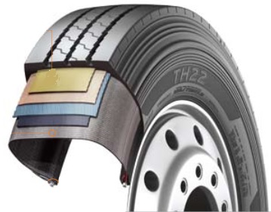

*1. Tyre design*

- Belt structure: Less belt deformation guarantees very low rolling resistance

- Carcass structure: The wider carcass profile with reinforced

belt cord guarantees excellent durability

- Bead structure: Reinforced bead structure ensures a long service life even at high load weights

*2. Tread design*

- Optimised zigzag rib design for good self-cleaning

- Wide and firm shoulder package for improved mileage and even wear

- Solid, continuous centre rib improves rolling characteristics and lateral stability

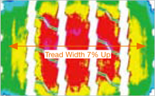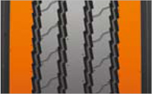

**###**

**About Hankook Tire**

Hankook Tire is one of the global top 5 companies in the mass production of tyres and manufactures innovative, award winning radial tyres of proven superior quality for passenger cars, light trucks, SUVs, RVs, trucks, and buses as well as motorsports (circuit racing/rallies).

Aspiring to bring consumers the utmost excellence in product quality, technological excellence and driving satisfaction, Hankook Tire continuously invests in research and development maintaining five R&D centers and seven production facilities around the world. Bespoke tyre solutions for the European markets as well as European Original Equipment according to the requirements of leading premium car manufacturers, are developed in the company’s regional Technical Centre in Hanover/Germany. Production for the European region is taking place in the state-of-the-art manufacturing site in Rácalmás/Hungary which was inaugurated in June 2007 and is continuously being expanded. Currently more than 3,000 employees produce up to 19 million tyres a year for passenger cars, SUVs and light trucks.

Hankook Tire’s European headquarters are located in Neu-Isenburg near Frankfurt am Main in Germany. The manufacturer operates further branches in Germany, UK, France, Italy, Spain, the Netherlands, Hungary, Czech Republic, Russia, Turkey, Sweden and Poland. Hankook products are sold directly through regional distributors in other local markets. Hankook Tire employs more than 22,000 people worldwide and are selling their products in over 180 countries. Internationally leading car manufacturers rely on tyres made by Hankook for their original equipment. Approximately 30 percent of the company's global sales are generated within the European and CIS-Region.

For more information please visit [www.hankooktire-mediacenter.com](http://www.hankooktire-mediacenter.com/) or [www.hankooktire.com](http://www.hankooktire.com/)

**Media-Contact:**

**Hankook Tire Europe GmbH | Corporate Communications Europe/CIS**

**Siemensstr. 5a, 63263 Neu-Isenburg | Germany**

Felix Kinzer, Director

Corporate and Finance Communications, Technologies, R&D/Production Operations

Tel.: +49 (0) 61 02 8149 – 170

f.kinzer@hankookreifen.de

Anna Pasternak, PR Manager

LT and Truck & Bus Tyres, Intl. Motorsports, CSR

Tel.: +49 (0) 6102 8149 – 173

a.pasternak@hankookreifen.de

Sabine Riedel, Public Relations

LT and Truck & Bus Tyres, Hankook Media Center, SNS, Corporate

Tel.: +49 (0) 6102 8149 – 174

s.riedel@hankookreifen.de

Larissa Büsch, Public Relations

PCR/ SUV, Event

Tel.: +49 (0) 6102 8149 – 171

l.buesch@hankookreifen.de

Yara Willems, Public Relations Assistant

Corporate, SNS

Tel.: +49 (0) 6102 8149 – 172

y.willems@hankookreifen.de