Press release

Hankook opens Technoring, Asia’s largest proving ground

- Opening of new test site on 25 May in Taean, South Korea
- As large as 125 football pitches and equipped with 13 test tracks
- Expansion of R&D infrastructure for future mobility and Hankook products

Seoul, Korea / Neu-Isenburg, Germany, 02 June 2022 – On 25 May 2022, premium tyre manufacturer Hankook has opened Hankook Technoring. The new proving ground in Taean, South Korea, is the largest in Asia with an area of 1.26 million square metres and will serve as a state-of-the-art research and development facility for Hankook’s pioneering products.

The site comprises 13 test tracks and allows for thorough testing of all product categories, including tyres for electric vehicles and supercars. The test tracks are designed for all types of vehicles – from supercars to trucks and buses. The test site also has a control tower, office buildings, workshops, filling stations and charging stations for electric vehicles. The 37.1-metre-high control tower records the test progress through integrated monitoring systems for all test areas and climate conditions.

With the completion of the Hankook Technoring, the company has created a complete research and development infrastructure to further drive its innovation capability. This infrastructure is designed to create synergies with existing facilities, which include the global headquarters, Hankook Technoplex (Seoul, Korea). In addition, the manufacturer also has its own test site, the Technotrac in the north of Finland for testing on snow and ice, as well as other regional R&D centres in Germany and in the USA. Original technologies are developed and secured at the Hankook Technodome, the central R&D centre outfitted with the latest equipment. The extended R&D infrastructure is what Hankook will use to further strengthen its position in the automotive industry in the future. Hankook Technoring will serve as an important basis for further technical developments and as a place of origin for innovations in the tyre sector. The test site is relevant to both future developments in e-mobility and autonomous vehicles in the replacement sector, and, with the necessary test capacities, will meet the stringent and diverse requirements of premium car manufacturers.

With the collected data from current tests at the Hankook Technoring, Hankook intends to accelerate its digital transformation as well. The company is working on a Big Data analysis platform to develop an artificial-intelligence-based “Virtual Optimisation Technology”. In the future, Hankook also wants to create a database with the evaluation data of tyres and vehicles that have been tested under the toughest conditions. With this database, Hankook is expanding the technology around what is referred to as the "digital twin". This digital testing of tires is an important addition to track and equipment testing and makes it possible to shorten the development time of a tire. Hankook thus brings together “real-life testing” for the mobility of the future with the use of virtual testing possibilities.

In addition, Hankook plans to actively expand its cooperation with mobility companies, research and educational institutions and start-ups. By utilising the state-of-the-art infrastructure of Hankook Technoring, cooperative work can continue to improve technologies. In this way, the company will not only further expand its research and development capabilities, but also contribute to the advancement of global mobility technology.

“Tyres are the only medium in a vehicle that comes into contact with the road surface. They are the key to maximising vehicle performance, safety, high fuel efficiency and ride comfort. To ensure the best product quality in all conditions, testing on a wide variety of tracks is of great importance,” says Hyunbum Cho, Chairman and CEO of Hankook & Company.

Hankook Technoring
- Completion: May 2022
- Location: Yangjam-ri, Nam-myeon, Taean-gun, Chungcheongnam-do
- Area: 1.26 million square metres
- 13 test tracks, office buildings, workshops, filling stations and charging stations for electric vehicles

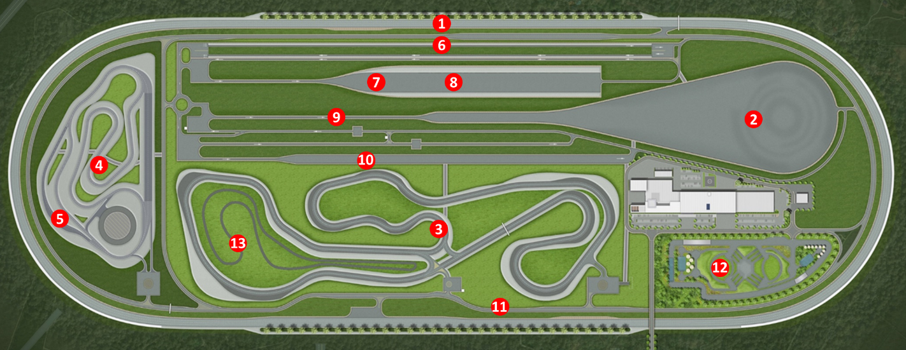

■ Test tracks

① High-Speed Oval
The high-speed main track, also known as “Hankook Technoring's Signature Course,” consists of four lanes with a total length of 4.6 km. The track was designed to reach a top speed of up to 250 km/h on a straight stretch and features a 38.87-degree banked curve on the slope.

② Vehicle Dynamics Area / Skidpad
In the vehicle dynamics area and on the skid pad, steering stability and performance limits are recorded through slalom tests, lane changes and tests in roundabouts. Tests can be carried out on this track at a maximum speed of 200 km/h.

③ Dry-Handling Circuit
The track tests the handling on dry roads, is 3.4 km long and consists of 16 curves. The straight is 670 m long and allows for a maximum speed of 190 km/h.

④ Wet-Handling Circuit / ⑤ Hydroplaning Curve
The wet track is 1.6 km long and consists of 11 different curves. It allows test drives at up to 128 km/h. The aquaplaning curve makes it possible to vary the conditions on wet roads by adjusting the water depth between 1 and 10 mm.

⑥ Ride
The 970 m long track, which will be used to test ride comfort while driving, includes four lanes and 15 road surfaces including motorways, asphalt and brick roads.

⑦ Braking
The braking track consists of four dry and four wet lanes with different road surfaces, including asphalt and concrete. The dry-brake test track allows for a test speed of up to 150 km/h.

⑧ Hydroplaning Straight
The 150 m aquaplaning straight allows aquaplaning tests to be carried out in wet road conditions, with the water depth adjustable between 1 and 10 mm.

⑨ Pass-by Noise
The 920 m track is designed to conduct tyre noise tests to meet car manufacturers’ requirements and ISO certification.

⑩ Noise/Vibration/Harshness
This 700 m long course is designed for measuring tyre noise. It consists of seven roads and five lanes of asphalt and a concrete ditch.

⑪ General Road
The 5 km long main road connects all test tracks. It enables comprehensive performance testing including ride comfort on different surfaces.

⑫ Off Road
The off-road course is equipped with various obstacles such as puddles and boulders and serves to test the performance of the off-road tyres.

⑬ Chip-Cut Road Tracks
The durability of the tyres is tested on the 1.4 km chip-cut track. The tracks also test wear from chips and cuts, a condition that is easily faced in normal driving conditions.

###

About Hankook

Hankook manufactures innovative high-performance radial tyres in the premium segment for passenger cars, SUVs, off-road vehicles, light trucks, motor homes, trucks, buses and automotive motorsport (circuit/rally) worldwide.

The company continuously invests in research and development to provide its customers with the highest quality combined with technological excellence. In five development centres and eight large factories worldwide, Hankook Tire develops and produces tyre solutions that are specifically tailored to the requirements and demands of regional markets. In Europe, tyre development for local markets and original equipment according to the specifications of leading European vehicle manufacturers takes place at the Hankook Technical Centre in Hanover/Germany. The tyres are produced, among others, in the company's state-of-the-art European factory in Rácalmás/Hungary, which was inaugurated in 2007 and is continuously being expanded. Currently, around 3,000 employees there produce up to 19 million tyres per year for passenger cars, SUVs and light trucks.

The tyre manufacturer's European and German headquarters are located in Neu-Isenburg near Frankfurt am Main. In Europe, Hankook maintains various own branches and additional distribution partnerships. The company employs 20,000 people worldwide and supplies its products to over 180 countries. Leading car manufacturers rely on Hankook tyres as original equipment. The company generates around 34 percent of its global sales within the European region. Hankook Tire has been included in the renowned Dow Jones Sustainability Index World (DJSI World) since 2016.

Further information can be found at www.hankooktire-mediacenter.com or www.hankooktire.com

Contact:
Hankook Tire Europe GmbH | Corporate Communications Europe/CIS | Siemensstr. 14, 63263 Neu-Isenburg | Germany

Felix Kinzer  Director  Tel.: +49 (0) 61 02 8149 - 170  f.kinzer@hankookreifen.de | Larissa Büsch  PR Manager  Tel.: +49 (0) 6102 8149 - 173  l.buesch@hankookreifen.de | Stefan Prohaska  Public Relations  Tel.: +49 (0) 6102 8149 - 171  s.prohaska@hankookreifen.de

