Hankook launches new generation of Laufenn car tyres

With its second brand Laufenn, tyre maker Hankook offers consumers a range of modern car and SUV tyres that are tailored to different lifestyles and above all meet the needs of price-conscious drivers. Hankook is continuing to develop its Laufenn tyre range and is set to unveil models with improved performance. From spring Laufenn S FIT EQ+ for the performance segment, and Laufenn G FIT EQ+ for the touring segment, will replace the respective existing models.

Neu-Isenburg, Germany, February 14, 2020 – The new Laufenn-Plus generation offers higher performance and greater stability on both wet and dry roads due to its optimised tread compound. This means that the new range of Laufenn summer tyres, which will be available on the European market from spring 2020, will meet the requirements of consumers who place a higher value on both performance and safety. Laufenn tyres for cars and SUVs are aimed in particular at a price-conscious, yet quality-conscious target group, and will cover all common sizes.

The new Laufenn S FIT EQ+ for the performance segment is equipped with an advanced Hydro-Flow block tread pattern which, together with its four straight main grooves and streamlined tread block arrangement effectively reduces aquaplaning. Furthermore, the use of an improved second-generation silica compound has led to a significant reduction in braking distance, especially on wet roads. The S FIT EQ+ also achieves optimised performance and good stability even at higher speeds thanks to reinforced tread bars which ensure greater block stiffness.

Designed specifically for the touring segment, the new Laufenn G FIT EQ+, like its predecessor, has been developed with a four-rib tread pattern that provides smooth, comfortable rolling in a wide range of road conditions. The variable depth tread grooves allow quick water run-off, and together with sipes attached to the blocks of the inner shoulder, improve wet grip. The Laufenn G FIT EQ+ has also been given a new tread compound for more grip on wet roads. A special base rubber layer below the tread helps reduce rolling resistance and increases fuel efficiency. The optimised tyre contour prevents irregular wear by distributing the weight evenly across the entire tread width. The tread blocks with differing stiffness depending on the position minimise vibration and noise levels for an altogether comfortable ride.

###

Technical features of the Laufenn S FIT EQ+:

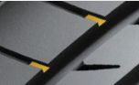
1. Dry conditions:
- Optimised tread design technology and block stiffness provide greater driving stability.
- Advanced asymmetric tread pattern eliminates road noise, improves cornering grip andmaximises dry road handling.
- Folded belt edge cover between the steel belts improves handling at higher speeds.
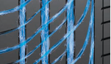
2. Wet conditions:
- Second generation Laufenn silica compound provides improved wet braking and handlingcharacteristics.
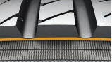
- Advanced Aqua-Hydro block profile for effective water run-off.

3. Comfort characteristics, rolling resistance and tyre wear:
- Optimised tyre contour for even load distribution and reduced wear.
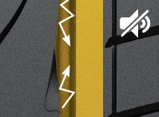
- Tread design and base rubber compound minimise rolling resistance
and improve fuel efficiency.
- Continuous tread rib on the outer shoulder reduces rolling noise.

4. Line-up:
- The Laufenn S FIT EQ+ will be available in 51 sizes from 15 to 20 inches with tread widths from 185 to 275 mm and aspect ratios from 70 to 35 in speed ratings H to Y; some sizes will also be available as extra load tyres (XL).

Technical features of the Laufenn G FIT EQ+:

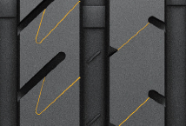
- Dry conditions:
- Improvement of the dry handling
- Four-rib tread pattern for smooth, comfortable rolling.
- Differing tread groove depths in the shoulder area of the tyre increase the block stiffness for goodhandling.

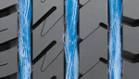
- Wet conditions:
- Second generation Laufenn silica compound improves wet braking performance
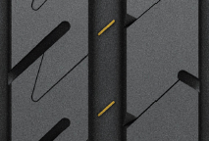
- Improved compound technology with nano-particles and special lamination of the tread blocks inthe inner shoulder area provide additional wet grip.

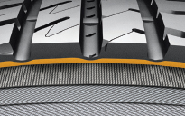
3. Comfort characteristics, rolling resistance and tyre wear:
- Tread design and base rubber minimises rolling resistance
and improves fuel efficiency
- The block tread pattern with varying degrees of stiffness reduces
vibration and noise to enhance driving comfort.

4. Line-up:
- The Laufenn G FIT EQ+ will be available in 40 sizes from 13 to 17 inches with tread widths from 135 to 235 mm and aspect ratios from 80 to 55 in speed ratings T to H; some sizes will also be available as extra load tyres.

About Laufenn

The Laufenn tyre brand launched on the European market in 2015 originated in the quest for simplicity and is oriented towards reliable performance and an attractive driving experience. Laufenn focuses on the basics and major functions of the tyre in order to offer customers a comprehensive range of practical products suitable for a wide range of different lifestyles, including high-performance radial tyres for passenger cars, SUVs and light trucks for both summer and winter. As the new Hankook Tire brand, Laufenn provides reliable quality and outstanding service from R&D through to production as well as a committed after-sales service with comprehensive warranty under the umbrella of a major company group.

Contact:
Hankook Tire Europe GmbH | Corporate Communications Europe/CIS | Siemensstr. 14, 63263 Neu-Isenburg | Germany
Felix Kinzer  Director  tel.: +49 (0) 61 02 8149 – 170  f.kinzer@hankookreifen.de | Larissa Büsch  PR Manager  tel.: +49 (0) 6102 8149 – 173  l.buesch@hankookreifen.de | Stefan Prohaska  PR Assistant  tel.: +49 (0) 6102 8149 – 171  s.prohaska@hankookreifen.de

