New treads for mixed on-road and off-road use supplement Hankook’s SmartWork line

New treads for mixed on-road and off-road use are supplementing Hankook’s existing tyre line for use on construction sites, Hankook SmartWork. The new products SmartWork AM11 for the steering axle, DM11 for the drive axle and the trailer tyre TM11, have been designed with the requirements of construction site supply vehicles in mind. This means the new series not only holds its own with good traction on site, it performs well on the road too, with a long service life amongst other things.

Neu-Isenburg/Germany, 21st September 2018 – The new treads in the Hankook SmartWork line, AM11, DM11 and TM11, have been specifically developed for construction site vehicles used for the supply and removal of raw materials, gravel, waste or similar to or from construction sites and thus cover most of their miles on public roads. Steering axle, drive axle and trailer tyres offer both a long service life for use on the road and high traction for off-road use on construction sites. The tread design to match all the axle positions on the vehicle and the specially developed rubber compound make sure of that.

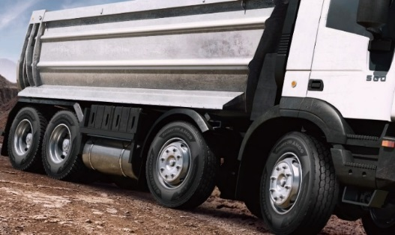The SmartWork AM11 for the steering axle or use on all axles, has three extra-wide main drainage tread grooves in a zigzag design to improve hydroplaning safety. Special rubber blocks in the tread grooves stop stones from becoming lodged. An angular sipe design guarantees optimum traction, while chamfered block edges and special sipes on the tread blocks contribute towards more block stability and also improve the braking and handling response. The SmartWork AM11 also has a closed shoulder design for more driving stability, lateral stability and even abrasion for a longer service life.

The trailer tyre TM11 differs from the SmartWork AM11 in that it has a half-open shoulder design. Lateral grooves enhance tyre traction particularly on muddy or snow-covered roads and on construction sites. Both the SmartWork AM11 and the SmartWork TM11 have M+S marking.

The SmartWork DM11 is available for the drive axle. The directional V-shaped tread design enables improved displacement of mud and water in the construction site area. The interblock tie-bars at the centre of the SmartWork DM11 ensure high block stability and guarantee outstanding straight driving performance and impact dispersion for blocks, thereby improving durability. Three-dimensional sipes also enhance tyre traction. The SmartWork DM11 also has the snowflake symbol, which means it can even be used under very wintry conditions.

Sizes of the SmartWork line available

Tread | Size | LI | Marking |  | M+S | Availability
AM11 | 315/80R22.5 | 156/150K | C/B/W2 (71dB) | - |  | Q2/2019
DM11 | 315/80R22.5 | 156/150K | C/B/W2 (74dB) |  |  | Q2/2019
TM11 | 385/65R22.5 | 160K | C/B/W2 (73dB) | - |  | Q2/2019

Technical properties of the Hankook SmartWork AM11

- Wide zigzag grooves for improved hydroplaning safety and optimised braking response
- Three extra-wide tread grooves in a zigzag design guarantee optimum water displacement both on tarmacked roads and off-road.
- Angular sipes for optimum traction.
- Additional pimples in the grooves support the tyre's self-cleaning function.
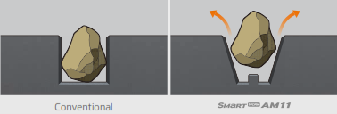

- Polygonal stepped blocks for a more pronounced edge effect
- Special edge angle at the individual tread blocks and chamfered block edges for optimum braking response.

- Closed shoulder design increases the tyre’s driving stability
- Improved resistance against forces acting at the side.
- Protection against damage to the block edges.
- Shoulder lugs help to reduce heat development while driving.
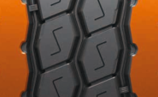

Technical properties of the Hankook SmartWork DM11

- Directional tread design
- V-shaped directional tread design for the outstanding displacement of mud and water.
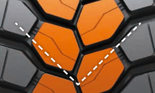

- Bars between the tread blocks
- Bars between the tread blocks stabilise the tyre.
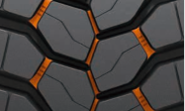

Technical properties of the Hankook SmartWork TM11

- Wide zigzag grooves for improved hydroplaning safety and optimised braking response
- Three extra-wide tread grooves in a zigzag design guarantee optimum water displacement both on tarmac roads and off-road.
- Angular sipes for optimum traction.
- Additional pimples in the grooves support the tyre's self-cleaning function.

- Polygonal stepped blocks for a more pronounced edge effect
- Special notches at the individual tread blocks and chamfered block edges for optimum braking response.

- Half-open shoulder design
- Half-open shoulder design for enhanced traction particularly on muddy or snow-covered roads, or within the construction site

About Hankook Tire

Hankook Tire manufactures globally innovative, award winning radial tyres of proven superior quality for passenger cars, light trucks, SUVs, RVs, trucks, and buses as well as motorsports (circuit racing/rallies).
Aspiring to bring consumers the utmost excellence in product quality, technological excellence and driving satisfaction, Hankook Tire continuously invests in research and development maintaining five R&D centres and eight production facilities around the world. Bespoke tyre solutions for the European markets as well as European Original Equipment according to the requirements of leading premium car manufacturers, are developed in the company’s regional Technical Centre in Hanover/Germany. Production for the European region is taking place in the state-of-the-art manufacturing site in Rácalmás/Hungary which was inaugurated in June 2007 and is continuously being expanded. Currently around 3,000 employees produce up to 19 million tyres a year for passenger cars, SUVs and light trucks.
Hankook Tire’s European headquarters are located in Neu-Isenburg near Frankfurt am Main in Germany. The manufacturer operates further branches in Czech Republic, France, Germany, Hungary, Italy, the Netherlands, Poland, Russia, Spain, Sweden, Turkey, UK and Ukraine. Hankook products are sold directly through regional distributors in other local markets. Hankook Tire employs approximately 22,000 people worldwide and are selling their products in over 180 countries. Internationally leading car manufacturers rely on tyres made by Hankook for their original equipment. Approximately 30 percent of the company's global sales are generated within the European and CIS-Region. Hankook Tire has been represented in the renowned Dow Jones Sustainability Index World (DJSI World) since 2016.

For more information please visit www.hankooktire-mediacenter.com or www.hankooktire.com

Contact:
Hankook Tire Europe GmbH | Corporate Communications Europe/CIS | Siemensstr. 14, 63263 Neu-Isenburg | Germany

Felix Kinzer  Director  tel.: +49 (0) 61 02 8149 – 170  f.kinzer@hankookreifen.de | Anna Magdalena Pasternak  PR Manager  tel.: +49 (0) 6102 8149 – 173  a.pasternak@hankookreifen.de | Sabine Riedel  PR Manager  tel.: +49 (0) 6102 8149 – 174  s.riedel@hankookreifen.de

