****

**Press Kit**

**Essen Motor Show**

**Essen 2016**

**Essen Motor Show**

**25th November – 04th December 2016**

Press Kit

**Content**

* **Hankook with sporty tyre line-up and Opel GT Concept at the Essen Motor Show**
* **Hankook UHP Premium winter tyres:** Optimised driving during the cold season; Now also with Hankook SEALGUARD® technology; Run-flat original equipment on premium vehicles
* **Hankook Winter i\*cept RS²:** “Auto Bild Eco-Master 2015” by Hankook receives a “highly recommended” rating from the car magazine
* **Hankook Ventus Prime³:** Premium comfort tyre for Europe is Auto Bild test winner
* **Hankook Ventus S1 evo²:** Hankook achieved “Outstanding” in *AutoBild Sportscars* Magazine’s 2016 UHP Summer Tyre Test
* **Hankook Ventus V12 evo²:** Performance, design and environmental excellence combined in a wide tyre
* **Noise-reducing sound absorber® technology invented by premium tyre maker Hankook**
* **Hankook Tire’s first SEALGUARD® OE Fitment to Volkswagen Touran and Passat Models**
* **Hankook Kinergy 4S all-season tyre:** 365 days of balanced performance for Europe's roads
* **Hankook ultra high-performance SUV tyres as original equipment for Porsche Macan**
* **Hankook achieves new premium original equipment approval for summer and winter tyres**
* **Hankook Design Tyres on visionary Opel GT Concept**
* **Hankook Technodome:** The tyre maker celebrates the inauguration of its new global R&D center to lead the future

**Hankook with sporty tyre line-up and Opel GT Concept at the Essen Motor Show**

**The focus at the Essen Motor Show is on sporty vehicles – Hankook has the tyres to match. At Booth F102 in Hall 10, the premium tyre maker has many exhibits well worth seeing on show – from tyres for the future on the Opel GT Concept car through to Ultra High Performance (UHP) favourites: the Ventus S1 evo series rated “Outstanding” by Auto Bild Sportscars magazine in both 2015 and 2016. “The UHP sector is an important business field for us as tyre makers,” explains Dietmar Olbrich, Hankook’s Vice President for Sales and Marketing in the German-speaking markets. “Tyres cannot allow themselves any weaknesses in this segment. The fact that we can deliver the necessary quality is illustrated by our OE business, where we will be introducing great innovations in a few days. From 0 to 100 kilometres/hour in only 4.8 seconds – and we are providing the grip for this. I cannot reveal any further details at the moment.”**

***Neu-Isenburg, Germany, 21 November 2016*** – Booth F102, Hall 10: Looking forward to 2017, premium tyre maker Hankook is presenting its sporty tyre line-up on more than 300 square metres of floor space to visitors to the Essen Motor Show – Europe’s leading trade fair for sporty vehicles – and has brought along plenty of highlights. In line with the subject of performance, the UHP flagship Ventus S1 evo² and DTM racing tyre *Ventus Race* are flanked by a prototype in a purist design. The Opel GT Concept with its red Hankook tyre has already made its way into every automotive magazine in the world. The concept sports car with the futuristic tyres is now being showcased on the premium tyre maker’s fair booth.

Hankook it getting off to a flying start to its twelfth appearance at the show on 25 November on the neighbouring booth belonging to the Verband der deutschen Automobiltuner 'VDAT' (*Association of German Car Tuners*) with the revelation of the “Tune it! Safe!” campaign vehicle. The initiative for safe tuning, which is promoted by the Federal Ministry of Transport, is traditionally supported by Hankook and – this much we can reveal – a police car not usually found on the roads will be at the heart of the campaign again this year.

Cross-sections of the promising tyre technologies Sound Absorber**®** and SEALGUARD® provide an insight as to how the reduction of internal noise works in the tyre and what the differences are between self-sealing and run-flat tyres.

In addition to the OE tyres for the 7-Series BMW and Porsche Macan, the 36,000 guests expected at the Essen Motor Show will be able to see the “Outstanding” (Auto Bild) Ventus Prime³ tyre, get an autograph from Sidney Hoffmann or experience BVB players live. Other events and competitions are planned which will impress visitors in addition to the tyre range.

###

**Hankook UHP Premium winter tyres:**

* **Optimised driving during the cold season**
* **Now also with Hankook SEALGUARD® technology**
* **Run-flat original equipment on premium vehicles**

**Hankook is currently applying further upgrades to its ultra high performance winter tyres for the coming season. The premium winter tyres of the i\*cept evo family, which have been released in a number of sizes for up to 270 km/h, is rounded off with various new sizes for sporty cars and SUVs, run-flat sizes for premium original equipment and, for the first time, includes a SEALGUARD® version. The ultra high performance winter profiles i\*cept evo, i\*cept evo² and i\*cept evo² SUV, which are optimised for winter conditions in Central and Western Europe, are provided with functional full-silica compounds and are already being fitted as original equipment on the new BMW 7 series. The asymmetric tread design used for all three versions ensures sporty yet comfortable handling on wet and dry roads as well as good traction and braking performance on snow-covered ground.**

Premium tyre maker Hankook is continuing to expand the line-up of its current ultra high performance (UHP) winter tyre specialist. Developed in order to guarantee more safety with continued high performance and superior comfort through the increasing changeable weather conditions in the cold season, the winter tyres of the i\*cept evo family have been tailored specifically for upper mid-range vehicles through to luxury saloons and sports cars. Furthermore, the Winter i\*cept evo² is also available in an SUV version, which has been adapted to meet the special requirements of the popular Sports Utility Vehicle category with its double-layer carcass.

In addition, the Hankook SEALGUARD® technology is being used for the first time in a number of sizes for the 2016 winter season, e.g. for the VW models Passat and Touran. The special SEALGUARD® sealing material seals punctures up to a diameter of 5 mm in the area of the tyre tread. This means that journeys can be continued with no problems even in the case of damage caused by puncture. Additionally vehicles that are equipped with self-sealing tyres no longer need to carry spare tyres. This makes more space available in the vehicle, saves weight and eliminates inconvenient wheel changing at the side of the road. In addition to their safety advantages, products equipped with Hankook SEALGUARD® technology offer particularly comfortable driving pleasure, as the tyres essentially have the same structure as the models without this technology.

Hankook Winter i\*cept evo tyres are also available in various dimensions as run-flat versions with reinforced sidewall for many BMW vehicles amongst others. Thus the Hankook Winter i\*cept evo in the size 245/50 R18 HRS (Hankook Runflat System) has been fitted as original equipment to the BMW 7 series.

Snow, ice, frost, heavy rain or wet leaves often produce dangerous road conditions in winter. The Hankook winter profiles i\*cept evo, i\*cept evo² and i\*cept evo²SUV are therefore meeting these challenges with maximum-grip tread compounds and optimised design functions. Among other things, a highly dispersible nano-silica compound is used, which prevents hardening of the tyre at low temperatures and thus ensures better grip on wintry and wet roads through greater elasticity of the tyre contact area. The contact area of the tyre has been further improved thanks to further optimisation of the tyre profile, which likewise has a positive effect on grip in snow and rain and moreover ensures improved hydroplaning performance.

The outside of the traditionally asymmetric profile of the Hankook UHP profiles ensures improved snow handling and increased traction performance, whilst the inside guarantees optimised braking performance on snow, slush and wet roads. The snow traction performance is aided by an increased number of profile block edges, which effectively “grip” into the snow. By minimising block movement and wear, specially developed 3D sipes applied to the entire tread area ensure additional driving stability as well as improving the general handling properties with the aid of maximised edge effects. The transverse profiling arranged at an optimised angle on the inside of the profile likewise improves performance on snow-covered roads.

The two wide main drainage grooves offer 30 % greater volume for particularly efficient drainage of water or snow slush. With the Hankook Winter i\*cept evo², they aid grip in the snow and hydroplaning performance for a safer driving experience on wet and slushy roads. In conjunction with the wide design of the tyre shoulder and the optimised cubic block design, a reinforced sidewall and bead area ensure direct steering response as well as improved cornering grip and optimised handling performance on dry roads too.

Both the Hankook winter tyre models i\*cept evo, i\*cept evo² and i\*cept evo² SUV as well as the Hankook SEALGUARD® system are manufactured predominantly in the modern European production plants of Hankook in Hungary. The various i\*cept evo versions are available in a total of 155 different dimensions for upper mid-range vehicles through to luxury saloons, sports cars and all popular SUVs.

The **Hankook Winter i\*cept evo** is supplied in 25 dimensions from 15 - 18 inches with tread widths of 185 - 265 mm and aspect ratios of 70 - 45 in the speed indices H and V, some with **HRS** (Hankook Runflat System) as sidewall-reinforced run-flat tyres suitable for many BMW models.

The **Hankook Winter i\*cept evo²** is available in a total of 87 sizes from 15 - 20 inches with tread widths of 195 - 295 mm and aspect ratios of 60 - 30 in the speed indices H, V and W, mainly as designs with increased load capacity (Extra-Load ‒ XL). The Hankook **SEALGUARD®** technology is being offered for the winter season 2016 initially for the tread Winter i\*cept evo² in the sizes 215/60 R 16 H and 215/55 R 17 V for the Volkswagen models Passat and Touran amongst others.

The **Hankook Winter i\*cept evo² SUV** is available in 37 sizes from 16 – 21 inches with tread widths of 215 – 315 mm and aspect ratios of 70 – 35 in the speed indices T to W.

**Technical Characteristics of the Hankook Premium Winter Treads**

**i\*cept evo, i\*cept evo² and i\*cept evo² SUV**

**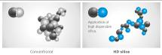**

1. *High-dispersible nano silica ~~t~~read compound*

* Improved wet traction, snow and ice performance.

*2. Double functional, asymmetrical performance tread*

* The outer tread and its compact shoulder profile offer better handling performance on dry roads.
* The inner tread surface increases braking power and traction on wet and snowy streets.
* Especially efficient water and slush removal.

**w320_F_kerf**

*3. 3D-sipesacross the entire tread surface*

* Optimised driving stability in dry or wet conditions, and better winter performance through minimised block movement.

*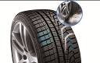*

*4. Lateral grooves on the inside of the profile act like ice axes*

* Improved snow traction through optimised angular arrangement of the lateral grooves.

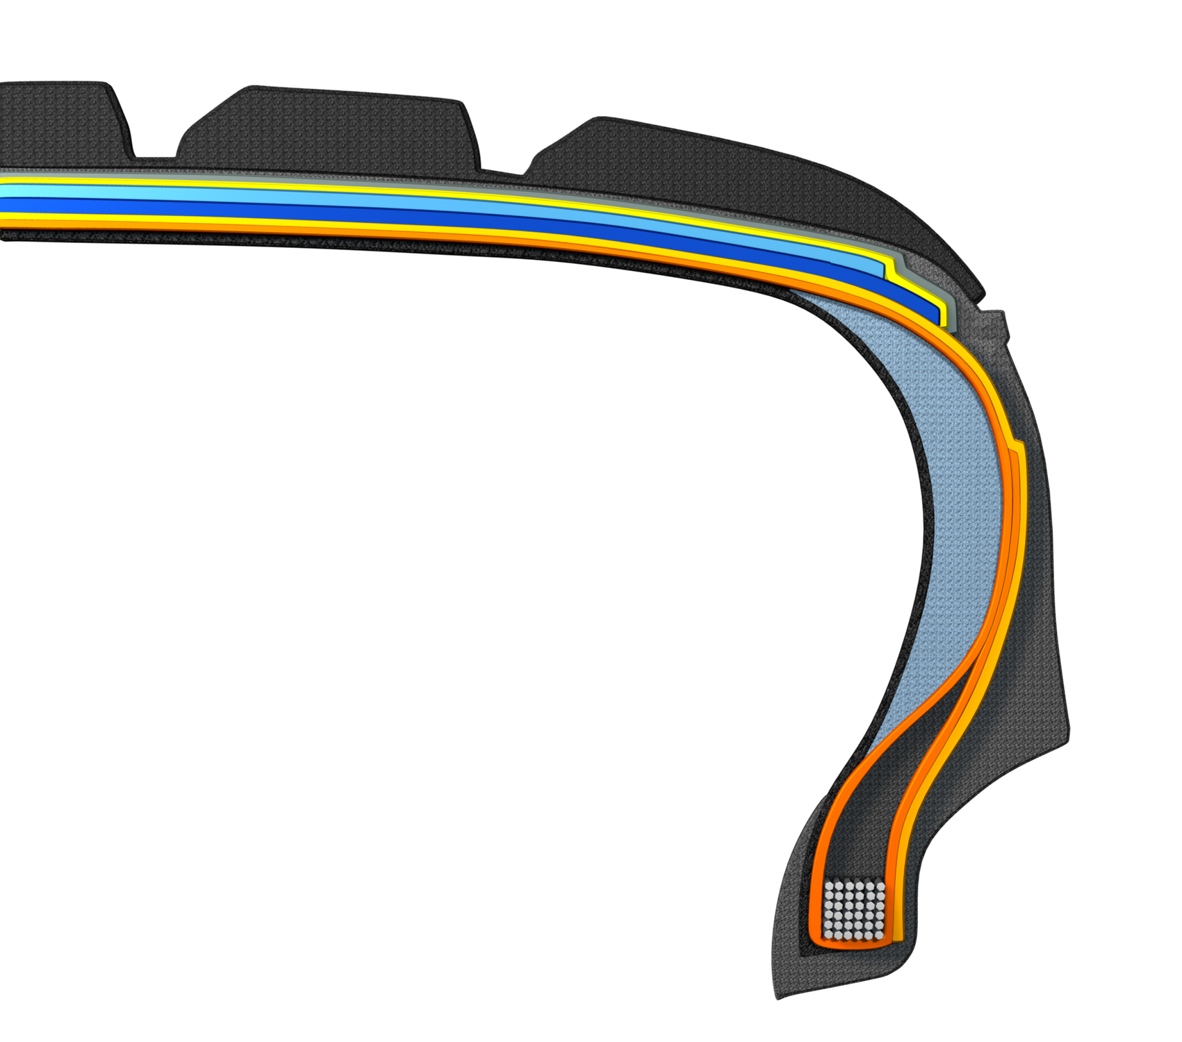

*5. HRS (Hankook Runflat System) technology:*

* *Side wall reinforced tyres with run-flat features.*
* *Available in various sizes, including for many BMW models, in the i\*cept evo tread.*

*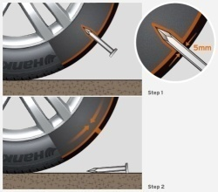6. Hankook SEALGUARD®technology:*

* *SEALGUARD®tyres contain a viscous material with which the interior of*

*the tire is coated shoulder to shoulder.*

* *In case of a puncture, holes with a diameter of up to 5 mm are immediately*

*sealed off by the Hankook SEALGUARD®technology*

* *Available in various sizes, including for VW Passat and Touran*

*in the i\*cept evo² tread*

*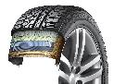7. Double-layer carcass:*

* *Especially even ground pressure distribution through ideal tyre contact surface.*
* *Outstanding driving stability, especially for high-power, heavy vehicles*
* *Available in a variety of dimensions, made especially for the demands of modern sorts utility vehicles*
* *Tread i\*cept evo² SUV*

**Winter i\*cept RS2: Very good test results!**

**The Hankook Winter i\*cept RS² is “highly recommendable”, write the editors of the Auto Zeitung in their current winter tyre test. The very good snow performance and an outstanding price-performance ratio of size 205/55 has once again impressed reviewers. Auto Bild emphasised; fuel-saving thanks to low rolling resistance as well as achieving high mileage, the Winter i\*cept RS² is economical and safe. Besides strong performance in the safety-related criteria in wet, snowy, and dry road conditions, the Winter i\*cept RS² beat 50 competitors in terms of mileage too and took the title of “Eco Master”.**

“Aspects such as fuel efficiency and the sparing handling of resources are becoming increasingly important for tyre buyers, too,” explains Tony Lee, Hankook’s Vice President of Marketing and Sales for Europe. “Our current winter tread shows that these days modern, high-performance winter tyres can also meet customers’ requirements in terms of sustainability and environmental compatibility. We are extremely pleased with the independent test results and the related evaluations for our Hankook Winter i\*cept RS².“

Developed to deliver balanced performance in all wintery driving conditions, the Hankook Winter i\*cept RS2 comes equipped with a special nano-sized, high dispersible silica compound, resistant to hardening in low temperatures, and a new solution-styrene butadiene rubber. The compound ensures the tread stays elastic even at very low temperatures, thus providing excellent traction and braking power by increasing the tyre’s contact area, in particular in the cool temperatures and wet roads typical during the colder seasons. The increased void volume of the tyre tread, designed using Hankook Aqua-Slant technology, is achieved through the highly effective interaction between two longitudinal wide grooves on the tread. This offers especially efficient water and slush displacement.

The directional V-shaped tread design of Hankook's Winter i\*cept RS2 features 28% more pitches as well as increased groove and block edge length. Enhanced traction on snow covered surfaces is the result of the tread design which effectively bites into the snow. Moreover, the corrugated 3D sipes applied throughout the tyre tread increase traction and braking performance on all smooth surfaces. In addition they improve driving stability in wintery conditions by minimising block movement, abrasion and enhancing the overall handling performance through maximised edge effects. Special ice slits and grip claw 3D edges make for further improved cornering performance and snow traction.

Further improvements to the structure of the i\*cept RS2 have resulted in an even load distribution and a footprint increase of up to 5% compared to conventional products which has further enhanced the braking performance on both wet and dry roads. The stiffer sidewall and bead area of the tyre ensures more direct steering reactions and improved steering feedback and a more precise lateral stability on dry roads as well.

The Winter i\*cept RS2 is available for vehicles ranging from city drivers to compact and mid-sized cars, and even for sedans and family vans. It was specially developed for the climate conditions in middle and western Europe, and is available in 55 sizes from 145/80 R 14 to 225/45 R 17 in speed indexes H and T.

**Technical Characteristics of the Hankook Winter i\*cept RS2**

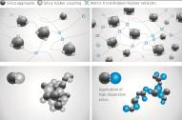

1. *New high-dispersible nano silica ~~t~~read compound for improved winter performance*

* Improved wet traction, snow and ice performance.

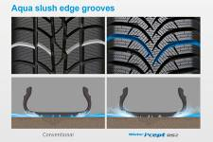

1. *Aqua slush edge grooves for improved wet performance*

* Water and slush are effectively drained away to reduce the risk of aquaplaning and improve wet braking performance.
* Significantly increased traction on snowy and slushy roads.

1. *3D sipes*

* w320_F_kerfEnhanced driving stability and improved winter performance through

minimised block movement.



1. *Grip claw technology and increased pitch number for improved snow traction*

* 3D sharp edges improve traction on snow covered roads.
* 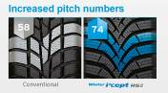28% increase of pitch sequence for high snow grip and increased traction

performance.

1. *Available sizes:*

* The Hankook Winter i\*cept RS2 is available in sizes from 14 – 16 inches, in tread widths of 195 – 275 mm with aspect ratios from 50 – 70 series in speed indexes H and T.

\* Evaluations by Auto Bild no. 40 dated 2 October 2015, 50 tyre treads from all brands, tested on a VW Polo in size 185/60 R 15 T; award: Eco Master, and Auto Zeitung 21/16 13 tyre treads from various brands, tested on a VW Golf in size 205/55 R 16; result: “Highly recommended”.

###

**Hankook Ventus Prime³: Premium comfort tyre for Europe is Auto Bild test winner**

**The newest model in the successful Ventus product family for premium performance passenger car tyres was developed to provide an ideal blend of performance, safety, comfort, and environmental friendliness. It was nominated in March 2016 in the summer tyre test by the magazine AUTO BILD as the test winner among 50 other brands in size 205/55R16V (22/03/2016). Besides its fuel efficiency, the tyre stood out by providing the best driving characteristics in its class on wet and dry streets.**

Premium tyre maker Hankook is introducing its new Ventus Prime³ for the European market. The tyre was developed with a focus on providing a balanced blend of performance, comfort, safety, and environmental friendliness, and is the newest premium comfort flagship in the successful Ventus product series offered by the company. Drivers benefit from well-designed driving characteristics, including even better braking performance on both wet and dry streets.

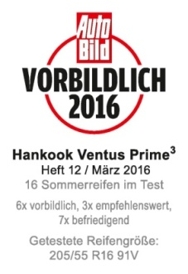Improving braking performance on wet surfaces was a key task for Hankook engineers in developing the next generation of Ventus Prime products. To do so, Ventus Prime³uses a new, high-grip silica tread compound and a new compounding technology which provides much better distribution of polymers and fillers in the tread compound. This allows the tyres to achieve both wet braking performance improved by around eight percent and reducing of rolling resistance. In addition, the four wide profiled grooves ensure fast drainage, which improves vehicle control on wet streets and helps reduce the danger of aquaplaning. The depth of the individual profiled grooves also depends on their position on the tyre, in order to counteract the classic conflict between wet and dry driving characteristics in the Ventus Prime³.

The new Ventus Prime³also made another developmental leap when it comes to dry handling. By using a newly designed, asymmetrical tread, the actual contact surface between the tyre and the street was increased by ten percent. Along with the improved tread stiffness in both radial and lateral directions, and in conjunction with new “hybrid hardness” pattern ribs (different hardness levels on the outside and inside) and a massive outer tyre shoulder, the Ventus Prime³provides significantly better dry performance. The dry braking performance of the tyre was also improved by three percent, whilst the traction was optimised, for instance, by applying chamfered profile block edges distributed across the entire tread surface, increasing the contact surface during braking.

Newly-developed, functionalised polymers with a high molecular weight in the tread blend of the Ventus Prime³increase its wear-resistance by nine percent. The tyre is equipped with a highly-modern, lightweight, and especially sturdy Rayon carcass and a wide steel belt including a wrapped bandage and high-strength bead filler. Besides improving handling, this ensures precise steering feedback and great control, even at high speeds. Thanks to an improved pitch design and the optimised angle of lateral profiling, as well as a sidewall optimised for air resistance, developers were able to further develop the noise level of the tyres, once again improving the outstanding comfort features of the Ventus Prime³. By using a new technology when positioning the profile grooves, development engineers at Hankook were able to achieve a significant reduction in the noise level of the tread, even with improved tyre life.

**Technical features of the Hankook Ventus Prime³:**

1. Improved performance on dry streets:

- Increased profile block stiffness in both radial and lateral directions.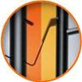

- Tyre contact area increased by ten percent.

- Different hardness levels on the outer ribs, and a massive outer shoulder block for improved curve stability.

- Longitudinally oriented tread design for outstanding directional stability, even at high speeds.

- Chamfered profile block edges broaden the contact surface while braking:

dry braking power improved by three percent.

- Light, yet highly sturdy Rayon carcass and extremely strong bead filler for better handling characteristics and precise steering feedback.

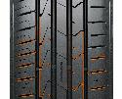

2. Improved performance on wet streets:

- Four wide main tread grooves for especially fast drainage.

- Newly developed, high-grip tread blend and new compounding technology for an improved distribution of polymers and fillers; eight percent better wet braking performance.

3. Reduced noise production and high comfort:

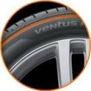- Innovative pitch design and newly developed technology to position the tread grooves in order to reduce noise production on the tread, even with continued use.

- Stable, single-strand bead wire for excellent concentricity / driving comfort.

- Air resistance optimised side wall design to reduce air vortices and vibrations at high speeds.

4. Low rolling resistance and less tyre wear:

- High-grip silica blend reduces rolling resistance.

- Polymers with high molecular weights in the tread compound:

- Wear performance improved by nine percent.

- Visual Alignment Indicator System on the outer tyre shoulder allows drivers to easily check for uneven wear caused by poor body alignment

5. Line-Up:

- The Ventus Prime³ is primarily produced in Hankook’s highly modern European production facility in Hungary, and is available in 53 sizes from 15 to 18 inches, with tread surface widths of 185 to 245 mm, aspect ratios of 65 to 40, and is available in speed classes H, V, W, and Y.

###

**Hankook achieved “Outstanding” in *AutoBild Sportscars* Magazine’s 2016 UHP Summer Tyre Test**

**Hankook Tire’s UHP flagship Ventus S1 evo² is rated ‘outstanding’ in the 2016 German Auto Bild Sportscars UHP Summer Tyre Test and is recognised in particular for its exemplary wet performance in the braking, handling and hydroplaning categories.**

Premium tyre maker Hankook achieved an ‘outstanding’ test result with its UHP flagship tyre Ventus S1 evo² in the 2016 UHP Summer Tyre Test by the renowned German automobile magazine Auto Bild Sportcars. The magazine put six leading tyre brands in the dimensions 255/35 R 20 (front axle) and 295/30 R 20 (rear axle) to the test on a Jaguar F-Type. Hankooks’ Ventus S1 evo² achieved the best test result of ‘outstanding’ and was recognised in particular for its wet performance, sharing an excellent overall result and test win with another European Premium brand.

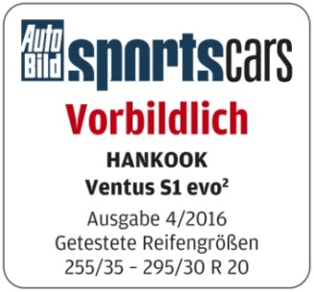

The 2016 Auto Bild Sportscars tyre test reflects various performance aspects including handling and braking on both dry and wet roads, as well as noise level and rolling resistance. During the test, the Ventus S1 evo² showed an overall very strong performance during the handling, braking distances, and hydroplaning as well as noise and rolling resistance tests. It is thus following in the footsteps of its predecessor model Ventus S1 evo, which received the “Outstanding” award from Auto Bild Sportscars in 2015. The UHP wide tyre received special recognition for its balanced, performance, low rolling resistance and convincing braking qualities in the wet.

Equipped with sophisticated DTM technology, the Hankook Ventus S1 evo² has repeatedly been recognized by premium automakers including Audi, BMW, Mercedes Benz and the Volkswagen Group, for its successful combination of performance, durability, comfort and energy efficiency. The tyre was particularly recognised by the testers for its exemplary performance on wet roads, scoring category wins in the hydroplaning, wet circle and wet braking tests.

The tyre’s asymmetric tread design provides an increased water drainage performance whilst dispersing friction heat. It also guarantees a precise and comfortable driving experience with reduced noise and vibration.

Ho-Youl Pae, COO for Europe at Hankook, explains: “We are extremely pleased with this excellent test result for our UHP flagship model Ventus S1 evo². Regularly achieving such results in independent tyre tests gives proof that our continuous commitment to technology advancement results in products that deliver the best possible driving experience at all times for our customers.”

###

Hankook Ventus V12 evo²:

Performance, design and environmental excellence

combined in a wide tyre

**With the new Ventus V12 evo², tyre maker Hankook presents a new performance and design oriented refitting wide tyre for sports-style inspired drivers. The elegant, directional design of the tread with 3D block structure and aerodynamically optimised sidewall combines style and excellent drive performance with good rolling noise and rolling resistance. As of the market launch, the Ventus V12 evo²is available in 25 refitting sizes ranging from 16 to 19 inches.**

Premium tyre maker Hankook offers the Ventus V12 evo² as a high-performing wide tyre specially developed for the European market and the retrofitting/tuning segment.

The flow-optimised, directional tread consists of the 3D block structure, already known from the predecessor model, which has been enhanced for excellent water channeling. The tyre contour in the Multi-Tread-Radius Technology, derived from the manufacturer's successful involvement with motor sports, in combination with the extremely stiff yet lightweight steel cord material of the belt layer, also guarantees the best possible tyre contact area under extreme stress, for example high cornering speeds.

With the usage of a high traction nano-silica tread compound in combination with the optimisation of tread block stiffness along the entire tread width, braking distances of both dry and wet braking is shortened by 4 to 5 percent. The high traction styrene polymer formula in the rubber compound enables improved wet performance while rolling resistance is reduced for maximised environmental excellence.

A refined cooling system of surface-enlarged fins anchored in the base of the tread grooves enable faster heat dissipation for more stable handling characteristics and longer tyre durability. In order to make the driving experience even more comfortable, like its "big" brother Ventus S1 evo², the new Ventus V12 evo² is also equipped with an aerodynamic shaped wing that further reduces tyre noise and highlights the sports-look of the tyre.

The Ventus V12 evo² is manufactured mainly in the company's state-of-the-art European factory in Hungary and will be available in spring 2014 in 25 dimensions starting with 16 to 19 inches with tread widths of 205 to 255 mm in the 30 to 50 series.

**Technical characteristics of the Hankook Ventus V12 evo²:**

1. *Improved handling characteristics*

* *Motor sports tyre contour and extremely stiff, ultra-lightweight belt layer for optimum power transmission*
* *Surface enlarged cooling fins in the tread base of the main grooves provide continuous heat reduction for more stable handling performance.*

*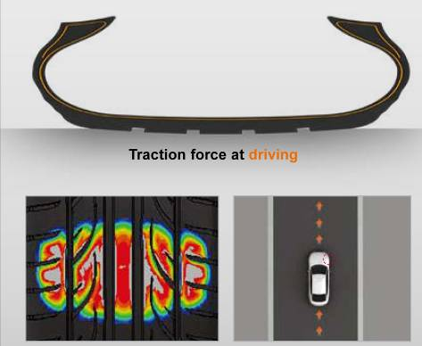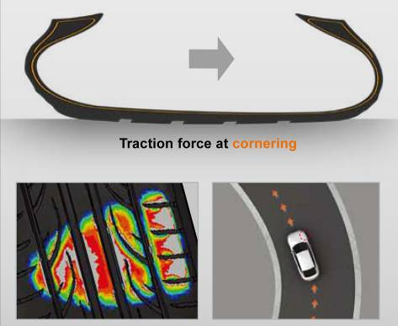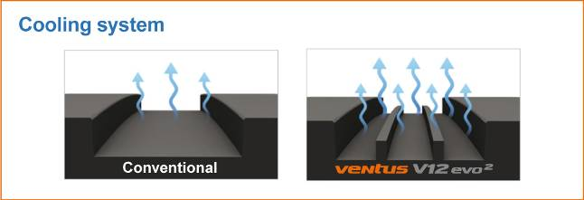*

1. *Secure water channelling on wet streets*

* *The flow optimised tread grooves channel water optimally and quickly.*

*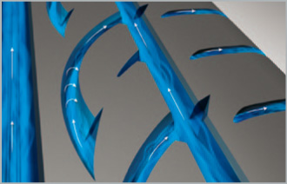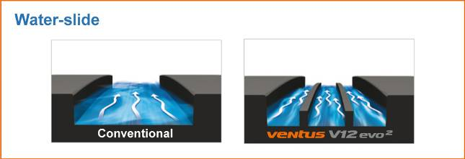*

1. *Reduced noise development*

* *Elaborate 5-pitch design and special block edges minimise rolling noise.*
* *The dimple sidewall design reduces noise and vibrations at high speeds.*

*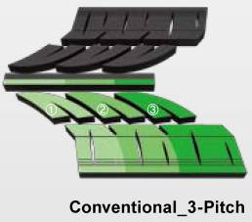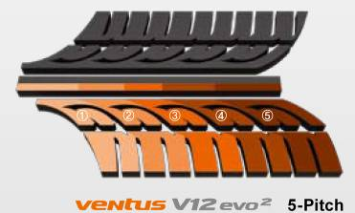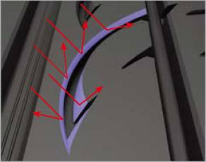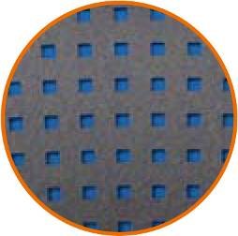*

1. *Improved rolling resistance*

* *New styrene polymer compound technology*

*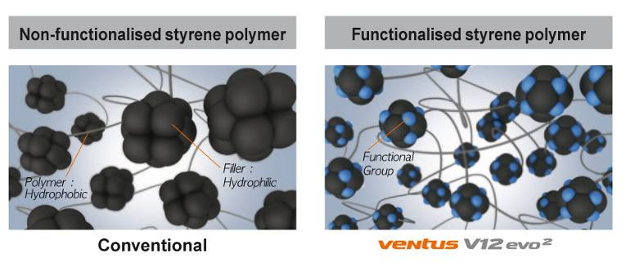*

1. *Vehicle Alignment Indicator*

* *Gives drivers the convenient and practical option of checking their wheel alignment by comparing the wear on the sipes of both tyre shoulders.*

*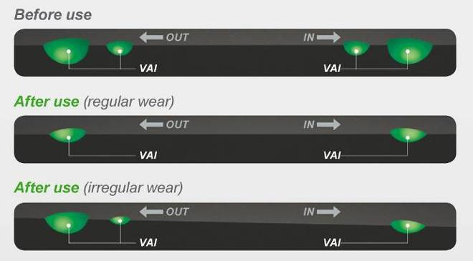*

1. *Line-Up*

* *The line-up will initially be available in sizes 16 to 19 inches covering the 30 to 50 series with tread widths of 195 to 255.*

*\*Kontrol Technology*

*Derived from the English terms* ***K****inetic (for movement) and C****ontrol*** *(for control), Hankook Tire Kontrol Technology reflects the best possible controllability of the interaction between the driver, the vehicle and the road by the tyres during the journey. Kontrol Technology has been developed in order to provide the vehicle driver with all currently available benefits of the latest Hankook tyre technology in terms of safety, driving characteristics, comfort and environmental compatibility.*

그림 10그림 11그림 12그림 13

###

**Noise-reducing sound absorber® technology**

**invented by premium tyre maker Hankook**

**Hankook’s innovative sound absorber**® **technology used on the flagship Ventus S1 evo² SUV tyres.**

Hankook’s ultra high-performance tyre Ventus S1 evo² SUV is the first tyre to be equipped with the sound absorber® technology, creating a comfortable, luxurious driving experience. The sound absorber® tyres have a specialised polyurethane foam plate attached to the inside of the tyre during the manufacturing process. By using the sound absorber® technology, the noise level generated inside of the tyre can be reduced by 5 to 7 dB(A).

The Ventus S1 evo² SUV is a tyre that combines sporty and dynamic driving characteristics with high suspension comfort, very low rolling noise, and reduced rolling resistance. The safety features, including for instance wet grip, were also specially tailored to the needs of drivers of high-performance luxury class SUVs.

By using the sound absorber® technology, Hankook’s engineers have developed an ultra high-performance model without losing any necessary comfort features, a must for this type of luxury car. Since higher interior noise is typical for lighter tyres with smaller aspect ratios, this reduction was a central aspect of the project and a focus of the development work, whose goal was to create a driving experience that is both high-performance and comfortable.

The advanced technology of the Ventus S1 evo² SUV with multi-tread radius always ensures the best possible tyre contact surface under all conditions. The tyre impresses not only for its outstanding aquaplaning performance, but also with optimal street contact for a perfect balance on wet and dry streets. Driving control and safety at high speeds were also significantly improved. The innovative, DTM-inspired 3-layer block design with specialised step arrangement of the outer rib blocks provides a better contact surface for the tyre as tyre wear increases, and guarantees high traction performance throughout the entire life cycle of the tyre.

A modern, high-grip styreme polymer silica compound facilitates not only optimised wet grip, but also a lower rolling resistance. Optimised wear and thermal aging resistance also contributes to a better service life and to the economic efficiency of the tyre. The sophisticated cooling system of the tyre also facilitates quicker heat dissipation for more stable handling and an overall longer service life for the tyre.

**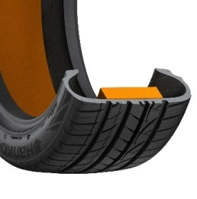Hankook ®**

**Hankook’s “sound absorber ®” technology for the Ventus S1evo 2SUV:**

* Sound absorber ®: Hankook’s patented technology for noise reduction.
* Reduces interior noise through a specialised, lightweight foam layer.
* The tyre’s driving characteristics remain unchanged.

###

**Hankook Tire’s first SEALGUARD® OE Fitment   
to Volkswagen Touran and Passat Models**

**Hankook Tire’s first self-sealing tyre, the Ventus Prime² SEALGUARD®, is to be OE fitted on the Volkswagen Touran. Hankook Tire’s exclusive SEALGUARD® self-sealing tyres align with the safety features of the Volkswagen Touran further enhancing the driver’s safety.**

Hankook will supply their Ventus Prime²SEALGUARD® tyres as Original Equipment to Volkswagen, starting with the VW Touran in size 215/55R17 as well as to the VW Passat in 2015/55R17 and 235/40R18. The high performance Ventus Prime² SEALGUARD®, developed with an exclusive self-sealing tyre technology, is designed to increase driver safety, offering a dynamic driving experience as well as outstanding driving comfort.

The unique SEALGUARD® sealing material in the self-sealing tyres repairs punctures to the tyre tread. Since the self-sealing tyres allow continued driving even in the event of a puncture, the vehicles equipped with these advanced tyres no longer need to carry the spares, which frees up extra space in the vehicle, eliminating the need to change tyres on the side of the road. In addition to its safety benefits, Hankook Tire’s SEALGUARD® products offers a high comfort driving experience as both structures are identical to those which aren’t equipped with such technology.

Hankook Tire was selected as the OE supplier to the Touran, fitted throughout Europe with its newly developed Ventus Prime² SEALGUARD®, having completed a rigorous series of tests to ensure the tyre meets Volkswagen’s high internal safety standards. The tyre’s bionic pattern delivers excellent grip performance on dry and wet road surfaces, improving safety for drivers. The innovative tyres’ triple-radius tread technology provides drivers with unsurpassed control when driving at high speeds or taking a sharp curve, even on wet roads. Designed with an advanced hybrid-silica tread compound that incorporates special hybrid polymer chains and nano particles the Ventus Prime² SEALGUARD® is able to maximise wet grip and tread life while simultaneously reducing rolling resistance leading to improved fuel efficiency.

“We are proud to announce that Hankook Tire will successfully begin to supply its Ventus Prime²SEALGUARD® to Volkswagen’s compact Touran MPV as our first self-sealing tyre OE contract, thus further strengthening our longstanding relationship with the Volkswagen Group.” said Mr. Ho Youl Pae, Head of Hankook Tire Europe. He added, “Based on our proven state-of-the-art technology, we will further diversify our SEALGUARD® OE business in the future.”

**Hankook Tire’s self-sealing technology**

Picture2.png **®**

*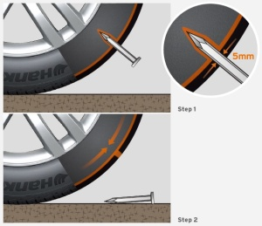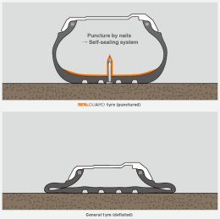Puncture sealing system of SEALGUARD® tyre (self-sealing tyre)*

* The *SEALGUARD®* tyre contains a tacky, viscous material coated   
  from shoulder to shoulder on the inside of the tyre
* When punctured, those damages with a diameter of up to 5mm can  
   be sealed immediately with Hankook’s *SEALGUARD®* technology.
* There is no need for an immediate stop or roadside tyre change.

###

**New Hankook Kinergy 4S all-season tyre:**

**365 days of balanced performance for Europe’s roads**

**With the Kinergy 4S, tyre maker Hankook is launching a brand-new all-weather specialist developed for European road conditions. Representing the fourth generation of all-season tyres from Hankook, the new Kinergy 4S is geared toward continuing to offer drivers in Europe an alternative that features balanced performance and safety through all seasons, including climate change and future legal requirements. The new tyre’s asymmetrical tread combines summer properties related to performance and safety on its block-tread outer side and tested suitability for winter conditions on the inner side, which features 3D sipes. The new Kinergy 4S will be launched in many popular sizes from 14 to 18 inches starting in the second quarter of 2015 and is available as original equipment on some models from leading vehicle manufacturers right away from market launch.**

With its new Kinergy 4S (4S - Four Seasons) all-season tyre, premium maker Hankook is continuing to gear its activities toward quality-conscious, ecology-minded drivers who prefer not to change their tyres every six months, but do not want to – or have to – go without balanced performance and safety. The Kinergy 4S is distinguished by its especially harmonious performance features across all seasons. This makes the tyre an attractive alternative when it comes to ensuring legally compliant year-round mobility as weather conditions in Europe become increasingly changeable. The tyre can be used all year round even in countries with seasonal winter tyre requirements, as it bears the M+S and snowflake symbols (which will be required for winter tyres in Europe, as elsewhere, starting in 2018).

A true all-weather specialist, the Kinergy 4S combines the advantages of a summer tyre – short braking distances and good driving characteristics on both wet and dry surfaces at higher temperatures – with the benefits of a winter tyre, especially in the areas of traction and braking performance under cold conditions or with moderate snowfall. With their asymmetrical tread configuration, the new generation of Hankook all-season tyres adopts major design elements from its successful predecessor type, but the new tyres have been fully redesigned, as the new name also indicates.

The “summer shoulder” of the Kinergy 4S has been given a larger block structure in combination with stepped tie bars between the blocks, aligning it in particular to the more stringent requirements that apply when driving in dry conditions at higher temperatures. Its five-rib tread design also offers excellent stability. Special summer sipes on the outer tread blocks deliver better steering precision even when driving briskly on a dry surface. At the same time, the extra-wide belt package and highly dispersed silica tread compound for maximum bonding of silica and rubber make the tyre especially durable and reduce wear, extending the tyre’s lifespan and boosting cost-effectiveness. In combination with four main grooves of which the outer one comes in slanted design, this ensures optimum drainage, shedding water (or even slush) from the tread with high efficiency and effectively guarding against hydro- or slush planning.

The tyre’s inner tread has a winter design, with a higher number of sipes and blocks providing secure braking abilities in fall or winter weather conditions. An optimised tread surface with V-shaped crosswise grooves also enables controlled handling on snowy roads. Winter tread wear indicators incorporated into the tread grooves at regular intervals also make it quick and easy for drivers to check whether the tread meets the minimum depth requirements for winter tyres.

Hankook is one of the first manufacturers to have recognised the potential of all-season tyres for the European market, and has been deliberately advancing its development efforts in this segment since the 1990s. The model that preceded the Kinergy 4S, the highly successful Optimo 4S was already granted the coveted German Federal Environment Agency (UBA) Blue Angel for environmentally friendly driving back in 2008 in recognition of its excellent safety and performance features combined with outstanding fuel efficiency.

“In developing our new all-season tyre, we focused on achieving a further improved combination of crucial winter and summer features in a single tyre in order to offer drivers a high-quality alternative to regular summer and winter tyre changes. With its balanced design, the Hankook Kinergy 4S can be a real alternative when it comes to staying mobile all year round – safely, legally, and without a lot of fuss. This is especially true in areas that tend to get less snow and have a more moderate climate, but also for example in urban settings,” explains Gangseung (“Tony”) Lee, Hankook’s Vice President of Marketing and Sales for Europe.

The Hankook Kinergy 4S line-up will initially include 45 sizes ranging from 14 to 18 inches in series 70 to 40 and tread widths from 155 to 255 in T, H and V ratings and in some cases also as extra load.

###

*\* Kontrol Technology*

*Derived from the terms Kinetic and Control, Hankook Tire Kontrol Technology reflects the best possible controllability of the interaction between the driver, the car and the road through the tyres while driving. Kontrol Technology was developed to provide drivers with all of the advantages of the newest Hankook tyre technology that is currently available in the areas of safety, handling, comfort and environmental compatibility.*

그림 10그림 11그림 12그림 13

**Technical characteristics of the Hankook Kinergy 4S**



*1. Improved combination of summer and winter properties*:

* Two differently designed types of sipes provide improved winter performance on the inner side (blue) and strong summer performance (green) on dry and wet surfaces on the tyre’s outer side at the same time.
* 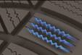Hankook’s 3D sipe system to enhance block stiffness provides optimum support for driving even under tough road conditions, and reduces wear.

**

*2. Improved wet grip and a reduced wear:*

* A highly dispersed Nano Silica mixture enables more even molecular bonding for improved performance on wet roads, a reduced wear and an improved rolling resistance (4 per cent shorter wet braking distance).

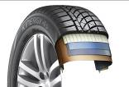

*3. Optimised tyre structure for a 6 per cent improved wet/dry handling*

*and lateral stability:*

- The wide tread belt package in combination with a jointless full cover reinforced belt and a high hardness bead filler provide improved handling, lateral stability and steering response for an overall more precise driving in summer.

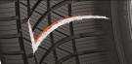

*4. Safe driving in winter:*

* Ice axe inspired V-shaped lateral groves offer effective driving and cornering capabilities on both icy and snowy roads.



* A larger number of tread blocks with a wider design, combined with highly dense self locking sipes, increases the contact area between the sipe and the road, giving the tyre better grip on road surfaces under winter conditions (10 per cent shorter snow braking distance) and an increased traction.

*5. Line-up:*

- The Hankook Kinergy 4S line-up will initially include 45 sizes ranging from 14 to 18 inches in series 70 to 40 and tread widths from 155 to 255 mm in T, H and V speed ratings, partially also as extra load versions (XL).

**Hankook ultra high-performance SUV tyres as original equipment for Porsche Macan**

**Tyre maker Hankook is successfully represented in the premium original equipment sector in the fields of Sports Activity and Sports Utility Vehicles (SUV). The SUV model of the company's flagship tyre, the Ventus S1 evo² SUV, is installed as original equipment on the Porsche Macan among others. Various sizes in 18 and 19 inches are being utilised, which are manufactured in Hankook's state-of-the-art European production facility in Hungary.**

Tyre maker Hankook provides high-performance tyres in original equipment quality for the Porsche Macan and is thus making a statement in its offensive in the premium segment of German car manufacturers.. This is the first time a model from the Stuttgart-based sports car manufacturer is being factory fitted with Hankook's UHP- tyres. The pattern being used is the Ventus S1 evo² SUV, which was introduced in 2014, providing a tread designed especially for this vehicle category with particularly sporty and dynamic genes in mixed tyre sizes 235/60 and 255/55 R 18 or 235/55 and 255/50 R 19 respectively.

"Our flagship tyre is also outfitted with innovative technologies and sophisticated designer features for high performance SUV's and we are excited that Porsche, another German premium automobile manufacturer, shows their confidence in our products as original equipment", says Ho-Youl Pae, President and Chief Operating Officer of Hankook Tire Europe. "Like its little brother from the car segment, the Ventus S1 evo² SUV provides a sporty and direct driving experience combined with safety and comfort, making it another exceptional example of Hankook Kontrol Technology, our philosophy of combining technology, top performance and safety in all of our products."

The concept behind the SUV model derived from Hankook's UHP-flagship, the Ventus S1 evo², is again aimed at driver's of high-performance, dynamic vehicles; driver's that demand sports-like performance from their tyres across all parameters without compromising on features like driving comfort or low rolling noise. "With the new Ventus S1 evo² SUV we have developed an ultra-high-performance tyre that optimally supports the character of sporty and dynamic vehicles like the new Porsche Macan," explained engineer Klaus Krause, Head of the Hankook European Technical Centre in Hanover, Germany.

The particularly sophisticated technology of the *Ventus S1 evo²* SUV with its multiple tread radius and double-layer rayon carcass provides a maximum tread contact area under all conditions. The tyre impresses not only with outstanding hydroplaning behaviour but also with optimum road contact for perfect balance in both wet and dry conditions. Driving control and safety at high speeds are also significantly improved. The innovative DTM inspired 3-layer block design with its special staircase arrangement of the outer rib blocks, provides an improved tyre contact area as tyre wear progresses thereby guaranteeing more effective traction performance throughout the entire life cycle of the tyre.

The *Ventus S1 evo²* SUV is equipped with a highly developed newest generation silica compound with an optimised cross-linking system that improves wet traction, wear characteristics and thermal ageing resistance. The high-grip styrene-polymer formula enables additionally improved wet properties. A refined cooling system, with surface enlarging fins anchored to the base of the tread grooves and micro-turbulence generating dimples arranged on the outer edges of the shoulder block enable faster heat dissipation for more stable handling characteristics and longer tyre durability. In order to make the driving experience even more comfortable the Hankook UHP flagship is equipped with an aerodynamically shaped sidewall that further reduces tyre noise and highlights the tyre's sporty look.

The *Ventus S1 evo² SUV* line-up is manufactured primarily in the company's European state-of-the-art factory in Hungary. Its line-up currently consists of 37 sizes between 17 and 22 inch of the 65 to 30 series with tread widths ranging from 225 to 315 mm, mainly in extra-load version (XL) and speed indices W/Y.

**###**

***Kontrol Technology***

*Derived from the terms Kinetic and Control, Hankook Tire Kontrol Technology reflects the best possible controllability of the interaction between the driver, the car and the road through the tyres while driving. Kontrol Technology was developed to provide drivers with all of the advantages of the newest Hankook tyre technology that is currently available in the areas of safety, handling, comfort and environmental compatibility.*

그림 10그림 11그림 12그림 13

**Hankook Ventus S1 evo² SUV:Technical characteristics**

1. 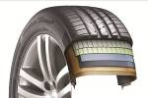*DTM-developed tread with Multi-Tread-Radius and double layered rayon carcass for especially even ground*  *pressure distribution thanks to an ideal tyre contact area. Considerable weight reduction by using* ultra- lightweight yet high tensile steel cord material for the belt package:

- Dynamic handling even under tough conditions

- Outstanding driving stability at high speeds

- Higher driving comfort and low rolling noise

- Improved performance especially in lateral hydroplaning

1. *DTM inspired 3-layer block design for constant high traction*

- Staircase-shaped design of the outer rib blocks to increase the

contact area for constant high traction and braking performance.

*3.* *State-of-the-art tread compound to optimise wet braking performance and mileage:*

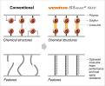 - Specially developed styrene-polymer for further

enhancement of wet brake performance.

- Optimised molecule linking system to improve

wear characteristics and heat-ageing resistance.

*4.* *Advanced cooling system and aerodynamic tyre wall for improved heat regulation:*

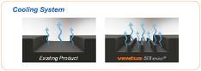 - Surface enlarging cooling fins in the base of the principal tread grooves

for continuous heat reduction thus more stable handling characteristics.

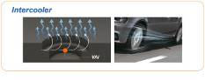 - Cooling micro-turbulences via two-stage dimples at outer

tread blocks and side wall to reduce heat build-up.

*5.* *Vehicle Alignment Indicator*

 - Offers drivers the practical option to check the wheel alignment by comparing the tread wear on both inside and outside tyre shoulders.

*6.* *Available sizes:*

- The Ventus S1 evo² SUV line-up consists of currently 37 sizes from 17 and 22 inch diameter with tread

width between 225 to 315 mm in nominal aspect ratios 65 to 30, mainly in extra-load version (XL) and

speed indices W/Y.

**Hankook achieves new premium original equipment approval for summer and winter tyres**

**Tyre maker Hankook will be supplying its premium tyres to the new BMW 7 Series as original fitment. The new generation of the BMW Group's luxury limousine will be fitted with Hankook’s ultra-high performance summer and winter tyres Ventus S1 evo² and i\*cept evo, both in runflat versions. The tyres have been developed in the company’s German-based European R&D Centre and are supplied to BMW directly from Hankook’s European high-end factory in Hungary.**

Hankook Tire has been selected as one of the original equipment suppliers for the all new BMW 7 Series.

The brand new luxury limousine by the Munich-based premium car maker will feature on Hankook tyres amongst others when rolled off the factory production line. Hankook’s high-end premium flagship tyre Ventus S1 evo² will be fitted in special runflat sizes 245/50 R 18 Y\*RSC (Runflat Safety Component) alongside mixed sizes 245/45 R19 Y\*RSC for the front and 275/40 R19 Y\*RSC for the rear axle providing ultra-high performing summer mobility. The tyre manufacturer’s ultra-high-performance cold weather pattern Winter i\*cept evo will be supplied in size 245/50R 18 H \*RSC on each corner ensuring superior winter performance is achieved.

The 7 Series Sedan is the seventh model by the BMW Group to be fitted with Hankook tyres including MINI, the BMW 1, 2, 3, 4 and 5 Series as well as the X5. This marks another important milestone in Hankook’s global expansion in to the premium automotive segment since it is the first time the tyre maker is supplying both summer and winter tyres to the BMW Group as original equipment. “We are proud to be supplying not only our UHP flagship tyre to the new 7 Series, but for the first time have also been chosen as the winter tyre original equipment supplier with our advanced runflat technology within this prestigious segment”, says Ho-Youl Pae, Head of Hankook Tire Europe.

During the intensive trial phase the tyres have proven to provide a high level of driving comfort whilst maintaining distinctively dynamic driving characteristics. The tyres had to meet the highest of demands in relation to dry handling performance, rolling resistance whilst providing low interior and exterior noise. “Excellent driving and comfort features had to be combined with exceptional wet and snow performance. This not only required the development of a special tread compound but also finding a fundamentally new balance between compound, tread design and construction”, explains Klaus Krause, Head of the Hanover-based European Technology Centre (ETC) at Hankook Tire, where the tyre development for the BMW Group in Europe takes place. “Winter tyre development is even more demanding, particularly for the high development objectives of reduced noise as winter tyres by nature have more block edges which generally lead to increased noise levels.”

Hankook’s ultra-high performance snow tyre Winter i\*cept evo in size 245/50 R \*RSC has been designed to provide superior performance especially in central and western European winter conditions by optimising wet, dry and snow performance. The tyre’s inside-to-outside asymmetric groove tread delivers a high level of stylish perfection with an enhanced pitch design that guarantees the optimal driving experience which was recently also awarded with the internationally renowned Red Dot Design Award.

At present roughly 50 engineers and technicians are developing bespoke tyre solutions for European car manufacturers at Hankook’s European Technical Center in Hanover, Germany. This is also where Hankook’s original equipment BMW Group tyres are developed and tested, with production taking place at the European plant in Ráclamás, Hungary. The company’s state-of-the-art factory specialises in the production of passenger car tyres for the European market and ranks among the most modern production facilities in the world.

###

**Hankook Design Tyres on visionary Opel GT Concept**

**Hankook’s futuristic concept tyres in a roller skate design are the result of a cooperation between Hankook and the traditional car maker Opel. The premium manufacturer has developed special red and black tyres for the fascinating Opel GT Concept study which, despite their prototype status, permit speeds in the three-digit km/h range. The red Hankook tyres on the front axle in particular place a focal emphasis to the futuristic look of the sports car study.**

With its concept tyres on the new Opel GT Concept, premium tyre maker Hankook is underlining its claim to take an active part in designing the tyre of the future. Despite its prototype status and futuristic roller skate design, the specially solid coloured tyres, red placed on the front axle and black on the rear axle, can be driven at speeds of up to 100 km/h. The tyre sidewall and tread design follows the seamless curves and futuristic look of the GT body reflecting the dynamic flowing shapes of the study. Its sophisticated door mechanism permits a pleasing view of the tyres especially adapted tread design including the incorporated GT logos.

When producing the concept tyres, Hankook engineers faced challenges of preparing the sidewall and tread pattern alongside the creation of rubber colour samples according to Opel specifications. The red front tyres in particular are reminiscent of the Opel Motorbike Motoclub 500 unveiled in 1928 that are an essential visual component of the study forming the beginning of the striking red “signature line” which highlights the contour of the GT Concept and makes it distinctive, resembling that of a pictogram. The prominent colouring is made possible by a special tread and side wall compound which contains alternative filler materials on a white colour basis rather than carbon black.

Design and structure of the concept tyres are similar to regular road tyres despite the red and black colour differences they both provide an identical construction. Referencing sizing of the concept tyres, they correspond approximately to the conventional tyre size 225/40R18.

The following processes of production are similar to the manufacturing steps for regular road tyres using the rapid prototyping method and subsequent construction of a mould, with suitable red and black rim inserts also produced from the same material as the tread compound. Hankook Vice President Klaus Krause, Head of the Company’s European Technical Centre in Hanover, Germany, which played a crucial role in turning the specifications into real tyres, confirms that coloured tyres do not have to remain an element of fun for exhibition cars. “Visual aspects can favour coloured tyres by all means. They would provide car drivers with further customisation options for their vehicles, and the beautiful Opel GT Concept will certainly provide drivers with an insight to what the future can hold.” However, Krause admits that “in technical terms, taking the coloured design further than the sidewall would lead to significantly higher production costs.”

###

**Hankook Technodome:  
The tyre maker celebrates the inauguration of its new global R&D center to lead the future**

**Hankook Tire aims to solidify its technology leadership in the automotive industry at the high-tech facility by providing an optimal research environment and by implementing Hankook Tire’s ‘Proactive’ corporate culture via innovation in the working process.**

On October 18th, 2016, premium tyre maker Hankook celebrated the opening of its new global research and development center ‘Hankook Technodome’ in Daejeon, Korea, which the company intends to becoming a global top-tier brand based on technological leadership.

Hankook Technodome is an embodiment of Hankook Tire’s strong commitment in R&D innovation, and will act as a core instrument of the company’s global R&D infrastructure. As the high-tech facility provides an optimized research environment, Hankook Tire plans to focus on securing original technology for the future to lead the way of Hankook Tire’s mid-long term R&D plans to lead the latest tyre technology and world class quality. The new R&D center will also play a pivotal role in implementing Hankook Tire’s proactive corporate culture by innovating the working process, and continuously strengthening the company’s R&D capability to step towards a top-tier company.

Hankook Technodome was designed by Foster + Partners, an architectural firm founded by Sir Norman Foster, and integrates Hankook Tire’s cutting-edge technology, vision and culture. Located in Daejeon, South Korea, Hankook Technodome is an outcome of a total investment of KRW 266.4 billion (an equivalent of approx. 220 Million EURO). The R&D center stands on a massive floor space of 96,328㎡, with an R&D building with 6 stories and a residence building consisting of 8 stories, equipped with employee accommodations including a fitness center, medical clinics, cafés and a day care center.

Through Hankook Technodome, Hankook Tire achieves a Gold certification of LEED (Leadership in Energy and Environmental Design) by USGBC (U.S. Green Building Council), one of the most prestigious green building certification systems.

In addition, Hankook Technodome is ready to further strengthen its technological leadership to effectively tackle the rapid changing business environment of the automotive industry as new technologies, such as electric vehicles and self-driving cars, prevail. It is equipped with various state-of-the-art research and testing facilities. The R&D center has introduced the Driving Simulation system as well as 'SPMM (Suspension Parameter Measuring Machine)' to carry out virtual tests and record digital results. At the Hankook Technodome, Hankook Tire will showcase future technology which integrates eco-friendly material, new material development and simulation technology, as well as networking technology.

Also, Hankook Tire plans to fulfill its corporate culture dubbed “Proactive Culture” via Hankook Technodome to solidify its position as a global top-tier company. Under the 'One Company Concept', 10 independent offices and laboratories are housed under the same roof to symbolize that all the offices are of one company. The center arena was created for employees to organically enjoy comfortable and active communication.

Mr. Seung Hwa Suh, Vice Chairman and CEO of Hankook Tire said, “Hankook Technodome is equipped with the high tech facilities and the optimal work environment to strengthen our global competitiveness through innovation, while actively dealing with rapid changes in the business environment and delivering products optimized for various customers’ needs.” He added, “I believe the new Hankook Technodome will be a great foundation to lead the future of tyre technology, as it symbolizes optimized process in development of future technologies and securing original technologies through strengthening our headway towards a global top-tier company.”

**About Hankook Tire**

Hankook Tire is one of the global top 5 companies in the mass production of tyres and manufactures innovative, award winning radial tyres of proven superior quality for passenger cars, light trucks, SUVs, RVs, trucks, and buses as well as motorsports (circuit racing/rallies).

Aspiring to bring consumers the utmost excellence in product quality, technological excellence and driving satisfaction, Hankook Tire continuously invests in research and development maintaining five R&D centers and seven production facilities around the world. Bespoke tyre solutions for the European markets as well as European Original Equipment according to the requirements of leading premium car manufacturers, are developed in the company’s regional Technical Centre in Hanover/Germany. Production for the European region is taking place in the state-of-the-art manufacturing site in Rácalmás/Hungary which was inaugurated in June 2007 and is continuously being expanded. Currently more than 3,000 employees produce up to 19 million tyres a year for passenger cars, SUVs and light trucks.

Hankook Tire’s European headquarters are located in Neu-Isenburg near Frankfurt am Main in Germany. The manufacturer operates further branches in Germany, UK, France, Italy, Spain, the Netherlands, Hungary, Czech Republic, Russia, Turkey, Sweden and Poland. Hankook products are sold directly through regional distributors in other local markets. Hankook Tire employs more than 22,000 people worldwide and are selling their products in over 180 countries. Internationally leading car manufacturers rely on tyres made by Hankook for their original equipment. Approximately 30 percent of the company's global sales are generated within the European and CIS-Region.

For more information please visit [www.hankooktire-mediacenter.com](http://www.hankooktire-mediacenter.com/) or [www.hankooktire.com](http://www.hankooktire.com/)

**Media-Contact:**

**Hankook Tire Europe GmbH | Corporate Communications Europe/CIS**

**Siemensstr. 5a, 63263 Neu-Isenburg | Germany**

Felix Kinzer, Director

Corporate and Finance Communications, Technologies, R&D/Production Operations

Tel.: +49 (0) 61 02 8149 – 170

f.kinzer@hankookreifen.de

Anna Pasternak, PR Manager

LT and Truck & Bus Tyres, Intl. Motorsports, CSR

Tel.: +49 (0) 6102 8149 – 173

a.pasternak@hankookreifen.de

Sabine Riedel, Public Relations

LT and Truck & Bus Tyres, Hankook Media Center, SNS, Corporate

Tel.: +49 (0) 6102 8149 – 174

s.riedel@hankookreifen.de

Larissa Büsch, Public Relations

PCR/ SUV, Event

Tel.: +49 (0) 6102 8149 – 171

l.buesch@hankookreifen.de

Yara Willems, Public Relations Assistant

Corporate, SNS

Tel.: +49 (0) 6102 8149 – 172

y.willems@hankookreifen.de