****

**Press Kit**

**Auto Zurich Car Show**

**Zurich 2016**

**Auto Zurich Car Show**

**10th - 13th November 2016**

Press Kit

**Content**

* **Hankook UHP Premium winter tyres:** Optimised driving during the cold season; Now also with Hankook SEALGUARD® technology; Run-flat original equipment on premium vehicles
* **Hankook Winter i\*cept RS²:** ”Auto Bild Eco-Master 2015” by Hankook receives a “highly recommended” rating from the car magazine
* **Hankook Ventus Prime³:** Premium comfort tyre for Europe is Auto Bild test winner
* **Hankook Ventus S1 evo 2:** Hankook achieved “Outstanding” in *AutoBild Sportscars* Magazine’s 2016 UHP Summer Tyre Test
* **Hankook Ventus V12 evo²:**Performance, design and environmental excellence combined in a wide tyre
* **Noise-reducing sound absorber® technology invented by premium tyre maker Hankook**
* **Hankook is an Original Equipment Supplier for Scania**
* **Hankook Supplies Original Equipment Tyres with 36 Sizes to MAN**
* **Hankook Tire Expands Original Fitment Supply Volume to Include Additional Sizes for Premium Trucks**
* **Hankook and Schmitz Cargobull AG to intensify their strategic cooperation**
* **Hankook SmartControl AW02:** Winter tyres developed for truck steering axles and all other tyre positions
* **Hankook SmartControl DW07:** Winter specialist for the drive axle
* **Hankook Technodome:** The tyre maker celebrates the inauguration of its new global R&D center to lead the future**Hankook UHP Premium winter tyres:**
* **Optimised driving during the cold season**
* **Now also with Hankook SEALGUARD® technology**
* **Run-flat original equipment on premium vehicles**

**Hankook is currently applying further upgrades to its ultra high performance winter tyres for the coming season. The premium winter tyres of the i\*cept evo family, which have been released in a number of sizes for up to 270 km/h, is rounded off with various new sizes for sporty cars and SUVs, run-flat sizes for premium original equipment and, for the first time, includes a SEALGUARD® version. The ultra high performance winter profiles i\*cept evo, i\*cept evo² and i\*cept evo² SUV, which are optimised for winter conditions in Central and Western Europe, are provided with functional full-silica compounds and are already being fitted as original equipment on the new BMW 7 series. The asymmetric tread design used for all three versions ensures sporty yet comfortable handling on wet and dry roads as well as good traction and braking performance on snow-covered ground.**

Premium tyre maker Hankook is continuing to expand the line-up of its current ultra high performance (UHP) winter tyre specialist. Developed in order to guarantee more safety with continued high performance and superior comfort through the increasing changeable weather conditions in the cold season, the winter tyres of the i\*cept evo family have been tailored specifically for upper mid-range vehicles through to luxury saloons and sports cars. Furthermore, the Winter i\*cept evo² is also available in an SUV version, which has been adapted to meet the special requirements of the popular Sports Utility Vehicle category with its double-layer carcass.

In addition, the Hankook SEALGUARD® technology is being used for the first time in a number of sizes for the 2016 winter season, e.g. for the VW models Passat and Touran. The special SEALGUARD® sealing material seals punctures up to a diameter of 5 mm in the area of the tyre tread. This means that journeys can be continued with no problems even in the case of damage caused by puncture. Additionally vehicles that are equipped with self-sealing tyres no longer need to carry spare tyres. This makes more space available in the vehicle, saves weight and eliminates inconvenient wheel changing at the side of the road. In addition to their safety advantages, products equipped with Hankook SEALGUARD® technology offer particularly comfortable driving pleasure, as the tyres essentially have the same structure as the models without this technology.

Hankook Winter i\*cept evo tyres are also available in various dimensions as run-flat versions with reinforced sidewall for many BMW vehicles amongst others. Thus the Hankook Winter i\*cept evo in the size 245/50 R18 HRS (Hankook Runflat System) has been fitted as original equipment to the BMW 7 series.

Snow, ice, frost, heavy rain or wet leaves often produce dangerous road conditions in winter. The Hankook winter profiles i\*cept evo, i\*cept evo² and i\*cept evo²SUV are therefore meeting these challenges with maximum-grip tread compounds and optimised design functions. Among other things, a highly dispersible nano-silica compound is used, which prevents hardening of the tyre at low temperatures and thus ensures better grip on wintry and wet roads through greater elasticity of the tyre contact area. The contact area of the tyre has been further improved thanks to further optimisation of the tyre profile, which likewise has a positive effect on grip in snow and rain and moreover ensures improved hydroplaning performance.

The outside of the traditionally asymmetric profile of the Hankook UHP profiles ensures improved snow handling and increased traction performance, whilst the inside guarantees optimised braking performance on snow, slush and wet roads. The snow traction performance is aided by an increased number of profile block edges, which effectively “grip” into the snow. By minimising block movement and wear, specially developed 3D sipes applied to the entire tread area ensure additional driving stability as well as improving the general handling properties with the aid of maximised edge effects. The transverse profiling arranged at an optimised angle on the inside of the profile likewise improves performance on snow-covered roads.

The two wide main drainage grooves offer 30 % greater volume for particularly efficient drainage of water or snow slush. With the Hankook Winter i\*cept evo², they aid grip in the snow and hydroplaning performance for a safer driving experience on wet and slushy roads. In conjunction with the wide design of the tyre shoulder and the optimised cubic block design, a reinforced sidewall and bead area ensure direct steering response as well as improved cornering grip and optimised handling performance on dry roads too.

Both the Hankook winter tyre models i\*ceptevo, i\*cept evo² and i\*cept evo² SUV as well as the Hankook SEALGUARD® system are manufactured predominantly in the modern European production plants of Hankook in Hungary. The various i\*ceptevo versions are available in a total of 155 different dimensions for upper mid-range vehicles through to luxury saloons, sports cars and all popular SUVs.

The **Hankook Winter i\*cept evo** is supplied in 25 dimensions from 15 - 18 inches with tread widths of 185 - 265 mm and aspect ratios of 70 - 45 in the speed indices H and V, some with **HRS** (Hankook Runflat System) as sidewall-reinforced run-flat tyres suitable for many BMW models.

The **Hankook Winter i\*cept evo²** is available in a total of 87 sizes from 15 - 20 inches with tread widths of 195 - 295 mm and aspect ratios of 60 - 30 in the speed indices H, V and W, mainly as designs with increased load capacity (Extra-Load ‒ XL). The Hankook **SEALGUARD®** technology is being offered for the winter season 2016 initially for the tread Winter i\*cept evo² in the sizes 215/60 R 16 H and 215/55 R 17 V for the Volkswagen models Passat and Touran amongst others.

The **Hankook Winter i\*cept evo² SUV** is available in 37 sizes from 16 – 21 inches with tread widths of 215 – 315 mm and aspect ratios of 70 – 35 in the speed indices T to W.

**Technical Characteristics of the Hankook Premium Winter Treads**

**i\*cept evo, i\*cept evo² and i\*cept evo² SUV**

**w320_F_kerf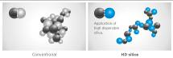**

1. *High-dispersible nano silica ~~t~~read compound*

* Improved wet traction, snow and ice performance.

*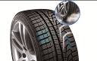*

*2. Double functional, asymmetrical performance tread*

* The outer tread and its compact shoulder profile offer better handling performance on dry roads.
* The inner tread surface increases braking power and traction on wet and snowy streets.
* Especially efficient water and slush removal.

*3. 3D-sipesacross the entire tread surface*

* Optimised driving stability in dry or wet conditions, and better winter performance through minimised block movement.

*4. Lateral grooves on the inside of the profile act like ice axes*

* Improved snow traction through optimised angular arrangement of the lateral grooves.

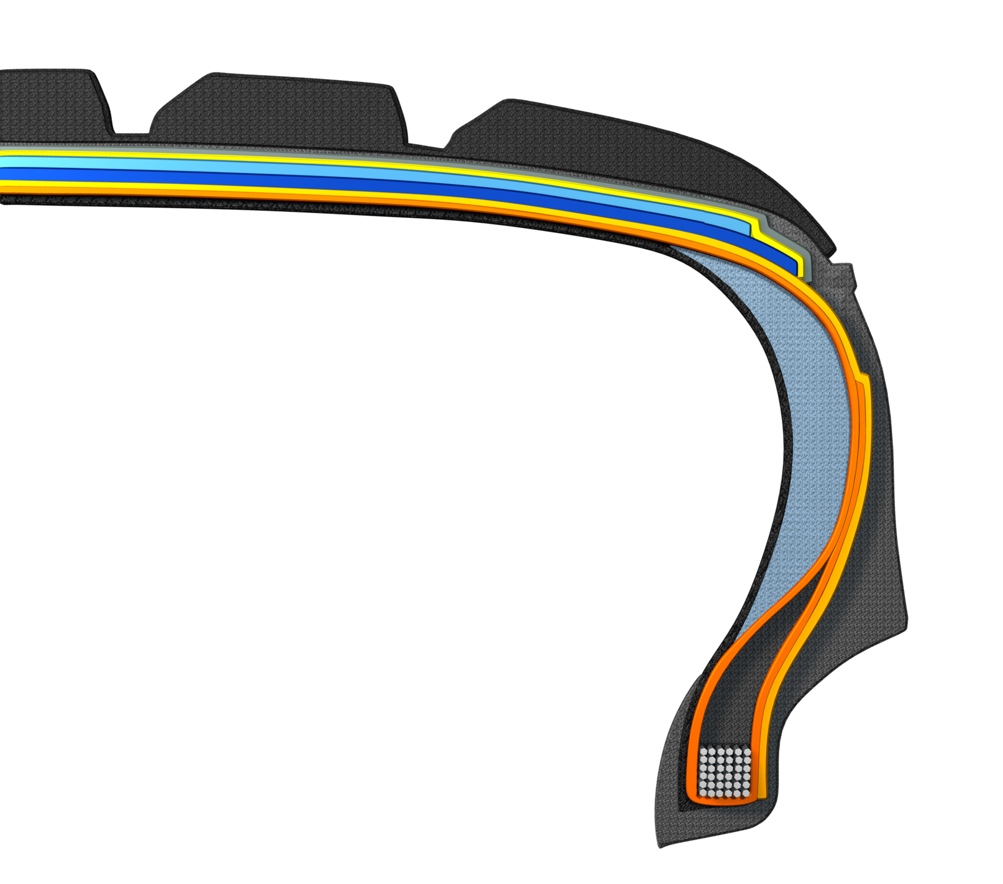

*5. HRS (Hankook Runflat System) technology:*

* *Side wall reinforced tyres with run-flat features.*
* *Available in various sizes, including for many BMW models, in the i\*cept evo tread.*

*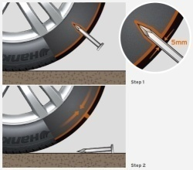6. Hankook SEALGUARD®technology:*

* *SEALGUARD®tyres contain a viscous material with which the interior of   
  the tyre is coated shoulder to shoulder.*
* *In case of a puncture, holes with a diameter of up to 5 mm are immediately   
  sealed off by the Hankook SEALGUARD®technology*
* *Available in various sizes, including for VW Passat and Touran  
  in the i\*cept evo² tread*

*7. Double-layer carcass:*

* *Especially even ground pressure distribution through ideal tyre contact surface.*
* *Outstanding driving stability, especially for high-power, heavy vehicles*
* *Available in a variety of dimensions, made especially for the demands of modern sorts utility vehicles*
* *Tread i\*cept evo² SUV*

**Winter i\*cept RS²: “Auto Bild Eco-Master 2015” by Hankook receives a “highly recommended” rating from Auto Zeitung**

**“Auto Bild Eco-Master 2015”, Winter i\*cept RS² is „highly recommendable,“ write the editors of the Auto Zeitung in their current winter tyre test. Hankook’s specialist for vehicles ranging from compact to mid-sized with very good snow performance and an outstanding price-performance ratio has once again impressed reviewers. Auto Bild emphasised; fuel-saving thanks to low rolling resistance as well as achieving high mileage, the Winter i\*cept RS² is economical and safe. Besides strong performance, the safety-related criteria in wet, snowy, and dry road conditions allowed the Winter i\*cept RS² to beat out 50 competitors.**

The current winter tyre generation by premium manufacturer Hankook offers not only the performance you need in relation to all safety-related criteria in winter, but also a high level of economic efficiency. The Auto Zeitung evaluated this performance as “highly recommendable” (Auto Zeitung 21/16 13 tyre treads from various brands, tested on a VW Golf in size 205/55 R 16).

The Hankook Winter i\*cept RS², nominated by Auto Bild as “Eco-Master 2015” (Auto Bild no. 40 dated 02 October 2015, 50 tyre treads from all brands, tested on a VW Polo in size 185/60 R 15 T) was able to once again beat out competitors, especially when it comes to sustainability and the environment.

“Aspects such as fuel efficiency and the sparing handling of resources are becoming increasingly important for tyre buyers, too,” explains Tony Lee, Hankook’s Vice President of Marketing and Sales for Europe. “Our newly developed winter tyre shows that these days modern, high-performance winter tyres can also meet customers’ requirements in terms of sustainability and environmental compatibility.. We are extremely pleased with the independent test results and the awards for our Hankook Winter i\*cept RS².“

Developed to deliver balanced performance in all wintery driving conditions, the Hankook Winter i\*cept RS² comes equipped with a special nano-sized, high dispersible silica compound, resistant to hardening in low temperatures, and a new solution-styrene butadiene rubber. The compound ensures the tread stays elastic even at very low temperatures, thus providing excellent traction and braking power by increasing the tyre’s contact area, in particular in the cool temperatures and wet roads typical during the colder seasons. The increased void volume of the tyre tread, designed using Hankook Aqua-Slant technology, is achieved through the highly effective interaction between two longitudinal wide grooves on the tread. This offers especially efficient water and slush displacement.

The directional V-shaped tread design of Hankook's Winter i\*cept RS² features 28% more pitches as well as increased groove and block edge length. Enhanced traction on snow covered surfaces is the result of the tread design which effectively bites into the snow. Moreover the corrugated 3D sipes applied throughout the tyre tread increase traction and braking performance on all smooth surfaces. In addition they improve driving stability in wintery conditions by minimising block movement, abrasion and enhancing the overall handling performance through maximised edge effects. Special ice slits and grip claw 3D edges make for further improved cornering performance and snow traction.

Further improvements to the structure of the i\*cept RS² have resulted in an even load distribution and a footprint increase of up to 5% compared to conventional products which has further enhanced the braking performance on both wet and dry roads. The stiffer sidewall and bead area of the tyre ensures more direct steering reactions and improved steering feedback and a more precise lateral stability on dry roads as well.

The Winter i\*cept RS² is available for vehicles ranging from city drivers to compact and mid-sized cars, and even for sedans and family vans. It was specially developed for the climate conditions in middle and western Europe, and is available in 55 sizes from 145/80 R 14 to 225/45 R 17 in speed indexes H and T.

**Technical Characteristics of the Hankook Winter i\*cept RS²**

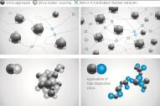

1. *New high-dispersible nano silica ~~t~~read compound for improved winter performance*

* Improved wet traction, snow and ice performance.

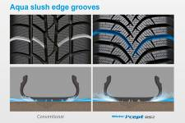

1. *Aqua slush edge grooves for improved wet performance*

* Water and slush are effectively drained away to reduce the risk of aquaplaning and improve wet braking performance.
* Significantly increased traction on snowy and slushy roads.

1. *3D sipes*

* w320_F_kerfEnhanced driving stability and improved winter performance through  
  minimised block movement.



1. *Grip claw technology and increased pitch number for improved snow traction*

* 3D sharp edges improve traction on snow covered roads.
* 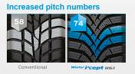28% increase of pitch sequence for high snow grip and increased traction  
  performance.

1. 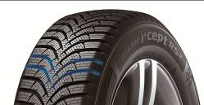*Available sizes:*

* The Hankook Winter i\*cept RS² is available in sizes from 14 – 16 inches, in tread widths of 195 – 275 mm with aspect ratios from 50 – 70 series in speed indexes H and T.

###

**Hankook Ventus Prime³: Premium comfort tyre for Europe is Auto Bild test winner**

**The newest model in the successful Ventus product family for premium performance passenger car tyres was developed to provide an ideal blend of performance, safety, comfort, and environmental friendliness. It was nominated in March 2016 in the summer tyre test by the magazine AUTO BILD as the test winner among 50 other brands in size 205/55R16V (22/03/2016). Besides its fuel efficiency, the tyre stood out by providing the best driving characteristics in its class on wet and dry streets.**

Premium tyre maker Hankook is introducing its new Ventus Prime³ for the European market. The tyre was developed with a focus on providing a balanced blend of performance, comfort, safety, and environmental friendliness, and is the newest premium comfort flagship in the successful Ventus product series offered by the company. Drivers benefit from well-designed driving characteristics, including even better braking performance on both wet and dry streets.

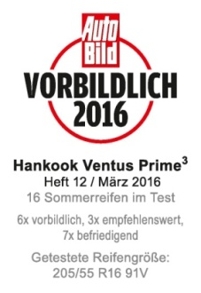Improving braking performance on wet surfaces was a key task for Hankook engineers in developing the next generation of Ventus Prime products. To do so, Ventus Prime³uses a new, high-grip silica tread compound and a new compounding technology which provides much better distribution of polymers and fillers in the tread compound. This allows the tyres to achieve both wet braking performance improved by around eight percent and reducing of rolling resistance. In addition, the four wide profiled grooves ensure fast drainage, which improves vehicle control on wet streets and helps reduce the danger of aquaplaning. The depth of the individual profiled grooves also depends on their position on the tyre, in order to counteract the classic conflict between wet and dry driving characteristics in the Ventus Prime³.

The new Ventus Prime³also made another developmental leap when it comes to dry handling. By using a newly designed, asymmetrical tread, the actual contact surface between the tyre and the street was increased by ten percent. Along with the improved tread stiffness in both radial and lateral directions, and in conjunction with new “hybrid hardness” pattern ribs (different hardness levels on the outside and inside) and a massive outer tyre shoulder, the Ventus Prime³provides significantly better dry performance. The dry braking performance of the tyre was also improved by three percent, whilst the traction was optimised, for instance, by applying chamfered profile block edges distributed across the entire tread surface, increasing the contact surface during braking.

Newly-developed, functionalised polymers with a high molecular weight in the tread blend of the Ventus Prime³increase its wear-resistance by nine percent. The tyre is equipped with a highly-modern, lightweight, and especially sturdy Rayon carcass and a wide steel belt including a wrapped bandage and high-strength bead filler. Besides improving handling, this ensures precise steering feedback and great control, even at high speeds. Thanks to an improved pitch design and the optimised angle of lateral profiling, as well as a sidewall optimised for air resistance, developers were able to further develop the noise level of the tyres, once again improving the outstanding comfort features of the Ventus Prime³. By using a new technology when positioning the profile grooves, development engineers at Hankook were able to achieve a significant reduction in the noise level of the tread, even with improved tyre life.

**Technical features of the Hankook Ventus Prime³:**

1. Improved performance on dry streets:

- Increased profile block stiffness in both radial and lateral directions.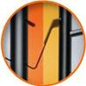

- Tyre contact area increased by ten percent.

- Different hardness levels on the outer ribs, and a massive outer shoulder block for improved curve stability.

- Longitudinally oriented tread design for outstanding directional stability, even at high speeds.

- Chamfered profile block edges broaden the contact surface while braking:  
dry braking power improved by three percent.

- Light, yet highly sturdy Rayon carcass and extremely strong bead filler for better handling characteristics and precise steering feedback.

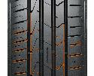

2. Improved performance on wet streets:

- Four wide main tread grooves for especially fast drainage.

- Newly developed, high-grip tread blend and new compounding technology for an improved distribution of polymers and fillers; eight percent better wet braking performance.

3. Reduced noise production and high comfort:

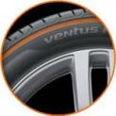- Innovative pitch design and newly developed technology to position the tread grooves in order to reduce noise production on the tread, even with continued use.

- Stable, single-strand bead wire for excellent concentricity / driving comfort.

- Air resistance optimised side wall design to reduce air vortices and vibrations at high speeds.

4. Low rolling resistance and less tyre wear:

- High-grip silica blend reduces rolling resistance.

- Polymers with high molecular weights in the tread compound:

- Wear performance improved by nine percent.

- Visual Alignment Indicator System on the outer tyre shoulder allows drivers to easily check for uneven wear caused by poor body alignment

5. Line-Up:

- The Ventus Prime³ is primarily produced in Hankook’s highly modern European production facility in Hungary, and is available in 53 sizes from 15 to 18 inches, with tread surface widths of 185 to 245 mm, aspect ratios of 65 to 40, and is available in speed classes H, V, W, and Y.

###

**Hankook achieved “Outstanding” in *AutoBild Sportscars* Magazine’s 2016 UHP Summer Tyre Test**

**Hankook Tire’s UHP flagship Ventus S1 evo² is rated ‘outstanding’ in the 2016 German Auto Bild Sportscars UHP Summer Tyre Test and is recognised in particular for its exemplary wet performance in the braking, handling and hydroplaning categories.**

Premium tyre maker Hankook achieved an ‘outstanding’ test result with its UHP flagship tyre Ventus S1 evo² in the 2016 UHP Summer Tyre Test by the renowned German automobile magazine Auto Bild Sportcars. The magazine put six leading tyre brands in the dimensions 255/35 R 20 (front axle) and 295/30 R 20 (rear axle) to the test on a Jaguar F-Type. Hankooks’ Ventus S1 evo² achieved the best test result of ‘outstanding’ and was recognised in particular for its wet performance, sharing an excellent overall result and test win with another European Premium brand.

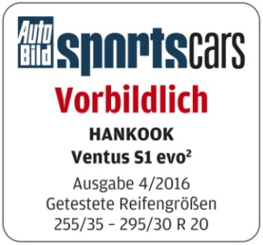

The 2016 Auto Bild Sportscars tyre test reflects various performance aspects including handling and braking on both dry and wet roads, as well as noise level and rolling resistance. During the test, the Ventus S1 evo² showed an overall very strong performance during the handling, braking distances, and hydroplaning as well as noise and rolling resistance tests. The tyre was particularly recognized by the testers for its exemplary performance on wet roads, scoring category wins in the hydroplaning, wet circle and wet braking tests.

Equipped with sophisticated DTM technology, the Hankook Ventus S1 evo² has repeatedly been recognized by premium automakers including Audi, BMW, Mercedes Benz and the Volkswagen Group, for its successful combination of performance, durability, comfort and energy efficiency. The tyre’s asymmetric tread design provides an increased water drainage performance whilst dispersing friction heat. It also guarantees a precise and comfortable driving experience with reduced noise and vibration.

Ho-Youl Pae, COO for Europe at Hankook, explains: “We are extremely pleased with this excellent test result for our UHP flagship model Ventus S1 evo². Regularly achieving such results in independent tyre tests gives proof that our continuous commitment to technology advancement results in products that deliver the best possible driving experience at all times for our customers.”

###

Hankook Ventus V12 evo²:

Performance, design and environmental excellence

combined in a wide tyre

**With the new Ventus V12 evo², tyre maker Hankook presents a new performance and design oriented refitting wide tyre for sports-style inspired drivers. The elegant, directional design of the tread with 3D block structure and aerodynamically optimised sidewall combines style and excellent drive performance with good rolling noise and rolling resistance. As of the market launch, the Ventus V12 evo²is available in 25 refitting sizes ranging from 16 to 19 inches.**

Premium tyre maker Hankook offers the Ventus V12 evo² as a high-performing wide tyre specially developed for the European market and the retrofitting/tuning segment.

The flow-optimised, directional tread consists of the 3D block structure, already known from the predecessor model, which has been enhanced for excellent water channeling. The tyre contour in the Multi-Tread-Radius Technology, derived from the manufacturer's successful involvement with motor sports, in combination with the extremely stiff yet lightweight steel cord material of the belt layer, also guarantees the best possible tyre contact area under extreme stress, for example high cornering speeds.

With the usage of a high traction nano-silica tread compound in combination with the optimisation of tread block stiffness along the entire tread width, braking distances of both dry and wet braking is shortened by 4 to 5 percent. The high traction styrene polymer formula in the rubber compound enables improved wet performance while rolling resistance is reduced for maximised environmental excellence.

A refined cooling system of surface-enlarged fins anchored in the base of the tread grooves enable faster heat dissipation for more stable handling characteristics and longer tyre durability. In order to make the driving experience even more comfortable, like its "big" brother Ventus S1 evo², the new Ventus V12 evo² is also equipped with an aerodynamic shaped wing that further reduces tyre noise and highlights the sports-look of the tyre.

The *Ventus V12 evo²*is manufactured mainly in the company's state-of-the-art European factory in Hungary and will be available in spring 2014 in 25 dimensions starting with 16 to 19 inches with tread widths of 205 to 255 mm in the 30 to 50 series.

**Technical characteristics of the Hankook Ventus V12 evo²:**

1. *Improved handling characteristics*

* *Motor sports tyre contour and extremely stiff, ultra-lightweight belt layer for optimum power transmission*
* *Surface enlarged cooling fins in the tread base of the main grooves provide continuous heat reduction for more stable handling performance.*

*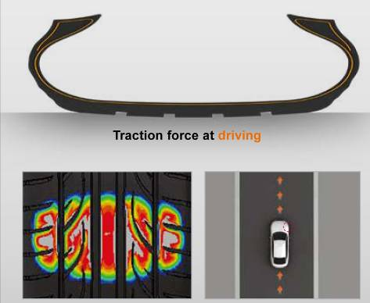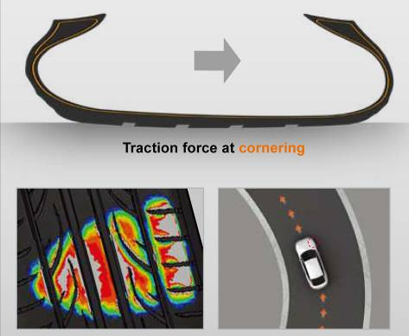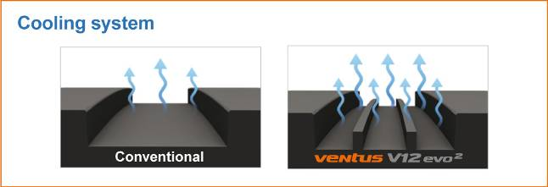*

1. *Secure water channelling on wet streets*

* *The flow optimised tread grooves channel water optimally and quickly.*

*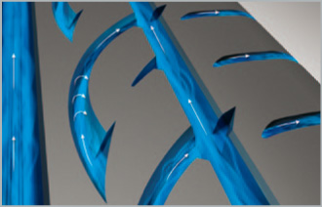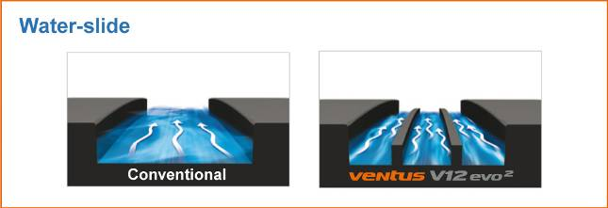*

1. *Reduced noise development*

* *Elaborate 5-pitch design and special block edges minimise rolling noise.*
* *The dimple sidewall design reduces noise and vibrations at high speeds.*

*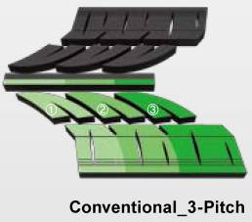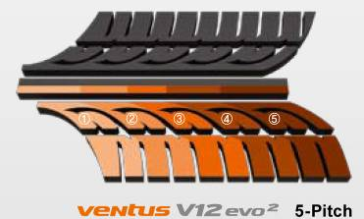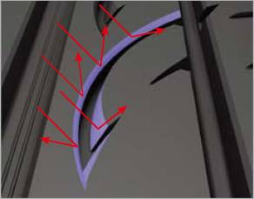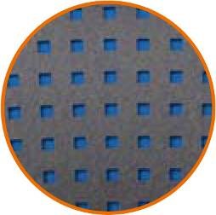*

1. *Improved rolling resistance*

* *New styrene polymer compound technology*

*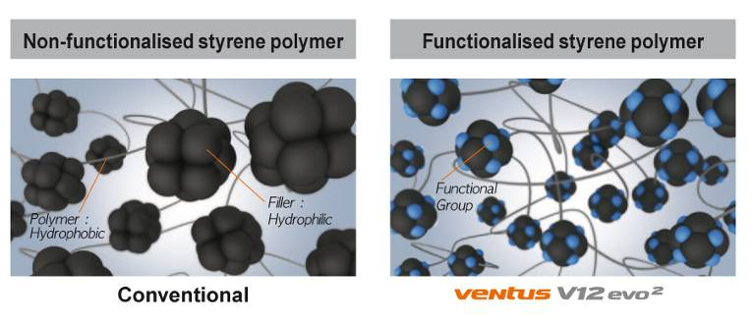*

1. *Vehicle Alignment Indicator*

* *Gives drivers the convenient and practical option of checking their wheel alignment by comparing the wear on the sipes of both tyre shoulders.*

*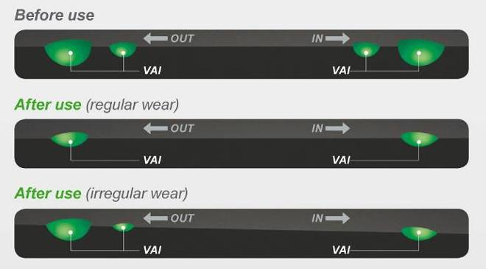*

1. *Line-Up*

* *The line-up will initially be available in sizes 16 to 19 inches covering the 30 to 50 series with tread widths of 195 to 255.*

*\*Kontrol Technology*

*Derived from the English terms* ***K****inetic (for movement) and C****ontrol*** *(for control), Hankook Tire Kontrol Technology reflects the best possible controllability of the interaction between the driver, the vehicle and the road by the tyres during the journey. Kontrol Technology has been developed in order to provide the vehicle driver with all currently available benefits of the latest Hankook tyre technology in terms of safety, driving characteristics, comfort and environmental compatibility.*

그림 10그림 11그림 12그림 13

###

**Noise-reducing sound absorber® technology**

**invented by premium tyre maker Hankook**

**Hankook’s innovative sound absorber**® **technology used on the flagship Ventus S1 evo² SUV tyres.**

Hankook’s ultra high-performance tyre Ventus S1 evo² SUV is the first tyre to be equipped with the sound absorber® technology, creating a comfortable, luxurious driving experience. The sound absorber® tyres have a specialised polyurethane foam plate attached to the inside of the tyre during the manufacturing process. By using the sound absorber® technology, the noise level generated inside of the tyre can be reduced by 5 to 7 dB(A).

The Ventus S1 evo² SUV is a tyre that combines sporty and dynamic driving characteristics with high suspension comfort, very low rolling noise, and reduced rolling resistance. The safety features, including for instance wet grip, were also specially tailored to the needs of drivers of high-performance luxury class SUVs.

By using the sound absorber® technology, Hankook’s engineers have developed an ultra high-performance model without losing any necessary comfort features, a must for this type of luxury car. Since higher interior noise is typical for lighter tyres with smaller aspect ratios, this reduction was a central aspect of the project and a focus of the development work, whose goal was to create a driving experience that is both high-performance and comfortable.

The advanced technology of the Ventus S1 evo² SUV with multi-tread radius always ensures the best possible tyre contact surface under all conditions. The tyre impresses not only for its outstanding aquaplaning performance, but also with optimal street contact for a perfect balance on wet and dry streets. Driving control and safety at high speeds were also significantly improved. The innovative, DTM-inspired 3-layer block design with specialised step arrangement of the outer rib blocks provides a better contact surface for the tyre as tyre wear increases, and guarantees high traction performance throughout the entire life cycle of the tyre.

A modern, high-grip styreme polymer silica compound facilitates not only optimised wet grip, but also a lower rolling resistance. Optimised wear and thermal aging resistance also contributes to a better service life and to the economic efficiency of the tyre. The sophisticated cooling system of the tyre also facilitates quicker heat dissipation for more stable handling and an overall longer service life for the tyre.

**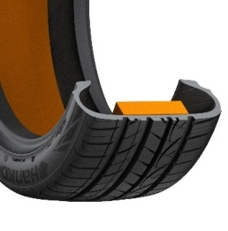Hankook ®**

**Hankook’s “sound absorber ®” technology for the Ventus S1evo 2SUV:**

* Sound absorber ®: Hankook’s patented technology for noise reduction.
* Reduces interior noise through a specialised, lightweight foam layer.
* The tyre’s driving characteristics remain unchanged.

###

**Hankook is an Original Equipment Supplier for Scania**

**Since November of this year, tyre maker Hankook is the OE supplier for various Scania heavy-goods trucks and buses. Scania, based in Södertälje in Sweden, is a part of Volkswagen Truck & Bus GmbH - one of the world’s leading manufacturers of trucks and buses for heavy transport applications. Scania is also leading provider of industrial and marine engines. Service-related products account for a growing proportion of the company’s operations, assuring Scania customers of cost-effective transport solutions and maximum uptime. Scania also offers financial services. From November 2016, Hankook will supply tyres to the production locations of the commercial vehicle manufacturer in Sweden. The equipment provided will include the truck tyre line e-cube MAX for long-haul traffic, as well as the SmartFlex, an all-year tyre for medium-haul applications suitable for the recently optimized Scania Euro 6 model among others. From 2017 onwards, the truck tyre line for construction sites that use SmartWork will also be added at the Sweden production location of the commercial vehicle manufacturer.**

Since November of this year, premium tyre maker Hankook is the Original Equipment Manufacturer to Scania, among others, in the future. Scania is part of the Volkswagen Group, one of Hankook’s largest OE customers world-wide. Hankook’s OE business with truck tyres for Scania will focus on Europe and will initially cover 18 dimensions in the 22.5 inch range. The new OE cooperation with Scania is Hankook’s second within the Volkswagen Group in the heavy commercial vehicles segment; Hankook has already been supplying various models within this segment to the MAN Truck & Bus GmbH since 2014.

“The cooperation with Scania in the original equipment segment is real proof of the quality of our products, since the e-cube MAX, SmartFlex and SmartWork lines were all able to meet the stringent specifications of the Scania engineers particularly in terms of performance, efficiency and sustainability,” says Ho-Youl Pae, COO for Europe at Hankook.

Plans include the equipment of all Scania truck and bus model ranges being produced in Europe. Tyres to be used include the e-cube MAX line for international long-haul traffic, a series which has been optimized for rolling resistance, and the new SmartFlex all-year tyre range, designed for flexible use between long-haul and delivery traffic. Construction site and offroad treads from the SmartWork series will also be introduced. Specially adapted for use on vehicles of the EURO 6 emissions class, the designated treads for the steering and drive axle score particularly well for environmental friendliness and service life – important aspects of TCO (Total Cost of Ownership) in the commercial vehicles OE business.

|  |  |  |  |  |  |  |
| --- | --- | --- | --- | --- | --- | --- |
| **Tread** | **Size** | **LI** | **Marking** |  | **M+S** | **Availability** |
| **AL10+** | 315/80R22.5 | 156/150L (154/150M) | B/B/W1 70dB | - | - | 🗹 |
| 315/70R22.5 | 156/150L | B/B/W1 70dB | - | - | 🗹 |
| 315/60R22.5 | 154/148L | C/B/W1 70dB | - | - | 🗹 |
| **DL10+** | 315/80R22.5 | 156/150L (154/150M) | C/C/W1 73dB | 🗹 | 🗹 | 🗹 |
| 315/70R22.5 | 154/150L | C/C/W1 73dB | 🗹 | 🗹 | 🗹 |
| 315/60R22.5 | 152/148L | C/C/W1 73dB | 🗹 | 🗹 | 🗹 |
| **AL10** | 295/60R22.5 | 150/147K  (149/146L) | C/C/W1 70dB | - | - | 🗹 |
| 295/80R22.5 | 152/148M (154/149L) | C/C/W1 70dB | - | - | 🗹 |
| 385/55R22.5 | 158L (160K) | B/C/W1 70dB | - | - | 🗹 |
| **DL10** | 295/80R22.5 | 152/148M | C/C/W2 75dB | - | 🗹 | 🗹 |
| 295/60R22.5 | 150/147K (149/146L) | D/C/W2 75dB | - | 🗹 | 🗹 |
| **AH31** | 295/80R22.5 | 152/148M | C/B/W1 73dB | 🗹 | 🗹 | 🗹 |
| 315/70R22.5 | 156/150L | C/B/W1 67dB | 🗹 | 🗹 | 🗹 |
| 315/80R22.5 | 156/150L | C/B/W1 73dB | 🗹 | 🗹 | 🗹 |
| **DH31** | 295/80R22.5 | 152/148M | D/C/W2 75dB | 🗹 | 🗹 | 🗹 |
| 315/80R22.5 | 156/150L | D/C/W2 75dB | 🗹 | 🗹 | 🗹 |
| 315/70R22.5 | 154/150L | D/C/W2 75dB | 🗹 | 🗹 | 🗹 |
| **AH15** | 385/65R22.5 | 160K | C/B/W1 70dB | - | - | 🗹 |

**###**

**Hankook Supplies Original Equipment Tyres**

**with 36 Sizes to MAN**

**Currently, tyre maker Hankook supplies 19 dimensions from its original equipment portfolio the bus and truck manufacturer. Among others, Hankook is supplying new sizes of its truck tyre ranges e-cube MAX, SmartFlex and SmartWork for various MAN models to the production facilities of the Munich-based manufacturer in Germany, Austria and Poland. The tyre ranges have been specially adapted for European conditions, boasting both ecological and economic advantages. The MAN Truck & Bus AG belongs to the Volkswagen Group, one of Hankook's largest OE customers worldwide. The OE business with Hankook truck tyres for MAN now covers a total of 36 dimensions in the 17.5, 19.5, 22.5 and 24 inch range.**

Premium tyre maker Hankook is already listed as an OE supplier for MAN with 36 dimensions. At the 66th IAA for Commercial Vehicles, the company will present 19 new dimensions of various Hankook truck tyre lines such as the e-cube MAX, SmartFlex and SmartWork series. The commercial vehicles specialist and the tyre maker have been cooperating since the first quarter of 2015. Ho-Youl Pae, Hankook COO for Europe comments: “The expansion of OE business in the commercial vehicles segment with MAN is of great strategic importance to us, as we can now offer further treads and dimensions for light to medium-duty trucks from MAN.”

The tyres will be fitted to the multi-award-winning MAN vehicle series TGX, TGS, TGM and TGL which are used for national and international long-haul, delivery and construction site traffic. Tyres used include the e-cube MAX line, which is tried-and-trusted for international long-haul traffic, the new SmartFlex all-year tyre range for flexible use between long-haul and delivery traffic, as well as construction site treads from the SmartWork series. Specially adapted for use on vehicles of the EURO 6 emission class, the treads – both as special steering and drive axle versions – score highly for environmental friendliness and mileage. This is also relevant to the TCO (Total Cost of Ownership), important for Original Equipment.

One special feature of Hankook's OE tyre portfolio for MAN are the new sizes in the low-line segment. With these, the premium tyre maker is demonstrating that its portfolio has already integrated the current market trend, namely the growing importance of low-line sizes in the truck business.

*Hankook's range of Original Equipment tyres for MAN:*

|  |  |  |  |  |  |  |  |
| --- | --- | --- | --- | --- | --- | --- | --- |
| **Tread** | **Size** | **Model** | **LI** | **Marking** |  | **M+S** | **Availability** |
| **AL10+** | 315/80R22.5 | TGX | 156/150L (154/150M) | B/B/W1 70dB | - | - | ☑ |
| 315/70R22.5 | TGX | 156/150L | B/B/W1 70dB | - | - | ☑ |
| 315/60R22.5 | TGX | 154/148L | C/B/W1 70dB | - | - | ☑ |
| 355/50R22.5 | TGX | 156L | C/B/W2 76dB | - | - | October 2016 |
| **DL10+** | 315/80R22.5 | TGX | 156/150L (154/150M) | C/C/W2 75dB | ☑ | ☑ | ☑ |
| 315/70R22.5 | TGX | 154/150L  (152/148M) | C/C/W2 75dB | ☑ | ☑ | ☑ |
| 315/60R22.5 | TGX | 152/148L | C/C/W2 75dB | ☑ | ☑ | ☑ |
| **AL10** | 295/60R22.5 | TGX | 150/147K  (149/146L) | C/C/W1 70dB | - | - | ☑ |
| 295/80R22.5 | TGX | 152/148M | C/C/W1 70dB | - | - | ☑ |
| 385/55R22.5 | TGX | 158L (160K) | B/C/W1 70dB | - | - | ☑ |
| **DL10** | 295/80R22.5 | TGX | 152/148M | C/C/W2 75dB | - | ☑ | ☑ |
| 295/60R22.5 | TGX | 150/147K (149/146L) | D/C/W2 75dB | - | ☑ | ☑ |
| **AH31** | 295/80R22.5 | TGM & TGS | 152/148M | C/B/W1 72dB | ☑ | ☑ | ☑ |
| 315/70R22.5 | TGM & TGS | 156/150L | C/B/W2 73dB | ☑ | ☑ | ☑ |
| 315/80R22.5 | TGM & TGS | 156/150L  (154/150M) | C/B/W2 73dB | ☑ | ☑ | ☑ |
| 385/65R22.5 | TGM & TGS | 160K | C/B/W1 69dB | ☑ | ☑ | October 2016 |
| 315/60R22.5 | TGM & TGS | 154L | C/B/W1 75dB | ☑ | ☑ | October 2016 |
| **DH31** | 295/80R22.5 | TGM & TGS | 152/148M | D/C/W2 75dB | ☑ | ☑ | ☑ |
| 315/80R22.5 | TGM & TGS | 156/150L  (154/150M) | D/C/W2 75dB | ☑ | ☑ | ☑ |
| 315/70R22.5 | TGM & TGS | 154/150L | D/C/W2 75dB | ☑ | ☑ | ☑ |
| 315/60R22.5 | TGM & TGS | 154/148L  (152/148L) | D/C/W2 75dB | ☑ | ☑ | October 2016 |
| **AH11** | 215/75R17.5 | MAN TGL | 128/126M | D/C/W1 67dB | - | - | October 2016 |
| 235/75R17.5 | MAN TGL | 132/130M | D/C/W1 67dB | - | - | October 2016 |
| 265/70R19.5 | MAN TGL | 140/138M | C/C/W1 67dB | - | - | October 2016 |
| 285/70R19.5 | MAN TGL | 145/143M | C/B/W1 67dB | - | - | October 2016 |
| **DH05+** | 215/75R17.5 | MAN TGL | 126/124M | D/C/W1 67dB | - | ☑ | October 2016 |
| 235/75R17.5 | MAN TGL | 132/130M | E/B/W2 75dB | - | ☑ | October 2016 |
| 265/70R19.5 | MAN TGL | 140/138M | D/B/W2 75dB | - | ☑ | October 2016 |
| 285/70R19.5 | MAN TGL | 145/143M | D/C/W2 75dB | - | ☑ | October 2016 |
| **AM06** | 325/95R24 | MAN TGS | 162/160K | D/C/W2 72dB | - | ☑ | October 2016 |
| **DM06** | 325/95R24 | MAN TGS | 162/160K | D/C/W2 73dB | - | ☑ | October 2016 |
| **AM15+** | 385/65R22.5 | MAN TGS | 158L | D/C/W2 74dB | - | ☑ | October 2016 |
| **AM09** | 315/80R22.5 | MAN TGS | 156/150K | D/B/W1 67dB | - | ☑ | October 2016 |
| 13R22.5 | MAN TGS | 156/150K | D/C/W1 68dB | - | ☑ | October 2016 |
| **DM09** | 315/80R22.5 | MAN TGS | 156/150K | D/B/W2 72dB | - | ☑ | October 2016 |
| 13R22.5 | MAN TGS | 156/150K | D/C/W2 75dB | - | ☑ | October 2016 |

**###**

**Hankook Tire Expands Original Fitment Supply Volume to Include Additional Sizes for Premium Trucks**

**At the 66th IAA for Commercial Vehicles, Hankook is presenting its premium truck tyres from the e-cube MAX, SmartFlex and SmartWork series for the European market. These are now available in more than 42 sizes and are suitable for the complete Mercedes-Benz Actros and Atego model range. This means that Hankook has almost doubled its portfolio of dimensions for the original fitment of Daimler AG trucks since the cooperation started in 2014.**

Hankook further expands its original equipment (OE) portfolio in the heavy commercial vehicle (HCV) and medium duty segment as part of its existing OE agreements for Mercedes-Benz truck model range: Actros, Antos, Arocs, Axor,Econic and Atego. The tyre maker’s latest original equipment line-up includes the Hankook treads AL10+ e-cube MAX and DL10+ e-cube MAX, as well as the SmartFlex AH31 and SmartFlex DH31, all of which have been specially developed for the European market. Since the start of their original equipment business with Daimler AG, Hankook has expanded its portfolio for the Stuttgart-based truck and bus manufacturer to include more than 42 dimensions.

Hankook supplies multiple options for 22.5 inch tyres, the top-selling standard wheel size for heavy duty trucks in Europe, as well as for commercial vehicle tyres in the 17.5 and 19.5 inch sizes. Extending the OE fitment of the most-demanded heavy duty and medium duty trucks further strengthens the Hankook brand in a highly competitive market and is yet another milestone in the company’s endeavor for sustainable growth in the TBR business.

The e-cube MAX AL10+ (all position long haul) utilises linear grooves with waved walls to prevent uneven wear, enhancing durability and providing improved long-term fuel efficiency. The improved tread compound and high load index of the AL10+ increases fuel efficiency whilst simultaneously increasing load capacity. The e-cube MAX DL10+ (drive axle long haul) offers drivers excellent traction with three-dimensional kerfs and superior long mileage performance with extra-wide tread blocks and deep grooves. The block supporter also provides the DL10+ with boosted longevity and low rolling resistance. Both of these treads will be supplied in three sizes: 315/80R22.5, 315/70R22.5 and 315/60R22.5.

The SmartFlex AH31 is an all-season TBR tyre well-suited for variable road conditions, providing even wear and long mileage performance with significantly lower rolling resistance. The revolutionary drive axle tyre SmartFlex DH31 is perfectly matched for a number of different applications with its cutting-edge technology providing excellent traction in a number of different operating conditions. These include regional, long-haul and winter conditions due to the 3PMSF (Three Peak Mountain Snowflake), and also guarantee high mileage durability. The SmartFlex AH31 and SmartFlex DH31 will be available as original equipment in four sizes: 295/80R22.5, 315/60R22.5, 315/70R22.5 and 315/80R22.5.

In 2014, Hankook Tire was selected as an OE supplier for Mercedes-Benz medium duty ‘Atego’ trucks and the heavy duty model range ‘Actros’. Based on its position as a strategic partner for leading automakers like Mercedes-Benz, Hankook Tire has built a reputation for global top-tier technology and quality products in the TBR segments.

*Hankook original equipment for Mercedes-Benz trucks:*

|  |  |  |  |  |  |  |  |
| --- | --- | --- | --- | --- | --- | --- | --- |
| **Tread** | **Size** | **Model** | **LI** | **Marking** |  | **M+S** | **Availability** |
| **Smart Flex AH31** | 295/80R22.5 | Actros, Antos, Arocs, Axor and Econic | 152/148M  (154/149L) | C/B/W1 72dB | ☑ | ☑ | ☑ |
| 315/60R22.5 | Actros, Antos, Arocs, Axor and Econic | 160K(158L) | C/B/W1 70dB | ☑ | ☑ | ☑ |
| 315/70R22.5 | Actros, Antos, Arocs, Axor and Econic | 156/150L | C/B/W2 73dB | ☑ | ☑ | ☑ |
| 315/80R22.5 | Actros, Antos, Arocs, Axora and Econic | 156/150L (154/150M) | C/B/W2 73dB | ☑ | ☑ | ☑ |
| **Smart Flex**  **DH31** | 295/80R22.5 | Actros, Antos, Arocs, Axor and Econic | 152/148M | D/C/W2 75dB | ☑ | ☑ | ☑ |
| 315/80R22.5 | Actros, Antos, Arocs, Axor and Econic | 156/150L | D/C/W2 75dB | ☑ | ☑ | ☑ |
| 315/60R22.5 | Actros, Antos, Arocs, Axor and Econic | 152/148 L | D/C/W2 75dB | - | ☑ | ☑ |
| 315/70R22.5 | Actros, Antos, Arocs, Axor and Econic | 154/150L | D/C/W2 75dB | ☑ | ☑ | ☑ |
| **AL10+**  **e-cube MAX** | 315/80R22.5 | Actros, Antos, Arocs, Axor and Econic | 156/150L (154/150M) | B/B/W1 70dB | - | - | ☑ |
| 315/70R22.5 | Actros, Antos, Arocs, Axor and Econic | 156/150L | B/B/W1 70dB | - | - | ☑ |
| 315/60R22.5 | Actros, Antos, Arocs, Axor and Econic | 154/148L | C/B/W1 70dB | - | - | ☑ |
| **DL10+**  **e-cube MAX** | 315/80R22.5 | Actros, Antos, Arocs, Axor and Econic | 156/150L (154/150M) | C/C/W1 73dB | ☑ | ☑ | ☑ |
| 315/70R22.5 | Actros, Antos, Arocs, Axor and Econic | 154/150L | C/C/W1 73dB | ☑ | ☑ | ☑ |
| 315/60R22.5 | Actros, Antos, Arocs, Axor and Econic | 152/148L | C/C/W1 73dB | ☑ | ☑ | ☑ |
| **AL 10**  **e-cube** | 295/80R22.5 | Actros, Antos, Arocs, Axor and Econic | 152/148 (154/149L) | C/C/W1 70dB | - | - | ☑ |
| 385/55R22.5 | Actros, Antos, Arocs, Axor and Econic | 158L (160J) | B/C/W1 70dB | - | - | ☑ |
| **DL 10**  **e-cube** | 295/80R22.5 | Actros, Antos, Arocs, Axor and Econic | 152/148M | C/C/W2 75dB | - | ☑ | ☑ |
| **AH15** | 385/65R22.5 | Actros, Antos, Arocs, Axor and Econic | 158L (160K) | C/B/W1 70dB | - | - | ☑ |
| **AH11** | 215/75R17.5 | Atego | 126/124M | D/C/W1 67dB | - | - | ☑ |
| 235/75R17.5 | Atego | 136/134M | D/C/W1 67dB | - | - | ☑ |
| 245/70R19.5 | Atego | 140/138M | C/C/W1 67dB | - | - | ☑ |
| 285/70R19.5 | Atego | 145/143M | C/B/W1 67dB | - | - | ☑ |
| 265/70R19.5 | Atego | 140/138M | C/C/W1 67dB | - | - | ☑ |
| **DH05+** | 215/75R17.5 | Atego | 126/124M | D/B/W1 70dB | ☑ | - | ☑ |
| 235/75R17.5 | Atego | 132/130M | D/B/W1 70dB | ☑ | - | ☑ |
| 245/70R17.5 | Atego | 136/134M | D/B/W1 70dB | ☑ | - | ☑ |
| 265/70R19.5 | Atego | 140/138M | E/B/W1 70dB | ☑ | - | ☑ |
| 285/70R19.5 | Atego | 145/143M | D/B/W1 70dB | ☑ | - | ☑ |
| **AM06** | 10R22.5 | Atego | 144/142K | C/B/W2 72dB | - | - | ☑ |
| 11R22.5 | Atego | 148/145K | D/B/W2 72dB | - | - | ☑ |
| 12R22.5 | Actros, Arocs and Axor | 125/148K | D/C/W2 72dB | - | - | ☑ |
| 13R22.5 | Actros, Arocs and Axor | 154/150K (156/150G) | D/C/W2 72dB | - | - | ☑ |
| 315/80R22.5 | Actros Antos, Arocs, Axor and Econic | 156/150K | D/C/W1 72dB | - | - | ☑ |
| **TH22** | 215/75R17.5 | Actros  (leading axle) | 135/133J | D/B/W1 70dB | - | ☑ | ☑ |
| **SmartWork AM15** | 385/65R22.5 | Actros Antos, Arocs, Axor and Econic | 160K (160J) | D/C/W2 74dB | - | ☑ | ☑ |
| **SmartWork AM15** | 275/70R22.5 | Atego | 148/145K | D/B/W2 74dB | - | ☑ | ☑ |
| **DM03** | 315/80R22.5 | Actros Antos, Arocs, Axor and Econic | 154/150M (156L) | D/B/W2 76dB | - | ☑ | ☑ |
| 13R22.5 | Actros, Arocs and Axor | 154/150K | D/C/W2 76dB |  | ☑ | ☑ |
| 12R22.5 | Actros, Arocs and Axor | 152 / 148 K | D/C/W2 76dB | - | ☑ | - |
| 11R22.5 | Atego | 148/145K | D/C/W2 76dB | - | ☑ | ☑ |
| **AH22+** | 245/70R17.5 | Atego | 136/134M | D/C/W1 70dB | - | - | ☑ |
| **DH05W** | 245/70R19.5 | Atego | 136/134M | D/C/W1 70dB | - | ☑ | ☑ |

**###**

**Hankook and Schmitz Cargobull AG to**

**intensify their strategic cooperation**

**At the 66th IAA for Commercial Vehicles, Hankook and Schmitz Cargobull agreed an early extension to their partnership. This includes expanding the existing supply contracts in the OE segment, strategic cooperation on a European level in the fleet business as well as developing the spare parts business of Hankook trailer tyres through the existing sales cooperation between the Schmitz Cargobull Service Partner network and its mutual service partner Pneunet. Hankook has been equipping Schmitz Cargobull trailer models since 2013 and currently offers 11 different sizes for the original equipment business. The two companies have been collaborating in the full-service business since the beginning of 2015 and are also concentrating on the European market.**

Premium tyre maker Hankook and Schmitz Cargobull AG, Europe's leading manufacturer of truck trailers, have extended their cooperation earlier than planned until 2019 on the occasion of the 66th IAA for Commercial Vehicles in Hanover. The innovative manufacturing and intelligent production technologies used by the company, which specialises in the production of semitrailers for heavy-duty trucks, set benchmarks for especially efficient transport solutions. Hankook TBR trailer tyres have been available at Schmitz Cargobull as original fitment tyres for years as premium products for all trailer types. The cooperation announced at the IAA includes extending the existing supply contracts in the OE segment, increasing the strategic cooperation on a European level in the fleet business, expanding the full-service range as well as developing the spare parts business of Hankook trailer tyres through the existing sales cooperation between the Schmitz Cargobull Service Partner network and joint service partner Pneunet. This cooperation offers the trailer manufacturer's contract customers full-service concepts, including standardised conditions both for tyres as well as for tyre services and tyre management in the vehicle fleet. It also covers tyre changes due to wear, punctures, deadline monitoring and fleet checks (air pressure adjustments). In addition, comprehensive cost and mileage analyses can be made available to fleet operators.

Dieter Olbrich, Vice President for Sales and Marketing of Hankook Tire Europe and Holger Guse, Manager of Truck Distribution at Hankook Reifen Deutschland agree: “Stepping up our partnership with Schmitz Cargobull is of strategic importance to us, particularly since it boosts both our OE and spare parts business in the trailer segment.”

“The further, long-term extension of the strategic partnership with Hankook is the right logical step for us, since Hankook's strategy effectively supports the Schmitz Cargobull strategy,” says Bernhard Schmitz, shareholder and Deputy General Manager - Purchasing. “We feel that the long-term cooperation with Hankook will complement our premium products so that we can deliver optimum transport solutions to our customers.”

Premium tyre maker Hankook supplies Schmitz Cargobull AG with its complete range of state-of-the-art trailer tyres for original fitment. These have been adapted for European conditions, are particularly eco-friendly and economic, and include the Hankook ranges e-cube MAX and SmartWork. The original fitment business for national and international heavy-duty traffic with Hankook TBR trailer tyres for Schmitz Cargobull is initially concentrating on the European market and currently covers 11 trailer sizes in the 19.5 and 22.5 inch range, including the mega-trailer size 445/45R19.5, 435/50R19.5 and 455/40R22.5 of the Hankook e-cube family. All Hankook tyres are delivered directly to the production plants of the trailer manufacturer, which is based in Altenberge in North Rhine-Westphalia.

**###**

**Hankook SmartControl AW02: Winter tyres developed for truck steering axles and all other tyre positions**

**The SmartControl AW02 is Hankook's winter specialist for trucks that can be used on the steering axle and all other positions. Like all the other treads in the SmartControl tyre line, the tyre, which is suitable for use on all axles, not only impresses with the M+S marking but also with the "Three Peak Mountain Snowflake" (3PMSF) symbol, which verifies its high winter performance.**

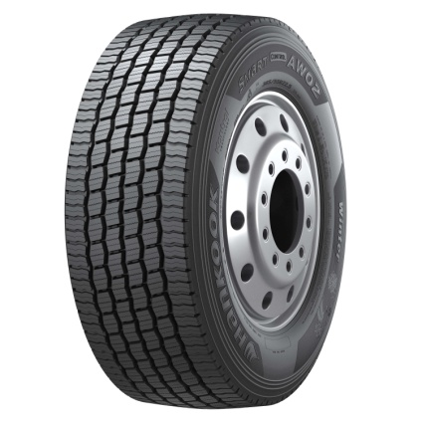The SmartControl AW02 and the SmartControl DW07 for the drive axle are part of Hankook's successful range of winter tyres for trucks which was recently completed at the 66th IAA for Commercial Vehicles in September of this year through the presentation of the trailer tyre SmartControl TW01.

The tyre tread of the SmartControl AW02 is designed entirely with safety in mind. Hankook's winter specialist for trucks has an extra wide tread which increases the contact area between the tyre and the road thereby improving handling. In addition, the tread design with five main drainage grooves enhances water displacement. Furthermore, 3D sipes in the tread surface fulfil two important tasks: On the one hand they ensure even tread wear and thus guarantee high mileage. On the other, in combination with the unique half-open shoulder design of the SmartControl AW02, they provide for outstanding tyre traction on ice- and snow-covered roads. The individual blocks are also connected with ridges that have a stabilising effect for even better handling properties and continuous high performance quality.

In 2015 the SmartControl AW02 received the Red Dot Design Award.

Thanks to the tyre compound especially designed for harsh winter conditions, the tyre is particularly cold-resistant and demonstrates full performance even at very low temperatures. At the same time, the special compound of the SmartControl AW02 achieves high mileage with a reduction of fuel consumption.

*Sizes of the SmartControl AW02 available*

|  |  |  |  |  |  |  |
| --- | --- | --- | --- | --- | --- | --- |
| **Tread l** | **Size** | **LI** | **Marking** |  | **M+S** | **Availability** |
| **AW02** | 295/80R22.5 | 154/149M | D/C/W1 70dB | 🗹 | 🗹 | 🗹 |
| 315/80R22.5 | 156/150L | D/C/W1 70dB | 🗹 | 🗹 | 🗹 |
| 275/70R22.5 | 150/145J | D/C/W1 70dB | 🗹 | 🗹 | In production |
| 315/70R22.5 | 154/150L | D/C/W1 70dB | 🗹 | 🗹 | 🗹 |
| 385/65R22.5 | 160K | C/C/W1 70dB | 🗹 | 🗹 | 🗹 |
| 385/55R22.5 | 160K | C/C/W1 70dB | 🗹 | 🗹 | 🗹 |

**Technical properties of the SmartControl AW02**

***1. Extra-wide tread and five grooves in zigzag design***

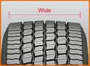

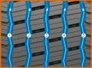

* Larger contact area

- Outstanding handling

- Excellent water drainage

***2. 3D sipes, bars between the blocks and half-open shoulder design***

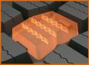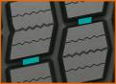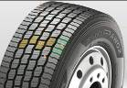

* Even tread wear
* High mileage
* Perfect traction and handling properties

***3. Innovative rubber compound***

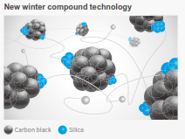

- The tread compound is tuned particularly to wintry conditions and promotes a consistent performance and low rolling resistance even at cold temperatures.

**###**

**Hankook SmartControl DW07:**

**Winter specialist for the drive axle**

**The SmartControl DW07 is Hankook's winter specialist for truck drive axles. The “Snowflake”**(**3PMSF) symbol attests the winter performance of the SmartControl DW07 on snow- and icecovered roads. Compared with predecessor models, the tyre offers up to 25% more traction on snow and up to 13% more mileage on wintry roads.**

The Hankook SmartControl DW07 was developed with use under extreme wintry conditions in European long-haul and delivery traffic in mind. It is part of the SmartControl tyre line, which also includes the SmartControl AW02 for the steering axle and the SmartControl TW01 for trailers.

Drivers and fleets must be equipped to face the toughest of wintry conditions in order to avoid expensive downtimes and arrive safely at their destination. Thus optimum snow traction is a central requirement on winter tyres on the drive axle in transport and delivery traffic, alongside high mileage. The special tread design and the tread compound for the SmartControl DW07 developed for winter use have been optimised particularly for journeys in regions with extremely demanding wintry conditions such as those which occur in northern Europe and the Alps.

The tyre tread of the SmartControl DW07 has been designed especially for snow performance and safety on wintry roads. The tread of Hankook's truck winter specialist for the drive axle is 8% wider than its predecessor model, increasing the contact area between tyre and surface and thus improving grip and handling. In addition, the tread design with five main drainage grooves improves hydroplaning safety. 3D sipes which are very close together in the tread fulfil two important tasks at the same time: on the one hand they ensure more even tread wear and thus guarantee a high mileage. On the other, in combination with the half-open shoulder design of the SmartControl DW07, they produce improved tyre traction on ice- and snow-covered roads. The serrated edges of the tyre tread blocks also support braking and traction performance thanks to optimum tyre grip on wintry surfaces.

Innovative technologies make the SmartControl DW07 particularly efficient. A specially developed tyre compound is used for Hankook's truck winter specialist, which has been optimised for tough wintry conditions and remains flexible even at cold temperatures. The tyre is particularly cold-resistant and has a high braking performance even at very low temperatures. At the same time, the arrangement of the tread blocks has been designed particularly with shock absorption in mind, making even wear and thus a high mileage possible.

*Sizes of the SmartControl DW07 available*

|  |  |  |  |  |  |  |
| --- | --- | --- | --- | --- | --- | --- |
| **Tread** | **Size** | **LI** | **Marking** |  | **M+S** | **Availability** |
| **DW07** | 12R22.5 | 152/148L | D/C/W1 72dB | 🗹 | 🗹 | 🗹 |
| 275/70R22.5 | 148/145J | D/C/W1 72dB | 🗹 | 🗹 | In production |
| 295/80R22.5 | 152/148L | D/C/W1 69dB | 🗹 | 🗹 | 🗹 |
| 315/70R22.5 | 154/150L | D/C/W1 71dB | 🗹 | 🗹 | 🗹 |
| 315/80R22.5 | 156/150L | D/C/W1 72dB | 🗹 | 🗹 | 🗹 |

**Technical properties of the SmartControl DW07**

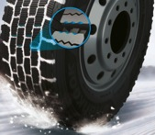

1. ***Pentagonal block design for optimum grip on snow and ice***

* Enlarged pentagonal blocks enable the load to be spread over the whole contact area for optimum winter performance.
* The serrated edges of the tread blocks make optimum grip on wintry surfaces possible for high braking and traction performances.

1. ***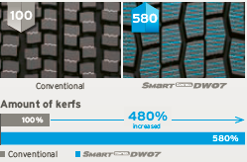3D sipe technology for driving stability and maximised traction on snow***

* Significantly larger number of 3D sipes for high snow grip and traction over the whole service life.
* Half-open shoulder design for improved traction and cornering on ice- and snow-covered roads.

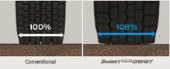

1. ***Extra-wide tread design for optimised driving stability***

* Wider shoulder blocks (+8% compared to the predecessor model) increase mileage by up to 13%.
* Optimised block design for high traction.

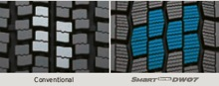

**###**

**Hankook Technodome:  
The tyre maker celebrates the inauguration of its new global R&D center to lead the future**

**Hankook Tire aims to solidify its technology leadership in the automotive industry at the high-tech facility by providing an optimal research environment and by implementing Hankook Tire’s ‘Proactive’ corporate culture via innovation in the working process.**

On October 18th, 2016, premium tyre maker Hankook celebrated the opening of its new global research and development center ‘Hankook Technodome’ in Daejeon, Korea, which the company intends to becoming a global top-tier brand based on technological leadership.

Hankook Technodome is an embodiment of Hankook Tire’s strong commitment in R&D innovation, and will act as a core instrument of the company’s global R&D infrastructure. As the high-tech facility provides an optimized research environment, Hankook Tire plans to focus on securing original technology for the future to lead the way of Hankook Tire’s mid-long term R&D plans to lead the latest tyre technology and world class quality. The new R&D center will also play a pivotal role in implementing Hankook Tire’s proactive corporate culture by innovating the working process, and continuously strengthening the company’s R&D capability to step towards a top-tier company.

Hankook Technodome was designed by Foster + Partners, an architectural firm founded by Sir Norman Foster, and integrates Hankook Tire’s cutting-edge technology, vision and culture. Located in Daejeon, South Korea, Hankook Technodome is an outcome of a total investment of KRW 266.4 billion (an equivalent of approx. 220 Million EURO). The R&D center stands on a massive floor space of 96,328㎡, with an R&D building with 6 stories and a residence building consisting of 8 stories, equipped with employee accommodations including a fitness center, medical clinics, cafés and a day care center.

Through Hankook Technodome, Hankook Tire achieves a Gold certification of LEED (Leadership in Energy and Environmental Design) by USGBC (U.S. Green Building Council), one of the most prestigious green building certification systems.

In addition, Hankook Technodome is ready to further strengthen its technological leadership to effectively tackle the rapid changing business environment of the automotive industry as new technologies, such as electric vehicles and self-driving cars, prevail. It is equipped with various state-of-the-art research and testing facilities. The R&D center has introduced the Driving Simulation system as well as 'SPMM (Suspension Parameter Measuring Machine)' to carry out virtual tests and record digital results. At the Hankook Technodome, Hankook Tire will showcase future technology which integrates eco-friendly material, new material development and simulation technology, as well as networking technology.

Also, Hankook Tire plans to fulfill its corporate culture dubbed “Proactive Culture” via Hankook Technodome to solidify its position as a global top-tier company. Under the 'One Company Concept', 10 independent offices and laboratories are housed under the same roof to symbolize that all the offices are of one company. The center arena was created for employees to organically enjoy comfortable and active communication.

Mr. Seung Hwa Suh, Vice Chairman and CEO of Hankook Tire said, “Hankook Technodome is equipped with the high tech facilities and the optimal work environment to strengthen our global competitiveness through innovation, while actively dealing with rapid changes in the business environment and delivering products optimized for various customers’ needs.” He added, “I believe the new Hankook Technodome will be a great foundation to lead the future of tyre technology, as it symbolizes optimized process in development of future technologies and securing original technologies through strengthening our headway towards a global top-tier company.”

###

**About Hankook Tire**

Hankook Tire is one of the global top 5 companies in the mass production of tyres and manufactures innovative, award winning radial tyres of proven superior quality for passenger cars, light trucks, SUVs, RVs, trucks, and buses as well as motorsports (circuit racing/rallies).

Aspiring to bring consumers the utmost excellence in product quality, technological excellence and driving satisfaction, Hankook Tire continuously invests in research and development maintaining five R&D centers and seven production facilities around the world. Bespoke tyre solutions for the European markets as well as European Original Equipment according to the requirements of leading premium car manufacturers, are developed in the company’s regional Technical Centre in Hanover/Germany. Production for the European region is taking place in the state-of-the-art manufacturing site in Rácalmás/Hungary which was inaugurated in June 2007 and is continuously being expanded. Currently more than 3,000 employees produce up to 19 million tyres a year for passenger cars, SUVs and light trucks.

Hankook Tire’s European headquarters are located in Neu-Isenburg near Frankfurt am Main in Germany. The manufacturer operates further branches in Germany, UK, France, Italy, Spain, the Netherlands, Hungary, Czech Republic, Russia, Turkey, Sweden and Poland. Hankook products are sold directly through regional distributors in other local markets. Hankook Tire employs more than 22,000 people worldwide and are selling their products in over 180 countries. Internationally leading car manufacturers rely on tyres made by Hankook for their original equipment. Approximately 30 percent of the company's global sales are generated within the European and CIS-Region.

For more information please visit [www.hankooktire-mediacenter.com](http://www.hankooktire-mediacenter.com) or http://www.hankooktire.com

**Media-Contact:**

**Hankook Tire Europe GmbH | Corporate Communications Europe/CIS**

**Siemensstr. 5a, 63263 Neu-Isenburg | Germany**

Felix Kinzer, Director

Corporate and Finance Communications, Technologies, R&D/Production Operations

Tel.: +49 (0) 61 02 8149 – 170

f.kinzer@hankookreifen.de

Anna Pasternak, PR Manager

LT and Truck & Bus Tyres, Intl. Motorsports, CSR

Tel.: +49 (0) 6102 8149 – 173

a.pasternak@hankookreifen.de

Sabine Riedel, Public Relations

LT and Truck & Bus Tyres, Hankook Media Center, SNS, Corporate

Tel.: +49 (0) 6102 8149 – 174

s.riedel@hankookreifen.de

Larissa Büsch, Public Relations

PCR/ SUV, Event

Tel.: +49 (0) 6102 8149 – 171

l.buesch@hankookreifen.de

Yara Willems, Public Relations Assistant

Corporate, SNS

Tel.: +49 (0) 6102 8149 – 172

y.willems@hankookreifen.de